# Excel Workshop Report

Dt:21/03/2019

Submitted By:

Pinaki Parasara Panda

Regd:160301120019

# A spreadsheet is essentially a matrix of rows and columns. Consider a sheet of paper on which horizontal and vertical lines are drawn to yield a rectangular grid. The grid namely a cell, is the result of the intersection of a row with a column. Such a structure is called a Spreadsheet. As we had taken the workshop course for the 6th Semester. We learnt about Microsoft Excel about it can help people in making data ready for corporate meetings which will decide much business.

# The ease of understanding can help in making various business environment run smoothly. MS-Excel has integrated into various environments and businesses helping in the process of data storage .Thus this report about it is being submitted as a learning experience and dispense off what was learnt during the workshop.

**Outcome for 20th March 2019:**

* Introduction to MS Excel interface.
* Creating new and opening existing workbooks.
* Saving , Autorecovery and Exporting workbooks.
* Cell Understanding, content,Find & Replace.
* Cell Formatting.
* Modifying columns, rows and cells
* Functions &Formulas
* Analysis operations with data.

**Outcome for 21st March 2019:**

* Learning calculation within data tables off the existing cells addresses.
* Learning to create pivot tables and Pivot charts
* Learning to create line, pie ,bar charts for tables.
* Learning to create various VBA macros.

### Excel Functions:

Excel 2016 has 484 functions. Of these, 360 existed prior to Excel 2010. Microsoft classifies these functions in 14 categories. Of the 484 current functions, 386 may be called from VBA as methods of the object "WorksheetFunction"and 44 have the same names as VBA functions.

The outcomes of the workshop are :

* **Introduction to MS Excel interface.:**

The interface contains the ribbon which is an integral part of the interface. The interface is quite intuitive thus easy to learn.

First and foremost is the worksheet. Each Excel workbook can have an unlimited number of worksheets. Worksheets appear as tabs at the bottom of an Excel workbook window.The worksheet is the main work area in Excel. Worksheets are made up of cells, displayed in a grid created by intersection of rows and columns. At the bottom and right edges of worksheets, are scroll bars.When you select one or more cells in a worksheet, the result is referred to as a selection.In the upper left of the Excel window, you'll find the Quick Access Toolbar, which you can easily customize with the commands most useful to you.Next is the Ribbon. The ribbon is the home for all commands and menus in Excel. It's divided into tabs, and each tab contains a group of related commands. Below the ribbon, at the left, is the name box. The name box displays the current location of the cursor, and can be used to assign names to cells.

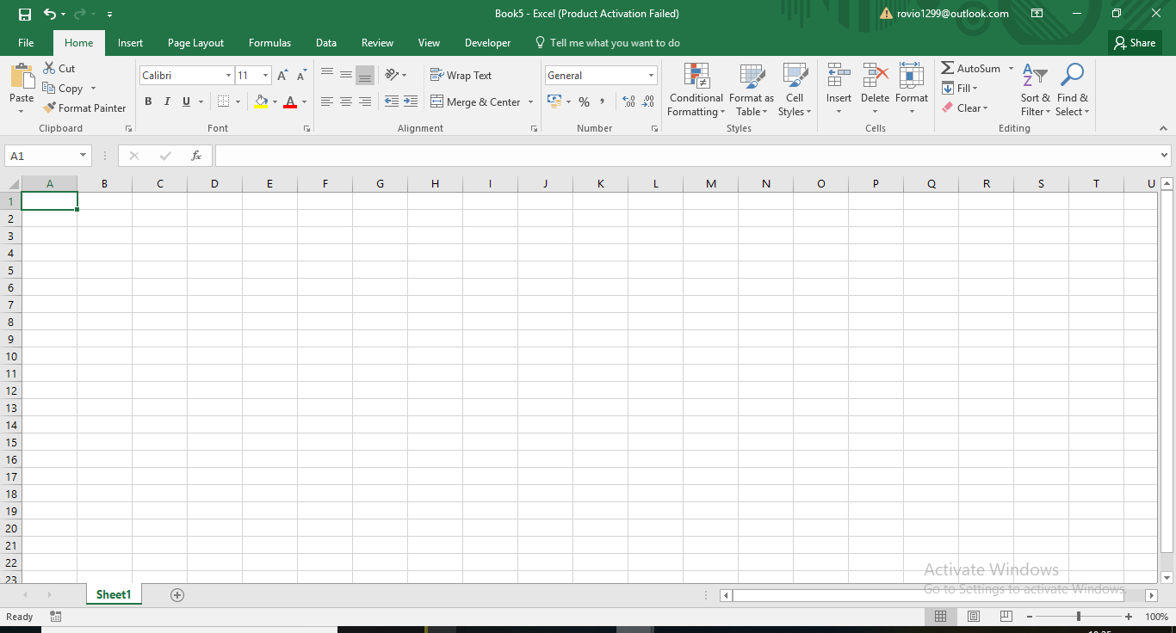

* **Creating new and opening existing workbooks.:**

**Creating and opening are simple tasks to be performed each time .**

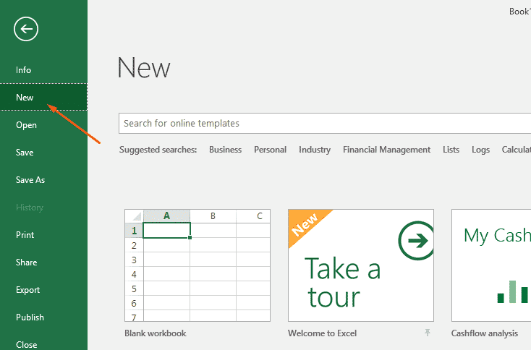

* **Saving , Autorecovery and Exporting workbooks.**

Excel periodically saves a copy of your Excel file. Learn how to recover a file that was never saved and how to recover a file that has been saved at least once.

If Excel crashes, it displays the Document Recovery Pane, the first time you open Excel again. This is a quick way to recover the last autosaved file.

Excel provides us with such good features as **AutoSave** and **AutoRecover**. If they are enabled, it won't be a problem for you to recover unsaved files and restore previous versions in Excel 2016 - 2010. But these two features are often misunderstood, so at first let's define what they mean.

**Excel AutoSave** is a tool that automatically saves a new document that you've just created, but haven't saved yet. It helps you not to lose important data in case of a computer crash or power failure.

**Excel AutoRecover** helps you retrieve unsaved files after an accidental closure or crash. It allows you to restore to the last saved version which displays in the *Document Recovery* pane when you start Excel next time.

If you need to export an Excel file to some other application, e.g. to the Outlook Address book or Access database, you can convert your Excel worksheet to CSV first and then import a .csv file in another program. Below you will find the step-by-step instructions to export an Excel workbook to the CSV format by using Excel's Save As command.

In your Excel workbook, switch to the File tab, and then click Save As. Alternatively, you can press F12 to open the same Save As dialog.

To convert an Excel file to CSV, switch to the File tab and click Save As.

In the Save as type box, choose to save your Excel file as CSV (Comma delimited).

Save your Excel worksheet as a CSV (Comma delimited) file.

Besides CSV (comma delimited), a few other csv formats are available to you:

CSV (comma delimited). This format saves an Excel file as a comma-separated text that can be used in another Windows program or another version of Windows operating system.

CSV (Macintosh). This format saves your Excel workbook as a comma-separated file for use on Mac operating system.

CSV (MS-DOS). Saves your Excel file as a comma-separated file for use on the MS-DOS operating system.

Unicode Text (*txt). This is a computing industry standard supported by almost all current operating systems including Windows, Macintosh, Linux and Solaris Unix. It can handle characters of almost all modern languages and even some ancient ones. So, if you Excel file contains data in a foreign language, save it in the Unicode Text format first and then convert to CSV, as explained in Exporting Excel to CSV UTF-8 or UTF-16.

Note. All of the above mentioned formats save only the active Excel sheet.

Choose the destination folder where you want to save your Excel file in the CSV format, and then click Save.

After you click Save, Excel will display two dialogs. Don't worry, these are not error messages and everything is going right.

The first dialog reminds you that only the active Excel spreadsheet will be saved to the CSV file format. If this is what you are looking for, click OK.

Only the active Excel spreadsheet will be saved to the CSV format.

If you need to save the contents of all the sheets your workbook contains, click Cancel and then save each spreadsheet individually as a separate Excel file (workbook). After that save each Excel file as CSV.

Clicking OK in the first dialog will display a second message informing you that your worksheet may contain features unsupported by the CSV encoding. This is Okay, so simply click Yes.

A worksheet may contain features unsupported by the CSV encoding.

This is how you convert Excel to CSV. The process is quick and straightforward, and you are unlikely to run into any hurdles along the way.

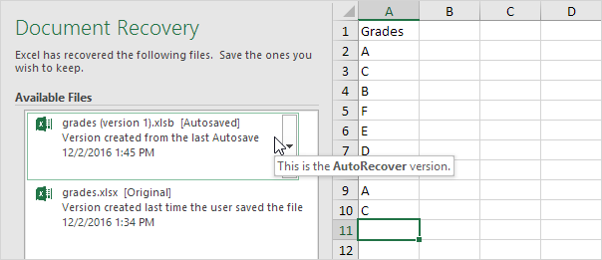

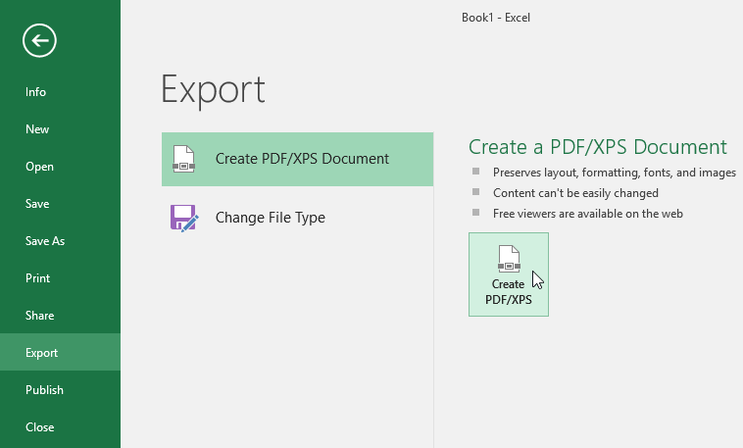

* **Cell Understanding, content,Find & Replace.**

**Oftentimes due to misspelt words or small mistake or various necessary updates the workbook can be searched upon to replace**

FINDING DATA:

Within: Search just the current worksheet or the entire workbook.

Search: Select whether to search first across the rows or down the columns.

Look In: Select whether you want to search through the values or formula results, through the actual formulas, or if you want to look in the comments.

Match Case: Check this box if you want your search to be case-specific

Match Entire Cell Contents: Check this box if you want your search results to list only the items that exactly match your search criteria.

Replacing data:

It’s a simple process of selecting the data to be replaced and giving the necessary replacement data.

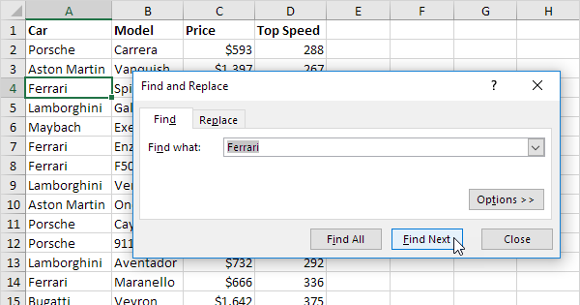

* **Cell Formatting.**

All cell content uses the same formatting by default, which can make it difficult to read a workbook with a lot of information. Basic formatting can customize the look and feel of your workbook, allowing you to draw attention to specific sections and making your content easier to view and understand. You can also apply number formatting to tell Excel exactly what type of data you’re using in the workbook, such as percentages (%), currency ($), and so on

A really important function of the MS Excel platform.It helps in highlighting various data and to emphasize.

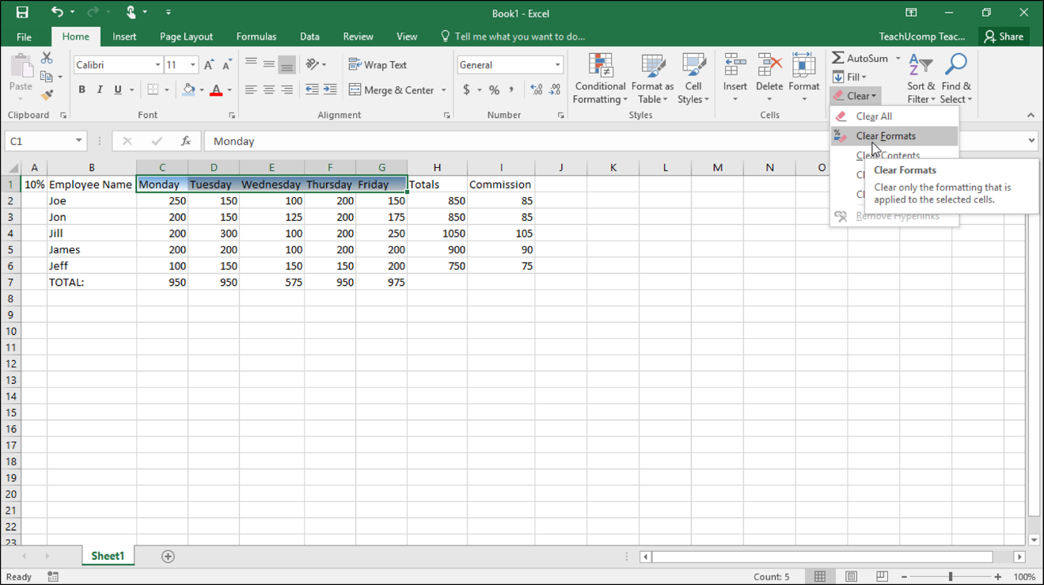

* **Functions &Formulas**

**Formulas**. In **Excel**, a **formula** is an expression that operates on values in a range of cells or a cell. For example, =A1+A2+A3, which finds the sum of the range of values from cell A1 to Cell A3.

Functions. Functions are predefined formulas in Excel

Formulas and functions are the bread and butter of Excel. They drive almost everything interesting and useful you will ever do in a spreadsheet. This article introduces the basic concepts you need to know to be proficient with formulas in Excel.

Cell references:

In the examples above, values are "hardcoded". That means results won't change unless you edit the formula again and change a value manually. Generally, this is considered bad form, because it hides information and makes it harder to maintain a spreadsheet. Instead, use cell references so values can be changed at any time.

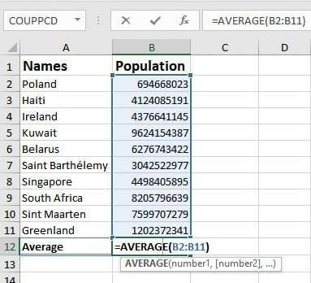

* **Analysis operations with data.:**

Excel provide commands, functions and tools that make your data analysis tasks easy. You can avoid many time consuming and/or complex calculations using Excel. In this tutorial, you will get a head start on how you can perform data analysis with Excel. You will understand with relevant examples, step by step usage of Excel commands and screen shots at every step.

Analysis of various operations is necessary for the better understanding of data.

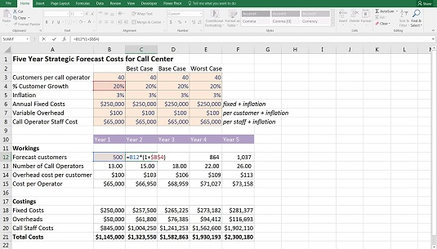

**Calculation:**

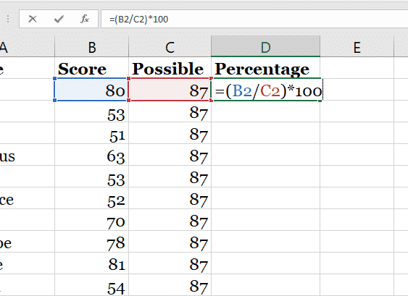

In the above diagram various calculations are performed namely percentage which was essential for validating and analysing the scores.

Instead of using a calculator, use Microsoft Excel to do the math!

You can enter simple formulas to add, divide, multiply, and subtract two or more numeric values. Or use the autosum feature to quickly total a series of values without entering them manually in a formula. After you create a formula, you can copy it into adjacent cells — no need to create the same formula over and over again.

The calculation serves various purposes like collating of forms.Pivot Table:

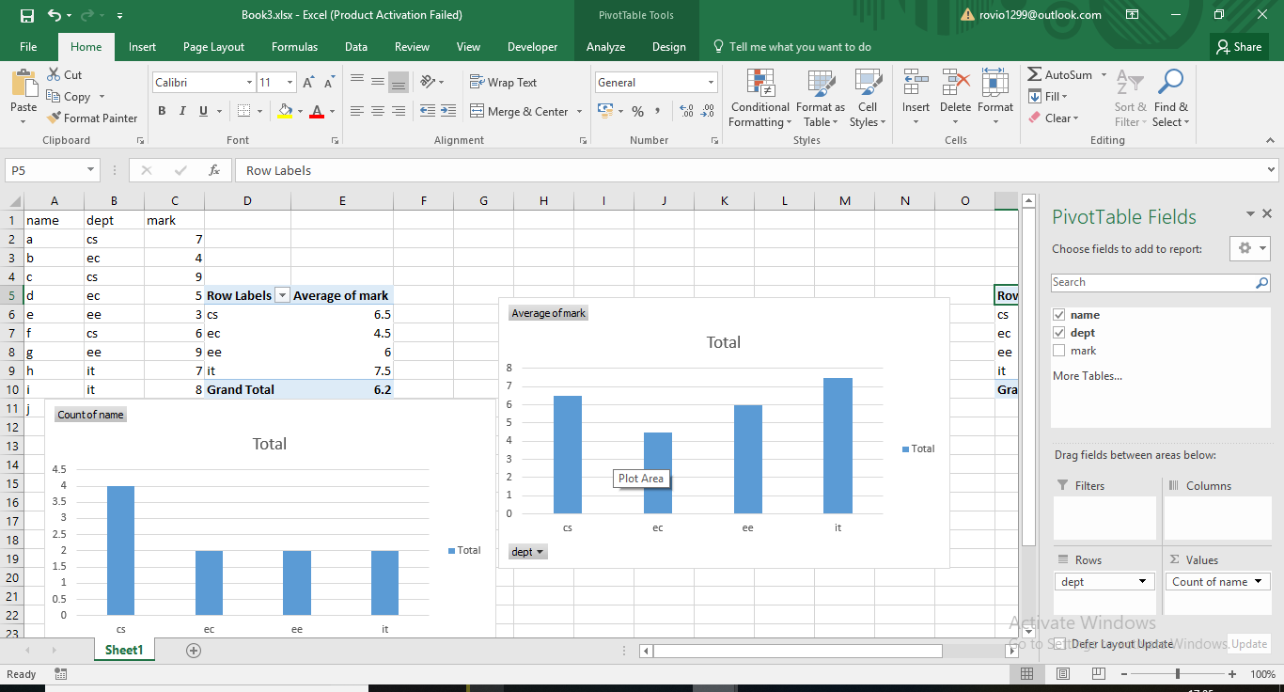

The above is a pivot table during the workshop.

There were quite a few features which were used while making the pivot table:

## Creating a Pivot Table

After your source data is prepared, you can create a pivot table. First, see which pivot table layouts are suggested by Excel.

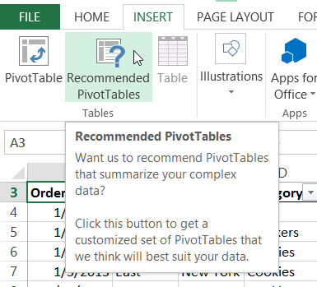

The pivot table was constructed by first selecting the insert option upon ribbon menu and selecting ‘as per necessary’ pivot table construction.

### 

### Line Charts:

**Create a line chart:**

1. The data was selected upon which the desired line chart was used from the insert menu.
2. This gave view for a detailed trend analysis.

**Create a chart:**

It can often be difficult to interpret Excel workbooks that contain a lot of data. **Charts**allow you to illustrate your workbook data **graphically,**which makes it easy to visualize **comparisons** and **trends**.

**Types:**

* Line Chart: The line chart is one of the most frequently used chart types, typically used to show trends over a period of time. If you need to chart changes over time, consider using a line chart.
* Column Chart: Column charts are typically used to compare several items in a specific range of values. Column charts are ideal if you need to compare a single category of data between individual sub-items, such as, for example, when comparing revenue between regions.
* Clustered Column Chart: A clustered column chart can be used if you need to compare multiple categories of data within individual sub-items as well as between sub-items. For instance, you can use a clustered column chart to compare revenue for each year within each region, as well as between regions.
* Stacked Column Chart: A stacked column chart allows you to compare items in a specific range of values as well as show the relationship of the individual sub-items with the whole. For instance, a stacked column chart can show not only the overall revenue for each year, but also the proportion of the total revenue made up by each region.
* Pie Chart: Another frequently used chart is the old pie chart. A pie chart represents the distribution or proportion of each data item over a total value (represented by the overall pie). A pie chart is most effective when plotting no more than three categories of data.
* Bar Chart: Bar charts are typically used to compare several categories of data. Bar charts are ideal for visualizing the distribution or proportion of data items when there are more than three categories. For instance a bar chart could be used to compare the overall revenue distribution for a given set of products.
* Area Chart: Area charts are ideal for clearly illustrating the magnitude of change between two or more data points. For example, you can give your audience a visual feel for the degree of variance between the high and low price for each month.
* Combination Chart: A combination chart is a visualization that combines two or more chart types into a single chart. Combination charts are an ideal choice when you want to compare two categories of each individual sub-item. They are commonly used to create visualizations that show the difference between targets versus actual results.
* XY Scatter Plot Chart: Scatter charts in Excel (also known as XY scatter plot charts) are excellent for showing correlations between two sets of values. For example an XY scatter plot can be used to illustrate the correlation between employee performance and competency, demonstrating that employee performance rises as competency improves. The x and y axes work together to represent data plots on the chart based on the intersection of x values and y values.
* Bubble Chart: A bubble chart is a variation of an XY scatter plot. Just like the XY scatter plot, bubble charts show the correlation between two sets of data. The difference is the addition of a third dimension that is represented by the size of each bubble in the chart. This third dimension is typically used to show the relative impact of a quantitative data item. For instance, in addition to showing employee performance versus competency, you can have the size of each bubble represent years of service, allowing your audience to quickly get a sense of how years of service may affect the relationship between competency and performance.

The data is selected upon which the desired chart from the insert menu is selected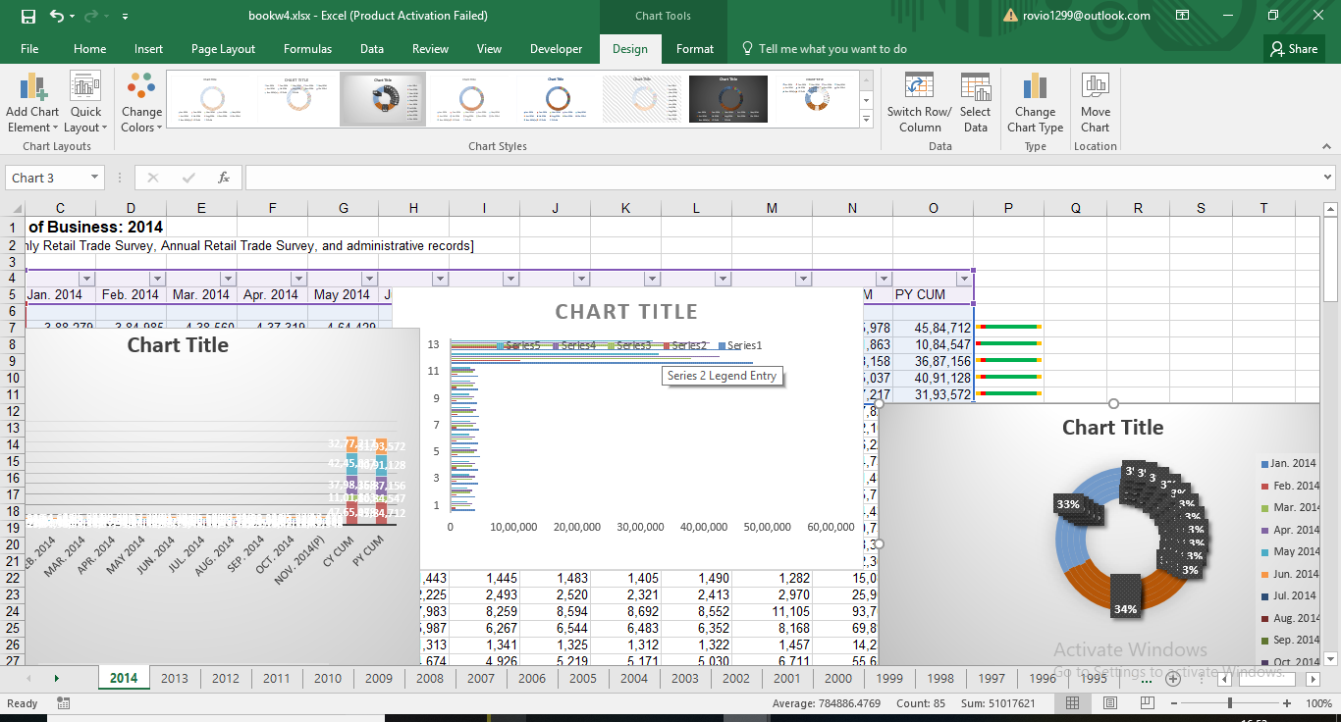

**Create a Macro:**

If you have tasks in Microsoft Excel that you do repeatedly, you can record a macro to automate those tasks. A macro is an action or a set of actions that you can run as many times as you want. When you create a macro, you are recording your mouse clicks and keystrokes. After you create a macro, you can edit it to make minor changes to the way it works.

The macro is created by first right click on ribbon menu and selecting customize ribbon then selecting developer option and then macro is added.

The macro can be created by selecting the command button and thus creating the code for it and enabling it.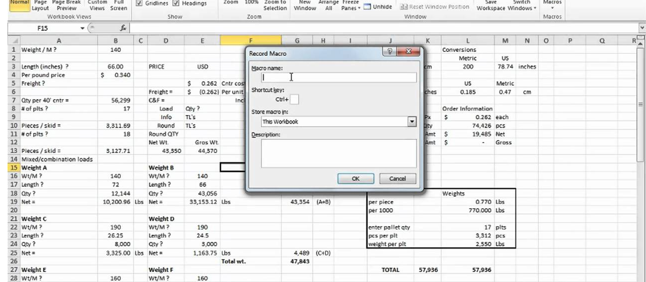

Basic Uses: are filtering, sorting Analyzing data Basic formulas and shortcuts Vlookup Understanding about the toolbar operations Basic charting Basic power pivotprotect etc. Thus the software gives a helping hand for better implementation of data.

**CONCLUSION:**

It gives the idea of how to implement the MS-Excel in corporate scenario.

It helps us understand that with data explosion data consumption too increases thus quality of data is the need of the hour.MS-Excel has continuously thrived upon those quality for a few years.

* Organize data in an easy-to-navigate way
* Do basic **and** complex mathematical functions so you don’t have to
* Turn piles of data into helpful graphics and charts
* Analyze data and make forecasting predictions
* Create, build, and edit pixelated images.

It gives easier the representation of the ideas and reports in business world  which helps us increase our skills for the utility for information storage and retrieval with better communication thus better results.

Various uses of Excel are:

* Calculating various numbers in the sheet to give results.
* Charting for display of graphical information.
* Inventory Tracking
* Planning & Scheduling.
* Goal Planning spreadsheet.

Thus MS-Excel has been one of the most important part of technical and digital business and services.

Submitted By:

Pinaki Parasara Panda

Regd : 160301120019

B Tech. CSE, 6th semester

CUTM,Jatni