Bengal Institute of Technology

Bits2Bytes 2009

Tech Town, Basanti Highway (Near Science City)

Kolkata – 700150

|  |  |
| --- | --- |
| Phone: (033) 2345-8004/8005 | E-mail- info@bitcollege.org |
| Fax: (033) 2345-8077 | E-mail- bits2bytes09@gmail.com |

**RULES FOR PATH-FINDER**

**1. ARENA SPECIFICATION**

1.1 The PathFinder maze shall comprise 10 x 10 multiples of an 18.5cm x 18.5cm unit square. The walls constituting the PathFinder maze shall be 5 cm high and 1.7 cm thick. Passage-ways between the walls shall be 16.8 cm wide. The outside wall shall enclose the entire PathFinder maze.

1.2. The side of the PathFinder maze walls shall be white, and the top of the walls shall normally be red. The floor of the PathFinder maze shall be made of MDF and finished with a matt variety of black paint (blackboard paint). The coating on the top and side of the wall shall be selected to reflect, and the coating on the floor shall be selected to absorb visible and infra-red light.

1.3. The start and end of the PathFinder maze shall be located at one of the four corners. The starting square shall have walls on two sides. The end square shall be its destination.

1.4. Square posts, each 1.7cm x l.7cm x 5cm high, shall be placed at the four comers of each unit square (the lattice points). The PathFinder maze shall be constituted such that there is at least one wall touching each lattice point, except for the destination square and start square.

1.5. The dimensions of the PathFinder maze shall be accurate to within 5% or 2cm, whichever is less. Assembly joints on the PathFinder maze floor shall not involve steps or gaps of greater than 1mm. The change of slope at an assembly joint shall not be greater than 5 degrees. Gaps between the walls and posts shall not be greater than 1mm.

1.6. A start sensor may be placed at the boundary between the starting unit square and the next unit square. A destination sensor may be placed at the entrance to the destination square. The light beam from each sensor will be horizontal and positioned 1 cm above the floor.

1.7. Multiple paths to the destination square are allowed and are to be expected.

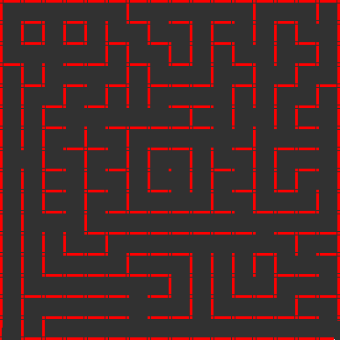

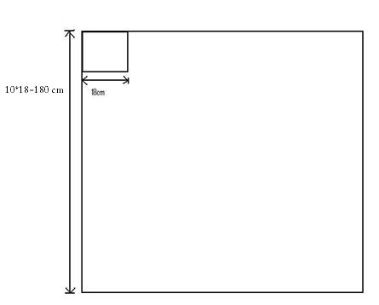

**2. THE PATHFINDER BOT**

2.1. A PathFinder Bot is subjected to the following size constraints –

* **Maximum width 25cm**
* **Maximum length 25cm**
* **There is no height limit.**

A PathFinder must be completely self-contained and must receive no outside assistance.

2.2. The method of wall sensing is at the discretion of the builder; however, the PathFinder must not exert a force on any wall likely to cause damage.

2.3. The power source will normally be batteries and electric motors; however alternative power sources will be permitted at the discretion of the judges.

2.4. If the judges consider that a PathFinder has a high risk of damaging the maze it will be disqualified from the competition.

2.5. The PathFinder must negotiate the PathFinder maze; it must not climb or jump over the walls of the PathFinder maze.

2.6. Nothing can be deposited in the PathFinder maze.

2.7. Each PathFinder should be fitted with a suitable hook or loop, for lifting the PathFinder out from the middle of the maze, should this prove necessary.

**Contestants will not be allowed to climb over the PathFinder maze.**

**3. THE COMPETITION**

3.1. The time taken to travel from the start square to the destination square is called the "run" time. Travelling from the destination square back to the start square is not considered a run. The total time taken from the first activation of the PathFinder until the start of each run is also measured. This is called the ‘maze’ or ‘search’ time. If the PathFinder requires any manual assistance at any time during the contest, it is considered ‘touched’. Scoring is based on these three parameters.

3.2. Each PathFinder is allowed a maximum of 10 minutes to perform. This may be reduced if time is limited. The judges have the discretion to request a PathFinder to retire in the event that it seems unlikely to reach the destination in the allocated time.

3.3. The **Scoring of a PathFinder** shall be obtained by computing a handicapped time for each run as follows:

**Score Time = Run Time + Search Penalty + Touch Penalty.**

**Search Penalty = 1/30 of the maze or search time, in seconds, associated with that run.**

**Touch Penalty = 3 seconds plus 1/10 of the run time, in seconds, if the PathFinder has been touched at any time prior to the run.**

For example, if a PathFinder, after being in the PathFinder maze for 4 minutes without being touched, starts a run which takes 20 seconds, the run will have a handicapped time score of 20 + 1/30 (4 x 60) = 28 seconds. However, if the PathFinder has been touched prior to the run, an additional touch penalty of (3 + (1/10 x 20)) seconds is added giving a handicapped time score of 33 seconds.

3.4. Manually lifting it out shall be considered touching the PathFinder and will cause a touch penalty to be added on all subsequent runs. If the PathFinder does not remain in the destination square at the end of a run, it may not be stopped manually and restarted.

3.5. The time for each run (run time) shall be measured from the moment the PathFinder leaves the start square until it enters the destination square. The total time on the PathFinder maze (maze or search time) shall be measured from the time the PathFinder is first activated.

3.6. The time taken to negotiate the PathFinder maze shall be measured either manually by the contest officials, or by sensors set at the start and destination. If sensors are used, the start sensor shall be positioned at the boundary between the start square and the next unit square.

3.7. The starting procedure of the PathFinder shall be simple and must not offer a choice of strategies to the handler. For example, a decision to make a fast run to the end as time runs out must be made by the PathFinder itself. The starting procedure shall be submitted to the judges when the PathFinder is registered on the day of the contest.

3.8. The PathFinder handler is given 1 minute, from the moment the PathFinder is required to start, to make adjustments to the PathFinder sensors (calibration).

However, no selection of strategies must be made and no information on the PathFinder maze configuration may be entered or captured in the memory.

3.9. The maze or search time clock will commence after the expiry of the 1 minute time limit even if the handler is still making adjustments to the sensors.

3.10. If a PathFinder "gets into trouble" the handlers can ask the judge for permission to abandon the run and restart the PathFinder at the start square. A PathFinder may not be re-started merely because it has taken a wrong turning. The judges may add a time penalty for a restart. The judges' decision is final.

3.11. Modification of the control strategy of the PathFinder is not permitted at any time once the mouse has entered the maze.

3.12. If a PathFinder elects to retire because of technical problems, the judges may, at their discretion, permit it to perform again later in the contest. The PathFinder will then be deemed to have taken an extra three minutes search time (i.e. if a PathFinder retires after four minutes, then when re-starting it will be counted as having taken seven minutes and will have only three more minutes to run). This permission is likely to be withdrawn, if time is limited.

3.13. Before the PathFinder maze is unveiled, the mice must be accepted and kept in view of the contest officials. The handlers will place the mice at the start under the officials' instructions.

3.14. The judges reserve the right to make changes to any of the above in the interest of fair play and sportsmanship, and to ensure that all competitors have an enjoyable competition. In the event of ambiguity, the judges' interpretation of any clauses of the rules shall prevail.

**NOTE: Event coordinators can bring change in rules at any time. Their decision will be final.**