Bengal Institute of Technology

Bits2Bytes 2009

Tech Town, Basanti Highway (Near Science City)

Kolkata – 700150

|  |  |
| --- | --- |
| Phone: (033) 2345-8004/8005 | E-mail- info@bitcollege.org |
| Fax: (033) 2345-8077 | E-mail- bits2bytes09@gmail.com |

**RULES FOR ROBO RALLY**

**1. GENERAL DESCRIPTION:**

Robo Rally is a competitive game where electric driven robots compete in a race track. The goal: build the fastest, smartest vehicle.

**2. DIMENSIONS**

* Overall Dimensions must not exceed 1 ft x 1 ft
* Maximum Height should not exceed 40 cm.
* The dimensions may exceed within a certain limits decided by referee at the venue once the event commences.
* Robots can be built using wheels and tracks.
* Length and width is measured to the extremities of the robot, i.e. includes any overhanging bodywork.

**3. POWER**

* A maximum voltage of 24V D.C. can be used to power the vehicle.
* Only AC power supply of 220V, 50Hz will be provided at the venue. Participants should bring their own adapter.
* All power connections (connections carrying a heavy current) must be of an adequate grade and adequately insulated. Cables must be routed to minimize the chances of being cut.
* Batteries must be totally sealed and not contain free-flowing liquid. (Whether electrolyte or otherwise.)
* Battery connections must be adequately insulated.
* Participants should bring the required length of wire along with them. The wires should remain slack throughout the match.
* No LEGO kits or complete car bases allowed.
* Readymade gearbox may be used.

**4. ARENA SPECIFICATION**

* The base of the arena is smoothly cemented.
* The track would be made of wood.
* The length of the track would be a maximum length of 30 ft.
* The maximum width of the track will be 3 ft.
* The track could consist of: sand, pebbles or any kind of obstacles, inclined planes, gravel terrain etc.
* The track would have boundary walls.
* The track may comprise of straight or circular paths in the entire length.
* Entries should be capable of driving over inclined planes.

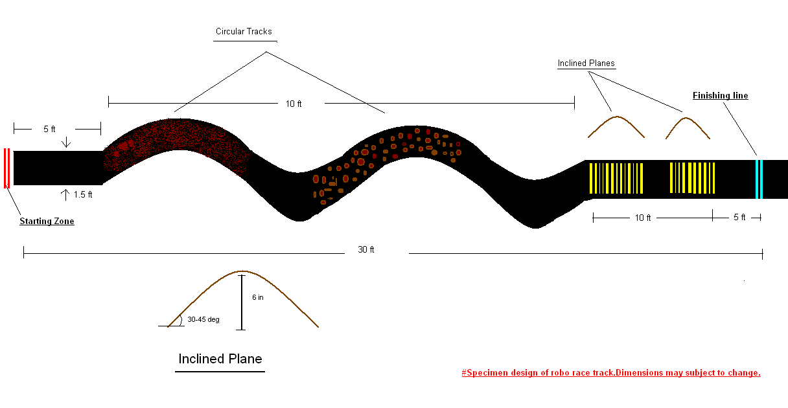

**5. GENERAL RULES OF THE GAME:**

* The competition involves two robots competitng on a race track.
* The robot is to start from a stationary position before the starting line in the StartingZone.
* It has to travel along the designated track either by walking, running or hopping, or any other motion.
* A valid Record Time is measured from the instance any part of the robot crosses the starting line to the moment when the last part of the robot (trailing edge) crosses the finishing line.
* No parts of the robot are to be left behind in the race-track.
* The robot has to complete the race track from starting point to finishing point taking minimum time.
* The winner of the competition will be the first robot to complete the race with minimum time taken without any faults.
* Once the event commences the robot will invite penalties for going off track as per scoring rules.
* If the robot falls in the track then it can be brought up by the team members. This invites penalties as per given in the scoring rules.
* After the start of the game, if the robot gets motionless for more than 1 min. it would be taken off the track and the opponent would be the clear winner of the game.
* Each race would last up to 4 min if no clear winner is established during this time.
* If neither robot has completed the course the match will restart. If this continues, the robots will be disqualified.
* The robot will be disqualified if it completely fell off the tracks to the ground before it fully crosses the finishing line.

**6. REPAIRING:**

* No repair could be done during the game.
* Repair could be done only before and after the game.
* Heavy repairing (e.g. welding, soldering, etc) has to be done before or after the game.
* No welding equipment is allowed on the premises. Welding facilities will be available in the Workshop. All welding will be undertaken by a technician from college.
* Tools and spares only will be allowed at each workstation and should be carried by the participants and should be declared in the technical check sheet.
* Modification of robot during competition is STRICTLY PROHIBITED.
* No extra parts are to be added to or removed from the robot once the competition time starts.
* On the other hand, the robot is allowed to change identical mechanical spare parts, electronic components (except for the control and memory unit if any) and power unit.

**7. JUDGING/SCORING:**

* The winner of the competition will be the first robot to complete the race with minimum time taken without any faults.
* The robot scores 10 points for swiftly going across the inclines on the track.
* The robot scores 30 points for finishing the event.
* Robot motionless for more than 30 sec. will lose 5 points.
* Any robot that becomes damaged or malfunctions and is unable to move for 1 min continuous shall be considered immobile and opponent wins the game.
* The robot getting off completely off the track or touches the ground then it loses the game.
* The robot falling on the track could be lift up by the team members but the team will lose 5 points.
* If the two robots finish the race at the same time then the points scored would determine the winner.

**8. OFFENSIVE BEHAVIOUR:**

* Entries may not damage or modify the track in any manner (such as depositing liquids or using spiked wheels).
* Any entry causing damage to the track surface or barriers, or judged to present a hazard to the track environment or spectators may be disqualified or penalized at the judges' discretion.
* Any entry found to intentionally inflict damage or disable another entry in any way will be disqualified or penalized at the judges' discretion.
* Entries should be designed to withstand accidental collisions with the track barriers and other robots.

# When in doubt, the decision of the Judges will be final.

**9. TEAM SPECIFICATION:**

* Maximum number of members per team is 4.
* The team members should produce valid identification (identity card) to claim that they are studying in the institute.
* However the team can consist of members from the same institute or different institutions.

**NOTE: Event coordinators can bring change in rules at any time. Their decision will be final.**