Bengal Institute of Technology

Bits2Bytes 2009

Tech Town, Basanti Highway (Near Science City)

Kolkata – 700150

|  |  |
| --- | --- |
| Phone: (033) 2345-8004/8005 | E-mail- info@bitcollege.org |
| Fax: (033) 2345-8077 | E-mail- bits2bytes09@gmail.com |

**RULES FOR ROBO WARS**

**1. GENERAL DESCRIPTION**

Robo Wars is a competitive, mechanical sporting event that features electric controlled robots in combat. Competitors must employ a combination of skill, power and strategy in this contest for survival.

**2. ROBOT SPECIFICATION/CONSTRUCTION:**

**2.1 DIMENSIONS:**

* Overall Dimensions must not exceed 30 cm x 30 cm
* Maximum Height should not exceed 40 cm.
* The dimensions may exceed within a certain limits decided by referee at the venue once the event commences.
* Robots can be built using wheels, tracks and legs ("Walkers").
* Length and width is measured to the extremities of the robot, i.e. includes any overhanging bodywork except weaponry.
* **No LEGO kits or readymade car bases** will be allowed.

**2.2 WEIGHT:**

* The maximum weight of bot should not be more than 4.0 Kg.
* Batteries (if any) are not exempted and will be considered part of the official weight.
* Spares will be weighed before the start of the game.

**2.3 POWER:**

* A combination of engines - e.g. electric drive and IC weapons is allowed.
* A maximum voltage of 30V D.C. can be used to power the vehicle.
* Only AC power supply of 220V, 50Hz will be provided at the venue. Participants should bring their own adapter.
* All power connections (connections carrying a heavy current) must be of an adequate grade and adequately insulated. Cables must be routed to minimize the chances of being cut.
* Batteries must be totally sealed and not contain free-flowing liquid. (Whether electrolyte or otherwise.)
* Battery connections must be adequately insulated.
* Participants should bring the required length of wire along with them. The wires should remain slack throughout the match.

**2.4 WEAPONS:**

* All weapons must be declared and logged on the technical check sheet. Failure to do this will result in extra weapons being excluded.
* Limited time will be allowed between rounds for repairs, adjustments, changing of batteries, etc.
* All pyrotechnics, explosives, flames, firearms, corrosives, liquids, electronic devices - e.g. heat-guns are banned.
* Devices using inflammable or combustion-supporting gases are banned
* Robots will be inspected for safety, reliability and conformity to the Rules before being allowed to compete.
* Autonomous weapons are allowed, although strict safety features must be incorporated.
* All sharp edges of weapons and robot bodywork in general that is sharp **MUST** be fitted with adequate protection that must be in place at all times except in the arena. (These guards are not included with the overall weight of the robot).
* The Judge/Referee/event coordinators will examine the bots at the start of the event
* **The Organizers reserve the right to ban or disqualify any robot that, in their opinion does not conform to the Rules or is unsafe and could cause injury to spectators.**
* Guidelines for safety require sound construction and operation. This means that tethers, blades, arms, levers, and all other mechanical parts and weaponry must be strong and secure.
* No LEGO kits or readymade car bases are allowed.

**3. REPAIRING:**

* If there is any damage of bot, the team will get 5 min. for repairing the bot between the rounds. (Body panels must be the same as the ones removed.)
* Heavy repairing (e.g. welding, soldering, etc) has to be done before or after the game.
* No welding equipment is allowed on the premises - tig and mig welding facilities will be available in the Workshop. All welding will be undertaken by a technician from college.
* Tools and spares only will be allowed at each workstation and should be carried by the participants and should be declared in the technical check sheet.
* Only repairs may be carried out in the workshop. Modifications (e.g. shape, size, weight, extra weapons) to the robot once technically checked are prohibited.

**4. ARENA SPECIFICATION:**

* The base of the arena is made of wood.
* The arena will be circular in shape.
* The diameter of arena will be 4-5 ft.
* A 2 ft. high wall of wood/metal surrounds the arena and protects the audience.
* There will be two circles with diameter 1 ft.
* At the start of the event the bot should be placed within those areas.

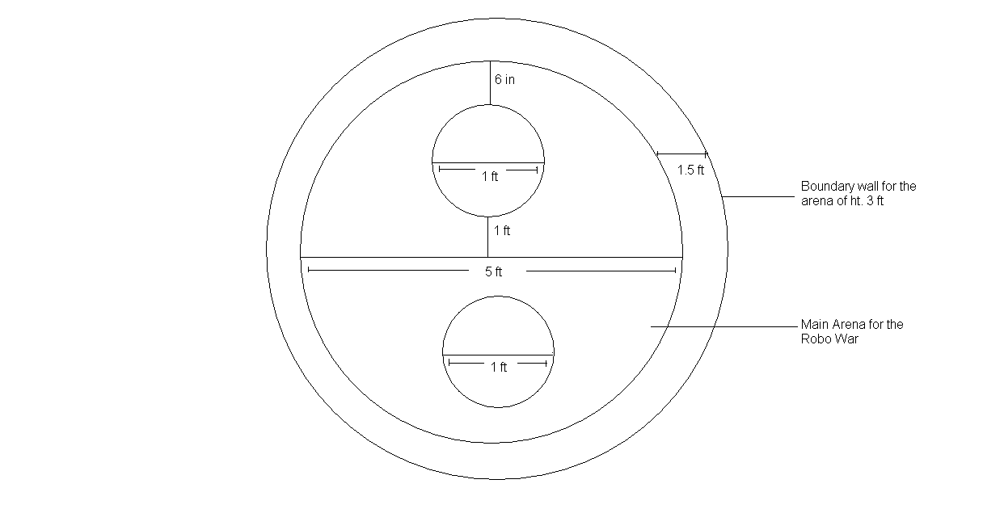

**5. GENERAL RULES OF THE GAME:**

* No. of rounds: 3(Pre). 5(Finals)
* Time duration of each round: 4 min.
* Break during each round: 2 min (In case of damage repairing 5 min if needed).
* Robots will compete, one on one.
* Winners advance through elimination rounds until the last fight for Final Championship.
* Scoring of the game will be done as per given scoring rules.
* The bots cannot cut each others power supply.
* **The event coordinators have full authority to revise the rules of the game at any point of time.**
* **The decisions of the judge/referee are final.**

**6. JUDGING/SCORING:**

* Each hit by the robot to the opponent will score 10 points.
* If the hit of the robot breaks/detaches opponent’s bot, then the attacking bot scores 20 points.
* Robot motionless for more than 30 sec. will lose 5 points.
* The first robot going out of the arena loses, even if the second robot subsequently falls.
* The first robot falls due to hit of opponent in the arena, opponent wins the round.
* Any robot that becomes damaged or malfunctions and is unable to move for 1 min continuous shall be considered immobile and opponent wins the round.
* If after 4 min both the robots are mobile and are still in the arena then the winner of that round will be decided by the points scored in that round.
* If any piece of the robot, no matter how small gets detached or falls out, the robot looses 5 points.
* The robot which will win maximum number of rounds will win the game.
* If both robots are clearly locked in a "deadly embrace" the match will be stopped to separate them and then the match will resume for the duration of the match.
* If the referee determines that both robots fell at the same time, then no point for either robot.

**7. TEAM SPECIFICATION:**

* **Maximum number of members per team is 3.**
* The team members should produce valid identification (identity card) to claim that they are studying in the institute as specified during registration.
* A team can consist of members from the same institute or different institutions.

**NOTE: Event coordinators can bring change in rules at any time. Their decision will be final.**