

Bengal Institute of Technology
Bits2Bytes 2009
Tech Town, Basanti Highway (Near Science City)
Kolkata – 700150
Phone: (033) 2345-8004/8005 | E-mail- info@bitcollege.org
Fax: (033) 2345-8077 | E-mail- bits2bytes09@gmail.com

RULES FOR ROBO WARS

1. GENERAL DESCRIPTION
Robo Wars is a competitive, mechanical sporting event that features electric controlled robots in combat. Competitors must employ a combination of skill, power and strategy in this contest for survival.
2. ROBOT SPECIFICATION/CONSTRUCTION:

2.1 DIMENSIONS:
- Overall Dimensions must not exceed 30 cm x 30 cm
- Maximum Height should not exceed 40 cm.
- The dimensions may exceed within a certain limits decided by referee at the venue once the event commences.
- Robots can be built using wheels, tracks and legs ("Walkers").
- Length and width is measured to the extremities of the robot, i.e. includes any overhanging bodywork except weaponry.
- No LEGO kits or readymade car bases will be allowed.

2.2 WEIGHT:
- The maximum weight of bot should not be more than 4.0 Kg.
- Batteries (if any) are not exempted and will be considered part of the official weight.
- Spares will be weighed before the start of the game.

2.3 POWER:
- A combination of engines - e.g. electric drive and IC weapons is allowed.
- A maximum voltage of 30V D.C. can be used to power the vehicle.
- Only AC power supply of 220V, 50Hz will be provided at the venue. Participants should bring their own adapter.
- All power connections (connections carrying a heavy current) must be of an adequate grade and adequately insulated. Cables must be routed to minimize the chances of being cut.
- Batteries must be totally sealed and not contain free-flowing liquid. (Whether electrolyte or otherwise.)
- Battery connections must be adequately insulated.
- Participants should bring the required length of wire along with them. The wires should remain slack throughout the match.

2.4 WEAPONS:
- All weapons must be declared and logged on the technical check sheet. Failure to do this will result in extra weapons being excluded.
- Limited time will be allowed between rounds for repairs, adjustments, changing of batteries, etc.
- All pyrotechnics, explosives, flames, firearms, corrosives, liquids, electronic devices - e.g. heat-guns are banned.
- Devices using inflammable or combustion-supporting gases are banned
- Robots will be inspected for safety, reliability and conformity to the Rules before being allowed to compete.
- Autonomous weapons are allowed, although strict safety features must be incorporated.
- All sharp edges of weapons and robot bodywork in general that is sharp MUST be fitted with adequate protection that must be in place at all times except in the arena. (These guards are not included with the overall weight of the robot).
- The Judge/Referee/event coordinators will examine the bots at the start of the event
- The Organizers reserve the right to ban or disqualify any robot that, in their opinion does not conform to the Rules or is unsafe and could cause injury to spectators.
- Guidelines for safety require sound construction and operation. This means that tethers, blades, arms, levers, and all other mechanical parts and weaponry must be strong and secure.
- No LEGO kits or readymade car bases are allowed.

3. REPAIRING:
- If there is any damage of bot, the team will get 5 min. for repairing the bot between the rounds. (Body panels must be the same as the ones removed.)
- Heavy repairing (e.g. welding, soldering, etc) has to be done before or after the game.
- No welding equipment is allowed on the premises - tig and mig welding facilities will be available in the Workshop. All welding will be undertaken by a technician from college.
- Tools and spares only will be allowed at each workstation and should be carried by the participants and should be declared in the technical check sheet.
- Only repairs may be carried out in the workshop. Modifications (e.g. shape, size, weight, extra weapons) to the robot once technically checked are prohibited.

4. ARENA SPECIFICATION:
- The base of the arena is made of wood.
- The arena will be circular in shape.
- The diameter of arena will be 4-5 ft.
- A 2 ft. high wall of wood/metal surrounds the arena and protects the audience.
- There will be two circles with diameter 1 ft.
- At the start of the event the bot should be placed within those areas.

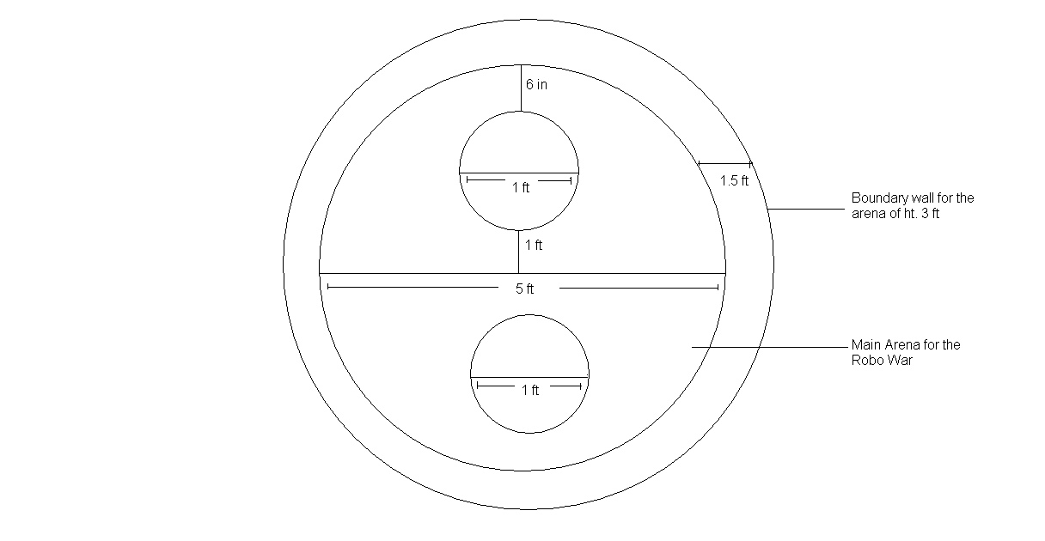

5. GENERAL RULES OF THE GAME:
- No. of rounds: 3(Pre). 5(Finals)
- Time duration of each round: 4 min.
- Break during each round: 2 min (In case of damage repairing 5 min if needed).
- Robots will compete, one on one.
- Winners advance through elimination rounds until the last fight for Final Championship.
- Scoring of the game will be done as per given scoring rules.
- The bots cannot cut each others power supply.
- The event coordinators have full authority to revise the rules of the game at any point of time.
- The decisions of the judge/referee are final.
6. JUDGING/SCORING:
- Each hit by the robot to the opponent will score 10 points.
- If the hit of the robot breaks/detaches opponent’s bot, then the attacking bot scores 20 points.
- Robot motionless for more than 30 sec. will lose 5 points.
- The first robot going out of the arena loses, even if the second robot subsequently falls.
- The first robot falls due to hit of opponent in the arena, opponent wins the round.
- Any robot that becomes damaged or malfunctions and is unable to move for 1 min continuous shall be considered immobile and opponent wins the round.
- If after 4 min both the robots are mobile and are still in the arena then the winner of that round will be decided by the points scored in that round.
- If any piece of the robot, no matter how small gets detached or falls out, the robot looses 5 points.
- The robot which will win maximum number of rounds will win the game.
- If both robots are clearly locked in a "deadly embrace" the match will be stopped to separate them and then the match will resume for the duration of the match.
- If the referee determines that both robots fell at the same time, then no point for either robot.
7. TEAM SPECIFICATION:
- Maximum number of members per team is 3.
- The team members should produce valid identification (identity card) to claim that they are studying in the institute as specified during registration.
- A team can consist of members from the same institute or different institutions.
NOTE: Event coordinators can bring change in rules at any time. Their decision will be final.

