***A Report***

*On*

**Statistical analysis of Academic Performance of Postgraduate Students in IIT Bombay**

*For the Course Project*

*in*

**BM 602: Biostatistics**

***Submitted By***

**Group 4**

Hitendra Sahu (113300017)

Durga Kumari (113300018)

Praveen Kumar (113300024)

Pinaki Chandra Dey (113300003)



**Department of Biosciences and Bioengineering**

**Indian Institute of Technology Bombay**

**May. 2012**

|  |
| --- |
| **PLAGIARISM STATEMENT** |

We as a team declare that none of the data or figures included in our report are copied or taken from other sources. We also state that right from the collection of data to documentation of results and inferences is our original work and contain no plagiarism. Also this study conducted by us has not been submitted previously for any kind of assessment in any other course.

By:

Hitendra Sahu (113300017)

Durga Kumari (113300018)

Praveen Kumar (113300024)

Pinaki Chandra Dey (113300003)

|  |
| --- |
| **CONTRIBUTIONS OF EACH MEMBER OF THE GROUP** |

The Project idea was thought by Praveen Kumar and Hitendra Sahu and developed under the guidance of Prof. S. Arunkumar.

The data were collected through an Online Survey as well as an offline questionnaire limited to IIT Bombay PG Students only. The online questionnaire was designed and developed by Pinaki Dey and Durga Kumari took the responsibility of collecting data through offline survey.

The data analysis methods were conceived by the entire team in a team meeting.

The statistical analysis of data was performed on R software and the underlying codes were developed by Pinaki Dey, Praveen Kumar and Hitendra Sahu.

Interpretation of the results was done by Durga Kumari and Pinaki Dey.

Final report and presentation were developed by Durga Kumari and Pinaki Dey.

|  |
| --- |
| **INTRODUCTION** |

Academics have always been a field of interest which could be meant as “pertaining to the development of mind”. As far as academic performance is concerned it refers to how students deal with their studies and how they accomplish different tasks given to them.

Academic performance could also be defined as the ability to study and remember facts, correlating those facts with the practical life and being able to communicate or implement one’s knowledge.

As a student of one of the most reputed institute of India we decided to conduct a statistical analysis using our knowledge and understanding of statistics as conveyed by Prof. S. Arunkumar in BM 602.

Our main emphasis in this Statistical analysis has been concentrated on determining the following aspects:

1. Whether or Not academic Streams (Core Engineering / Biosciences) of Students in Undergraduate affect their Performance in PG at IIT?
2. Whether or Not Students coming from Private or Government universities perform differently?
3. Whether or not the academic performance of students in PG courses at IIT Bombay is gender biased?
4. Does the Gate Percentile and Academic performance of students in Undergraduate level can be used to predict their academic performances in Post Graduate at IIT Bombay?

Keeping in mind the above facts and data obtained from their analysis many interesting aspects have come to light.

We have tried our best to concise everything that we observed in best possible and simplest way for easy understanding.

|  |
| --- |
| **DATA COLLECTION** |

To obtain appreciable amount of randomised data suitable for normalization, we used following two methodologies:

1. **Online method**: A Google Form was designed for online data collection in anonymous manner.

Following are the questions asked in the questionnaire for collection of required information for this statistical analysis:

1. Kindly mention your Gender.
2. What was your Last Qualifying Degree?
3. What was your Stream of Undergraduate Study?
4. Kindly mention the Name of the University from where you have completed your Undergraduate Degree.
5. Kindly mention your CPI in Undergraduate Degree (in Scale of 10).
6. What was your 'Percentile' in the Post-Graduate Entrance examination (GATE etc.)?
7. Kindly mention your CPI in the Post Graduate degree that you are currently pursuing.
8. How satisfied you are with your own performance in your current PG course (in Scale of 1 to 5, with 1 being the Lowest and 5 being the highest level of Satisfaction)?
9. **Manual method**: Data were also collected by personal oral interaction with the students of Hostel 11 based on the same questionnaire as mentioned above.

Data were collected anonymously and one at a time in a complete randomized fashion, hence does not bear any chance of dependency.

|  |
| --- |
| **FORMAT OF QUESTIONNAIRE** |

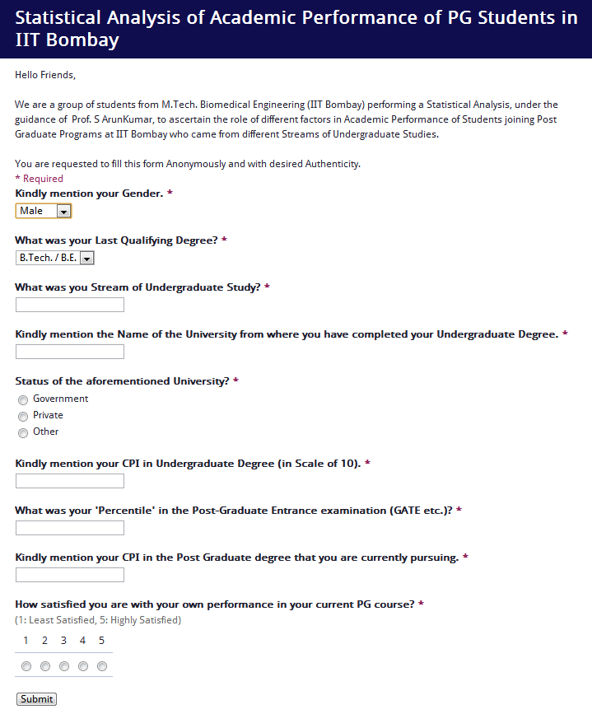

|  |
| --- |
| **COLLECTED DATA IN TABULAR FORMAT** |



Sample size: n=36 (> 30, Hence, suitable for Normalization)

ENGG includes: ECE, BME, EIE, and EEE.

BIO includes: BIOTECH, MBBS.

GATE percentile, UG_CPI and PG_CPI ranges were segmented into classes/intervals as per **Sturge’s formula: k = 1 + 3.322*(log10n)**, where k is No. of intervals and n is sample size.

|  |
| --- |
| **STATISTICAL ANALYSIS OF DATA** |

For the analysis of the obtained data R statistical software package was used.

Following are the analysis Performed with their significance mentioned:

1. **1-way ANOVA to determine the role of Stream in UG on Student’s Academic Performances in PG:**

**Motive of analysis**:

* To find if there is any effect of change in stream, from UG to PG level, on academic performance (say from Biotech to Biomedical).
* To find the perception of students towards the level of difficulties of PG course based on their stream.
* How well can they adapt to new academic program?

**Results:**

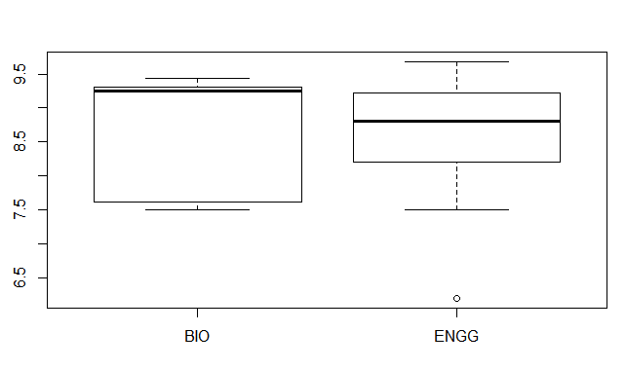

 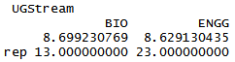

**Interpretations:**

* The median of PG CPI is higher for students from Biosciences streams as compared to those from core engineering.
* The majority of students from Biosciences streams perform better as depicted by their PG CPI whereas the performances of students from core engineering streams are almost equally dispersed in terms of PG CPI.
* However, the highest level of PG CPI has been observed from student belonging to core engineering category.

1. **1-way ANOVA to determine the role of the status of Undergraduate University on Student’s Academic Performances in Post Graduate at IIT-Bombay:**

**Motive of analysis:**

* The infrastructure, academic policies and competence of faculties differ among Government and Private universities, which might have an effect on the academic foundation of students and thereby on their academic performances on higher level of education.
* Apart of that there is a cynical perception in the society about the quality of education provided in the private colleges and the students passing out from there.
* To find if the nature of universities really matters in academic performance of students in higher level or is it the student’s own capabilities and merit which determine his/her performance?

**Results:**

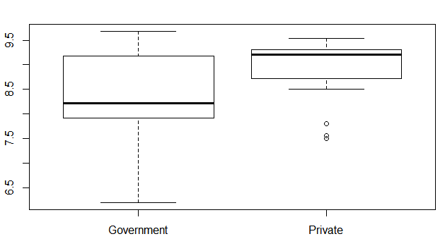

 

**Interpretations:**

* The median of PG CPI is much higher for students from Private universities as compared to those from Government universities.
* Although the highest level of academic performance, in terms of PG CPI, came from the student of Government university but this is also true for the lowest performance as well.
* We can infer that the students from private universities maintain a standard in their performance and do not deviate much in terms of their acquired CPI. But students from Government universities differ in their academic performance within themselves to a large extent without being able to hold any standardized level of performance.

1. **1-way ANOVA to determine the effect of Gender on Student’s Academic Performances in PG:**

**Motive of analysis:**

* This test was performed to find if there is any role of gender behind the academic performance of students in PG level.
* Do the female students are more committed to their studies than their male counterparts or is it opposite?

**Results:**

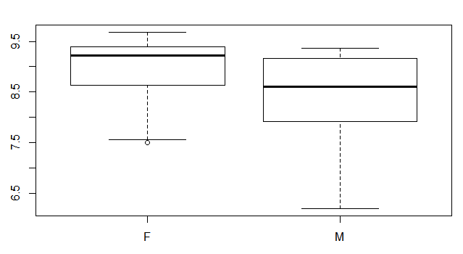

 

**Interpretations:**

* The median of PG CPI is higher for female student as compared to that of male students.
* The majority of female students perform better as depicted by their PG CPI whereas the performances of male students are almost equally dispersed in terms of PG CPI.

1. **2-way ANOVA to determine if the GATE percentile and UG CPI can actually demonstrate or influence a Student’s Academic Performances in PG:**

**Motive of analysis:**

* This test was performed to determine the trend of academic performance of students who have performed well in both GATE and their UG level to those who did not.
* Are the better performers in GATE and UG level being able to hold their level of performance in PG as well?
* Was there any positive effect of relatively lower performance in GATE and/or UG level on the performance in PG?
* Was there any negative effect of relatively higher performance in GATE and/or UG level on the performance in PG?

**Results:**

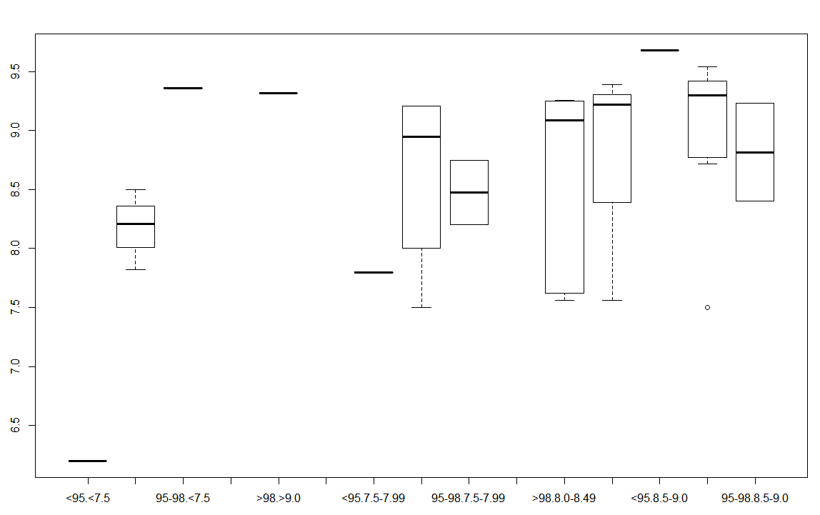

ANOVA Table

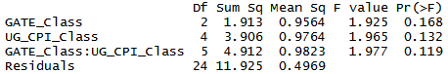

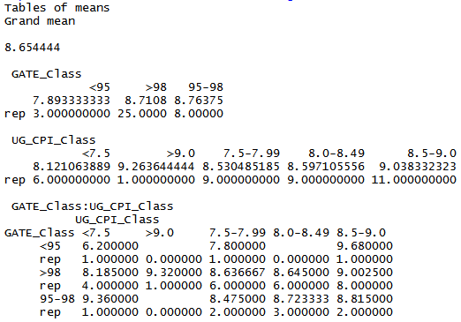

**Interpretations:**

* Results show that UG CPI is a better determinant of student’s academic competence than that represented by the GATE percentile.
* As it can be observed , amongst the students who have secured >98 percentile in GATE, those who have obtained higher UG CPI also have performed better in PG. Hence, they have maintained a consistency in their performance.
* Those combinations of GATE percentile and UG CPI which have only one data have resulted in those horizontal lines and hence they are neglected in interpreting the results.

1. **2-way ANOVA to determine the combined effect of Gender and UG-Stream on Student’s Academic Performances in PG:**

**Motive of analysis:**

* To find if students from any specific gender perform better in PG based on their UG stream?
* To find if students from any specific UG stream perform better in PG based on their gender?

**Results:**

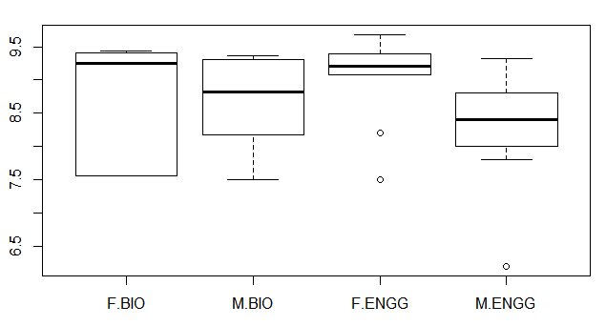

ANOVA Table

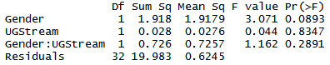

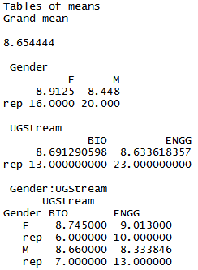

**Interpretations:**

* For female students, performance in PG is equally good irrespective of their stream in UG.
* Male students from Biosciences stream perform better in PG as compared to other male students from core engineering background.
* The median level of performance of female in PG is found to be always better than their male counterparts, irrespective of their stream in UG.

1. **2-way ANOVA to determine the combined effect of Gender and status of UG-University on Student's Academic Performances in PG:**

**Motive of analysis:**

* To ascertain if there is any effect of the type of UG university of students on their performance in PG based on their gender.
* More specifically, do the students from any particular gender better groom in any particular type of universities in their UG level.

**Results:**

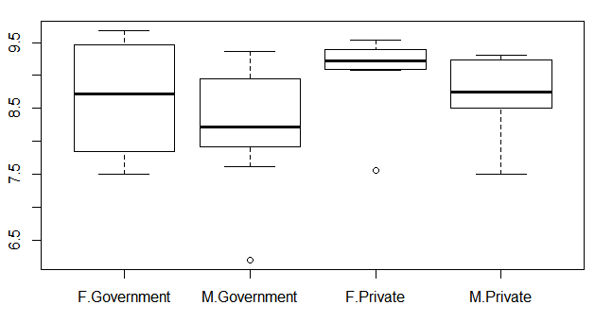

ANOVA Table

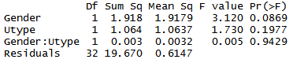

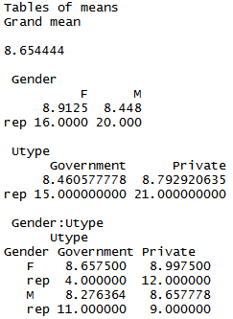

**Interpretations:**

* The median level of performance in PG is better for both the male and female students in private universities than respective male and female students in Government universities.
* Although, male students from private universities have shown slightly higher level of performance in PG compared to the female students from Government universities.
* The role of the type of UG university is more dominant than the effect of gender of students in their performance in PG.

1. **2-way ANOVA to determine the combined effect of Gender and PG CPI on Student's Satisfaction level in PG:**

**Motive of analysis:**

* This test was performed to find how PG CPI level of a student, influence his/her satisfaction level based on their gender.

**Results:**

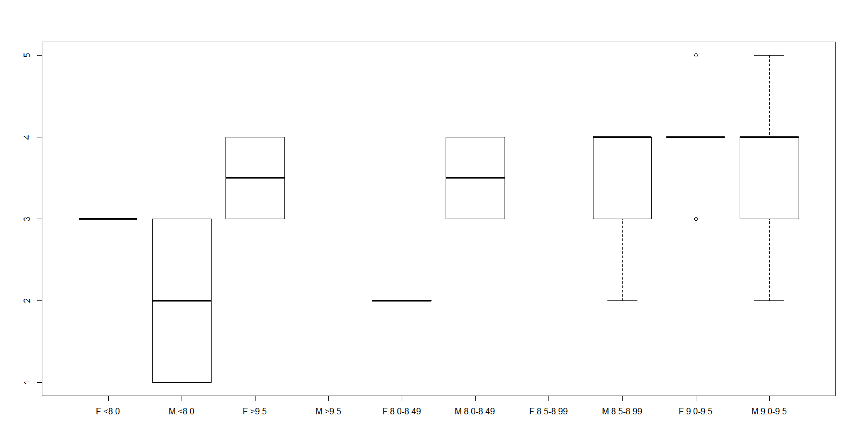

ANOVA Table

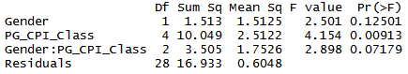

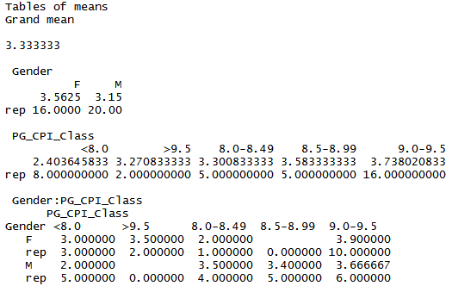

**Interpretations:**

* It’s been observed that for any given level of CPI in PG, the male students are more satisfied with their academic performance compared to their female counterparts.

1. **Regression analysis:**

Null Hypothesis H0: B = 0

Ha: B != 0

B = slope of the line

a)

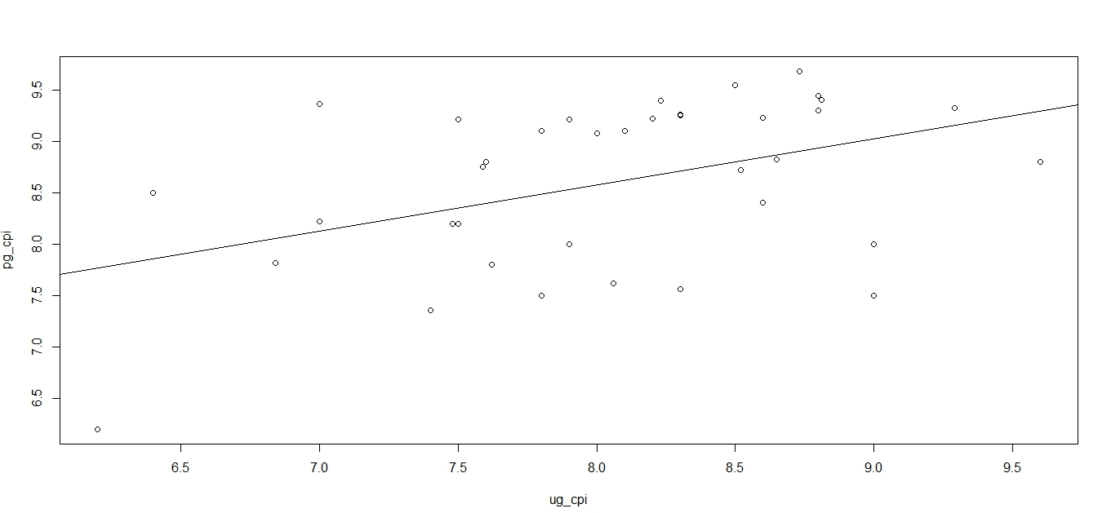

Graph: Regression curve fitting between UG CPI and PG CPI of students

α1 = 4.991

β1 = 0.447

r12 = 0.1792

**Inference**: since r12 = 0.1792, therefore we can say that approximately 18% of the variation in the response variable can be explained by the explanatory variable.

b)



Graph: Regression curve fitting between Students’ GATE percentile and PG CPI

α2 = -2.250

β2 = 0.110

r22 = 0.2102

**Inference**: since r22 = 0.2102, therefore we can say that approximately 21% of the variation in the response variable can be explained by the explanatory variable.

**Conclusion**: As it can be seen from the graphs hypothesis H0 is rejected in each of the cases because the slope of the line is not equals to zero or parallel to the x-axis.

Thus in both the cases, the Null hypothesis will not be accepted as slope of the line is not equal to zero and there exist dependency but it is very less.

|  |
| --- |
| **CONCLUSIONS** |

1. Academic performance in PG (i.e. PG CPI) is better for the students from Biosciences background compared to those from core engineering background. Although the dispersion in CPI is higher for core engineering students.
2. There is perception, even in the educated society, that the quality of education in Private universities is poorer as compared to that in the Government universities. But our analysis of the data, which was of course random and normalized, gives results in contrast to that perception. It’s evident that the students from Private universities show satisfactory and better results, on average, in terms of their academic performance in Post-graduation level compared to their counterparts from Government universities. The reason behind these might be inadequate infrastructure, poor maintenance, improper syllabus, inefficient teaching with lack of motivation, student’s mentality towards academics or others.
3. Academic performances of Female students are better compared to that of the male students in PG.
4. The result shows that there is not much deviation in the academic performance of the student who had secured at least 95 percentile in GATE and CPI of 8.0 in UG level.
5. It’s evident that the female students from private universities show better academic performances compared to other female students in Government universities as well as than that of male students from any sort of universities.
6. It is proven that the male students are more satisfied than the female students in terms of the academic performance at PG level.
7. It’s evident that there exists a correlation between student’s academic performances in PG with that in UG as well as in GATE.

|  |
| --- |
| **LIMITATIONS OF THIS STUDY** |

1. The data were collected from only the M.Tech students of Biomedical engineering and hence they may not represent the nature and characteristics of the whole PG population spread across different departments in IIT Bombay.
2. The offline/manual mode of data collection was limited to Hostel 11 only, which is a female hostel. This reduces the randomness of the data, as gender has also been used as a variable in our study.
3. It was not possible to verify the data as obtained in the Survey as it was completely anonymous. Hence, the credibility of the data can’t be assured. This, in turn, might limit the credibility of the study.
4. The number of samples from ENGG and BIO was significantly different (23 vs. 13) which might affect the randomness of the sample.
5. The nature of GATE is invariable across India, in terms of Percentile secured in any of the paper; which is not the case in different Universities. There exist huge differences in quality of education amongst different universities and the UG CPI is not a standardized quantity like GATE percentile. Therefore it might well be a limitation of such kind of studies.
6. The volume of the collected data could not be abundant as this kind of survey was not encouraged by neither of the General Secretary Academic Affairs, PG nor the Dean, Academic Programs of IIT Bombay since disseminating such kind of data is against the Institute policy; which limits the credibility of our study.