**Point 1: Payment Process & Invoice Generation through SV App:**

Concern:

* We are unable to process payment through SV app <PINAK> Please check the screenshot. As per SOP we are collecting Payment. There is already a request to capture Payment Type to be developed by WEQ.

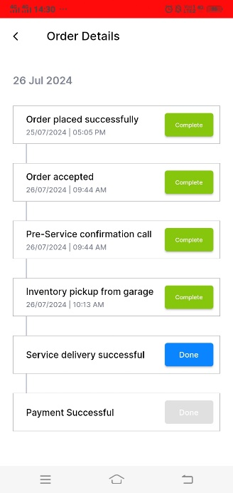

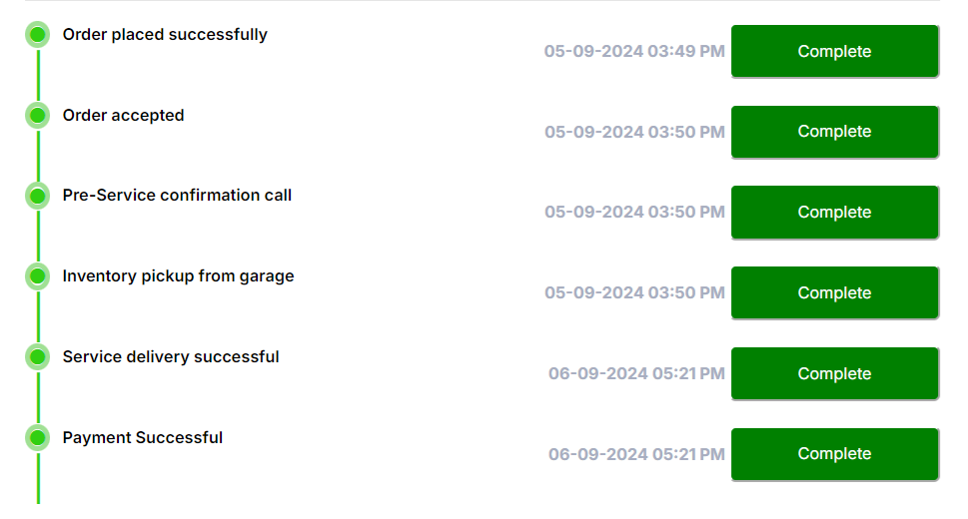

* Payment confirmation taken verbally no auto process <PINAK> Payment is confirmed at SV App by Technician and at Admin for SV App. For below payment types : CC, DC, UPI we get confirmation using RazorPay. For UPI Payment we have BOB – UPI as well. For Cash Collection, process is outlined in SOP. As we discussed 2 Factor Authentication, can be developed.

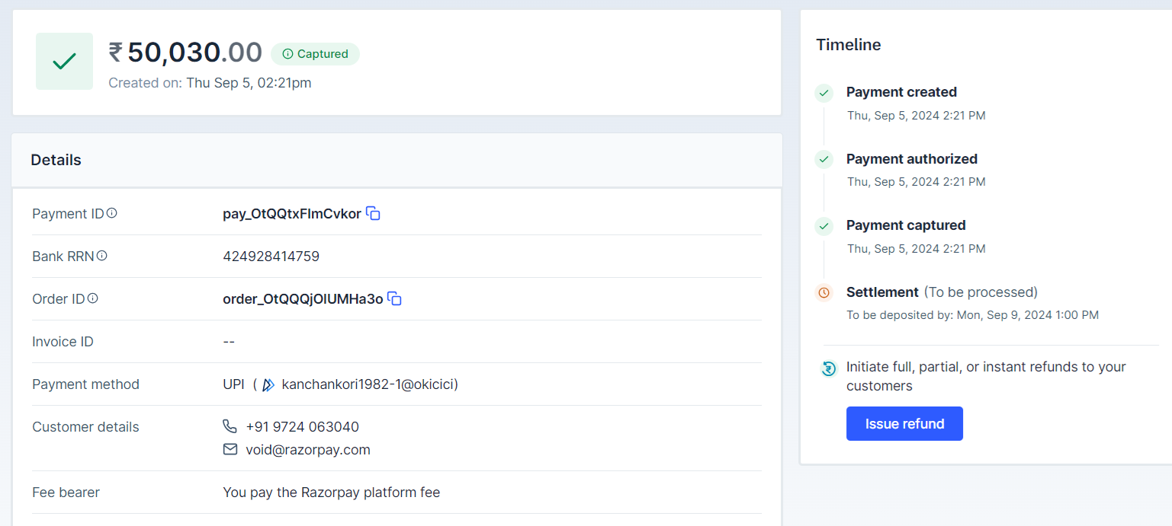

* We are unable to generate invoice through SV app <PINAK> Can be generated. We would need all parts and all labour charges for the vehicles we would like to generate. If required we can schedule a meeting with Engineering to check the feasibility.
* Invoice payment collection against the package value <PINAK> Same as above.

Expectation:

* Build payment option in SV app before payment successful option <PINAK> The CRs can be built. Please get me approval.
* Payment must be process with OTP (cash/online/card) <PINAK> The CRs can be built. Please get me approval.
* Add Part & Labour option and Discount option (with OTP authorization) - 2FA <PINAK> The CRs can be built. Please get me approval.
* Build invoice generation option through SV app <PINAK> The CRs can be built. Please get me approval.

**Point 2: PMS Price Revision**

Concern:

* PMS pricing need to revise at actual part and labour price
* PMS part applicability as per the PMS schedule / package
* Vehicle segment need to review & revise
* PMS wise check point need to review & revise

Expectation:

* Most contributed make wise PMS part and Labour price incorporate (Data ready)
* Current segment need to review and mapped with new segment
* PMS wise check point need to incorporate along with PMS schedule / package

<PINAK> We can revise the pricing after discussion. However, for creation of new segment details, entire DB migration would take place. We can plan it. As explained, it would undergo a full cycle of development, functional testing, followed by UAT. Let me know when can I get approval for the details. We would need WEQs timeline and resource planning for the same like above activities. This would require Engineering activities followed by UAT and Product Cross-Checking.

**Point 3: VAS Price and Package Creation**

Concern:

* VAS price and Package need to add in app

Expectation:

* 25 types of VAS list ready need to map it with SG & SV as applicable

<PINAK> There can be 2 approaches. With current implementation, we can get VAS created and then derive the package pricing. With new segment, we can need to plan accordingly with after segment creation and data migration.

**Point 4: Customer Service Alert / Recommendation:**

Concern:

* Text box is available to add service alert
* No criticality option for recommended job
* Battery test report upload option not available
* Type report input data option not available

Expectation:

* Along with text box check box should be available for Critical & Non Critical option
* Battery test report upload option need to build
* Tyre check report input data option need to build

<PINAK> We have already discussed with WEQ team. Will involve you during development process so that we can build it better for tomorrow.

**Point 5: Morning Shift Slot (7:30am to 10:00am)**

Concern:

* Morning Shift Slot not available in app

Expectation:

* Morning Shift Slot need to build in app

<PINAK> As explained, slots can be changed for all the SVs. Since, this is repeatable, scalable model – for 1 SV to change form 7-30 AM to 9-30 AM, we need to re-develop it. If this is a short term objective, just for one vehicle – my suggestion would be we can define slots form 7-30 to 9-30, 10-30 to 12-30 and 1-30 to 3-30 or any such similar 2 HRs slots and 3rd slot can be blocked. We have already built a granular configurable system to hide slots.

**Point 6: AMC Package / Subscription**

Concern:

* AMC Package / Subscription not available
* No process for AMC Package / Subscription redemption

Expectation:

* AMC Package / Subscription need to design
* AMC Package / Subscription redemption process need to build

<PINAK> For AMC, I have discussed with Vihaan earlier about Subscription Package Development. We need to sync up and take it from here.