**Insights from the Analysis**

**1️⃣ Order Slot Preferences Based on Creation Time (Hour-wise Analysis)**

| **Created Hour** | **10 AM - 12 NOON** | **1 PM - 3 PM** | **4 PM - 6 PM** |
| --- | --- | --- | --- |
| **11 AM** | 2 orders | 1 order | 1 order |
| **2 PM** | 0 orders | 1 order | 0 orders |

🔹 **Peak Booking Hour:** **11 AM** is when most orders are created.  
🔹 **Most Preferred Slot at 11 AM:** **10 AM - 12 NOON** has the highest bookings.

**2️⃣ Order Slot Preferences Based on Creation Day (Day-wise Analysis)**

| **Created Day** | **10 AM - 12 NOON** | **1 PM - 3 PM** | **4 PM - 6 PM** |
| --- | --- | --- | --- |
| **Wednesday** | 1 order | 0 orders | 0 orders |
| **Thursday** | 1 order | 1 order | 1 order |
| **Friday** | 0 orders | 1 order | 0 orders |

🔹 **Thursday is the busiest day** – It has bookings across all slots.  
🔹 **Least activity on Monday, Tuesday, Saturday, and Sunday.**

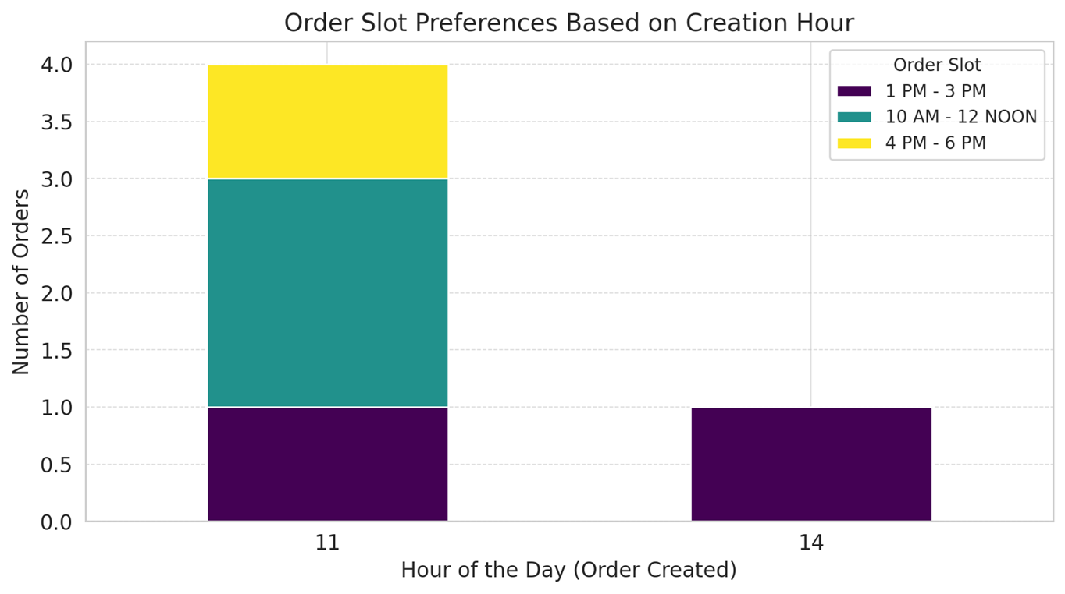

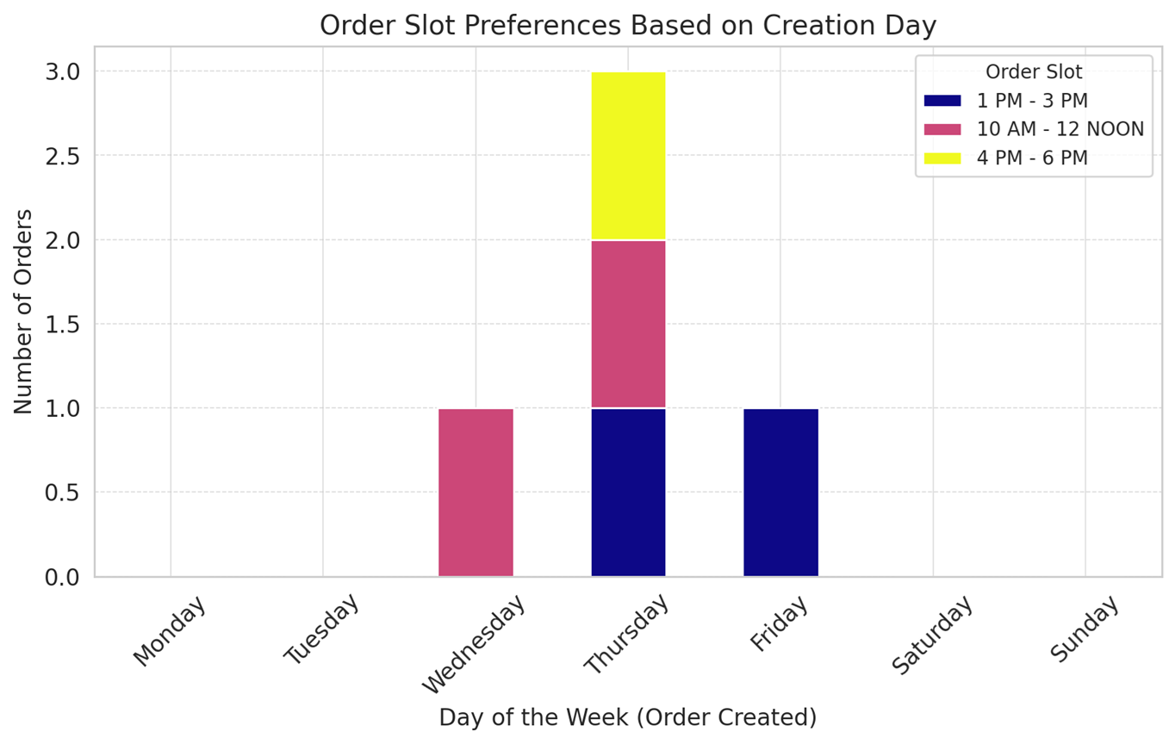

📊 **First Graph (Hourly Analysis)**:

* Shows **order slot preferences based on the time of order creation**.
* **Peak booking time** is around **11 AM** with a preference for the **10 AM - 12 NOON** slot.

📊 **Second Graph (Day-wise Analysis)**:

* Shows **which days have more bookings for each slot**.
* **Thursday has the highest activity**, while other days have minimal or no bookings.

**Deeper Insights & Recommendations 🚀**

**1️⃣ Booking Behavior Analysis (Based on Created Timestamp)**

* **Most orders are created around 11 AM** 📅.
* This suggests users prefer booking **before noon**, likely during work breaks.
* **2 PM sees fewer bookings**, indicating a midday drop.

**2️⃣ Slot Preference Insights**

* **10 AM - 12 NOON is the most preferred slot.**
* **1 PM - 3 PM and 4 PM - 6 PM have fewer bookings** but are still chosen.
* Users might prefer **morning slots for convenience before their day gets busy.**

**3️⃣ Day-wise Booking Trends**

* **Thursday is the busiest day.**
* **Other days (Monday, Tuesday, Saturday, Sunday) show little to no bookings.**
* Possible reasons:  
  ✅ People prefer getting car services before the weekend.  
  ✅ Thursday might align with payday cycles or work-from-home days.

**📌 Recommendations for Business Growth**

✅ **Push Promotions on Thursday Mornings**

* Offer **discounts or special deals** on Thursday to capitalize on peak booking trends.

✅ **Increase Availability for 10 AM - 12 NOON Slot**

* Since it’s the **most popular slot**, consider **adding more service vans** or technicians.

✅ **Encourage Off-Peak Bookings (2 PM Onwards)**

* Offer **lower prices or extra services** for less popular time slots (e.g., 1 PM - 3 PM).

✅ **Weekend Awareness Campaigns**

* Since **weekends have fewer bookings**, run campaigns targeting weekend slots.