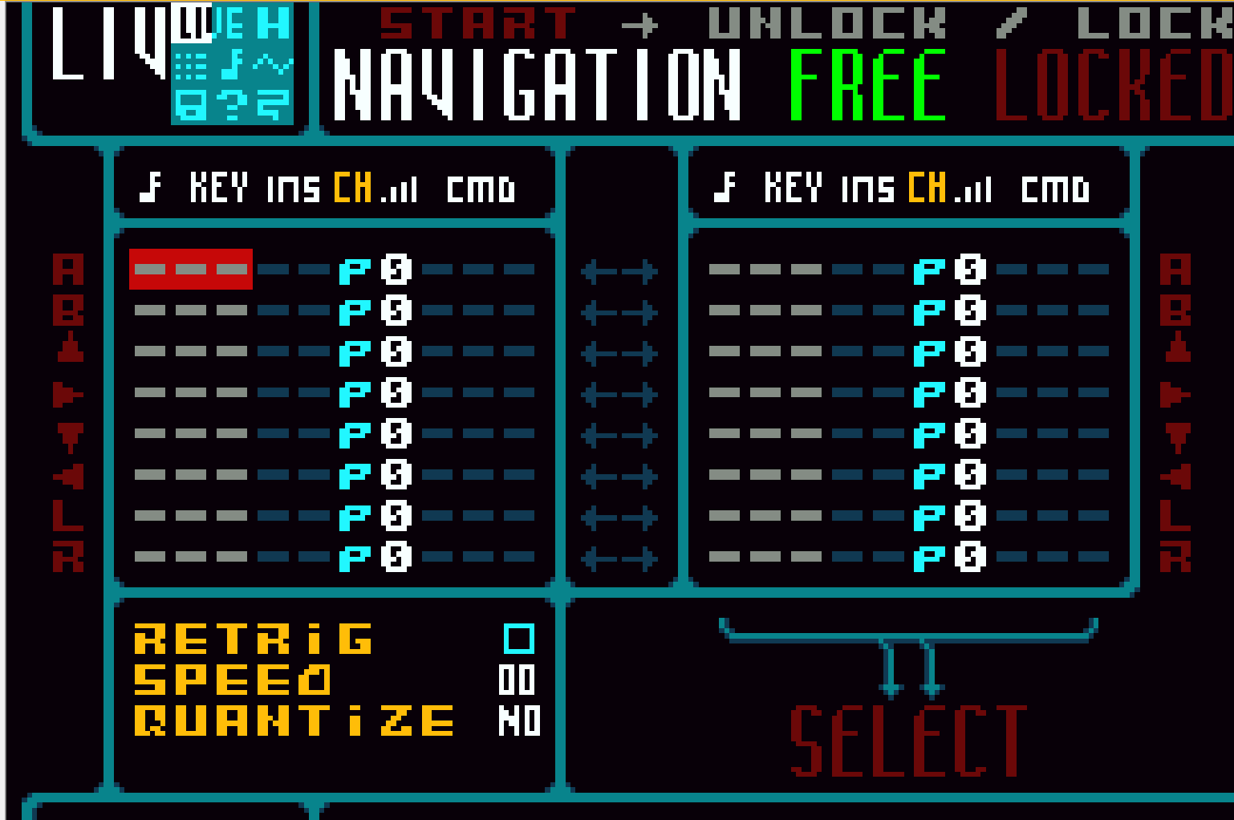 |   □ Send KEYS+INS+VOL to selected channel @ keydown  □ Send CMD+VAL to selected channel @ keypress  □ Consider toggling between LIVE1 and LIVE2 using combo (SELECT + START for instance )  □ Support both Retrig and Continuous mode
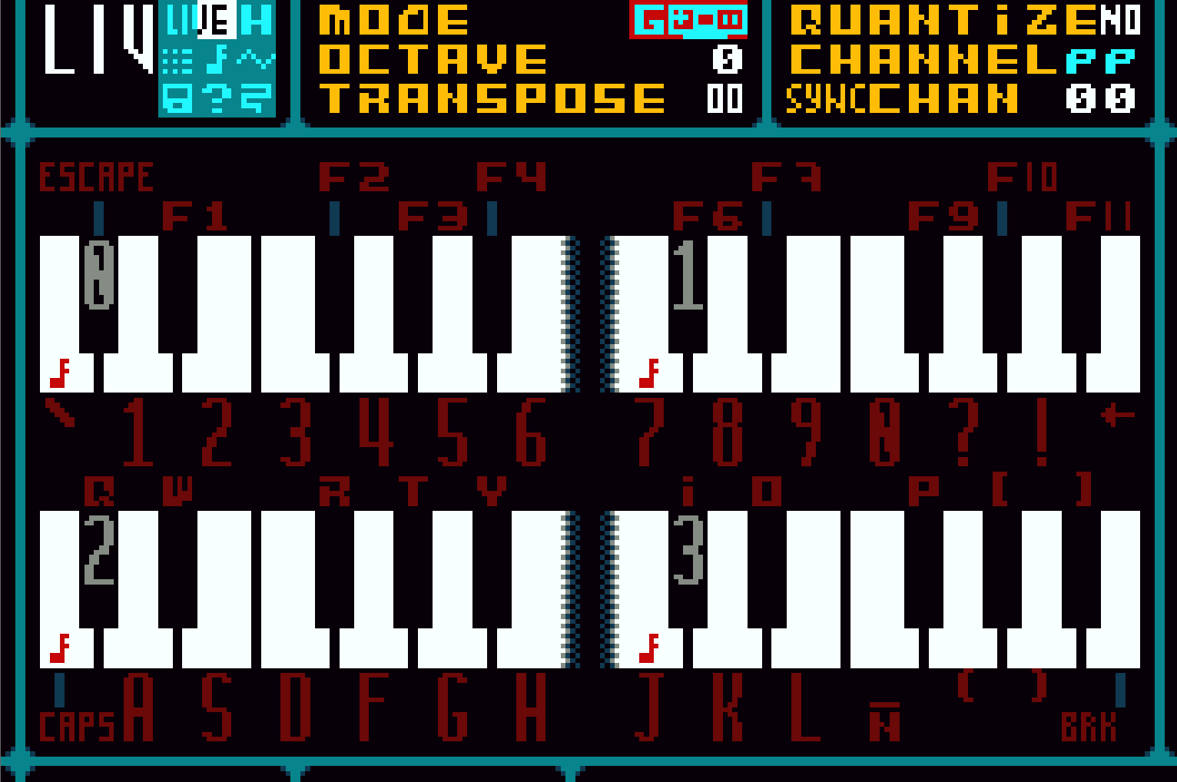 | □ Fix bug causing MODE to display incorrect piano  □ Work out a method to lock input here  □ Trigger notes accordingly with settings @ keydown
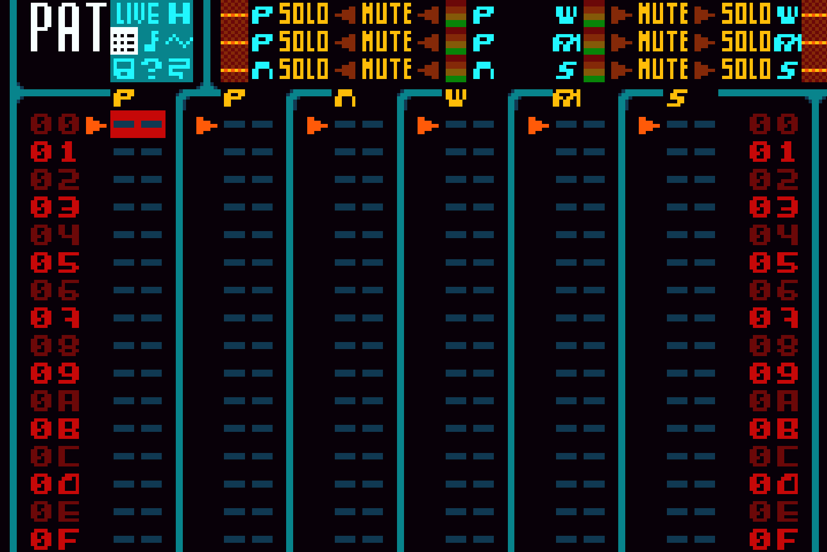 | □ Pattern shift  □ Shift column up ( R + SELECT + UP )  □ Shift column down ( R + SELECT + DOWN )  □ Pattern Transpose Sequences - Saved along Pattern Orders  □ This may need to expand datatype from U8 to U16 to fit them in memory.
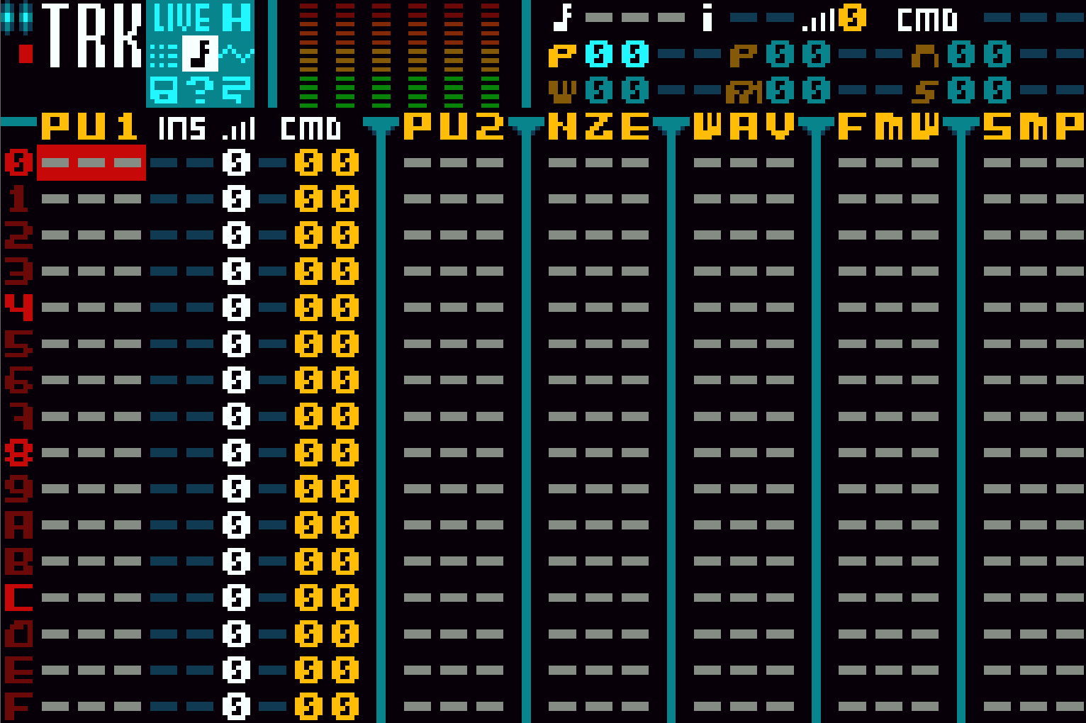 | □ Single column shift  □ Shift column up/down ( R + SELECT + UP / DOWN )  □ Single column transpose/modification  □ Column up / down ( R + SELECT + RIGHT / LEFT )  □ VU-Meters need to be animated along their envelope values  □ Effect support
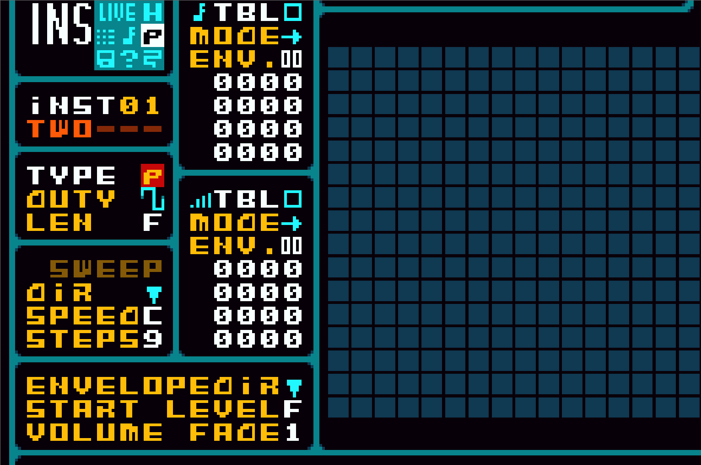 | □ Show shape @ duty change  □ Fix bug causing WAV type Mix% parameter interfering with duty parameter in PWM  □ Table envelopes must indicate SPEED ( first nibble) and LENGTH ( second nibble )
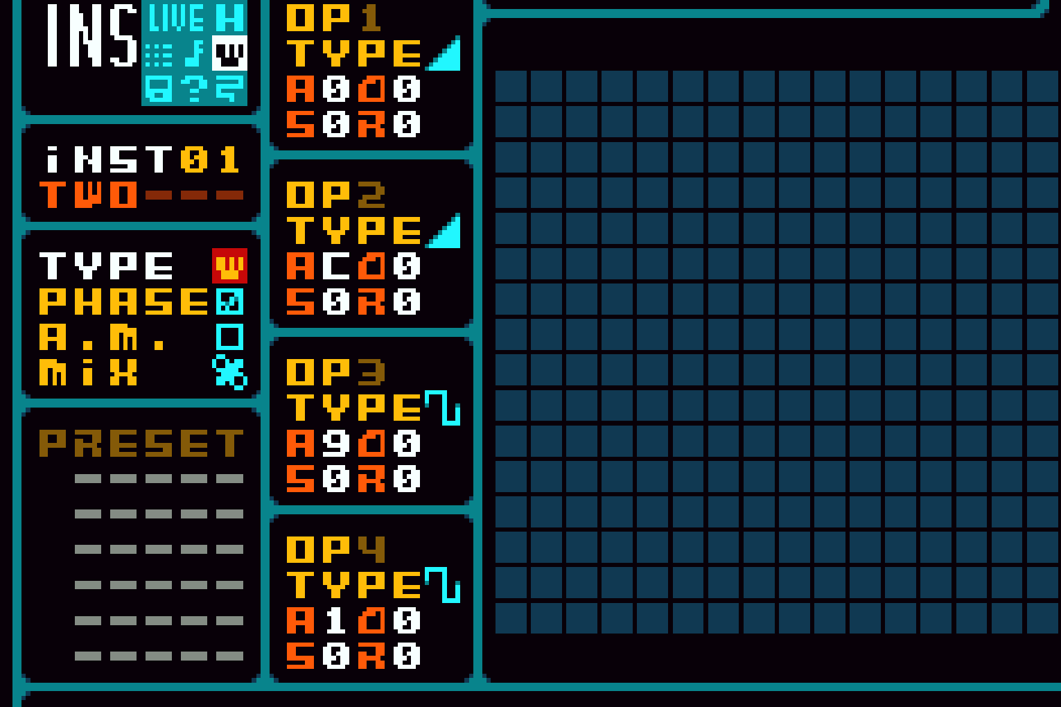 | □ WAV channel wavedata display  □ Show shape @ operator change  □ Live wavedata rendering ( HOLD SELECT during playback )  □ Table envelopes must indicate SPEED ( first nibble) and LENGTH ( second nibble )
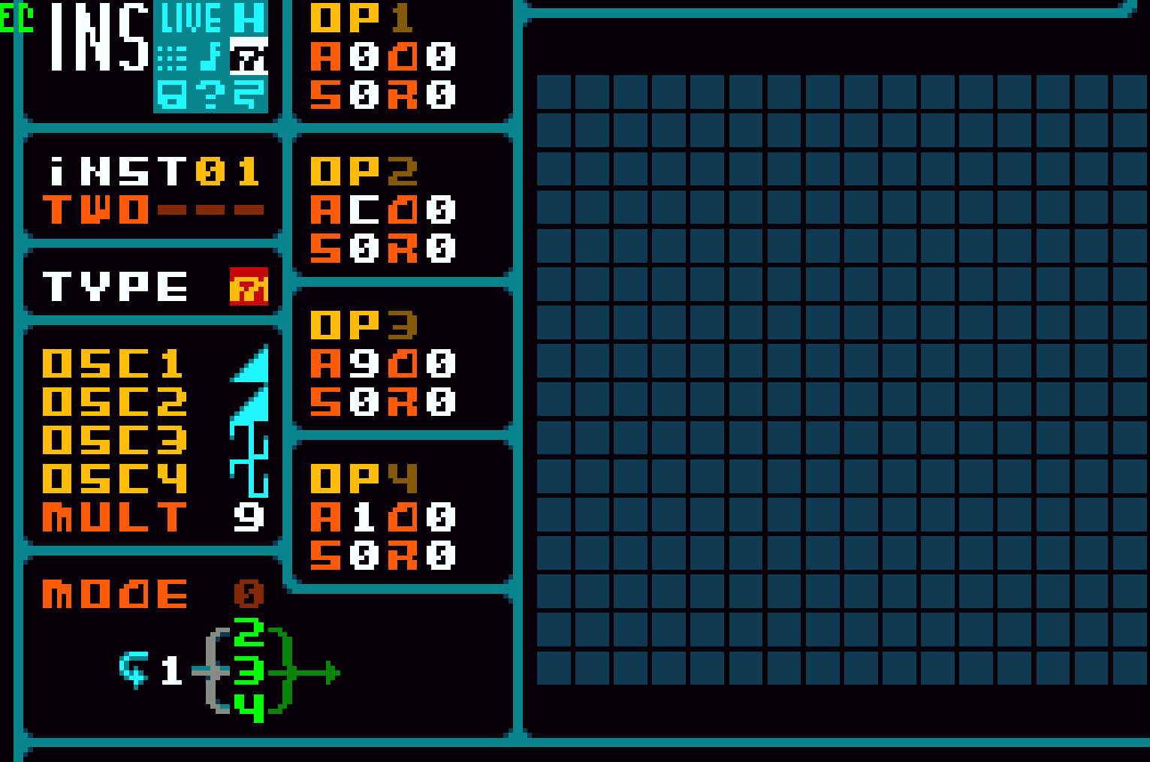 | □ FMW Audio  □ FMW channel wavedata display  □ Show shape @ operator change  □ Live wavedata rendering ( HOLD SELECT during playback )
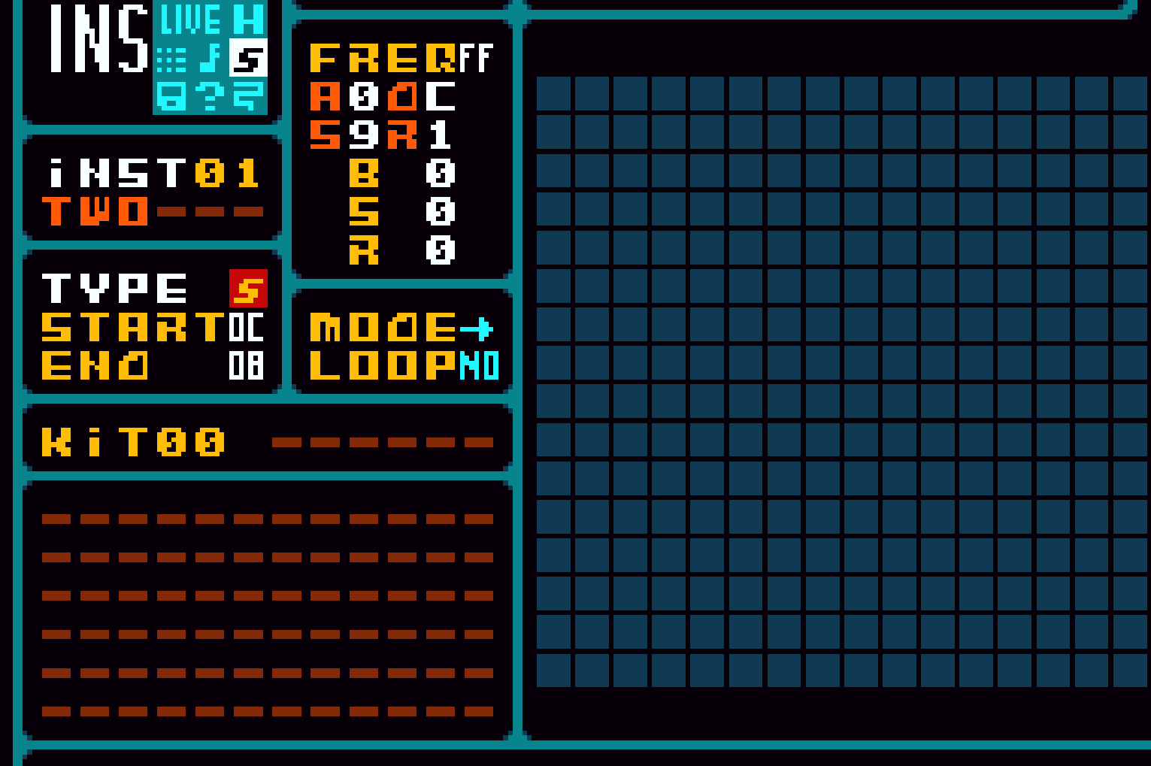 | □ SMP Audio  □ SMP channel wavedata display  □ Show sample @ kit change  □ Live wavedata rendering ( HOLD SELECT during playback )  □ Synth mode (Playback each sample in the kit on each note (C-X=>0, D-X=>1, etc)
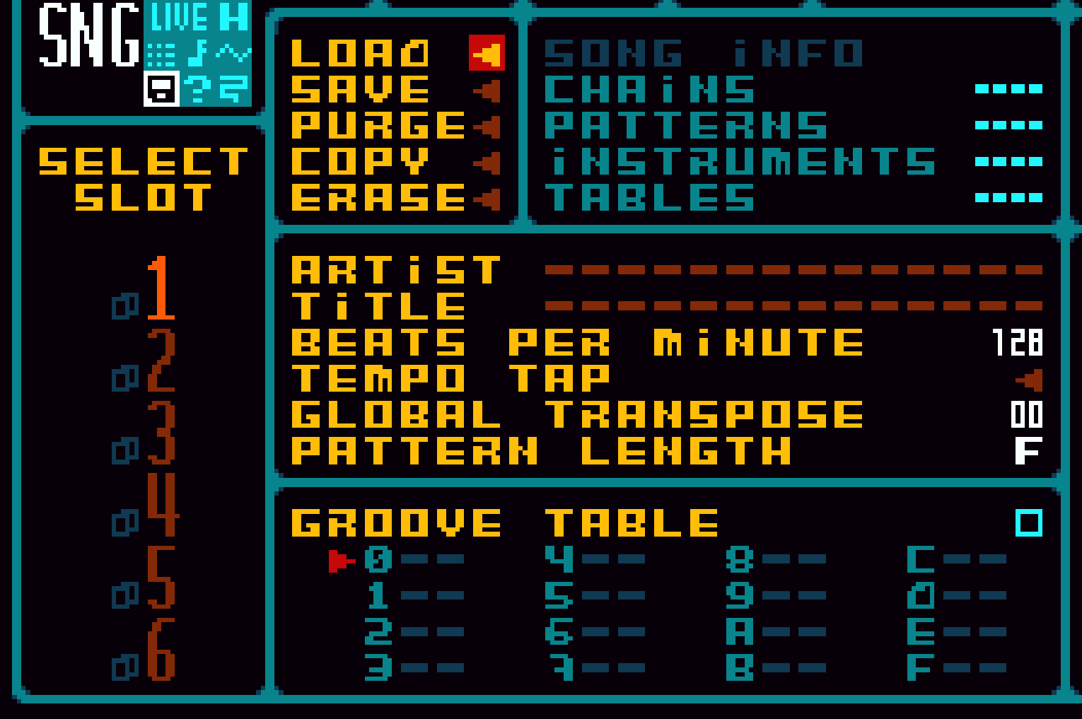 | □ Groove table  □ Pattern transpose data saving  □ Check every slot is usable
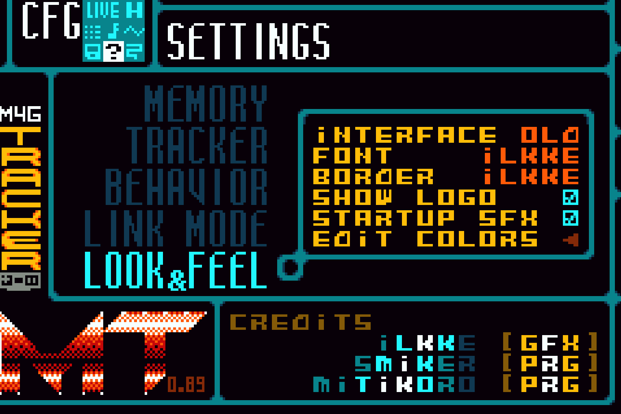 | □ Color editor  □ Decide the new interface amongst all the mockups:  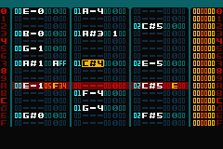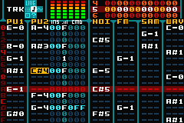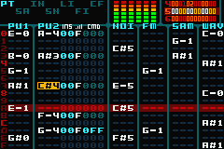
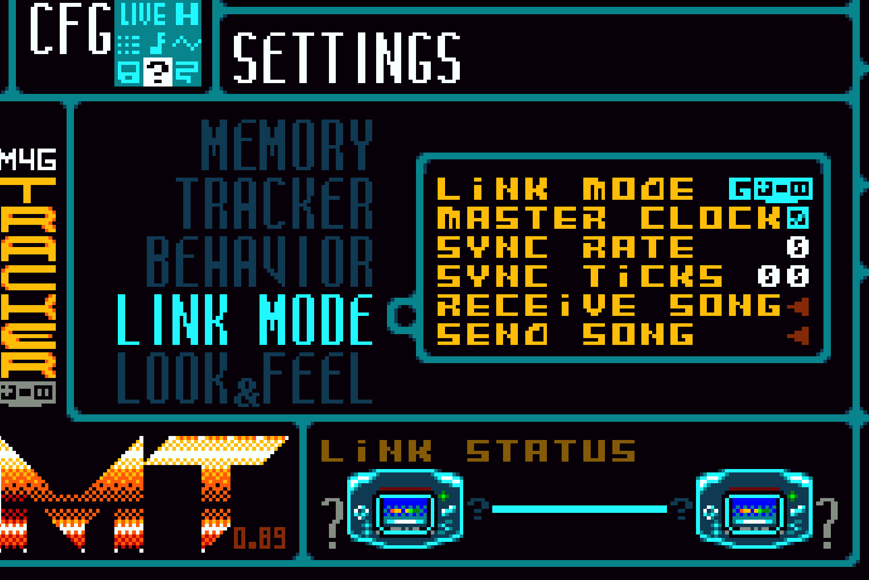 | □ Hide master clock if link mode is not GBA  □ Involve sync rate and ticks into sync net code  □ Send data through serial  □ Receive data through serial  □ Show link status on bottom of the screen
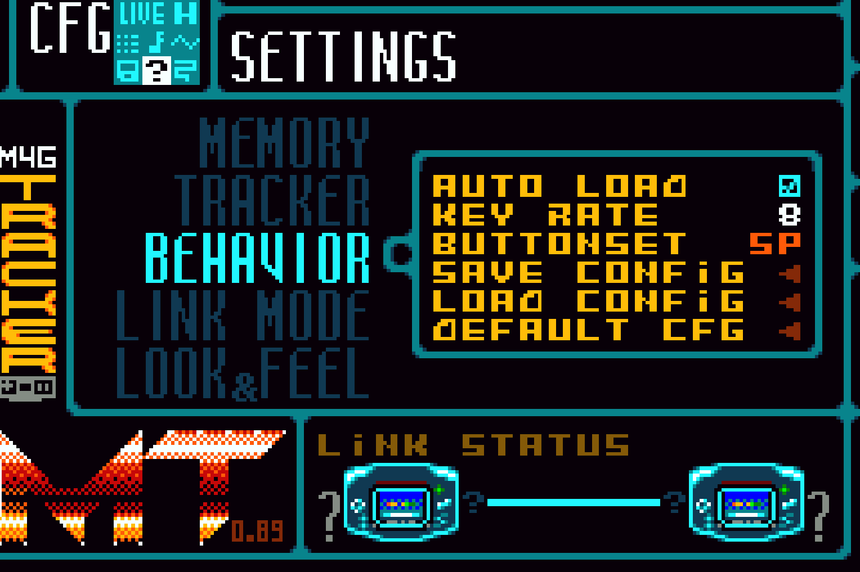 | □ AUTOSAVE Option @ Behavior: If enabled, song is autosaved on playback stop  □ Multiple input schemes ( input code should be rewritten for this )  □ Take key rate in consideration  □ Autoload if SRAM data is valid and only if its valid.  □ Show basic keys ( which change with buttonset ) @ footer
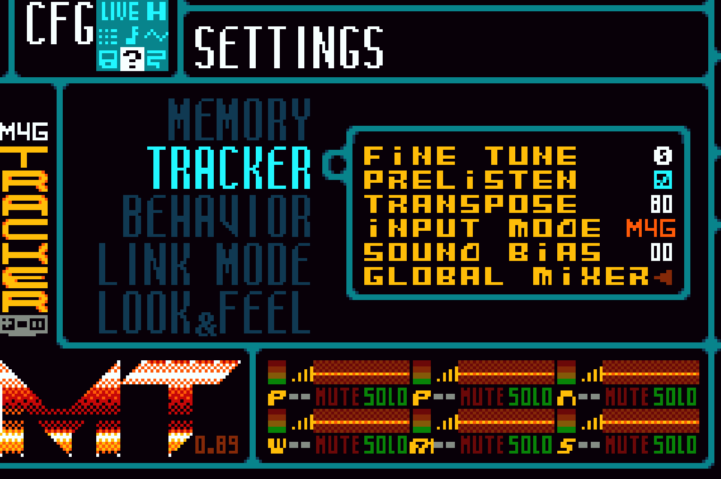 | □ Prelisten on Tracker class  □ Remove input mode setting  □ Remove sound BIAS setting, it does no function and it can be harmful for real hardware  □ Global mixer interface
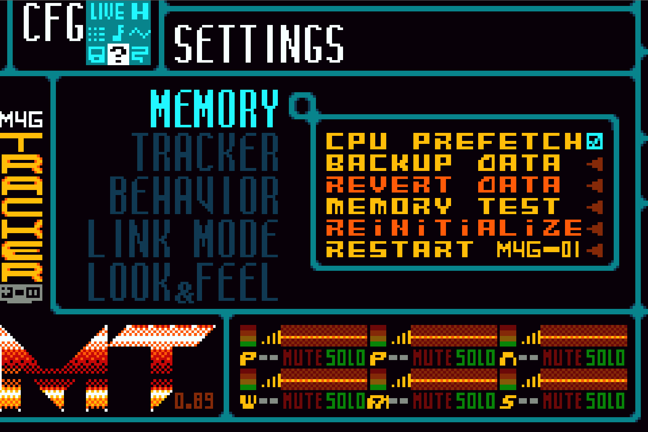 | □ Show total memory in blocks @ footer
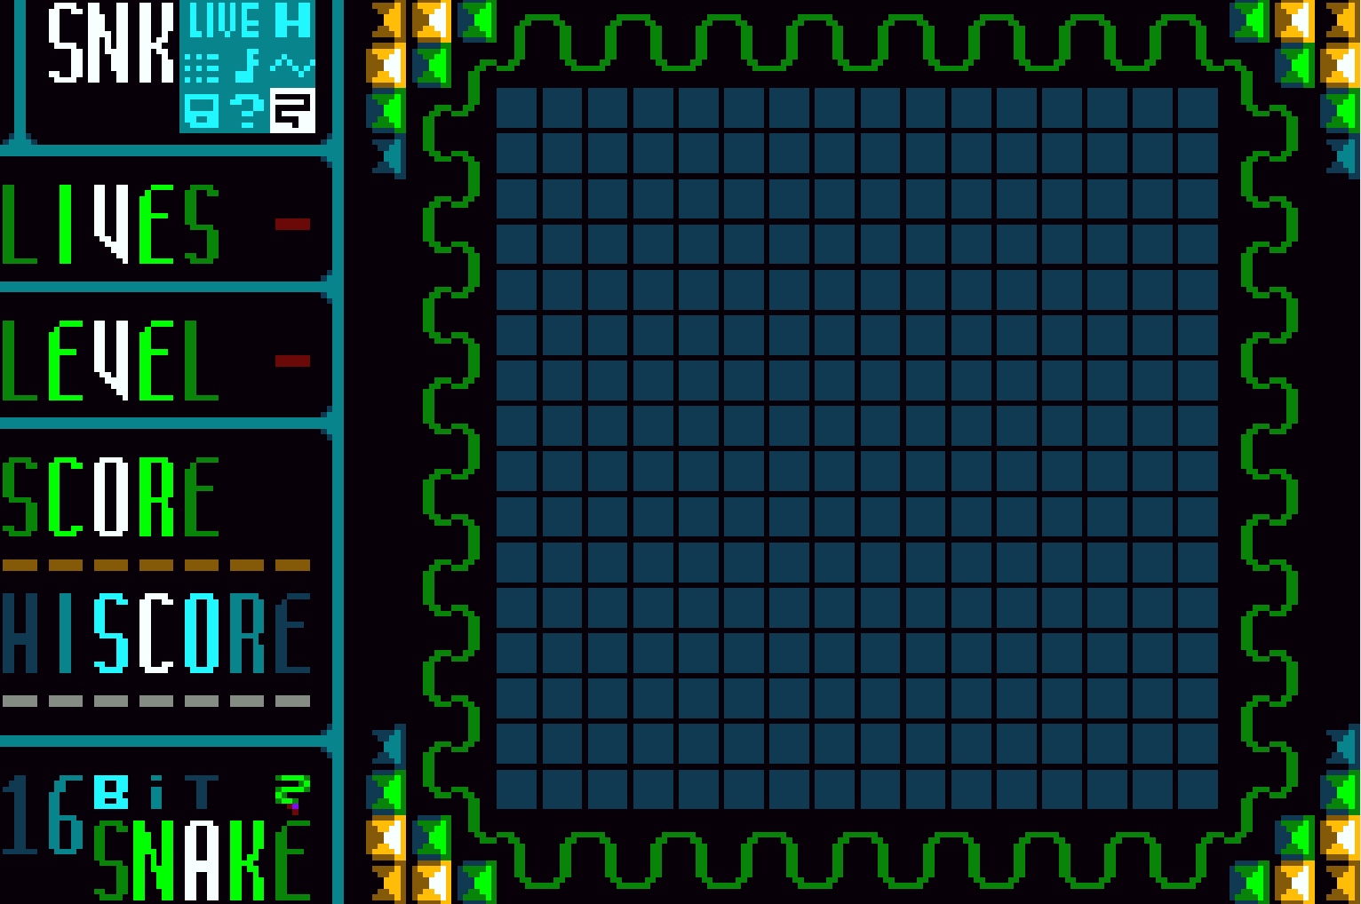 | □ Snake Score Backup / Loading  □ Emit sounds using Synth::polysynth function
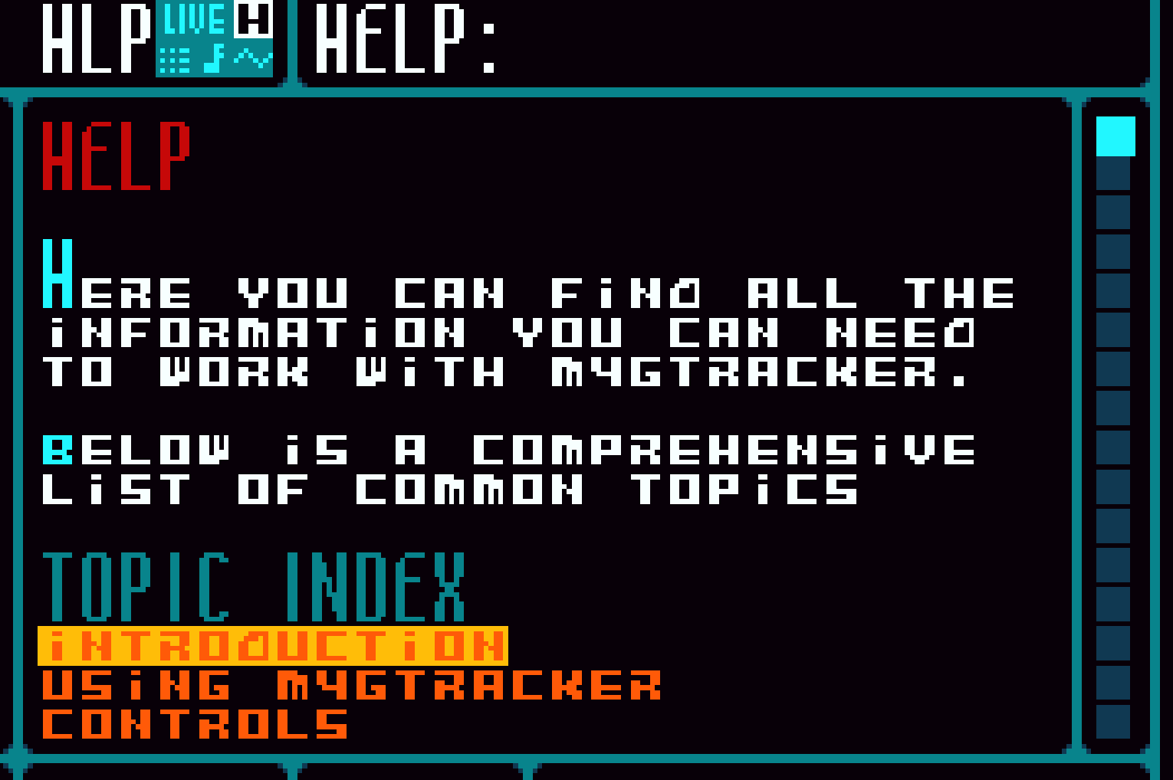 | □ Help pages for Nze Channel

