Devsecops-demo

DevSecOps CI/CD Pipeline Implementation | Beginner to Advanced | Tiktactoe Game

Step 1 — Set up the application
Clone the source repository, install Node.js dependencies, and run the game locally.
npm install
npm run dev
Verify that the application works before adding DevSecOps tools.
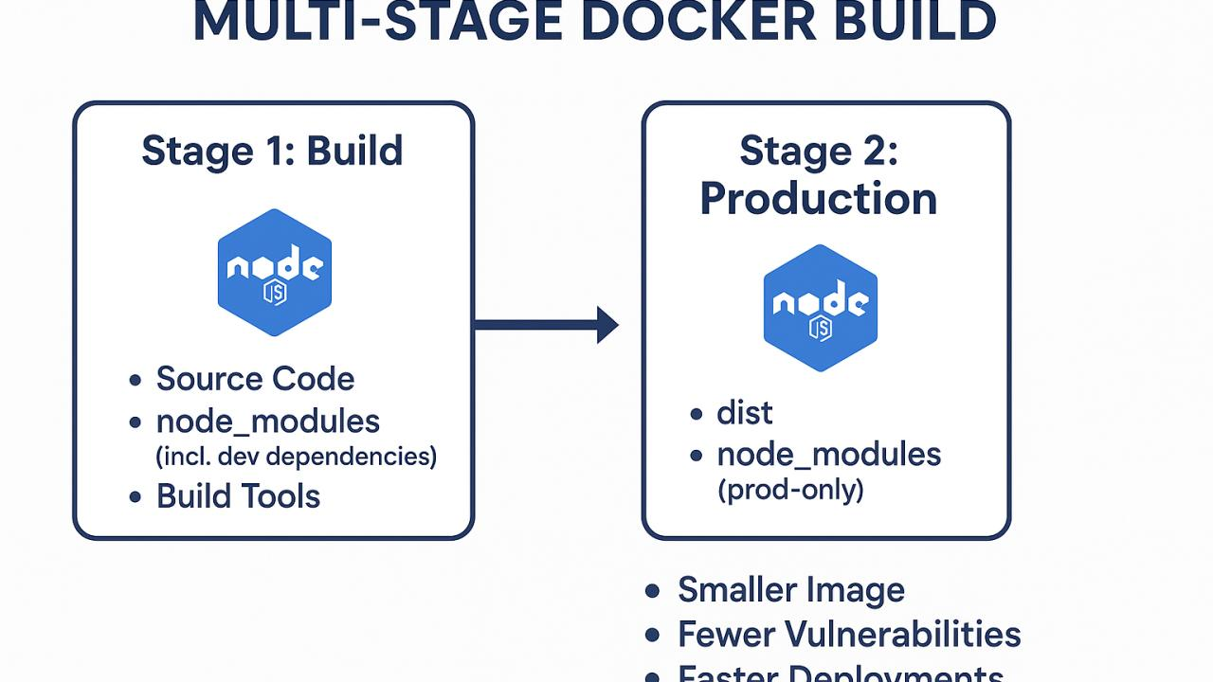
Step 2 — Containerize using Docker
Create a multi-stage Dockerfile. Build the application in a Node.js image, then serve the generated static files using Nginx.
docker build -t tictactoe:v1 .
docker run -d -p 8080:80 tictactoe:v1
Test the application at http://localhost:8080.

Step 3 — Create the CI/CD workflow
Add a workflow YAML file under .github/workflows/. Configure GitHub Actions to trigger on the required pushes or pull requests.
The workflow can automate testing, code analysis, building, artifact publishing, and subsequent delivery stages.

Step 4 — Integrate security checks
Add the security and quality tools used in your implementation, such as static code analysis and Trivy image vulnerability scanning.
Document what each check scans and what happens when it finds an issue.

Step 5 — Publish the Docker image
Authenticate securely to your container registry and push the versioned image. Store credentials in GitHub Actions secrets rather than hardcoding them in YAML files.

Step 6 — Deploy using Kind and GitOps
Update the Kubernetes deployment manifest with the intended image tag. Configure Argo CD to monitor the GitOps configuration repository or path and synchronize the desired state, according to your setup.
Verify the pods, deployment, and application access.

Explain your Dockerfile to beginners
# Stage 1: Build the application
FROM node:20-alpine AS build

# Set the working directory
WORKDIR /app

# Copy package files first
COPY package*.json ./

# Install dependencies
RUN npm ci

# Copy the remaining source code
COPY . .

# Generate production build files
RUN npm run build

# Stage 2: Serve the application
FROM nginx:alpine

# Copy the production build into Nginx
COPY --from=build /app/dist /usr/share/nginx/html

# Document the port used by Nginx
EXPOSE 80

# Keep Nginx running in the foreground
CMD ["nginx", "-g", "daemon off;"]

DevSecOps Interview Questions — Ready-to-Speak Answers
1. Why did you choose Node.js for the build stage?
We first inspected the developer's source code and configuration files. The project uses Node.js-based tooling and npm dependencies, so we selected a compatible Node.js image to install dependencies and build the application.
2. Why use a separate Nginx runtime image for a static frontend?
After the frontend is built, it produces static HTML, CSS, and JavaScript files. Nginx can serve these files without needing Node.js in production, reducing the final image size and unnecessary components.
3. Why do you copy package manifests before the source code?
We copy package.json and the lockfile first so Docker can cache the dependency installation layer. When only source code changes, Docker can reuse that layer instead of reinstalling dependencies.
4. What is the difference between RUN, CMD, and EXPOSE?
- RUN: Executes commands while building the image.
- CMD: Specifies the default command when a container starts.
- EXPOSE: Documents the port the application is expected to use; it does not publish the port.
5. What is the difference between a Docker image and a container?
An image is the packaged template containing the application and its required components. A container is a running or stopped instance created from that image.
6. Why do you trigger the pipeline on a push or pull request?
A push can automatically validate new changes, while a pull request allows us to test changes before merging them. This helps identify issues early and prevents unverified changes from progressing.
7. What is the purpose of needs in GitHub Actions?
needs defines job dependencies. For example, a Docker image publishing job can depend on successful testing and security scanning jobs, preventing publishing when those required jobs fail.
8. How do you securely authenticate to a container registry?
We store registry credentials in GitHub Actions secrets and reference them in the workflow. We use appropriately scoped credentials and avoid hardcoding passwords or tokens in source code or YAML files.
9. How do you prevent a failed security scan from reaching deployment?
We configure the scanner to fail the workflow when findings exceed our defined security threshold. Deployment depends on the successful completion of that security job, so it will not proceed when the required check fails.
10. How does the pipeline update and deploy the correct image version?
We tag the image with a unique identifier, such as a Git commit SHA, and publish it to the container registry. The deployment manifest is updated to reference that exact image tag, allowing Kubernetes to deploy the intended version.

