

**COMPE/ISE/SE 494 Senior Project Report**

**ELDTRACK SYSTEM**

Team Members: Kazım Kuzukıran, Pınar Özkanlı, Yaren Ceylin Gani

|  |  |
| --- | --- |
| Course Coordinator | : Ali Yazıcı |
| Supervisor | : Ziya Karakaya |

**Abstract**

Our senior project is an elder tracking application that is called to “EldTrack”. The purpose of this documentation is to give brief and sharp information about this project. The problems increase for people who getting older in their daily lives and so, their family usually worried about how they deal with those problems? Or do they deal with those problems? Therefore, it is aimed to inform family members or doctor by taking these problems into consideration in our project. These problems were chosen by considering the problems of elderly people. These problems are heart problems, forgetfulness, blood pressure. Our application can measure heartbeat with an IOT device which is a wearable thing on the elderly person. The GPS can track the current location and when the elder person leaves at home with the measuring Wi-Fi signal level from elder person’s smart phone. The smart phone is very helpful for these measurements. The charge status of the phone and the presence of the person next to the elderly are very important. Therefore, application can view the charge status of the smart phone. For an addition, EldTrack application can reminder any significant things such as, doctor appointments, medication hours etc. and family members or elder person can set alarm at the elderly person’s phone. Thus, family members or doctors can track the elder’s some status and take warning notifications when elder person’s conditions be critic.

**Keywords:** GPS tracking, Wi-Fi signal level, IOT devices, smart phone’s battery percentage, Heartrate Monitor Belt, Bluetooth, maximum heart rate, minimum heart rate, average heart rate

**Table of Contents**

**Table of Contents**

**Abstract 3**

**Keywords 3**

**Ch1: Introduction 6**

**Ch2: Literature Review 7**

**Ch3: Requirements 9**

**Ch4: Design 19**

**Ch5: Implementation & Test 41**

**Ch5.1 Implementation 41**

**Ch5.2 Test 53**

**Ch6: Evaluation 69**

**Ch7: Impact of the Project & Compliance with the Constraints 71**

**Ch7.1 Compliance with the Realistic Constraints 71**

**Ch7.2 Impact of the Project 75**

**Ch8: Conclusions 76**

**Appendix A 77**

**References 78**

**List of Figures**

**List of Tables**

1. **Introduction**

As time goes by, aging is a process that no man in the world can resist, and the common problems that most people experience in this process begin. Before we started our project, we did some research on what these problems might be, and of course we shared our observations by sharing the problems of elderly people in our families. It is very important to observe the lives of people living these problems so that we can help them to make their lives easier.

In our research, we used the heartrate belt, which is an IOT device that an elderly person can wear to monitor the heart rate for 24 hours. The Heartrate Belt must put the data collected from the BLE, heartrate sensors into the phone of the elderly, but we had some hardware problems. We've had a hard time getting a Bluetooth pairing on the belt and the phone. We also encountered some problems with the software. We have been forced to send the data out of the device instantly and continuously.

The second major problem was the memory of the elderly. Some elderly people have a great deal of trouble keeping their information in memory, and such a problem can cause great hazards. That's why his family members should have been able to keep track of them by GPS all the time and be aware of when he was leaving home. In this case, the location of the elderly person should be shared with the family instantly and this part was a bit difficult to do. We also used his phone's distance from the Wi-Fi modem signal in his house to measure his communication with the house. And of course, we thought of a reminder interface for the memory problem. In this interface, the elderly person or his family can set an alarm on some dates or on repeated dates. These alarms can be medication hours that need to be taken continuously, doctor appointments or an activity set up by family members. Before making these parts, we had a hard time deciding how to distinguish the elder and other users using the same application.

The EldTrack application can be further improved in health, and other IOT devices can be added. In addition, the location of the user can be the doctor's own doctor out of the elderly person, even this is more useful. Because these problems can be increased by older people and it is better for the person to be observed by the doctor when it comes to the disease size.

Family members or doctors can monitor the health status or position of the elderly person from their smart phones. be aware of the critical situation of the elderly person. For example, the heartbeat may increase or decrease abruptly.

You can see different chapters in this report document. The requirements of the system shown in the third chapter. The fourth chapter includes Software Development Methodology, System Architecture, and different diagrams. In the fifth chapter implementation details and test procedures have been discussed. Evaluation part of the system has been provided in the sixth chapter. Impact of the project and compliance with the constraint 5 are investigated in the seventh chapter. In Chapter 8, conclusion part.

**2. Literature Review**

**2.1 Mobile Applications**

As people get older, they are physically debilitating over time, and therefore the risks of getting some diseases are increasing. We, as their family members, cannot always be there to help. Sometimes they want to live alone, sometimes they live in a place far away from us, or even if we live in the same house, we cannot constantly control. Therefore, with this project, we decided to develop the EldTrack system to enable us to keep track of what the elderly people are doing with their families and their health status.

In this literature review, we conducted research on the problems experienced by the elderly people in their daily lives from various sources. As a result of our research, we discovered some products following the elderly people. For example, a telephone produced for older people can make large, urgent calls. But we don't have a product like our product, because the EldTrack system is part of a wearable system with internet of things. The piece allows many things to be checked, checked and displayed. After an investigation, we decided to use a wearable product with HRM belt in our IOT system.

BodyGuardian Heart is a hidden remote monitor that records important physiological data such as heart rhythm, ECG, respiratory rate and activity. Like many of the other products here, the wearer, his doctors, and his caregivers are connected to an application that allows them to monitor vital signs and to quickly alert when there is a change that proposes potential health problems. [1] From here on, a project will be used to measure the heart rate every second. The HRM will constantly check and measure the heart rate of the elderly person. This is a device that old people can wear.

In our project, we decided to use data mining by using GPS and heartbeat sensor. In this system, we wanted to check how much the streets and roads he used and forced him while he was outside his home. Thus, we can decide that this person should use other streets. Declination detection systems are used in fall detection technology for elderly and patients. In this system, it allows to detect and monitor fall events for the elderly, and hence provide the necessary assistance when necessary. In this article, we use three-axis accelerometers which are hidden under smart tiles. Force sensors allow the detection, placement and monitoring of falls of elderly people, and recognize human activities (walking, standing, sitting, reaching, falling and passing between them). Thus, it can control where the elderly person is forced in the house or if they fall.[2]

We wanted to know the presence of the elderly person at home so that family members can learn if he is at home or when to follow him/her. In this study, they characterize the effect of human bouncing on wireless signals with beam-bouncing models. and propose a measurable measurement on commodity Wi-Fi infrastructure as a proxy for detection accuracy. They are designing a light subcarrier and road configuration scheme that includes frequency diversity and spatial diversity in order to achieve higher detection speed and wider detection coverage in multi-directional intense indoor scenarios. They are prototyping programs with standard Wi-Fi devices.

**2.1 References**

|  |  |  |
| --- | --- | --- |
| [1]. |  | Preventice. BodyGuardian Remote Monitoring System.™ <http://www.preventice.com/products/bodyguardian>(accessed 01/11/2013).  [Google Scholar](http://scholar.google.com/scholar?hl=en&q=%0A+++++++++++++++Preventice.+BodyGuardian+Remote+Monitoring+System.%E2%84%A2+http%3A%2F%2Fwww.preventice.com%2Fproducts%2Fbodyguardian+%28accessed+01%2F11%2F2013%29.) |

[2] [IEEE Sensors Journal](https://ieeexplore.ieee.org/xpl/RecentIssue.jsp?punumber=7361)( Cilt: 17 , [Sayı: 2](https://ieeexplore.ieee.org/xpl/tocresult.jsp?isnumber=7792229), Oca.15, 15 2017 )

[Mohamad Daher](https://ieeexplore.ieee.org/author/37085714293); [Ahmad Diab](https://ieeexplore.ieee.org/author/37085640275) ; [Maan El Badaoui El Najjar](https://ieeexplore.ieee.org/author/38108828700) ; [Muhammed Ali Halil](https://ieeexplore.ieee.org/author/37086198471) ; [François Charpillet](https://ieeexplore.ieee.org/author/37284255200)

 [3] M. Youssef, M. Mah, A. Agrawala, "Challenges: Device-free Passive Localization for Wireless Environments", Proc. of ACM MobiCom, 2007.

**3. Requirements**

**3.1 Overall Description**

**3.1.1 Product Perspective**

This system is mostly tracking system to sure safety of elder person’s in a family with a mobile application. There are many people over a sixty-five age and those people be encounter some issues in their daily life. This system helps family members to tracking elderly people remotely and monitor their health status in some situations. First of these situations that elder people may forget where they are, so they could disappear, and family members can track the elder. The system has own GPS interface in mobile application. This system tracking the live location of the elder people’s device and if they leave their house, the system sent a message to family members using of distance from mobile phone to the wi-fi. So the system measures the signal level from elder person phone's to wi-fi connection. If the signal level between -45 and -100 means elder person in home but increase from -100 the person has been leave from the house. Therefore, family members can easily connect to the tracking system application interface and always monitor locations of the older person on GPS. Also, they forget other things too. For instance, they forget when they take a pill or when their doctor appointment etc. for these reasons, elder person or him/her family members can set up an alarm for elder person in order to reminded special and important date and times on Reminder interface in the mobile application (EldTrack). Thus, family members can control the elder person from a distance. Another situation is that as the body gets older, the human body loses its former strength and the risk of having some health problems increases. At the beginning of these problems, chronic heart disease and high blood pressure(hypertension) are coming. Therefore, the system can monitor measurement of the heart rate of older person in HRM interface. Family members can monitor the heart rate data via Bluetooth from the Geonaute Dual HRM Belt that the elder person is wearing in a day. This HRM belt measures heart rhythm, transfers data to your device with ANT + / Bluetooth smartphone. An HRM belt collect heart rate data via "photoplethysmography" (PPG) or using light to measure blood flow. Under wearable bands with optical heart rate monitors, there are small LEDs that light green on the skin. Different light wavelengths from these optical emitters interact differently with the flowing blood. When this light reflects your flowing blood, another wearable sensor captures this information. This data can then be processed with algorithms to generate understandable pulse readings, together with the motion information detected by the device's accelerometer. Another way, the system can monitor the highest and lowest rate of heart and measure the average HRM of own person’s heart rate thus the system sends a warning message if the heartbeat is well above the average. And another disease was hypertension. High blood pressure increases your risk of serious health problems, including heart attack and stroke. For this reason, the elder people are always should be controlled from their family. EldTrack system measure the elder person's blood pressure with blood pressure sensors and when tension is too high or low, system send a notification message to family.

Another situation is that elder person continuously walks to specific places such as markets, shops, relatives and mosque etc. And in some places elder person may walk there may be exhausting things for him/her, such as streets have slopes, broken sidewalks, narrow roads. The system determines such roads and avenues according to the heart rate of the elderly person and encourages him / her to use new ways. In addition, the family can learn the cause of the increase in his heart rate. In this section, the program enters data mining, i.e. it will process data from the GPS and the heartbeats of the elder person and calculate where the heart rate increases.

Another condition is that the elderly may be sick at times. The system measures the fire of an elderly person and sends a warning message to his family in case of too high a mobile application. And finally, sometimes you can forget to charge the old person's phone and the phone can go off. This prevents the EldTrack system from performing its task and worries when family members notice that data from the older person has stopped. If the old person constantly forgets to charge the phone, the family members can see the battery percentage of elder's phone so that they can set an alarm in the system to remind him/her.

Our system is very useful for families who want to track elder family members, especially if the elderly person insists on living alone or lives away from his/her family. For the elderly person, they can be reminded of things that should not be forgotten, they can check their health status, and they can even put photos in the reminder section to remember them. With EldTrack, the old man won't feel lonely.

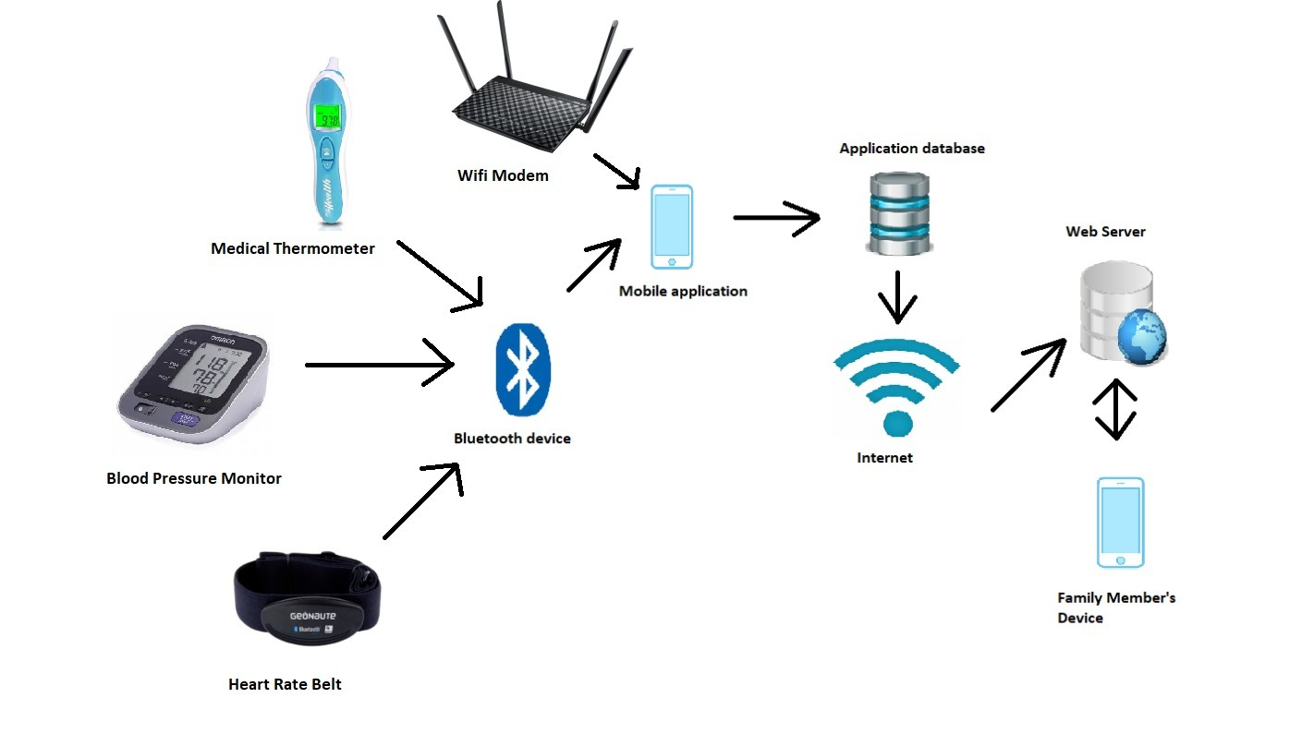

**Figure 3.1 Product Overview**

**3.1.2 Product Functions**

Tracking Elder People shall perform the following functions:

1) Sign up, login, user (elder, family or doctor) account

2) Measure the heartbeat, blood pressure and body temperature of elder person

3) Monitored location, wi-fi signal level, battery percentage of elder person

4) Create, modify, delete family members from the system

6) Give some notes about elder’s locations for example, elder person’s heart rate increases too much in this street.

7) Reminded some needs such as medication hours, doctor appointments, exercise hours, etc.

8) Send warning notifications for some critic situations to family members such as body temperature 39 degrees Celsius of elder person!

**3.1.3 User Characteristics**

**Family member**: Owner of family member has a family account to monitor owner locations, blood pressure and heart rate.

**Owner:** Who has a wearable device to detect heartbeat rate and location.

**3.1.4 Constraints**

* Elders must have a wearable device.
* Elders and their family must have a smartphone.
* Elders and family must have the mobile application.
* Elders must have an account.
* The system only works on Android

**3.1.5 Assumptions and dependencies**

* The mobile android application should be supported with the device that have Bluetooth protocols. This implementation used with Bluetooth heart rate monitor. The hardware supports BLE (Bluetooth Low Energy), the application will be developed for Android.

**3. Specific Requirements**

**3.2 External interface requirements**

**User Interface**

* The system provides ease of use to the users especially elder people.
* The system displays user’s healthy state with graphs and statistical values.
* The system reminds user’s schedule program using with calendar for hours.

**Hardware Interfaces**

* User must to have an android smartphone with a capability of Bluetooth and GPS connection.
* User shall have a Heart Rate device with a capability of Bluetooth.
* User shall have a thermometer device with a capability of Bluetooth.
* System shall have a web server for storing database and web services /pages to display results.

**3.2 Software Interface**

**Mobile Application Interface**

* The mobile application able to make measurements and displays the results.
* The mobile application able to save new data in the schedule program.
* The mobile application shall send a message.
* The mobile application shall send an emergency message in case of risky result.

**3.3 Functionality**

**Functional Requirements**

Functional and nonfunctional requirements are listed below. In figure 3.1 is a use-case diagram of the EldTrack. This diagram helps to show system users and their interactions. Our measuring device, smart phone and mobile application are also system user. Each user’s tasks specify in the diagram.

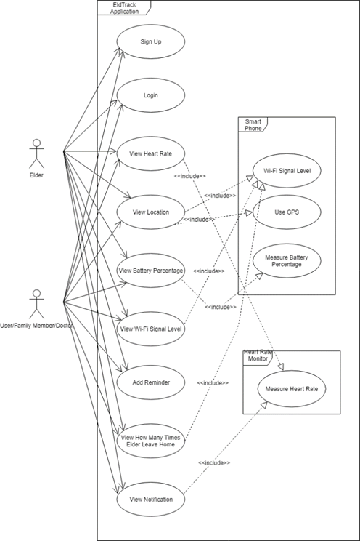

**Figure 3.2**

**Sign Up**

**Description and Priority**

The owner who has a wearable device, must create an account that specifies the owner to create an account the system needs an email address and a password.

**Stimulus and Response**

Stimulus: Owner has to click on “sign up” button to create an account.

Response: The system opens the page to make owner create an account

Stimulus: Owner have to enter her/his email address and a password.

Response: If the mail address exists, new account is created.

**Functions**

|  |
| --- |
| Sign Up : The system allows to user to create an account by requesting some personal information. |
| Email Address: The system is needed an email address to create a reliable unique account. |
| Password: Owner have to create a password to increase safety. |
| Username: The user has to enter a username. |

**Login**

**Description and Priority**

The owner and owner’s family members can log in the system with their usernames and passwords.

**Stimulus and Response**

Stimulus: Owner and family members have to click on “login” button to enter the

system.

Response: If the system requirements are satisfied to log in the system, the main page

is opened.

**Functions**

|  |
| --- |
| Username: The username is required by the system to log in to it. It is necessary to enter the right information. |
| Password: The owner and users have to enter ttheir own passwords. |

**Make Measurements**

**Description and Priority**

Owner should have a wearable device to make measurement. This wearable device is connected with the mobile app via Bluetooth connection. Thus, family members and owner can see the data that are sent from device.

**Stimulus and Response**

Stimulus: The device always tracking heart rate of the owner.

Response: The data are shown by the mobile app.

Stimulus: Owner can measure own blood pressure by clicking on the button.

Response: The device measures the blood pressure and send the data to the mobile app.

Stimulus: Owner can measure fever.

Response: Fever is measured, and the data is sent to mobile app.

**Functions**

|  |
| --- |
| Measurement Device Connection: There should be established a connection between the device and the mobile app. To view measurements, device sends the data via the Bluetooth connection to the mobile app. |
| Measurement Sense: The wearable device should sense the heart rate, blood pressure and fever of owner. |
| Measurement Send Data: The wearable device should send the data to mobile app. Thus, the family members can see the data. |

**Send Warning Messages**

**Description and Priority**

It is important to send an informative message to family members or a data center if there is an emergency, so the system is also designed to response to this condition.

**Stimulus and Response**

Stimulus: Owner can click on the button to inform their family or the data center.

Response: The automatic message is sent to the family members or the data center.

**Functions**

|  |
| --- |
| Send Warning Messages: The automatic message is sent by the system to the family or data center. |

**Make a Reminder**

**Description and Priority**

Family members can make a schedule to add appointments or any programs to remind the elder person.

**Stimulus and Response**

Stimulus: Owner or family members click on the button to schedule

Response: The mobile app opens the calendar.

Stimulus: Owner or family members can add a message to remind to them for

something.

Response: Calendar view to changes that are done by the family members.

Stimulus: Owner or family members click on the button to save the changes.

Response: The changes are saved, and the system sends an informative message when

the appointment, meeting date is closer.

**Functions**

|  |
| --- |
| Making A Reminder: The family or the owner can add an appointment on the calendar over the mobile application. |
| Save Reminder: The family or the owner saves the changes. |
| Send Notification: When the day is closer, a message remind to the owner  the appointment. |

**GPS Tracking**

**Description and Priority**

The elder person’s family or her/his doctor can track where she/he is. They can track using with using elder person’s GPS device in her/his Smartphone. If the elder people’s GPS is not active, they cannot use Google maps. In this condition the app can automatically reactivate the GPS or the elder person can activate her/his GPS device to some situation.

**Stimulus/Response Sequences**

Stimulus: User clicks on “GPS” button.

Response: The system opens GPS view.

Stimulus: User track the current location.

Response: GPS share the current location.

**Functions**

|  |
| --- |
| *GPS Tracking :* The system shall connect with GPS. |
| *Location Sharing:* The system shall share the current location. |

**Send Wi-fi Signal Level**

Elder can leave the home when he/she want to. Therefore, elders may need extra attention while they are out from their family in order to protect them. Consequently, family members may need to track to them. Thus, EldTrack app, measures the Wi-Fi signal level of the phone to the router in elder’s home. When elder leaves the house or lost the Wi-Fi connection, EldTrack app will send a notification to the family. The Wi-Fi signal level scaled from “-45” to “-100”. In addition to that “-45” means connection quality is very good and “-100” is very bad. When Wi-Fi connection is lost, EldTrack app will check GPS location in order to understand whether Elder inside of the building and outside of the house or left the building.

Stimulus: Elder person in home.

Response: The system measure Wi-Fi signal level of the phone to router.

Stimulus: Elder person’s phone disconnected from Wi-Fi.

Response: The system sends a notification message.

**Functions**

|  |  |
| --- | --- |
| Sense Wi-fi Signal Level: | The system measures with Wi-Fi level. |
| Wi-fiSignal Level Disconnect: | The system will detect when phone’s Wi-Fi connection is lost. |
| Send Wi-fi Signal Level Send: | The system will send a notification which includes whether elder inside the building or outside. |

**3.3.1.11 Battery Percentage**

In some situations, elder’s phone cannot be reached by family members. In this case, they cannot track the elder’s location and health state. This case is highly unwanted by the family and it can be dangerous for elder. Therefore, the system allows family members or users to learn battery percentage of the elder’s phone and send a warning message whenever battery percentage is very low.

Stimulus: Elder person’s phone battery is very low.

Response: The system monitors to battery percentage of elder’s phone.

**Functions**

|  |  |
| --- | --- |
| Sense Battery Percentage: | The system monitors the phone battery percentage. |
| Batter Percentage Notification: | The system will send a warning notification to the users and elder whenever elder’s battery percentage is very low. |

**3.4 Nonfunctional Requirements**

**3.4.1 Performance Requirements**

* The system allows to work for all users, if they are log in the system same time.
* The system is compatible with hardware.
* The system processes the data, that is sent by the wearable device or Arduino, within 5 seconds.
* The system responses the buttons within the 2 seconds.

**3.4.2 Security Requirements**

* User’s information is stored as encrypted in the database.
* All users and their family members have a unique id to specify they are family so they cannot see other owners’ information.

**3.4.3 Availability Requirements**

* Family members and owners can use mobile app anytime they want.
* If owner takes off wearable device, family members and owner cannot track the heart beating.

**3.3.4 Database Requirements**

* Database compares hold the old measurements and compare them with the new ones.

**3.4.5 Hardware Requirements**

* System works with the Arduino and a wearable device as synchronized.

**4. Design**

* 1. **Software Methodology**

The purpose of the Agile development process; plan, documentation, process and tools rather than customer satisfaction, employee software, compatible software development team and customer requests to be developed according to changes in a short time to produce software.

Scrum is an agile project management methodology primarily used for software development projects to provide new software capabilities. One of the Agile approaches that expresses a set of principles to guide decisions about how to improve high-quality software faster. Scrum is one of the agile methods designed to guide teams in the iterative and incremental delivery of a product. It is based on a self-organizing, functional team. The Scrum team is self-organizing, because there is no general team leader who decides what person to do or how to solve a problem. The focus is on using an empirical process that enables the team to adapt quickly, efficiently and effectively to change.

In waterfall software development approach consists of design, coding, testing, version and maintenance. In traditional software methods, these stages are linearly as in the waterfall model. But it is a very systematic method that does not give error. It is not possible to deal with changes in this methodology. It is also more suitable for projects in larger time periods. Therefore, waterfall model is not applicable too.

In prototyping software development approach tends to solve a number of different problems that arise in the Waterfall method. It is a special software development procedure that goes right to validate its functional essence to customers and to make only one instance of the analysis to make the necessary changes before creating the authentic final solution. Too many changes affect the workflow of the software. Prototype methodology is not a good option as this project may change.

Scrum methodology is the most appropriate method for this project as technology and systems develop and change very quickly. Scrum advocates that processes, documents and designs should not be fully defined at the beginning of the project, but that decisions should be made in accordance with the changing conditions. In this way it is a very convenient method for the development of our project. In other words, it is compatible with the project process to provide repetitive and incremental product delivery, which uses frequent feedback and collaborative decision making. However, since the time to use in this project is not long, it should be ensured that the decisions made are stable.

**4.2 Architecture Diagram**

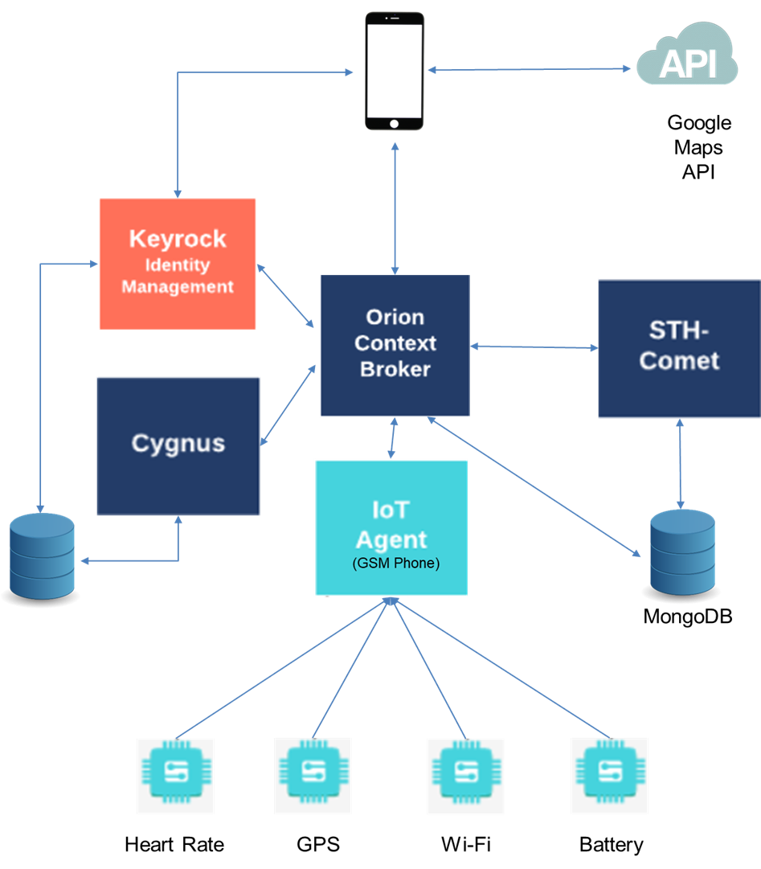

**Figure 4.2.1**

Figure 4.2.1 is the architecture diagram of EldTrack Mobile Application. It represents the interaction between elements and components of the system. Also, it shows that how to communicate between each other.

Components and parts are:

- Heart Rate Monitor

- GPS

- Wi-Fi

-Battery

**4.3 Use-Case and Collaboration Diagrams**

**4.3.1 Use-Case Diagrams**

Use-case diagram shown in the below represents the interaction between system users and system functions. System users represent actors that shown in the left hand side and the right hand side of the rectangle. It shows us the system allows which user to use a which function. There are 5 subsystems and three of them are used for receiving data via Bluetooth. It is designed to understand easily what system does. When Elders and their family want to use the system, the path to be followed is seen below.



**Figure 4.3.1**

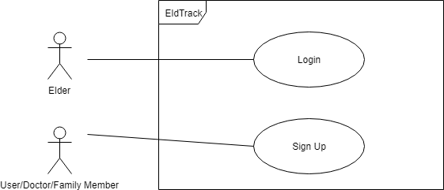

**Figure 4.3.2**

In figure 4.3.2 registration part of the system. Elder and other user must register the system using their mail address. Then they can log in the system.

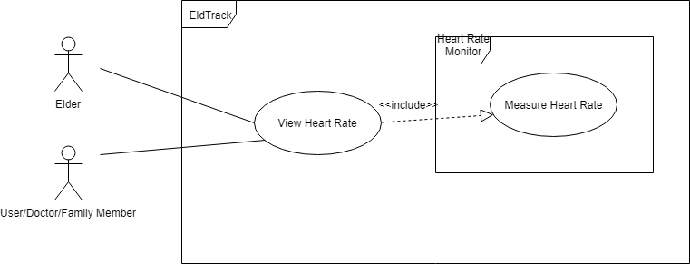

**Figure 4.3.3**

In figure 4.3.3 View Heart Rate function and Heart Rate Monitor actor are seen. Heart Rate Monitor is a heart rate tracking device that Elder wear. This device sends the sensed data to the mobile application via Bluetooth so Elder and their family member can track the data.

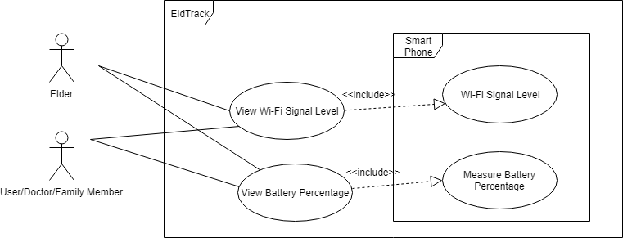

**Figure 4.3.4**

In figure 4.3.4 Mobile Application receive the battery percentage and signal level from the Smart Phone and it shares the data.

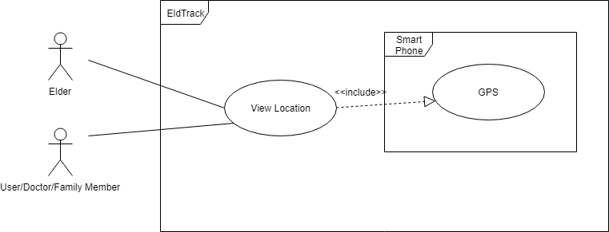

**Figure 4.3.5**

In figure 4.3.5 Eldtrack share locations of Elder with their family or relatives.

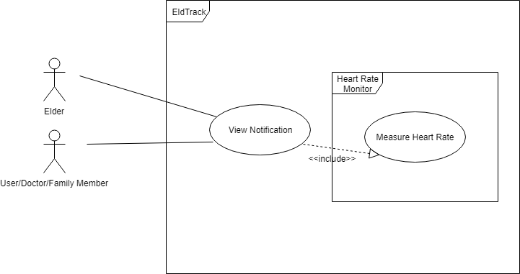

Figure 4.3.7

When Elder’s Heart Rate is higher or lower than normal it sends a notification.

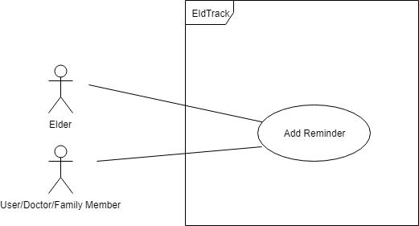

**Figure 4.3.6**

In figure 4.3.6 all users can make a reminder for Elder.

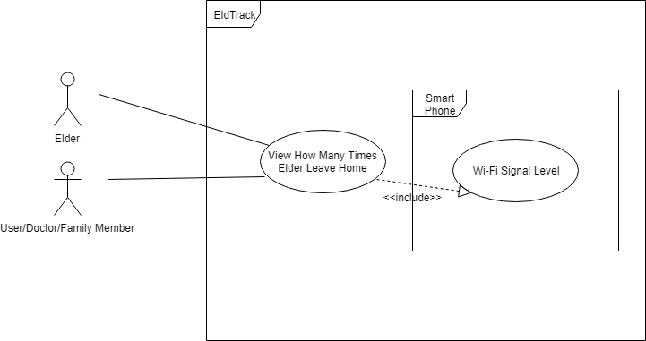

**Figure 4.3.7**

When Wi-Fi connection is lost, the system supposes that Elder leaves home and it shows that.

**4.3.2 Collaboration Diagrams**

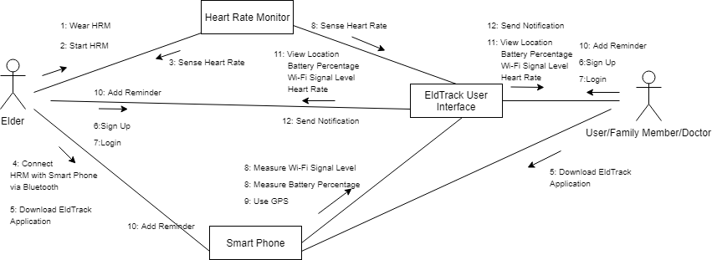**Figure 4.3.8**

Collaboration diagrams shows us relationship between objects. Each object has lines to clarify these relationships. Figure 4.3.8 shows us the steps that must be followed by Elder to use the system. First, Elder and all users must create an account to register the system. After registering the system Elder/User/Family Member can login the system.

**4.4 Class Diagrams**

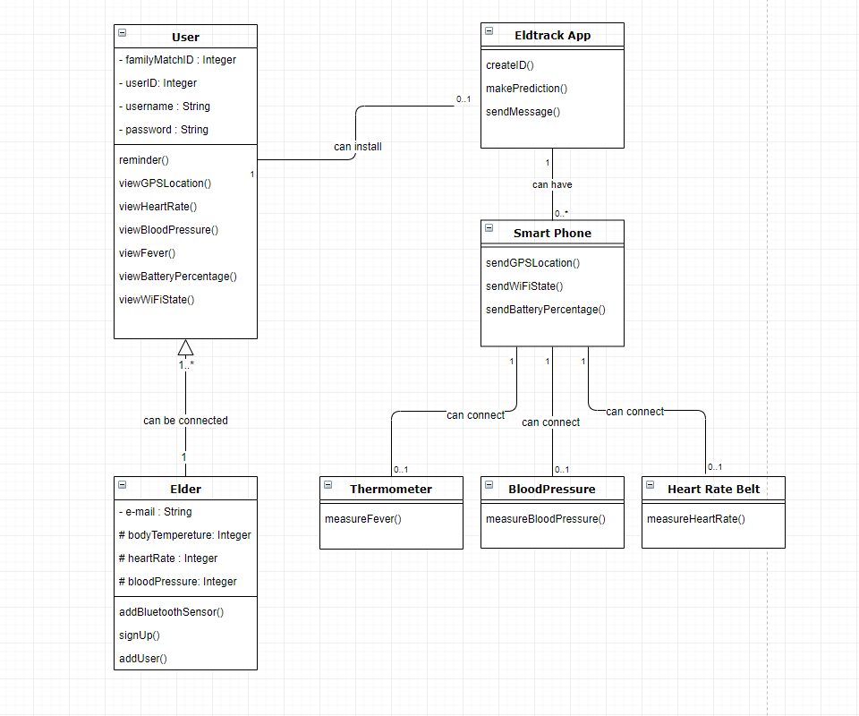

**Figure 4.4.1**

Figure 1 is the visual representation of EldTrack’ s class diagram. In this class diagram there are seven classes. Their relationship with other classes is defined in the diagram. Thermometer, Blood Pressure and Heart Rate Belt classes do not have attributes unlike User, Elder and EldTrack App classes. In addition to that, User is parent class of Elder class which means all the users attributes and functions can be used by Elder class. Therefore, Elder class also have its own attributes and functions which User class do not have.

**4.5 Deployment Diagram**

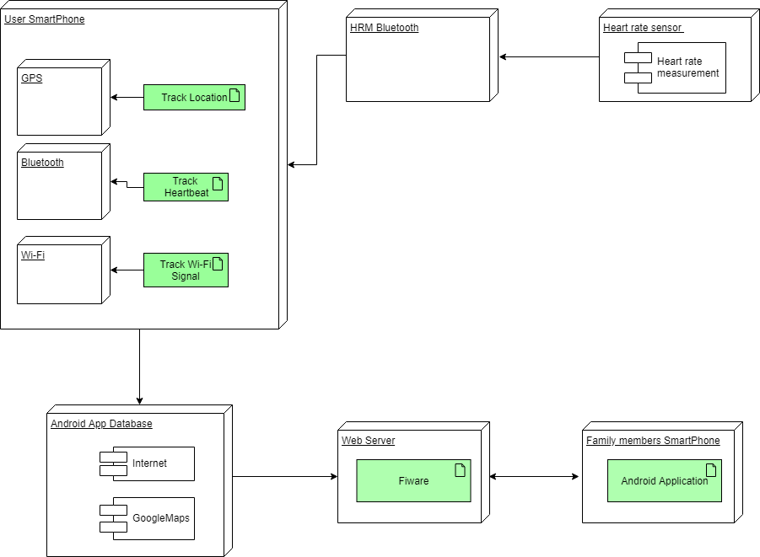 **Figure 4.5.1**

Deployment Diagram represent the deployment view of a system. Deployment diagrams are a type of UML diagram used to visualize the physical hardware and software of a system. Thanks to the deployment diagram, it can be easily understood how the system is physically deployed on hardware.

In Figure 4.5.1, there are six divisions, namely, Smartphone, Sensor, Bluetooth, web server, Android application Database and Family member smartphone. The most important part of the connection between Bluetooth sensors and a user smartphone.

The data from the heart rate sensor comes to the android application on the smartphone of the old person via Bluetooth. Application; It collects data using GPS, Bluetooth and Wi-Fi tools. This data is stored and managed in the database through the Fiware components. Fiware is an open source platform and contributes to the development of SMART solutions. The information stored and managed in this framework reaches the application on the family members' smartphones. Sometimes they provide remote management of their information.

**4.6 User Interface Design**

In this section of this report, user interface designs will be shown and explained in order to provide general knowledge about the system. Also, this section shows and explains how this system and user interface works together.

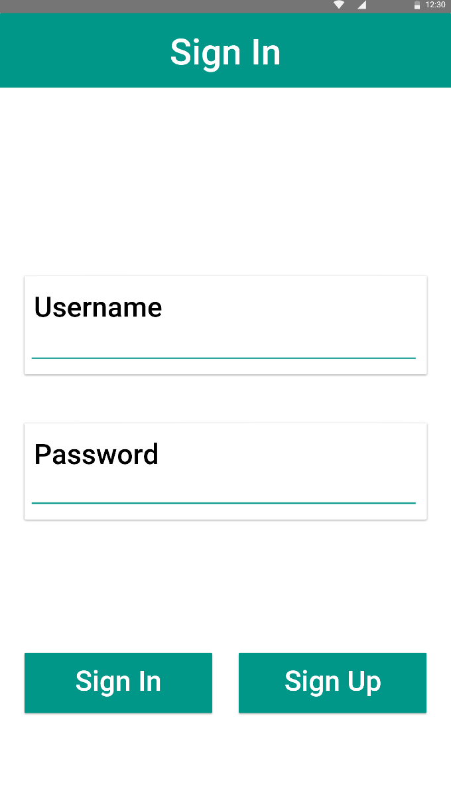

**Figure 4.6.1**

Figure 1 represents the first screen that welcomes new users. In order to use EldTrack app, users must have an account. Figure 1 is a sign in screen. That screen provide user to log in to system with their EldTrack username and password. If users do not have an account, new users can switch to sign up screen with the Sign-Up button in the Figure 1.

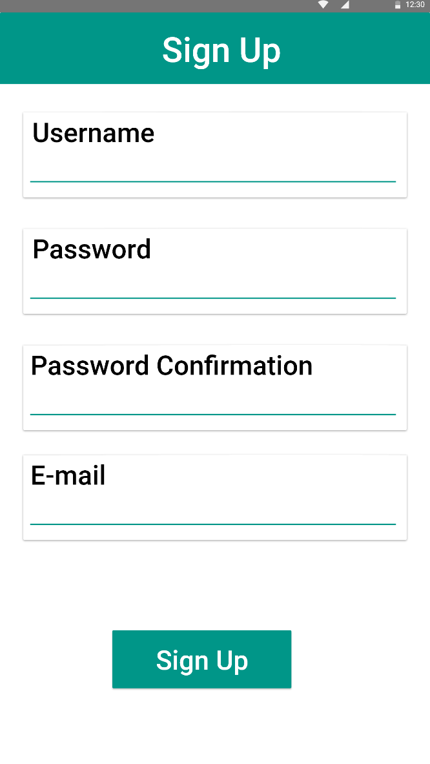

**Figure 4.6.2**

Figure 4.6.2 is the Sign Up Screen where new users can sign up the EldTrack app. In this screen, user must fill four input fields. These fields are;

* Username: This field is the place where user creates his/her username.
* Password: This field is for creating a password for the account.
* Password Confirmation: User should enter the same password again. If this field is not the same with the password field. User will get an error message which says the password fields are not the same.
* E-mail: This field is where users enters their email addresses in order to create a unique account. After user entered the address system checks whether entered email address is registered into the system or not.

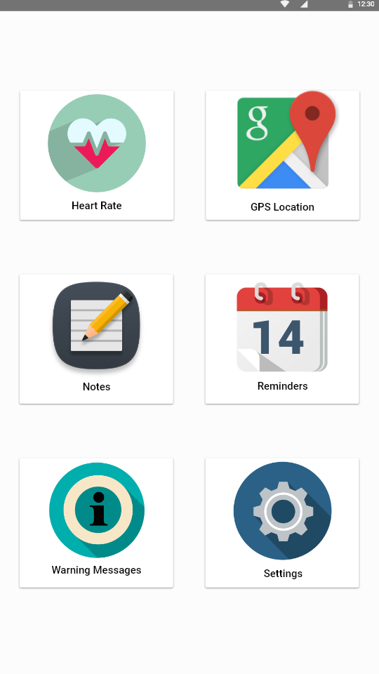

**Figure 4.6.3**

Figure 4.6.3 represents the Main Screen. Main screen is the part where users can access EldTrack’s functionalities. This screen behaves like a bridge to the other screens. In addition to that, there are six cards in this main screen. Whenever the user clicks on a card, the user will be navigated to the corresponding card’s screen. These cards are;

* Heart Rate Card
* GPS Location Card
* Notes Card
* Reminders Card
* Warning Messages Card
* Settings Card

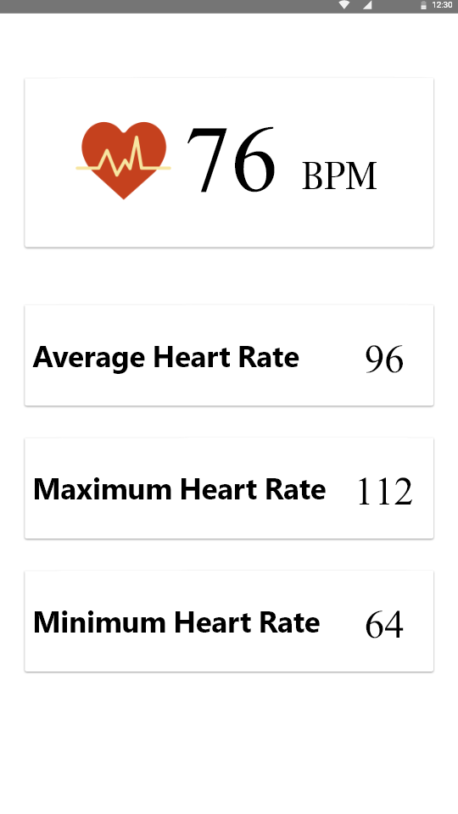

**Figure 4.6.4**

Figure 4 is the visual representation of the Heart Rate Screen. In this screen, family members, doctor or the user have been added to Elder’s account can view the Elder’s heart rate information as can be seen in the Figure 4.6.4. In addition to that there are 4 view cards in this screen. These cards are informative cards which gives the users Elder’s current heart rate, daily average heart rate information, daily maximum heart rate data and daily minimum heart rate info.

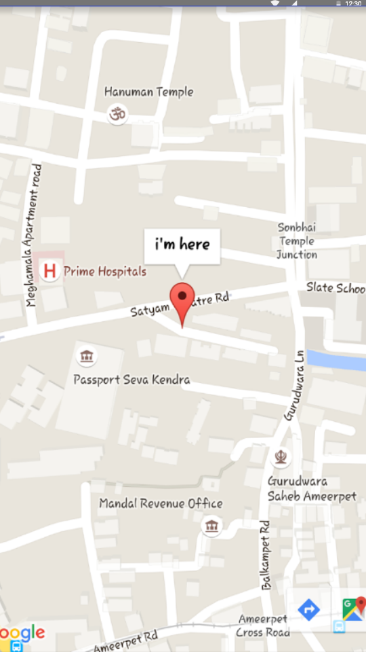

**Figure 4.6.5**

Figure 4.6.5 is the representation of the GPS Location Screen. In this screen users which were added by Elder’s phone, they can access to Elder’s GPS Location in order to track them in the Maps. Users will see the exact location of Elder with an indicator which can be seen in the Figure 4.6.5.

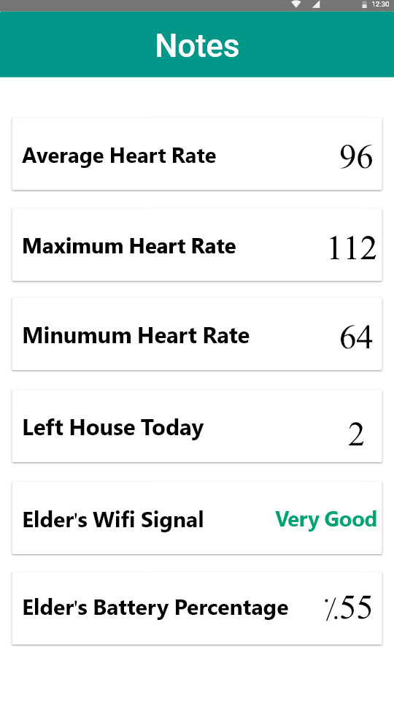

**Figure 4.6.6**

Figure 4.6.6 is the visual representation of the Notes Screen which informs users with the Elder’s general information that they might want to be informed by the Eldtrack app. In this screen there are six information cards. Which are;

* Average Heart Rate which informs users with Elder’s average heart rate of that day
* Maximum Heart Rate which informs users Elder’s maximum heart rate of the day.
* Left House Today gives the information how many times Elder is left the house for that day.
* Elder’s Wi-Fi Signal informs users the signal level of the Elder’s phone.
* Elder’s Battery Percentage informs users the battery percentage of the Elder’s phone.

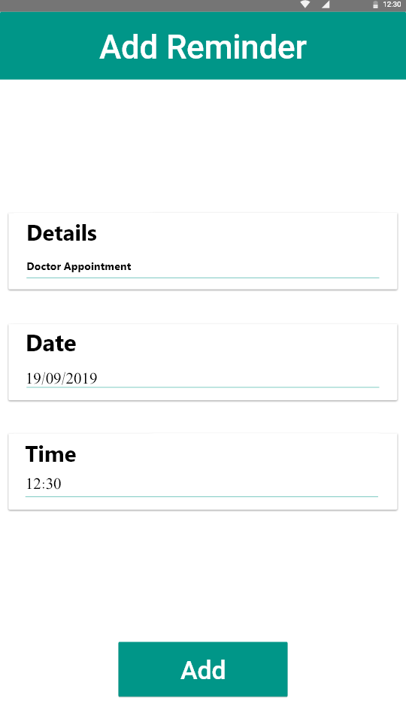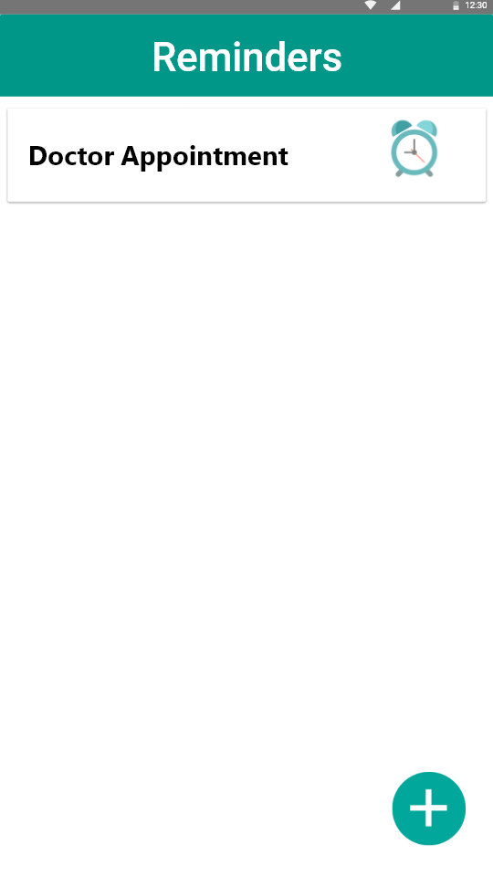

**Figure 4.6.7 Figure 4.6.8**

EldTrack app provides a reminder service for the Elders. With the help of this function users can add reminders which will behave as an alarm when the reminder time comes. Therefore, this reminder is different from built in phone reminders. The difference is users set this reminder for the Elder’s smartphone. Thus, this is a reminder for specifically for the Elder, in order to remind them important events. For example, doctor appointment or reminder for the regularly used medicine times. Users or Elder, can access this Reminders screen via just one click from the Main Screen. In order to add reminder, users should click the “+” symbol on the bottom right of the Reminders Screen. This “+” button will navigate users into the Add Reminder Screen. Thus, users can add reminders here. In order to delete or edit the reminders, users should click the reminder that they want to edit.

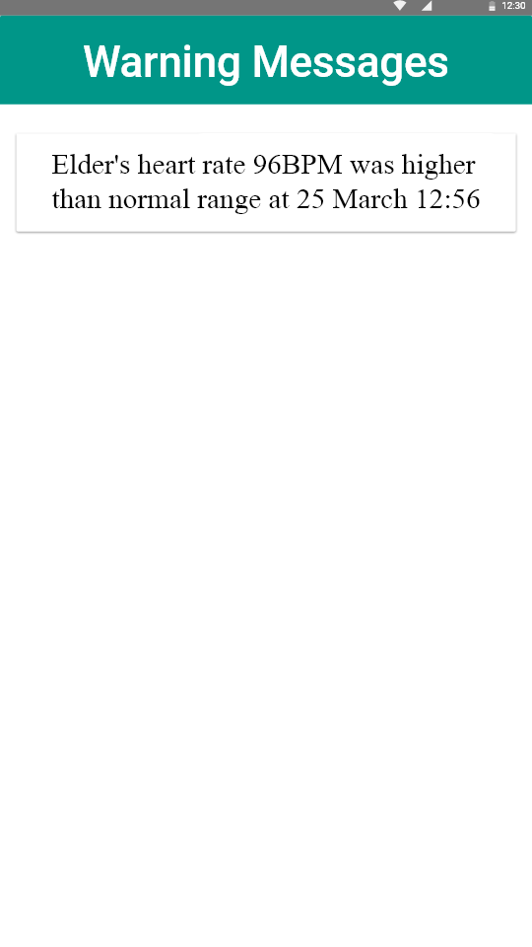

**Figure 4.6.9**

EldTrack app also provides users the Warning Messages Screen which can be seen in the Figure 9. This screen shows users the important information about Elder. If Elder’s heart rate was higher than normal range, users can see when this is happened and specifications of that important information in this screen. In addition to that, if Elder’s phone battery is very low, this screen also shows that to users in order to let them know Elder’s phone can be shut down. Therefore, this screen also informs users when the Elder’s phone Wi-Fi connection is lost. Which means Elder may be left his house. When the Wi-Fi connection is lost, GPS system will tell the exact information to users to let them know whether Elder is outside of the building or inside the building.

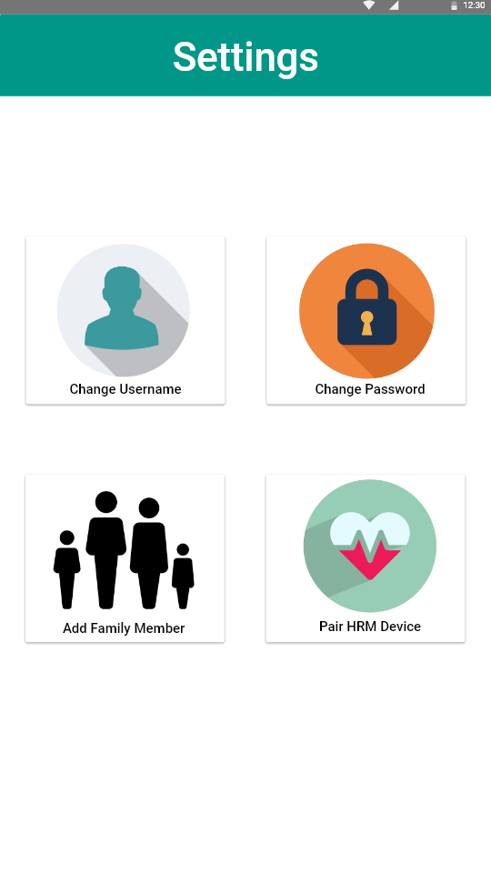

**Figure 4.6.10**

Figure 4.6.10 is the visual representation of Settings Screen. This screen can be accessed by users via the Main Screen. In addition to that, in this screen, there are four cards which are;

* Change Username Card navigates users into the Change Username Screen where they can change their usernames.
* Change Password Card navigates users into the Change Password Screen where they can change password.
* Add Family Member Card navigates user to Add Family Member Screen where they can add family members, friends or doctors which they can access the Elder’s specific information.
* Pair HRM Device Card navigates to the Pair HRM Device Screen where they can add heart rate sensor.

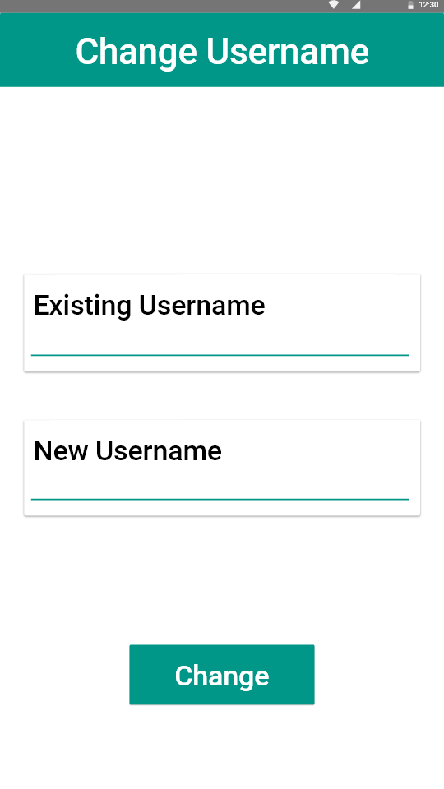

**Figure 4.6.11**

Change Username Screen can be accessed from Main Screen Card, Settings Screen Card and Change Username Cards respectively which can be seen in the Figure 4.6.11. In this screen users can chance their existing usernames with the new ones. This screen includes;

* Existing Username Card where users enter existing username correctly.
* New Username Card to set new username.
* Change Button to apply the changes.

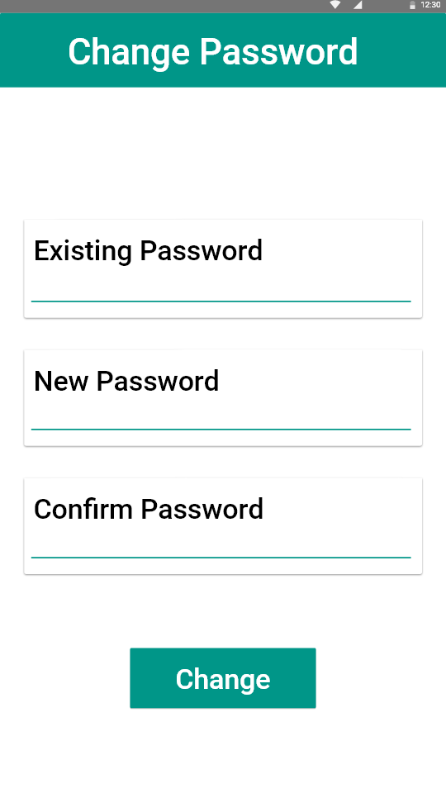

**Figure 4.6.12**

Change Password Screen is the screen where users can change their own passwords. This screen can be accessed from Main Screen Card, Settings Screen Card and Change Username Cards respectively which is represented at Figure 4.6.12. Inside this screen there are three cards and one button which are;

* Existing Password Card where users must enter existing passwords correctly
* New Password Card to set new password.
* Confirm Password Card to confirm that entered password is the same with new password.
* Change Button to apply the changes.

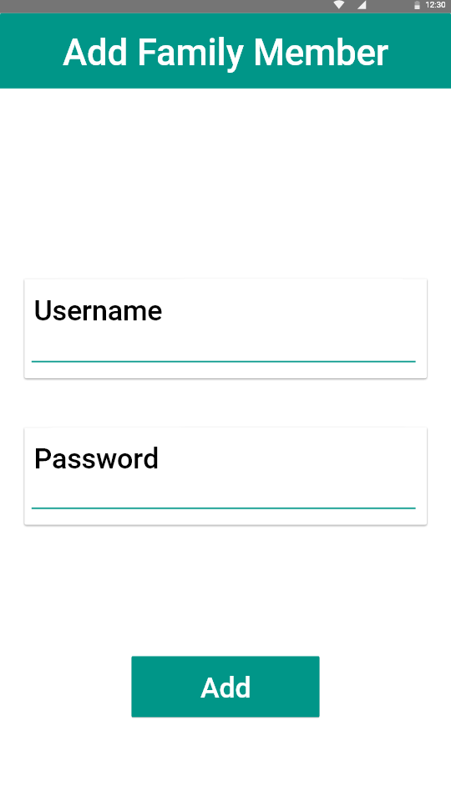

**Figure 4.6.13**

Add Family Member is the screen where Elder can create new users which are also connected to the Elder. User adding is very easy with that screen. It only requires a username and password which are both can be changeable by that user later. Add Family Member Screen includes;

* Username Card which will be the username of the newly added user in the system.
* Password Card which will be the password of the newly created account.
* Add Button in order to add new user into the system.

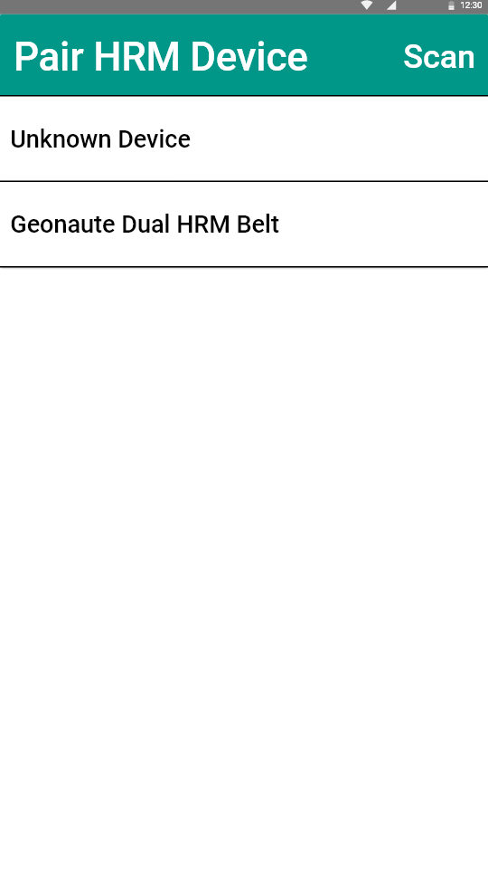

**Figure 4.6.14**

Pair HRM Device Screen is for adding new heart rate devices to the phone. In order to get heart rate data from the elder, there must be a heart rate sensor which uses Bluetooth technology for communication. In addition to that, user or elder must choose from elders phone the correct sensor from the Pair HRM Device Screen in order to connect. After connecting the device Heart Rate of the Elder can be accessed from Main Screen and Heart Rate Screen respectively.

**5. Implementation & Test**

**5.1 Implementation**

This part of the report will explain and show the implementation part of the Eldtrack App with details. This project implements Java, XML and Fiware Platform and works on android phones which are connected to internet. Therefore, in order to achieve heart rate information, users must have a heart rate sensor which uses BLE protocol.

Figure 5.1 is the visual representation of the user interface flow in order to provide insight how Eldtrack App works.

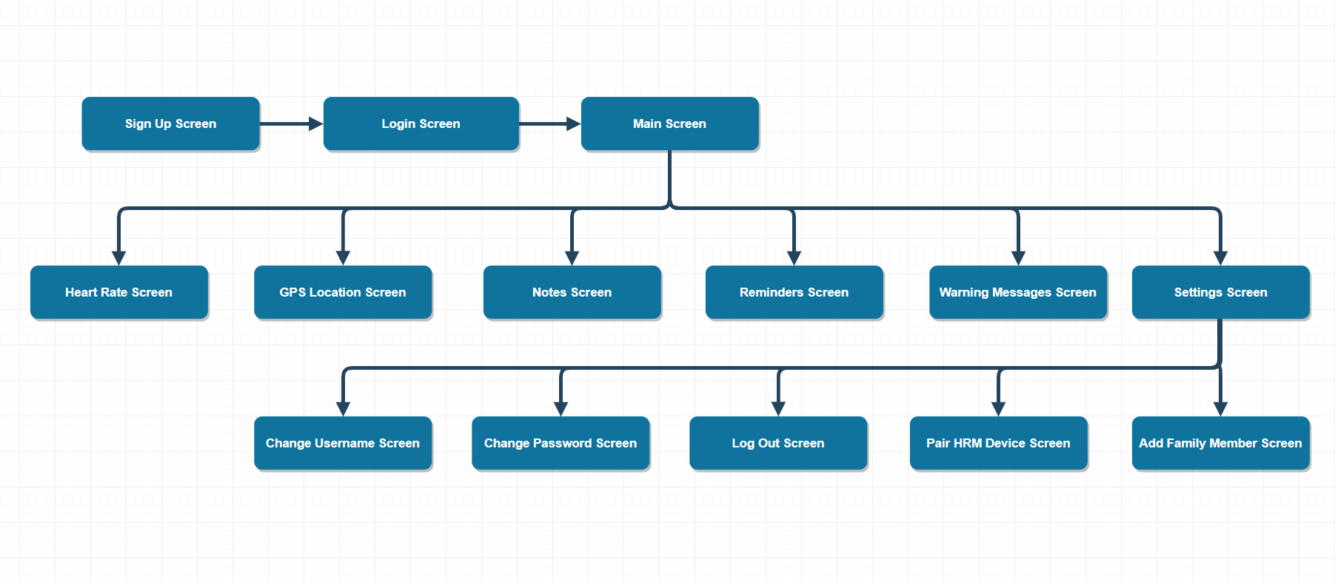

Figure 5. User Interface Flow

Implementation of each module in the system explained in the following part of this report.

**Login Screen**

Login Screen is the first screen that will welcome the users that are not logged in the mobile app currently which is represented on Figure 4.6.1. In addition to that, users also will be seeing this screen just after logged of from the mobile app. With the help of this screen, after a successful log in to system users can use the Eldtrack App.

In this screen, Eldtrack app is getting the input from user from necessary fields and stores these inputs to related variables. In addition to that, these variables will be searched from database and check whether username and password is matches. If the username and password matches, user will be notified and logged in to the Eldtrack app. Therefore, if username and password does not match, user will be notified with wrong username or password output.

**Sign Up Screen**

Sign Up Screen can be accessed from a button which is implemented in Login Screen. In this screen users will be registered into the system with username, password, email and a switch button which users can select their account roles as user or elder which is in the Figure 4.6.2. Therefore, there is a field which named password confirmation in order to register users into system with a correctly entered password. After these, users must confirm the confirmation e-mail which was sent to entered e-mail by the users in order to register into the system. If username or email address is already existing in the system, there will be an error message and registration of the user into the system stops.

**Main Menu Screen**

Main Menu Screen is the gateway screen where users can navigate and use application functions in this Eldtrack App which is represented at Figure 4.6.3. In addition to that, whenever users are logged in to the system, Main Menu Screen will be displayed to the users. Therefore, when this screen displayed, system checks user’s role in the application whether its role is tracker or elder. After the checking if user is elder, Eldtrack App requests permission from the elder in order to activate tracking activities which is represented in the Figure 5.2. Therefore, when user accepts the permission request, a service which named backgroundDataService awakes and starts collecting information from elder’s phone such as battery percentage which can be seen in Figure 5.3, Wi-Fi signal level which is represented in Figure 5.4 and GPS location data which is represented in Figure 5. Consequently, these gathered data will be sent to Fiware platform. Therefore, if role of the user is tracker, a service which named notificationService awakes and notifies trackers with important information such as high heart rate, low battery and Wi-Fi connection lost and so on which is represented at Figure 5.6 which shows a heart rate notification.

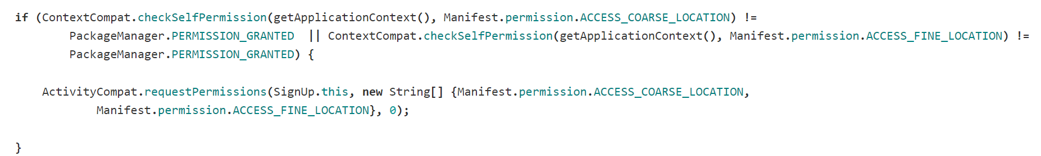

Figure 5.2 Requesting Permission

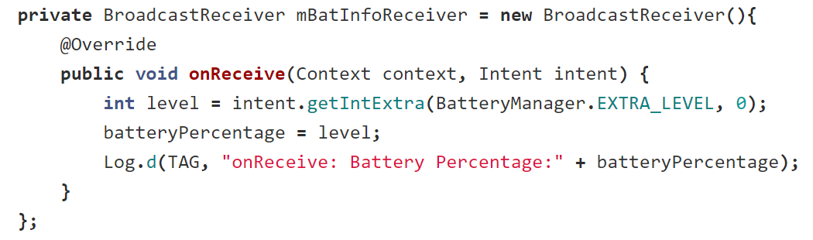

Figure5.3 Battery Percentage

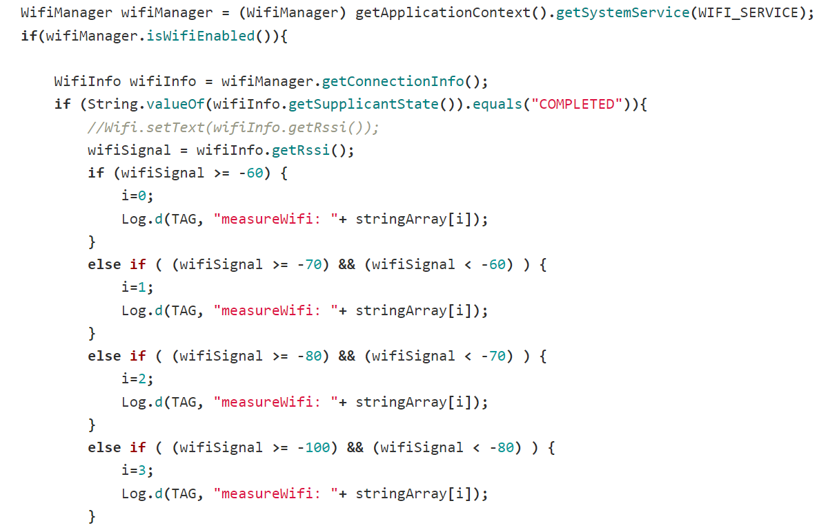

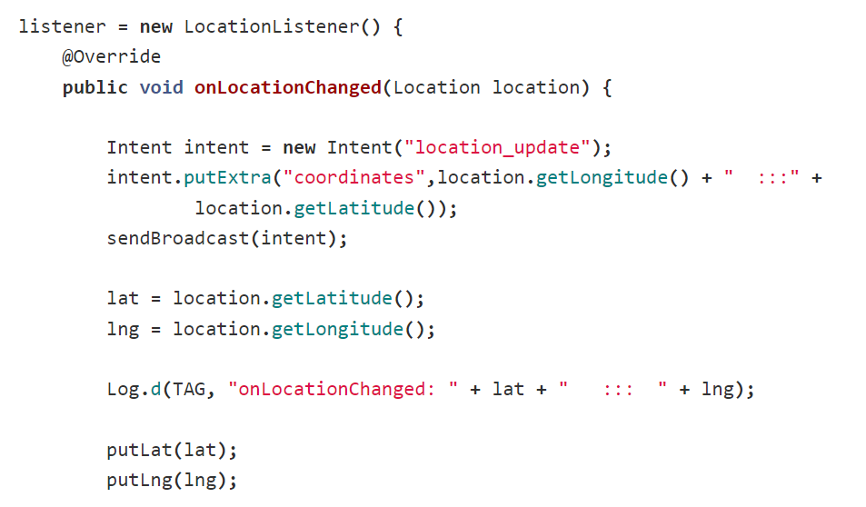Figure5.4 Wi-Fi Signal

Figure 5 GPS location

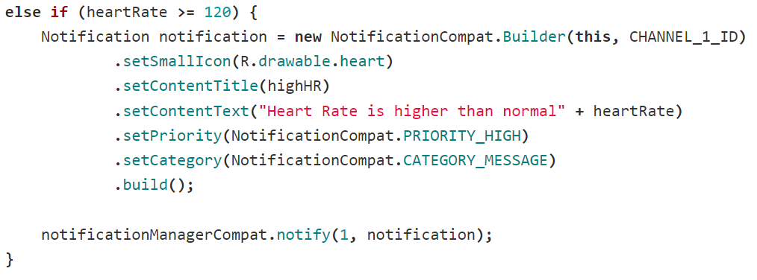

Figure 5.6 Notification

**Heart Rate Screen**

Heart Rate Screen can be accessed from the Main Menu Screen via just one click. This screen is only for showing the heart rate data which is collected from the Fiware Platform which can be seen in the Figure 4.6.4. While this screen is displayed on the screen, every second this HeartRate activity checks heart rate data and refreshes the views in order to show users the correct data which is represented at Figure 5.7. Thus, while heart rate screen is not displaying, HeartRate activity sleeps.

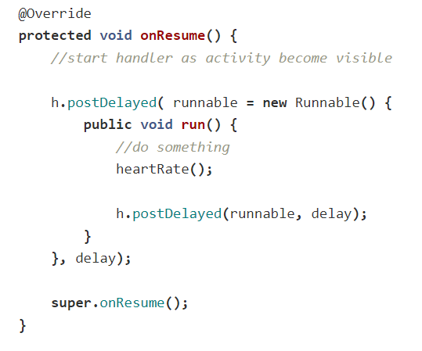

Figure 5.7 Refresh Heart Rate Interface

**GPS Location Screen**

GPS Location Screen is the screen where users can see tracked elder’s location which can be seen in Figure 4.6.5. Consequently, this screen can be accessed from the Main Menu Screen with just one click. In addition to these, GPS location view is refreshed every five seconds in order to show users the precise location of the elder while GPS Location Screen is displaying.

The gathering GPS location coordinates will be collected with MapsActivity activity from the Fiware Platform. In addition to that, whenever elder’s location is changed, Elder’s phone refreshes the location coordinates in Fiware platform and this activity refreshes the GPS marker location in order to show users precise location which can be seen in the Figure 5.8. Therefore, users also can click that marker to navigate to elder’s position. Whenever, users clicked that marker, google maps will be opened and google maps will show the alternative routes to that location. Thus, the users can navigate the location easily.

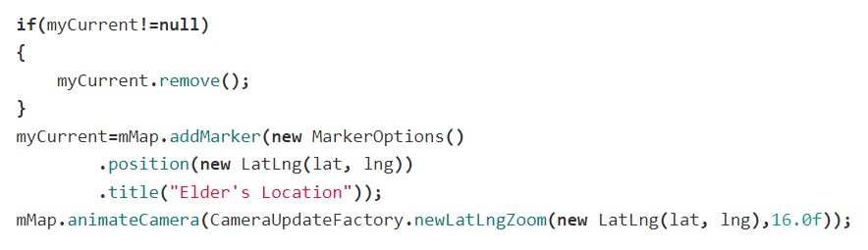

Figure 5.8 Renew GPS Location Marker’s Position

MapsActivity is only working while the GPS Location Screen is displaying, if this screen is not displayed, MapsActivity sleeps.

**Notes Screen**

Notes Screen is the screen where users can see the specific information such as elder’s Wi-Fi signal level, phone battery percentage and a counter where users can see how many times elder left house that day etc. as notes with other notable information in this screen which is represented in Figure 4.6.6. In addition to that Notes Screen can be reached from Main Menu with just one click. Whenever notes screen is displayed by the users, an activity is invoked by the Eldtrack app which named Notes.

Notes activity is the activity that gets required note data from Fiware Platform which is refreshing the Notes Screen’s view within specified time period which can be seen in the Figure 9.

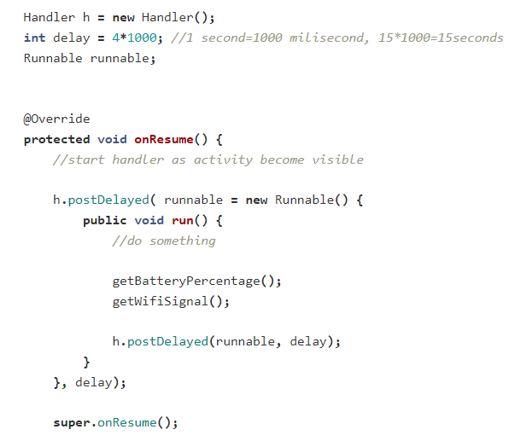

Figure 5.9 Refresh Battery Percentage and Wi-Fi Signal Level

**Reminders Screen**

Reminders screen is the screen where users set reminders and notes for the tracked elder in order to remind them important dates and times of day like medicine times and doctor appointments etc. by alarming the elder which is represented in Figure 4.6.7. In addition to that, Reminders screen can be reached from Main Menu Screen with just one click. Therefore, creating, updating and deleting alarms only available for the users which tracks and helps elder’s daily life. Consequently, users can create these reminders with alarms in order to alarm the elder when arranged reminder’s time is come.

**Warning Screen**

Warning screen is the screen where users and elder can see the warning messages that informs users about the elder’s conditions like higher heart rate, lower heart rate, low battery, Wi-Fi connection is lost etc. which is represented at Figure 4.6.9. Consequently, this screen can be accessed from the Main Menu Screen with just one click. In addition to that, these warnings also generate notifications in order to notify users about elder’s warning conditions. Therefore, these notifications will navigate users to the related activity whenever user clicks on the notification.

**Settings Screen**

Settings screen is the screen where users and elders can configure the account settings which can be seen in the Figure 4.6.10. In addition to that, elders can add users to their account in order to send their data to them and users can also search for elder and request tracking permission from the elder in order to track them. In addition to that, in Settings Screen, there is also a Log Out button which helps to users log out from the mobile application. Therefore, there is one option in the Settings Screen which only elders can use is the adding Bluetooth sensors for example heart rate sensor. In case of users clicking on the Add HRM Device button, users will be notified with a message only elders can add devices.

**Change Username Screen**

Change Username Screen is the screen where users and elders change their account’s username which can be seen in the Figure 4.6.11. In addition to that, users can access this screen from Main Menu Screen and Settings Screen respectively. When users clicked on the change button in this screen, change username activity takes the inputted data from the users and changes the user’s previous username field in the Fiware Platform.

**Change Password Screen**

Change Password Screen is the screen where users and elders change their account’s passwords which is represented in the Figure 4.6.12. In addition to that, users can access this screen from Main Menu Screen and Settings Screen respectively. When users clicked on the change button in this screen, change username activity takes the inputted data from the users, checks whether the existing password is correct. Also, activity checks whether new password and password confirmation fields are matching or not. If existing password is not matching with the current password, user will see a message which notifies them inputted existing password field is not matching with the current password. If, new password and password confirmation fields are not matching with each other, user will be notified with a message that password fields are not matching. Consequently, if all the inputted fields are correct, activity changes the user’s previous password in the Fiware Platform.

**Pair HRM Device Screen**

Pair HRM Device is the screen is only for elders in order to pair heart rate sensor with the Eldtrack App which is represented in Figure 4.6.14. If any of the users which role is not elder clicks on the Pair HRM Device button, will have a message that notifies them only elders can add Bluetooth devices. Consequently, Pair HRM Device Screen can be accessed from the Main Menu Screen, Settings Screen and Pair HRM Device button respectively. Therefore, if Bluetooth is not supported by that device, Eldtrack app stops searching for Bluetooth devices and returns user to main menu screen which can be seen in Figure 5.10. In addition to that, when this screen displayed by the user, Eldtrack App starts scanning Bluetooth Low Energy devices which can be seen in the Figure 5.11 and lists them in the Pair HRM Device Screen in order to help users find the BLE sensor that they want to pair with the phone. In order to get heart rate data, elder’s phone must be paired with a heart rate sensor in Eldtrack app. Thus, elder must be wearing the heart rate sensor in order to collect heart rate data. Hence, user can add the sensor by clicking on it from the listed devices. Consequently, Eldtrack app connects the sensor and list its properties. After this listing, user must click on the needed properties in the list in order to receive the wanted data such as heart rate data which can be seen in the Figure 5.12. Therefore, when this sequence is done, Eldtrack app starts to send these heart rate data to Fiware platform which can be seen in the Figure 5.13.

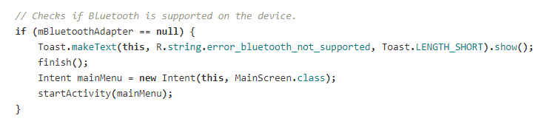

Figure 5.10 Check Bluetooth is Supported

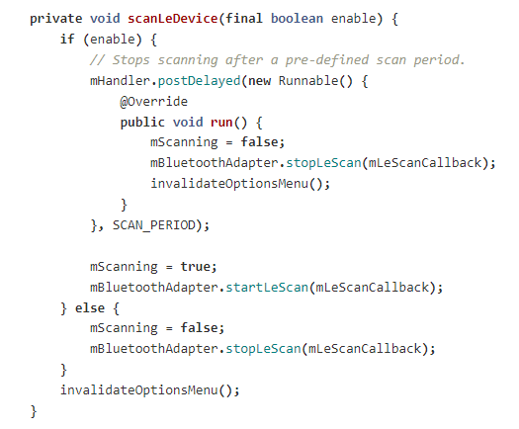

Figure 5.11 Scanning BLE Devices

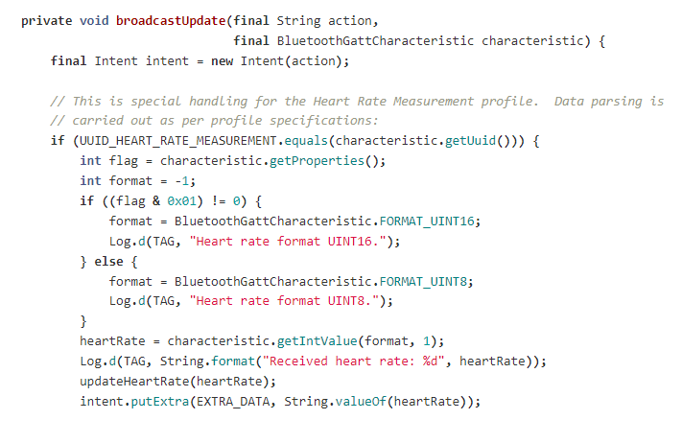

Figure 5.12 Getting Heart Rate Data

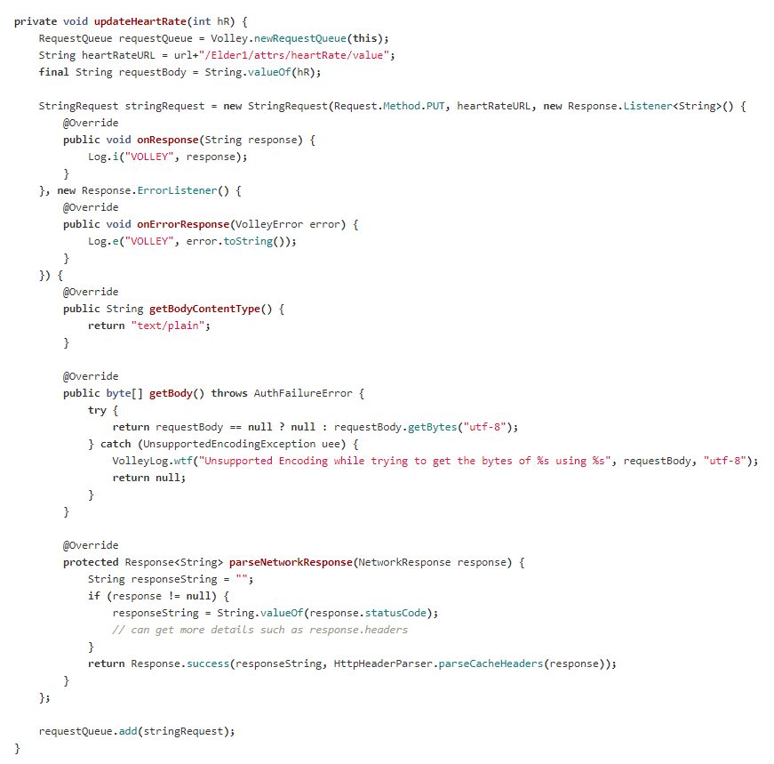

Figure 5.13 Updating Heart Rate Data in Fiware

**5.2 Test**

**Testing**

The purpose of this test plan is to verify Eldtrack App suits its requirements. Therefore, testing of Eldtrack application in order to show application functions demonstrated by the Eldtrack App properly.

The main aim of the Eldtrack App is to make elders life easier and tracking of elders by users, family members and doctors which are permitted by elders to track them in order to notify family members and help elders in real life situations. Following tests and procedures are created and applied to test these properties.

**Test Plan**

**Testing Approach**

As mentioned before, Eldtrack App is designed and implemented in order to help elders by tracking them in real-life conditions at real-time basis. Thus, Eldtrack App must have high performance, must be reliable and easy to use in order to help elders and trackers.

1. To test usability, usability tests which are created by project team are applied.
2. To test performance, software performance tests are applied on a mobile phone.
3. To test reliability, software reliability tests are applied on Eldtrack App.

All tests in our project was performed with smartphones and heart rate sensor in Eldtrack Application Environment. All the tests are done by project team and test records are saved for each test result. Detailed information and test procedures which are done are explained in the following part of this report.

|  |  |  |  |  |
| --- | --- | --- | --- | --- |
| Category ID  Table 1 Test Identification | Description | Test Case | Description | Objective |
| 1 | Usability Test/Hallway Method | 1.1 | Start Eldtrack App | Find Eldtrack App in the mobile phone. |
| 1.2 | Sign Up the Eldtrack app | Sign Up the Eldtrack App as user or elder. |
| 1.3 | Login the Eldtrack App | Login the Eldtrack App via created account. |
| 1.4 | Check the GPS Location | Click the GPS Location Button and check the GPS location of elder. |
| 1.5 | Check the Heart Rate | Click the Heart Rate Button and check the elder’s heart rate. |
| 1.6 | Check the notes | Click the Notes Button and check the notes which was gathered from elder by Eldtrack App. |
| 1 | Usability Test/Hallway Method | 1.7 | Check Warning Messages | Click the Warning Messages Button and check the messages which gathered from elder by Eldtrack App. |
| 1.8 | Check Settings Screen | Click the Settings Button and check the functions. |
| 1.9 | Change Username | Click the Change Username Button and change the username. |
| 1.10 | Change Password | Click the Change Password Button and change the username. |
| 1.11 | Log out | Click the Log out button and check if logged out from the application. |
| 1.12 | Pair HRM Device | Click the Add HRM Device Button and pair the wanted HRM device with app. |
| 2 | Performance Test | 2.1 | Server Transaction Time | Calculation of the data transfer time between mobile application and Fiware server. |
| 2.2 | System Load | Check the system when more than four users are tracking the elder. |
| 2.3 | Connection Test with the sensor | Check heart rate sensor is working correctly with elder and the phone. |
| 2.4 | Performance of Eldtrack App | Check the execution time for Eldtrack application. |
| 3 | Reliability test | 3.1 | Mean time between failures | Calculate the mean time between the failures if happens. |

**Test Schedule**

In this section of the report, testing schedule is given in Table 2.

Table 2 Test Schedule

|  |  |  |  |  |
| --- | --- | --- | --- | --- |
| Duration  (Hours : Minutes) | Test Objective | Test Event | Dependencies | Comments |
|  | Usability test/ Hallway method | 1.1, 1.2, 1.3, 1.4, 1.5, 1.6, 1.7, 1.8, 1.9, 1.10, 1.11, 1.12 | 1.2, 1.3 | 4 Trackers and 1 Elder will test the Application. |
|  | Server transactions |  | 1.2, 1.3 | Average data gathering and updating will be calculated |
|  | System Load |  | 1.2, 1.3 | 1 Elder will be tracked by more than 5 tracker. |
|  | Connection Test with the sensor |  | 1.2, 1.3, 1.12 | Pairing time of the sensor and data transfer rate |
|  | Performance of Eldtrack App |  | 1.2, 1.3 | Eldtrack application will be executed 50 times and calculate each execution time. |
|  | Reliability test |  | 1.2, 1.3 | Eldtrack app and the system will be used for ? hours with no gap in order to calculate MTBF |

**Fault Reporting and Data Recording**Test results are kept in table formats with their specific values in minute, second and millisecond format

**Resource Requirements**

Resources that are used in this testing phase are listed below:

* Hardware requirements: Android phones, Fiware Server, BLE Heart Rate Sensor, stopwatch.
* Software requirements: Android operating system and Fiware Platform.
* Documentation requirements: Test documentation, fault report tables, data record tables.
* People requirements: More than 10 random people are selected in order to perform Hallway Testing Technique.

**Test Environment**

Applied tests are performed on both Android and Linux platforms. Tests that requires people are held in Atılım University. Testers performed tests on Android phones.

**Test Responsibilities**

All the group members are performed user interface, performance and reliability tests. In order to test usability, Hallway Testing Technique is applied. This technique requires randomly selected people. Therefore, we applied this test to more than ten people while we are presenting our senior project in school. Our project group is recorded the completion times of each test case’s completion time and calculated average test completion time for each test case.

**Test Procedures**

This section of the report includes the test cases, expected results and actual test results that are collected from testing procedures which our project group is applied, while testing the Eldtrack application.

**Usability Test / Hallway Method**

User interface tests are tested by using Hallway Method. This method is a general testing method for usability testing of applications. Therefore, this method requires random people in order to test usability. We have chosen this method and applied this method while we are presenting our senior project in our school. In addition to that, more than ten people are tested our Eldtrack application and we have noted the findings and test results.

The test scenario for user account is:

* Open the Eldtrack App which is installed on mobile phone.
* Login the Eldtrack App with a predefined user account.
* Track GPS location of elder.
* Track notes about elder.
* Track heart rate of elder.
* Track warnings about elder.
* Change username and password
* Log out

The test scenario for elder account is:

* Open the Eldtrack App which is installed on mobile phone.
* Login the Eldtrack App with a predefined elder account.
* Go the settings menu and pair HRM sensor with Eldtrack App.
* Check own location on app
* Check own heart rate.
* Check notes about yourself.0
* Check warning messages about yourself.
* Log out

These two scenarios fulfill all the frequently used functions in our Eldtrack application. In addition to that, more than 10 people are tried to perform these tasks by using our Eldtrack app and android phones.

**Usability Tests**

**Test Case 1.1 – Start EldTrack Application**

**Test Description**

Purpose of this test determines that type of all users whether can find application and opened it or not .

**Initialization**

* EldTrack is found on the mobile phone
* Eldtrack is started

**Test Inputs**

* Users click on the button that is specified with application logo.

**Test Procedure**

* The application that is loaded on a smart phone running on Android Operating System is given the testing objects.
* EldTrack is found.
* EldTrack is opened.
* Duration of the process is recorded.

**Expected Test Results**

The testing objects found and opened the application successfully. (Pass/Fail)

Starting process can be performed under 4 seconds (Pass/Fail)

**Actual Test Results**

* 4 people were used to test the application and they started the application successfully.(Pass)
* Subject started the application 3.39 seconds in average.(Pass)

**Test Case 1.2 – Sign Up to system**

**Test Description**

Purpose of this test determines that type of all users can sign up the application whether or not.

**Initialization**

* Eldtrack is started
* People, that are different ages, are selected as testing objects and they are wanted to do sign up to system with their required information.

**Test Inputs**

* Username: elder1
* Password: elder
* Email: [elder1@gmail.com](mailto:elder1@gmail.com)
* Type of all users must indicate whether they are elder or user by clicking button.

**Test Procedure**

* The application that is loaded on a smart phone running on Android Operating System is given the subjects.
* EldTrack is opened.
* The required information spaces are filled properly.
* Duration of the process is recorded.

**Expected Test Results**

The subjects signed up the application successfully. (Pass/Fail)

Sign up process can be performed under 2 minutes (Pass/Fail)

**Actual Test Results**

* 4 people were used to test the application and they signed up the application successfully.(Pass)
* Subjects signed up the application 1.53 minutes in average.(Pass)

**Test Case 1.3 – Login to system**

**Test Description**

Purpose of this test determines that type of all users can login the application whether or not.

**Initialization**

* Eldtrack is started
* People, that are different ages, are selected as testing objects and they are wanted to do login to system with their required information.

**Test Inputs**

* Username: elder1
* Password: elder

**Test Procedure**

* EldTrack is opened.
* The required information spaces are filled properly.
* Duration of the process is recorded.

**Expected Test Results**

The subjects logged in the application successfully. (Pass/Fail)

Login process can be performed under 1 minutes (Pass/Fail)

**Actual Test Results**

* 4 people were used to test the application and they logged in the application successfully.(Pass)
* Subjects signed up the application 0.50 minutes in average. (Pass)

**Test Case 1.4 – Check GPS Location**

**Test Description**

This test aims to test and analyze that can users can access GPS Location Screen in Eldtrack App easily and correctly.

**Initialization**

* An android phone was given to users
* Eldtrack application is started.
* Main Menu Screen is opened.

**Test Procedure**

* Task is explained to user
* User’s actions were recorded until task is complete.
* Completion time is recorded.

**Expected Test Results**

* Test subject is successfully found and selected the GPS Location Screen button. (Pass/Fail)
* Subject completed the test under 10 seconds. (Pass/Fail)

**Actual Test Results**

* All 10 subject is completed the task successfully. (Pass)
* Test subjects found and selected the GPS Location Screen button with an average 4.6 seconds.

**Test Case 1.5 - Check Heart Rate**

**Test Description**

This test aims to test and analyze that can users access the Heart Rate Screen of Eldtrack App easily and correctly.

**Initialization**

* An android phone was given to users
* Eldtrack application is started.
* Main Menu Screen is opened.

**Expected Test Results**

* Test subject is successfully found and selected the Heart Rate Screen button. (Pass/Fail)
* Subject completed the test under 10 seconds. (Pass/Fail)

**Test Procedure**

* Task is explained to user
* User’s actions were recorded until task is complete.
* Completion time is recorded.

**Actual Test Results**

* All 10 subject is completed the task successfully. (Pass)
* Test subjects found and selected the GPS Location Screen button with an average 4.2 seconds.

**Test Case 1.6 – View Notes**

**Test Description**

Purpose of this test checks that all users of the system whether the data that is gathered from elder’s is shown or not.

**Initialization**

* Eldtrack is opened
* People, that are different ages, are selected as testing objects and they are wanted to do find and click the notes button

**Test Inputs**

* Click notes button

**Test Procedure**

* The application that is loaded on a smart phone running on Android Operating System is given the testing objects.
* EldTrack is opened.
* The notes button is found and clicked.
* The data is checked to test whether it can be viewed or not.
* Duration of the process is recorded.

**Expected Test Results**

The testing objects view the data successfully. (Pass/Fail)

Clicking button and viewing data processes can be performed under 4 seconds. (Pass/Fail)

**Actual Test Results**

* 7 people were used to test the application and they viewed the data successfully.(Pass)
* Testing objects signed up the application minutes in 3 seconds in average.

**Test Case 1.7 - Check Warning Messages**

**Test Description**

This test aims to test and analyze that can users access the Warning Messages Screen of Eldtrack App easily and correctly.

**Initialization**

* An android phone was given to users
* Eldtrack application is started.
* Main Menu Screen is opened.

**Expected Test Results**

* Test subject is successfully found and selected the Warning Messages Screen button. (Pass/Fail)
* Subject completed the test under 10 seconds. (Pass/Fail)

**Test Procedure**

* Task is explained to user
* User’s actions were recorded until task is complete.
* Completion time is recorded.

**Actual Test Results**

* All 10 subject is completed the task successfully. (Pass)
* Test subjects found and selected the Warning Messages Screen button with an average 4.8 seconds.

**Test Case 1.12 - Pair HRM Device**

**Test Description**

This test aims to test and analyze that can users access the Pair HRM Device Screen of Eldtrack App easily and correctly. In addition to that users are expected to pair a heart rate sensor with the Eldtrack application.

**Initialization**

* An android phone was given to users
* Eldtrack application is started.
* Main Menu Screen is opened.

**Expected Test Results**

* Test subject is successfully found and selected the Heart Rate Screen button. (Pass/Fail)
* Subject completed the test under 30 seconds. (Pass/Fail)
* Test subject is paired the heart rate sensor after selected Pair HRM Device Screen button.
* Subject completed pairing test under 30 seconds

**Test Procedure**

* Task is explained to user
* User’s actions were recorded until tasks are completed.
* Completion times are recorded.

**Actual Test Results**

* All 10 subject is completed the first task successfully. (Pass)
* Test subjects found and selected the Pair HRM Device Screen button with an average 17.2 seconds.
* All 10 subject is completed the second task successfully. (Pass)
* Test subjects paired the heart rate sensor with an average 17.2 seconds with the Eldtrack application.

**Reliability Tests**

**Test Case 2.1 - Server Transaction Time**

**Test Description**

This test aims to test and calculate the Mean time between failures.

**Initialization**

* Start Eldtrack application.

**Test Inputs**

* Gathered heart rate data from elder with a heart rate sensor.
* Gathered battery percentage data from elder’s phone.
* Gathered Wi-Fi signal level data from elder’s phone.
* Gathered GPS location data from elder’s phone.

**Expected Test Results**

* Use Eldtrack app with both elder and user accounts and track elder via user account.
* System works without having failures.

**Test Procedure**

* Use Eldtrack app for 5 hours
* Note down the system failures and their occurrence times.

**Actual Test Results**

Eldtrack app return the Main Menu Screen at some times while tracking elders data in screens for example Heart Rate Screen and Notes Screen.

**Test Case 2.2– System Load**

**Test Description**

Purpose of this test observing the system behavior when number of large people use it.

**Initialization**

* Application is loaded on the 17 different people’s mobile phone.
* plication is ready to use.

**Test Inputs**

* None

**Test Procedure**

* All users signed up, logged in to the application and viewed data.
* System behavior is observed

**Expected Test Results**

The subjects successfully signed up and logged in the application and they viewed data. (Pass/Fail)

**Actual Test Results**

* 17 people can use application successfully.

**Test Case 2.3 - Connection Test with the Sensor**

**Test Description**

This test aims to test and calculate the connection time while connecting a heart rate sensor to Eldtrack app.

**Initialization**

* Eldtrack application is started.
* Main Menu Screen is opened.
* Heart Rate Sensor is paired with elder account.

**Expected Test Results**

* Heart rate sensor is connector with the Eldtrack application less than 10 seconds. (Pass/Fail)

**Test Procedure**

* Record the until heart rate sensor is connected to Eldtrack application.

**Actual Test Results**

* Average heart rate sensor connection time with the Eldtrack application is .

**Test Case 2.4– Performance of EldTrack App**

**Test Description**

Purpose of this test to check execution time of EldTrack.

**Initialization**

* Find the application on the mobile phone.
* Click on the application logo.
* Click all buttons and observe results

**Test Inputs**

* None

**Test Procedure**

* Click on the buttons
* Observe execution time

**Expected Test Results**

Each button works successfully and the data is shown under 5 seconds in average. (Pass/Fail)

**Actual Test Results**

* Execution process performs 4.8 seconds to show data.

**6.Evaluation**

**Problems**

**-** If there is a problem with the database connection or internet connection, the application will not work correctly because the old person cannot transfer the information.

- If there is any problem with the heart rate sensor, the values in the system are not transmitted correctly.

- If the user and elder option button on the sign-up page does not work, the status of the people in the system will be incorrect.

- Interfaces may not fit the screen on different android phones.

**Performance**

**-** Data transfer speed and synchronization are high, data are integer or double values and can be transferred instantly(real-time).

- System requirements are low and work without problem in target phones (devices).

- The heart rate sensor in the belt uses BLE (Bluetooth Low Energy) when transferring data. Thus, it can transfer the data in real time without interruption.

**Usability**

**-** The IU in the system has fast learning and simple icons.

- The size of the text and icons in the interface can be read easily by an elderly person.

**-** The written texts in the system are understandable and clear.

**Deployment**

**-**The android phones or tablets required for the system will be provided by the persons themselves.

-The application can be downloaded once on each phone or tablet.

- In order for the data in the database to reach the android phone, phone need to have a wireless internet network connection.

**Maintenance**

**-**When the system is updated, the new version system should be downloaded from google store because it is an android application.

-The elderly person can choose the people who own the family to track him/her.

**Backup & Recovery**

**-** If all data is transmitted in real time, the device will not be a problem. data from hardware devices are saved in the database and some calculations are made on a daily basis.

**Security**

- The data is stored daily in the database and there is no interface to change or delete this information. The information is stored locally and cannot be accessed by anyone else.

**-** A foreign person cannot easily track the elderly person at any time. However, it is possible if the elderly person wants to add that person.

**7. Impact of the Project & Compliance with the Constraints**

**7.1. Compliance with the Realistic Constraints**

The constraints of the system, such as requirement for high performance and fast loading times, are met when the system is evaluated. Below, on Table 7.1, the summary of those constraints and conditions are given.

**Table 7.1** Realistic Constraints & Conditions

|  |  |
| --- | --- |
| **Economic Factors** | **Please specify/explain realistic constraints and conditions (type, use, amount, etc.)** |
|  | |
| **EXPENDITURES** | |
| Computer | We have used our own personal computers for development and UI design of the system. |
| Other Devices | We took dual Heart Rate Monitor belt geonaute and paid 199 tl. |
| Peripherals | NA |
| Internet Connection | Currently owned connection was used. |
| Software | For coding, **Android Studio** version 3.1.4, 2019 for Linux was used. |
| Textbook/Magazine/Support Material | We used Android Studio developers guide. |
| Human Resources | Our project team consists of 3 people. |
| Other | NA |
|  | |
| **FUNDING Sources** | |
| University Resources | NA |
| Project support (SANTEZ, TÜBİTAK, and so on) | NA |
| Support by the Industry | NA |
| Self-funded | NA |
| Other sources | NA |
|  |  |
| **OTHER CONSTRAINTS** |  |
| Memory | The application is optimized to run on target device, initial constraints are met. |
| Runtime efficiency | The application is light weight by its foundation addition, there are no intense graphics either; thus constraints regarding runtime efficiency are met. |
| **MANAGERIAL** |  |
| Schedule (time) | The software was expected to be completed in 16 weeks, where 18 weeks were needed to complete the project. |

## 7.2 Impact of the Project

The project does not impose any cost for its maintenance. The project is expected to have a positive impact on the healthcare domain indirectly by providing speed, efficiency and usability. On Table 7.2, impact assessment of the project is provided.

**Table 7.2** Impact Assessment Report

|  |  |  |
| --- | --- | --- |
| **Professional/Ethical Issues** | **Please specify/explain (existence of items, violation of items, awareness about items)** | |
|  | | |
| **ETHICS/IT Law** | Are there any applicable laws or legislation that will be relevant to the use and/or the construction of the system you are building?  How have you addressed them? | |
| Copyright in copying multimedia (sound, video, text) | NA | |
| Use of licensed software | For the construction of the project, some open source frameworks and some licensed software were used. The product itself is free and does not require any license-fee  for its use. | |
| Data Privacy | The data stored in the system is forbidden to be used by 3rdparty, as stated by laws. During the development, no real patient data was neither accessed nor used. Only doctor or family members can reach those data. | |
| Use of patented products/ideas | NA | |
| IT Laws in Turkey (5661 and others) |  | |
| IT Laws - International | NA | |
| Plagiarism | NA | |
|  | | |
| **PROFESSIONAL** | | Liability/Sustainability Issues – What is the potential for liability either to yourself or your customer or users of the system, if it is misused or has flaws? Financial Impact – Have the financial costs of deploying and supporting the system been fully evaluated for yourself, the customer, users, and society as a whole? |
| Sustainability (use of Licenced and/or opensource code) |  | |
| Maintenance |  | |
| Liability |  | |
| Financial impact/Manufacturability |  | |
|  |  | |
| **SOCIAL/POLITICAL/**  **ENVIRONMENTAL** | Societal Issues – What is the potential for this system to be beneficial or detrimental to society as a whole?  What have you done to address the potentially detrimental use? Are there any side-effects on the environment? Are there any potential political implications of the use of your system? What impact will this system have on the intended user community?  Have you taken steps to safeguard the interests of that community? | |
| Political impact |  | |
| Impact on health |  | |
| Gambling | NA | |
| Pornography | NA | |
| Equal Access/equity |  | |
| Environmental impacts (energy, carbon footprint and so on) |  | |
| Technology acceptance & Human/Business psychology |  | |
| Security issues | NA | |
|  |  | |
| **PROFESSIONAL (CODES, STANDARDS, FRAMEWORKS)** | What technical standards are relevant to the software system you have built?  How have you ensured conformance?  These could be government standards, industry standards, or even just conventions that are followed in the market for your system.  Be sure to clearly identify what type of standard you are talking about and who is the relevant authority for the standard. | |
| IEEE | NA | |
| ISO | NA | |
| ANSI | NA | |
| TSE | NA | |
| ITIL/COBIT | NA | |
| OTHER | APA (American Psychological Association) style was used for this report. | |
|  |  |  |

**8. Conclusion**

As a result of the EldTrack application, families or doctors can collect important information and make observations about the elderly person on the smartphone. Our project consists of several stages, for example, GPS tracking, heart rate monitoring. These stages can be improved over time in terms of health. As seen, this application is developed for the elder people but can be used for patients as long as the doctor is under control. As a result, our practice by the elderly people and their families by the remote monitoring of many problems by increasing the quality of life of the elderly person.

**Appendixes**

**Q1:** Does system always track heart rate? If doesn’t how often does system track the heart rate?

**A:** System always tracks the heart rate if the wearable device works.

**Q2:** Does system always show the location of the elder?

**A:** If the elder person is in the home, system doesn’t show the location. Also, elder people may not want to show their locations if so, the system doesn’t track their location.

**Q3:** Does anybody see the data of elder people?

**A:** No, they do not. The data is shared only with the family members.

**Q4:** How often should heart beats be measured?

**A:** Heart beats should always be measured but sometimes it cannot be possible. For instance, elder person might sleep in the bed and so, the heart rate belt may be uncomfortable. Therefore, this system can be a watch in the next versions.

**Q5:** How can they (elder person’s family) understand when they should track the elder person? Must they control the application all the time?

**A:** No, they are not. Because, If the elder person tries to leave own home, the motion sensor will sense the door movement and send signal to mobile app. Mobile application share a notification in order to inform.

**Q6:** Can use some people who have any disease?

**A:** Yes, they can use this application especially for who are Senile. This system mostly thought for reminders because older people usually inclined to forgetfulness. Therefore, this system makes a schedule program for them from by their self or their family.

**Q7:** What kind of helps provide to elder people’s life using prepared program?

**A:** It is important to elder people that make some activity physically and mentally and live in a certain order. Because of that elder people or their family add some activities in the application.

**References**

|  |  |  |
| --- | --- | --- |
| [1]. |  | Preventice.BodyGuardianRemoteMonitoring System.™ <http://www.preventice.com/products/bodyguardian>(accessed 01/11/2013).  [Google Scholar](http://scholar.google.com/scholar?hl=en&q=%0A+++++++++++++++Preventice.+BodyGuardian+Remote+Monitoring+System.%E2%84%A2+http%3A%2F%2Fwww.preventice.com%2Fproducts%2Fbodyguardian+%28accessed+01%2F11%2F2013%29.) |

[2] [IEEE Sensors Journal](https://ieeexplore.ieee.org/xpl/RecentIssue.jsp?punumber=7361)( Cilt: 17 , [Sayı: 2](https://ieeexplore.ieee.org/xpl/tocresult.jsp?isnumber=7792229), Oca.15, 15 2017 )

[Mohamad Daher](https://ieeexplore.ieee.org/author/37085714293); [Ahmad Diab](https://ieeexplore.ieee.org/author/37085640275) ; [Maan El Badaoui El Najjar](https://ieeexplore.ieee.org/author/38108828700) ; [Muhammed Ali Halil](https://ieeexplore.ieee.org/author/37086198471) ; [François Charpillet](https://ieeexplore.ieee.org/author/37284255200)

 [3] M. Youssef, M. Mah, A. Agrawala, "Challenges: Device-free Passive Localization for Wireless Environments", Proc. of ACM MobiCom, 2007.

"Home - Step-by-Step", Fiware-tutorials.readthedocs.io, 2019. [Online]. Available: https://fiware-tutorials.readthedocs.io/en/latest/. [Accessed: 14- May- 2019].

“Documentation", Android Developers, 2019. [Online]. Available: https://developer.android.com/docs. [Accessed: 14- May- 2019].

MongoDB Documentation", Docs.mongodb.com, 2019. [Online]. Available: https://docs.mongodb.com. [Accessed: 14- May- 2019].