Finish My Sentence.
A Controlled Pilot Separating Activation-Derived Structure from First-Token-Conditioned Continuation in Multi-Token J-Lens
Pınar Patton, Model: Qwen/Qwen3.5-4B | 15 controlled minimal pairs | 1 pilot + 14 held-out | J-Lens reproduction + lightweight multi-token readout
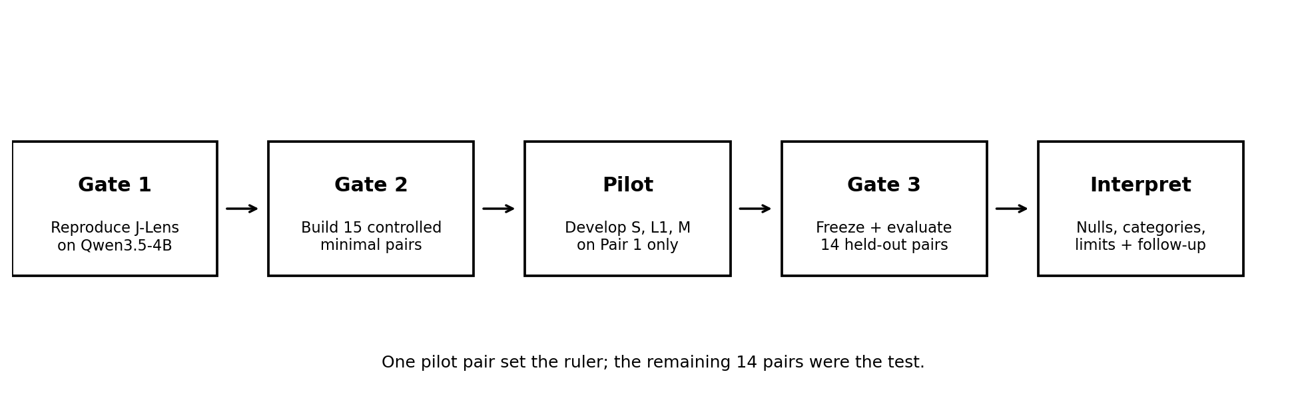
Figure 1: One pilot pair set the ruler; the remaining 14 pairs were the test.

Executive Summary
What I wanted to understand in this project was this: if a multi-token readout recovers a correct phrase, how much of that information is really represented in the activations, and how much of it is completed by the model’s own continuation prior once it is given a useful first token? A multi-token output can look clean and convincing, but that alone doesn’t tell you where the information came from.
I tested this on Qwen3.5-4B with an open-source J-Lens implementation. I first reproduced a known J-Lens sanity check, then built 15 structural minimal pairs across five different relation types. Pair 1 was used only as a pilot to develop the measurement design. I then froze all the settings and evaluated the remaining 14 pairs as a held-out set, without changing anything.
Two conditions did the real work in the comparison. L1 is an oracle-head continuation baseline: the model is given the source context and the candidate’s correct first token, and a frozen language model scores only the remaining tokens. M is a lightweight activation-side alignment metric: it measures how closely the direction that separates two source contexts in residual-activation space aligns with the direction that separates the two multi-token concepts.
A mixed pattern emerged: both signals were present, but continuation was far more consistent. L1 tracked the expected structural reversal in the correct direction on all 14 held-out pairs. The matched mean absolute shift was 2.1646, about 15.8 times the value of the 20-permutation null baseline (0.1370). M was correct in direction on 9 of the 14 pairs. That 9/14 result was not significant on its own, so for M I used a 500-sample Monte Carlo permutation test. I repeatedly broke the correct source-concept pairing, recomputed the mean alignment, and used those 500 randomized results as the null distribution. The real matched mean alignment was +0.0420, while the null mean was −0.0021, giving an empirical one-sided p ≈ 0.002. This showed that M was capturing more than random alignment and carried a pair-specific structural signal. Even so, the continuation baseline was clearly more consistent.
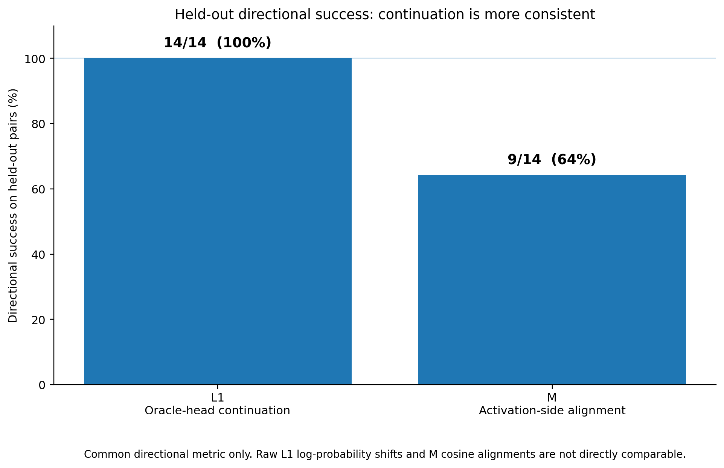
Figure 2: Held-out directional success on the common directional metric: L1 succeeded on 14/14 pairs, while M succeeded on 9/14. Raw magnitudes are not directly comparable because the metrics use different units.

Key Takeaways
- First-token-conditioned continuation was the more consistent signal. Given the correct first token, L1 captured the expected structural reversal in the right direction on 14/14 held-out pairs. The matched mean absolute shift was 2.1646. When I broke the source-candidate matching, this signal dropped sharply: about 23 times smaller under the mismatched-source control, and about 16 times smaller under the 20-permutation null. So I don’t think what I’m seeing in L1 comes merely from the model’s general phrase preference; it seems strongly tied to the correct source-candidate correspondence.
- The activation-side signal was real, but less consistent. M gave the correct direction on 9 of the 14 held-out pairs. But the 9/14 count alone was not significant, at p ≈ 0.15. So I also ran a 500-sample Monte Carlo permutation test. The real matched mean alignment was +0.0420, versus a null mean of −0.0021 for the randomized pairings, giving an empirical p ≈ 0.002. So the alignment I see in M doesn’t seem to come from random pairing alone. Even so, there was no pair where M succeeded on its own.
- Recoverability varied by relation type. M didn’t behave the same way across every relation type. Results were generally positive for role/argument binding, modifier attachment, and spatial relation. Quantifier binding showed no clear direction. Comparative relation was the most clearly problematic category: all three pairs had negative mean alignment. Post-hoc whitening moved the comparative mean from −0.0786 to −0.0391 and flipped Pair 11’s sign, but the category still failed to clear its own null, p = 1.0. So whitening softened the result somewhat but didn’t resolve the comparative failure.
What this tells me is that there really is a signal on the activation side, but the continuation side is far more consistent. In other words, both are present, they’re just not equally strong or equally regular.
M and L1 are not two fully independent causal components. Continuation already arises from the model’s own internal activations and representations. What’s more, I’m not measuring the two with the same metric: L1 uses a log-probability shift, while M uses cosine alignment. Therefore, it wouldn’t be valid to conclude with percentages like 70% continuation or 30% activation.
I think the real question this pilot raises involves readout provenance. A readout can produce the correct phrase without that meaning the whole phrase was read out directly from the activations. The model can complete the rest after the first token using its own continuation prior. So the distinction that matters to me is this: "the lens said the right thing" and "this information really came from the activations" are not the same claim. Separating exactly these two things is what I was trying to do in this project.

Randomly Selected Examples
Since the results depend on pair-level judgment, I’m showing the raw examples right after the summary rather than at the end. To avoid selecting only flattering cases, I drew a fixed random sample of 4 held-out pairs using a fixed seed (seed 42, 04_analysis_figures.ipynb, cell 4.9a): Pairs 2, 3, 6, and 12.
Pair | Category | Candidate contrast | M mean | L1 shift
2 | role / argument | doctor helps patient ↔ patient helps doctor | +0.1845 | +1.3340
3 | modifier | red box contains key ↔ box contains red key | +0.2034 | +3.8337
6 | role / argument | teacher follows student ↔ student follows teacher | +0.0533 | +1.3855
12 | comparative | train longer than bus ↔ bus longer than train | -0.1472 | +2.4820
Table 1: Fixed-seed random sample of held-out pairs, shown before any category-level framing.

1. Why I Asked This Question
J-Lens is a useful measurement tool that lets us see what a model’s intermediate layers are starting to represent. But the standard J-Lens readout operates at the single-token level. When we move to a multi-token concept, an ambiguity appears: the first token can be read from the activations, but we can’t directly see how much of the rest of the phrase was already there in the activations versus how much was completed by the model’s own continuation mechanism. Once the model has a plausible first token, strong next-token predictions kick in. So interpreting the entire resulting phrase as activation-derived can be too strong a conclusion.
In this experiment, I wanted to test these two possible sources, activation-derived structure and the continuation prior, as separately as possible. On one side, I gave the model the source context and the oracle first token and measured how well ordinary continuation could complete the rest of the phrase. On the other side, I used a separate activation-side metric that directly measures whether the source relation and the concept relation point in the same direction within the residual stream.
I’m deliberately not treating this as a literal additive decomposition, i.e., "performance = activation + continuation + noise." M and L1 are different measurements operating in different score spaces. Instead, I’m treating this as nested evidence. First, I look at how much ordinary continuation can recover once the first token is known, then I separately test whether the activation-side metric carries pair-specific structural information beyond random pairing.

2. Gate 1: Does the Lens Actually Work?
Estimated active research time for Phase 1: 2.0-2.5 hours, covering repo/model setup, fitting the lens on 100 WikiText prompts, the Spanish reproduction check, and Gate 1 itself.
Before doing anything original, I verified the pipeline. I loaded Qwen3.5-4B (32 layers), fit the J-Lens calibration on 100 WikiText prompts, and used "Lo opuesto de ‘grande’ es ‘" as the reproduction check. The model’s greedy generation completes this with "pequeño." At later layers, J-Lens surfaced the "pequeño" direction earlier than the plain logit lens’s top-5: around layer 25 for J-Lens versus layer 28 for the logit lens.
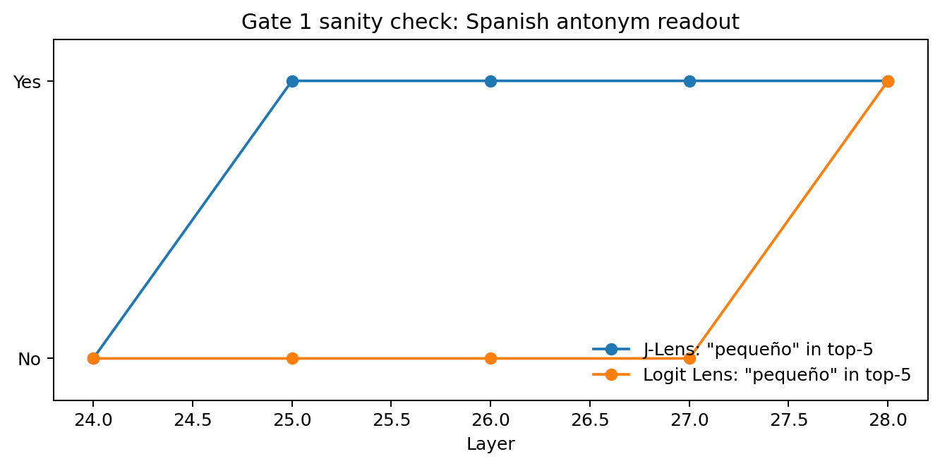
Figure 3. Gate 1 reproduction: not an original research result, but a wiring/sanity check.
This late-layer behavior later influenced my choice of the layer band I used for the lightweight activation-side metric. In the J-Lens sanity check, the relevant signal started appearing around layer 25, while the logit lens showed it later, around layer 28. So for M, I used layers [20, 22, 24, 25, 26, 27, 28]. Rather than picking a single "best" layer after seeing the final results, I measured across this small, pre-specified late-layer band.

3. Gate 2: Building a Dataset Where Words Can’t Do All the Work
Estimated active research time for Phase 2: 2.0-2.5 hours, covering minimal-pair construction, tokenizer-level validation, capitalization/space-prefix fixes, and freezing the final dataset.
I built 15 minimal pairs across five categories: role/argument binding, modifier attachment, spatial relation, comparative relation, and quantifier binding. The goal was to keep the lexical material as fixed as possible while changing the relation. I checked the semantic contrast by hand, then verified candidate token length and token-multiset equality using the same Qwen tokenizer used in the experiment. The first quantifier example ran into a capitalization/tokenization snag, which I fixed by adding a shared prefix ("In this scene, ...").
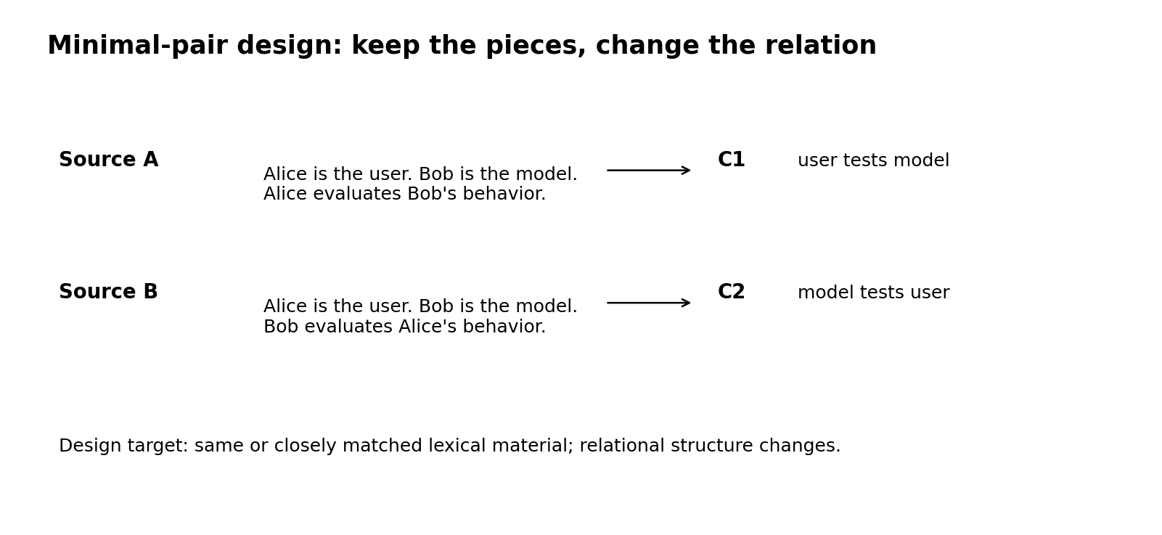
Figure 4: The source/candidate split used later in both L1 and M. The source states the relation in natural language; the candidate is a short, canonical phrase.
In the core experiment, I also kept the source wording separate from the candidate wording. For example, the source "Alice evaluates Bob’s behavior" maps to the candidate "user tests model" rather than directly restating it. This was meant to reduce the trivial "surface copying" explanation.

4. Phase 3: Core Experiment
Estimated active research time for Phase 3: 6.0-7.0 hours, the largest block: failed S attempts, tokenization debugging, building L1, the copying-confound redesign, building M, the layer sweep, freezing the estimator, held-out runs, and null controls.

4.0 The condition ladder: S → L0 → L1 → M
The core experiment is organized around four conditions, run in this order in 03_core_experiment.ipynb. Each answers a different question about where recoverability might be coming from:
- S: single-token J-Lens. The standard readout, one token. Tests whether the original single-token vocabulary already makes the relation legible on its own.
- L0: context-only LM baseline. The frozen model scores both candidates given only the source context, with no oracle first token and no activation-conditioned readout. It measures what the source context and the LM’s ordinary contextual/world-knowledge priors can recover without either of those additional signals.
- L1: oracle-head continuation. L0 plus the candidate’s correct first token. The key continuation baseline: how much of the remaining multi-token distinction can ordinary completion recover once the head is known?
- M: lightweight activation-side alignment metric. It does not generate the phrase. With no oracle token, it asks whether the source-reversal direction aligns with the concept-reversal direction in the model’s residual-activation space. This is the condition that could reveal structural information not captured by first-token-conditioned continuation.
S turned out not to be a usable structural metric for this task (4.1). L0 is included as a context-only reference condition and is not the more meaningful comparison in this pilot. The results below instead focus on L1 versus M, since that is the comparison that most directly contrasts continuation once the head is known with an activation-side alignment test that uses no oracle head.

4.1 First attempt: single-token S
I first tried the standard single-token J-Lens score. But I quickly saw that it wasn’t well suited to the relations I was testing, because most of these relations don’t show up in a single token; they emerge from the order and interplay of several tokens.
There were also small but important problems on the tokenization side. The same word could turn into different token IDs depending on a leading space, capitalization, or how the tokenizer split it. That made the first-token score quite sensitive. In some examples, S highlighted an entity or predicate cue rather than the relation itself.
So I didn’t interpret this as the model not knowing the relation. Instead, I concluded that a single-token readout simply isn’t a good measurement for this kind of multi-token structure. Because of this, I didn’t use S as the main metric, and made the real comparison between L1 and M.

4.2 L1: if I hand it the head, can the frozen LM finish the rest?
What I wanted to ask with L1 was fairly simple: if I hand the model the correct first token, how accurately can it complete the rest of the multi-token phrase using its own ordinary continuation behavior?
For each source, I used two competing candidates, C1 and C2. I gave the model each candidate’s first token as an oracle. After that, the frozen LM scored only the probability of the remaining tokens. So I’m not giving the model any activation-side readout here; there’s only the source context, the correct first token, and the model’s own next-token prediction mechanism.
How high a score a single candidate got wasn’t enough for me on its own. What I really looked at was whether the model’s preference between the two candidates shifted in the expected direction when the relation changed. To do so, I computed the preference difference between C1 and C2 for Source A and Source B, and then compared these two differences:
ΔL1i = [score(C1|A) − score(C2|A)] − [score(C1|B) − score(C2|B)]
A positive ΔL1 means the model’s continuation preference shifted in the expected direction when the source relation was reversed.
I deliberately kept this baseline strong, because for the research question I wanted a demanding comparison: if I give the model the correct beginning, how much can ordinary continuation already explain without needing an activation-side readout at all? L1’s role was exactly to measure that.

4.3 M: does the relation leave the same directional trace inside the model?
For M, I stopped looking at token probabilities and moved to residual activations. At each selected layer, I took the final-token activations of sources A and B and formed a difference vector, Δh_source = h_A − h_B. Separately, I placed C1 and C2 in the same fixed carrier prompt and mean-pooled the four residual states right after the concept, giving
Δh_concept = v_C1 − v_C2.
M is the cosine alignment between these two difference directions.
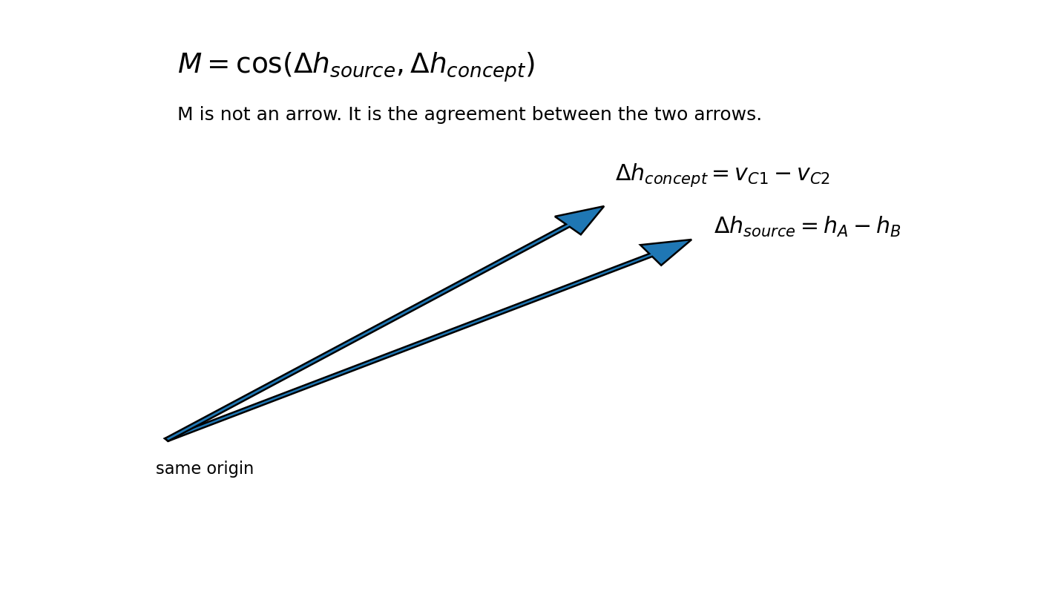
Figure 5: M compares two directions, the source-reversal direction and the concept-reversal direction, rather than reading either one in isolation.
The carrier prompt, the pooling rule, the source-readout position, and the layer set [20, 22, 24, 25, 26, 27, 28] were all developed on Pair 1 alone. Pair 1 gave a positive mean alignment (+0.0565; 6 of 7 layers positive). I froze the estimator there, and only then moved on to Pairs 2-15.

5. Gate 3: Frozen Held-Out Evaluation
Gate 3 is not a separate time block; it falls within the Phase 3 estimate above. It covers the frozen 14-pair evaluation and the permutation-based falsification checks.
This stage mattered to me because, after setting things up on Pair 1, I moved on to the remaining 14 pairs without changing anything further. If the signal had disappeared here, most of the earlier results would have been specific to the pilot alone. So I ran L1 and M on all the held-out pairs, and then tested whether the effect I was seeing genuinely depended on the correct source-candidate matching.
L1 gave a fairly clean result here. All 14 pairs moved in the expected direction, and the matched mean absolute structural shift was 2.1646. I then broke the source-candidate matching and recomputed; in that case, the permutation-null mean absolute shift dropped to 0.1370. So the signal under the correct matching was about 15.8 times larger than under random matching.
In addition, I ran a simpler sanity check. I matched each pair’s source against the next pair’s candidate instead of its own. In this mismatched case, the mean absolute shift dropped to 0.0931, compared with 2.1646 for the matched case. That’s a difference of about 23.3 times, and the matched value was higher than the mismatched value on all 14 pairs.
This second check was separate from the 20-permutation L1 null. Seeing the signal drop sharply both times I broke the correspondence, in two different ways, gave me more confidence that the L1 result comes from the correct source-candidate correspondence rather than from a generic phrase preference.
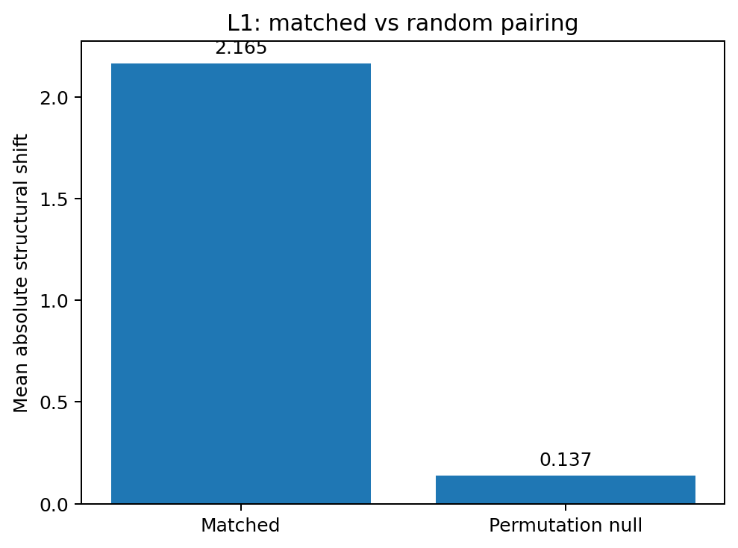
Figure 6: L1 depends strongly on the correct source-candidate correspondence. The 15.8x figure is a null-control ratio, not a probability ratio or a percentage decomposition.
The M side was somewhat weaker. Alignment was positive on 9 of the 14 held-out pairs, but the 9/14 result wasn’t strong enough on its own, at p ≈ 0.15. Therefore, I didn’t want to draw a strong conclusion from that count alone.
What I really wanted to know was this: did the alignment I was seeing genuinely depend on the correct source-concept matching, or would I get a similar value by pairing them randomly? To check this, I ran a 500-sample Monte Carlo permutation test. I repeatedly broke the correct correspondence between source-difference vectors and candidate-concept difference vectors and recomputed the mean alignment. These 500 randomized results gave me the null distribution.
The real matched mean came out to +0.0420. The null mean under randomized pairings was −0.0021, giving an empirical one-sided p ≈ 0.002. As a result, I had stronger grounds to think that the signal I was seeing in M wasn’t just a coincidental alignment, but a genuine structural signal tied to the correct pairing.
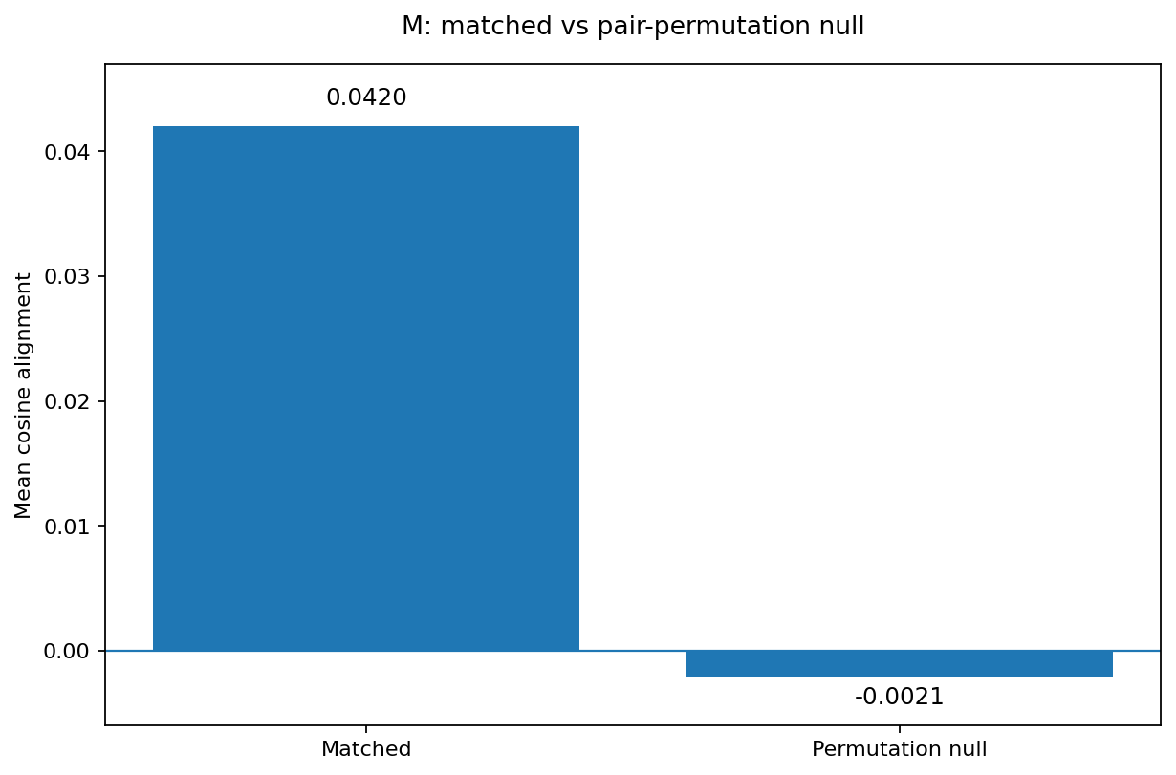
Figure 7: The activation-side matched mean sits above the pair-permutation null. This is the main evidence that M carries pair-specific structural information.
When I looked at the shared comparison, the picture was actually quite clear. 9 pairs succeeded under both L1 and M, and 5 pairs succeeded only under L1. There was no pair where only M succeeded, and L1 never failed on any pair. It was very clear that L1 was more consistent.
I didn’t subtract the M and L1 scores from each other directly here, because they don’t measure the same thing in the same units. M uses cosine alignment, L1 uses log-probability shift. Therefore, it wouldn’t be right to compare these two numbers as if they were on the same scale.
Also, before I started writing up the results, I wanted to make sure the numbers were actually correct. I reloaded the saved heldout_m_results.json, heldout_l1_results.json, and m_permutation_verification.json files from disk and recomputed the headline statistics from scratch. I got an M matched mean of 0.042004, a null mean of −0.002069, a null 95th percentile of 0.017852, and an empirical p of 0.001996. These values, computed across all 500 permutations, matched exactly what I had saved earlier.
This mattered to me because it confirmed that the numbers I used in Gate 3 didn’t come from a one-off calculation; they reproduce independently.

6. What Changed by Relation Type
Estimated active research time for Phase 4: 1.5-2.0 hours, covering category summaries, the four main figures, comparative-layer inspection, and the headline synthesis.
What caught my attention here was that M didn’t behave the same way across every relation type. Results were generally positive for role/argument binding, modifier attachment, and spatial relation.
For quantifier binding, no clear direction emerged. Some pairs were positive while others were negative, so I couldn’t see a consistent pattern at the category level.
The clearest difference showed up in comparative relation. All three pairs in this category had negative mean alignment. In other words, where M struggled didn’t look like a few randomly scattered examples but seemed concentrated in one specific relation type. So I decided to look at the comparative category more closely.
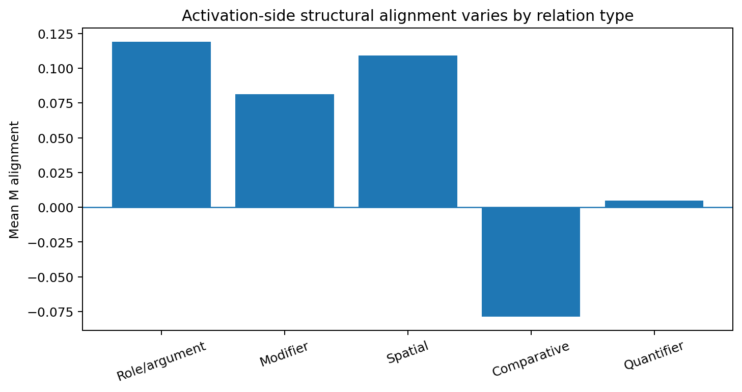
Figure 8: Category-level M alignment. This heterogeneity is one of the pilot’s more useful signals.
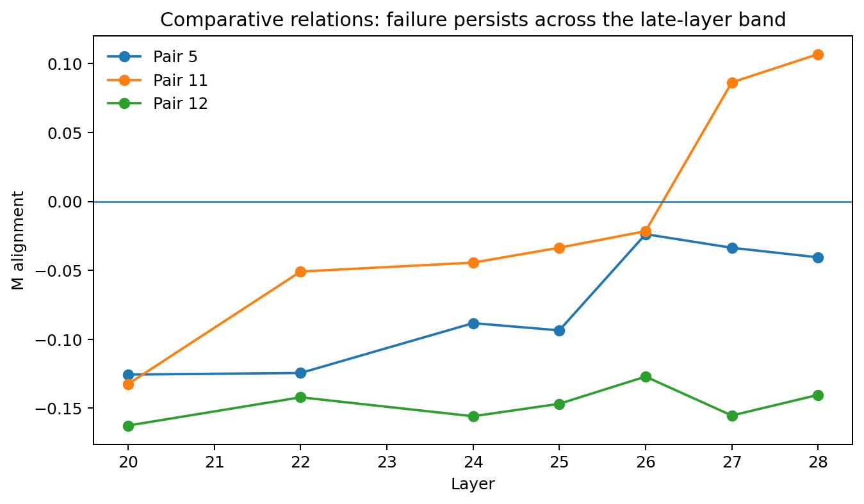
Figure 9: The comparative failure isn’t a single-layer accident: Pairs 5 and 12 stayed negative across the entire tested band; Pair 11 only turned positive in the last two layers.
I didn’t interpret the comparative result as the model not representing comparison. It could just as easily be a mismatch between the source-final-token geometry and the carrier-based concept geometry, or the lightweight calibration simply being insufficient. Telling these apart is exactly what I’d want to do in a follow-up study.

7. Post-Hoc Robustness Check: M+
Post-gate robustness time-box: ≤ 2 hours. M+ was deliberately kept as a limited follow-up; I didn’t let it rewrite the frozen Gate 3 result.
After freezing the Gate 3 result, I wanted to understand the negative results in comparative relation a bit better. My question was: is M genuinely struggling with this relation type, or does part of the negative values I’m seeing come from some dimensions in activation space carrying much larger variance than others?
To check this, I ran a single post-hoc robustness check. I estimated the variance of each residual dimension from 100 WikiText prompts, about 21k tokens, and rescaled to reduce the outsized influence of dimensions with very high variance (diagonal whitening). Because I did this after already seeing the main result, I didn’t treat it as part of Gate 3, and I didn’t change the original result.
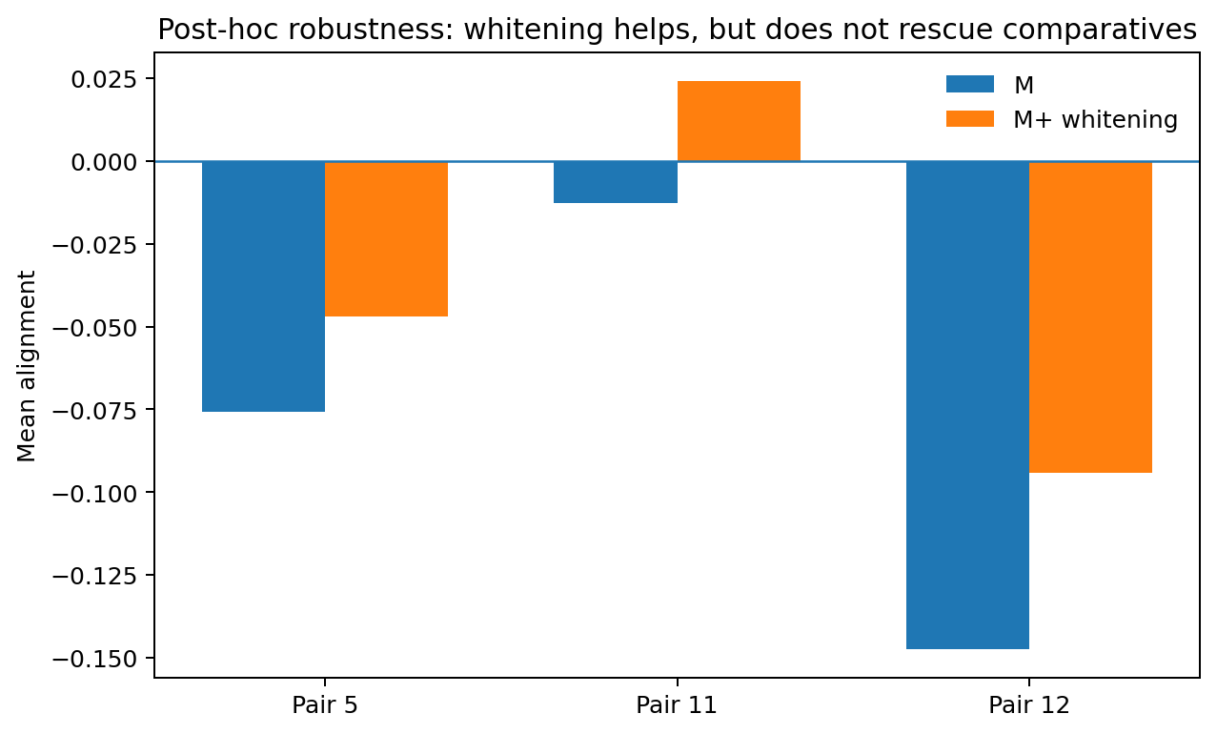
Figure 10: M+ pushed all three comparative pairs in the positive direction and flipped Pair 11’s sign, but the category as a whole stayed negative.
Whitening moved all three comparative pairs in the positive direction and flipped Pair 11’s sign from negative to positive. But the category as a whole was still negative. The comparative mean moved from −0.0786 to −0.0391, and it still failed to clear its own freshly recomputed null distribution, with an empirical one-sided p = 1.0.
So whitening softened the result somewhat but didn’t fix the problem. This suggested that the comparative failure doesn’t come from a simple variance issue alone.

8. What I Think This Means
Estimated active research time for Phase 5 (interpretation + limitations): 1.0-1.5 hours, covering supported/unsupported claims, alternative explanations, follow-up design, and the final interpretation.
The simplest conclusion I draw from this experiment is this: there is a real signal on the activation side, but the continuation side is far more consistent.
In M, the correct source-concept pairs aligned more than random pairs did. So I can genuinely see a relation-dependent structure in activation space. But when given the correct first token, ordinary LM continuation gave a much stronger result and captured the expected direction on all 14 held-out pairs.
This is where the distinction that matters to me begins. A lens producing the correct phrase is not the same thing as that phrase actually being read out from the activations. Once the model has the correct first token, it already has a strong continuation mechanism. So when the whole phrase comes out correct, I don’t want to assume that all of it came from the activations.
For the same reason, I don’t turn this result into a percentage of how much is activation, how much is continuation. M and L1 are not independent causal components. Continuation already arises from the model’s own internal activations and representations. I also measure the two differently: L1 uses a log-probability shift, M uses cosine alignment. So an interpretation like 70% continuation, 30% activation doesn’t follow from this experiment.

What does this pilot tell me?
- There is a pair-specific activation-side signal in M. The matched mean sits clearly above the 500-sample Monte Carlo permutation null, p ≈ 0.002.
- L1 is far more consistent. Given the correct first token, 14/14 pairs are in the right direction, and the signal drops sharply when the matching is broken.
- M doesn’t work the same way across every relation type. It struggles noticeably in particular with comparative relation.
- This result isn’t a general claim of failure about the full multi-token J-Lens method. The M used here is my own lightweight activation-side metric.
- Likewise, I can’t say the model doesn’t represent comparative relation. It’s only that the readout I used here failed to capture it well.

9. Alternative Explanations
Several explanations other than "the model lacks comparative structure" could produce the pattern above, and this pilot cannot distinguish between them:
- Shared carrier-template geometry: I don’t construct the source representation and the candidate concept representation the same way. On the source side I use the final-token residual state, while on the candidate side I build the concept representation inside a fixed carrier prompt. These two geometries may not line up exactly.
- Final-token readout location. The source representation is read only at the final residual-stream position; I only look at the source’s last token. If the relation information is spread across earlier positions, attention patterns, or other subspaces, M could be missing it.
- Another possibility is that comparative relation simply isn’t well represented by the simple difference-vector geometry I used. The model may know the relation but not encode it as the linear direction I expected.
- L1’s oracle first token is a strong hint. The model receives the correct first token as an oracle, which is a very strong clue. So L1’s success doesn’t mean the same internal structure was read out directly; the model could just as well complete the phrase using lexical and semantic continuation priors.
- Small samples. Each category has only two or three held-out pairs. So I see the category-level results not as a settled taxonomy, but as clues for the next experiment.

10. Limitations
- The biggest limitation in this project is that M is not a fully calibrated multi-token J-Lens. M is a simpler activation-side alignment metric. I use a fixed carrier, mean-pool for the four residual states after the concept, and measure cosine alignment between the source and concept difference directions. So when M fails on a pair, I can’t distinguish between no information in the activations and the readout failing to capture that information.
- The dataset is also small. After setting Pair 1 aside as the pilot, 14 held-out pairs remained, with only two or three examples per category.
- I designed the source-candidate mappings myself. I did this specifically to reduce direct copying, but I haven’t fully isolated how much the wording or synonym choices affect the result.
- On the source side, M only looks at the final-token residual state. If the relation is spread across other positions or attention structure, it may not be able to see it.
- L1, on the other hand, is a deliberately strong baseline. I give it the correct first token, so L1 doesn’t represent a natural generation setting; its purpose is to be a demanding continuation control.
- Because M and L1 are different metrics, I can’t subtract their raw scores from each other to get a causal decomposition.

11. What I’d Try Next
In the next experiment, I would keep the same held-out design and the same L1 baseline. What I would change is M.
I would want to use a better-calibrated activation-side readout instead of M. In particular, I’d want to better match the geometry between the source and concept representations, test different positions, use a larger calibration set, and build normalization methods like whitening into the design from the start.
The most interesting outcome for me would be an M-only success, that is, a held-out example where L1 fails but the activation-side readout captures the correct relation while clearing the permutation controls.
A result like that would show much more clearly that the activation readout is capturing something continuation alone can’t explain.
Conversely, if M-only examples still don’t turn up even after using a stronger, better-calibrated M, and L1 remains just as consistent, the continuation explanation would become even stronger.

Appendix A: Notebook Map
- 00_setup_check.ipynb: environment and GPU/package sanity checks.
- 01_reproduce_jlens.ipynb: Qwen3.5-4B load, 100-prompt J-Lens fit, Spanish reproduction sanity check.
- 02_dataset_design.ipynb: 15 controlled minimal pairs, tokenizer validation, category balance, and the Pair 13 fix.
- 03_core_experiment.ipynb: S pilot, L1 construction, lightweight M, Pair 1 freeze, 14-pair held-out evaluation, nulls, and post-gate M+ robustness.
- 04_analysis_figures.ipynb: held-out table, category analysis, result figures, comparative-failure analysis, and the fixed-seed random raw examples.
- 05_interpretation_limitations.ipynb: claims, non-claims, limitations, alternatives, follow-up, final interpretation, and the independent re-verification of the headline statistics.

Appendix B: Active Research Time Log
These aren’t exact wall-clock timestamps; they’re active-work estimates reconstructed from project time-budget notes. Breaks, passive GPU waiting, and generic cloud setup are excluded. I used ranges rather than false precision. The core Phase 1-5 estimate, before post-gate robustness and the final write-up, is 12.5-15.5 active hours (planning midpoint ≈14 hours).
Phase | What actually happened | Est. active time
Phase 1: Setup + reproduction | Repo/model setup; fit lens.pt on 100 WikiText prompts; Spanish J-Lens vs. logit-lens sanity check; Gate 1. | 2.0-2.5 h
Phase 2: Dataset design | 15 minimal pairs across 5 categories; non-copying redesign; tokenizer length/multiset validation; capitalization/space-prefix fixes; final CSV. | 2.0-2.5 h
Phase 3: Core experiment + Gate 3 | Failed single-token S attempts; L1 oracle-head scoring; source redesign; paired structural shift; M concept/source directions; layer sweep; Pair 1 freeze; 14-pair held-out run; L1 and M permutation controls. | 6.0-7.0 h
Phase 4: Analysis + figures | Held-out table; category analysis; M vs. L1 common directional comparison; null-control figures; comparative-layer failure analysis. | 1.5-2.0 h
Phase 5: Interpretation | Supported / unsupported claims; alternative explanations; limitations; strongest follow-up; log cleanup. | 1.0-1.5 h
Core total through Phase 5 | Completed core research, before post-gate additions. | 12.5-15.5 h (midpoint ≈14 h)
Post-gate M+ robustness | 100-prompt WikiText residual statistics; diagonal whitening on comparative pairs; fresh whitened null; frozen Gate 3 left unchanged. | time-boxed ≤ 2 h
Manual verification + raw examples | Recomputed headline statistics from saved result files; fixed-seed random draw of 4 held-out examples to avoid cherry-picking. | ≈ 1 h
Final write-up | Executive summary, figures, limitations, narrative tightening, application polish. | 2.5 h
TOTAL |  | ≈ 19.25 h

Tags (from Neel’s Suggested Research Problems)
- Applied Interpretability → Other techniques → Lens faithfulness / activation-conditioned readouts
- Basic Science → Does a proposed interpretability tool actually read out what it claims to?
- Novelty → Decomposing multi-token recovery into an activation component and a continuation-prior component

Resources
- idhantgulati/j-lens: reproduction target for the published J-Lens implementation and fitted-lens format.
- Qwen3.5-4B (32 layers), via the repo’s own model/tokenizer loader.
- WikiText: 100-prompt calibration set for both lens fitting and, later, the M+ whitening statistics.

Research Trajectory (Short Log)
- Day 1 / Phase 1: Before doing anything original, I got the published pipeline running. The first useful result wasn’t my hypothesis: it was seeing that the lens, tokenizer, and model behaved coherently on a known Spanish antonym example.
- Day 2 / Phase 2 → early Phase 3: The first single-token structural attempt revealed the first real trap: tokenization and copying meant a weak design could still look good. I rebuilt the sources to express the same relation without copying the candidate’s wording, then used Pair 1 to develop and freeze the L1 and M measurement choices.
- Day 3 / Phase 3 → Phase 5: I ran the frozen 14-pair evaluation and got a cleaner result than I expected: L1 14/14, M 9/14. Rather than stopping there, I tried to break both signals with mismatched-source and permutation controls. M held up as a real but weaker pair-specific signal; L1 was far more consistent. The comparative failures turned out to be the most interesting anomaly, which motivated the bounded M+ whitening check and the final limitations/follow-up section.

What I’m Taking Away From This Pilot
- Readout provenance matters: a correct verbalization is weaker evidence than an activation-dependent verbalization.
- A strong baseline is part of the inference. L1 changed how far I was willing to go in interpreting the multi-token result.
- Failure patterns can be more useful than a single success rate. Comparative relations produced a coherent anomaly and pointed to representation/readout geometry as a concrete follow-up target.
- The next decisive experiment is finding held-out, M-only recoveries that clear permutation controls, ideally with a more fully calibrated multi-token readout.

