|  |  |  |
| --- | --- | --- |
| fb profile pic.jpg | **Dean Pinckert** | Sunnyvale, CA  Cell: (408) 857-5438  [pinckert@gmail.com](mailto:pinckert@gmail.com?subject=resume%27%20query) |



**Software Engineer / Release Engineer**

Senior software engineer with a background in metrology, machine-control applications, and release engineering returning to the job market after hiatus

Extensive background in all aspects of the software development cycle from project conception

and requirements gathering through design, code and maintenance.

**Objective**

I’m seeking an opportunity to apply my extensive experience in software development and process automation to an organization committed to providing exceptional products to their customers.

**Technical Skills** 

|  |  |
| --- | --- |
| **∙ C++ Software Development** | Fluent C++ developer with over 12 years C/C++ development experience. I have written over one hundred thousand lines of production software for the Software, Semiconductor, and social media industries. |
| **∙ Software Tools** | IDE’s: MS Visual Studio, Eclipse  Source Code Control: Subversion, Git  Platforms: Windows, Linux |
| **∙ Software Design** | Strong background in object-oriented and pattern based development. |
| **∙ Process Automation**  **∙ Additional Proficiencies** | Build Systems:Jenkins, Pulse  Defect tracking: JIRA, Bugzilla  Scripting: Javascript, python, BASH  Build: Ant, Make, Maven  Installers: RPM, Innosetup, Installshield, Nullsoft, Visual Studio packager |
| **Education** |  |
| [**UC Santa Barbara**](http://www.ucsb.edu/) | Bachelor of Science, Computer Science 1986 |
| [**Foothill College**](http://www.foothill.edu/index.php) | Sept 2006 – June 2007  Courses: AJAX, Java, Advanced Java, Javascript, PHP with MySQL, C# |
| **Employability** | US Citizen with passport. Former holder of ‘secret’ security clearance. No criminal record. |

**Career at a glance:**

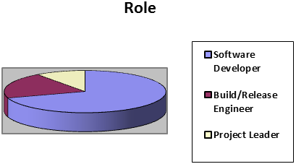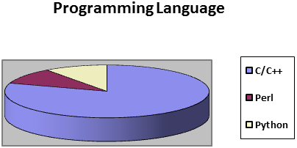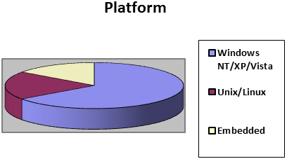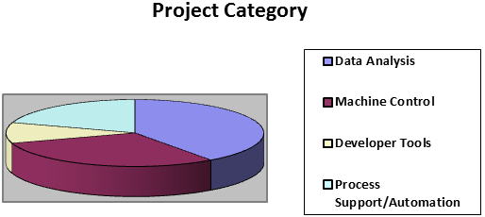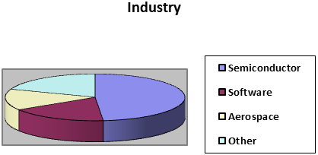

**Detailed Work History** 

|  |  |
| --- | --- |
| **Work Experience** | June 2012-Present Raleigh, NC Personal projects.  Activities included writing fiction, weight loss and health improvement.  Aug 2010-June 2012 [Yahoo!](http://www.yahoo.com/) Santa Clara, CA **Release Engineer**  Release engineer for Yahoo’s advertising products group which executed two thousand builds daily, covering three thousand Hudson projects. Developed graphical browser-based dashboard for Hudson that included overall performance, performance by server, and a number of specific reports – eg. jobs executing longer than three hours. I developed a library that provided a class-like interface to Hudson available from perl. Other responsibilities included assisting development teams in migrating to process standards: Hudson buildfarm, subversion, platform configuration tool and routine administration such as branching projects, migration to newly deployed tools, etc.  Dec 2007-Mar 2010 [Pelco](http://www.pelco.com/) Pleasanton, CA **Build&Release Engineer**  Build engineer on a team supporting 250 software engineers developing software for physical security systems. Primary responsibilities included: migrating projects to a Pulse automated build system, developing installers using RPM, inno setup, nullsoft, and installshield; creating, branching and merging subversion source repositories; Additional responsibilities included: automating build statistics using python and the Pulse xmlrpc interface; Using windows OPK to setup a branded OS installation; maintaining/updating additional development tools including, viewvc, fisheye, jira, and several subversion clients; providing development tool training and evangelizing process standardization. |
|  | Aug 2005- Nov 2005 [Symantec](http://www.symantec.com) Redwood City, CA  **Senior Software Engineer**  Software developer for the Host Intrusion Detection System, an enterprise client/server application running on Linux and Windows used to determine unauthorized usage of the client system. Developed an application to convert the format of the policy files from a proprietary grammar to XML. Cross platform development (Linux/Windows) utilizing C++/STL. |
|  | 2003 - 2005 [Propel Software Inc](http://www.propel.com) San Jose, CA  **Software Engineer**  Propel Software manufactures the most widely used internet accelerator.  I was responsible for branding and localization of the product for individual customers, which required modification of XML, C++ source, makefiles and additional build scripts Streamlined the process to reduce the effort for branding while dramatically increasing capacity. Other responsibilities included doing daily builds for the product, branching the CVS tree for major releases and maintenance and modification of the build scripts. |
|  | 2001-2002 [KLA-Tencor](http://www.kla-tencor.com) Milpitas, CA  **Project Manager**  Led a team of software, electronic and hardware engineers to develop the next generation controller for the robotic material handling unit. Tasks included defining schedules and deliverables, coordinating with other projects in terms of resources and objectives, and presentations to management to demonstrate performance against milestones. |
|  | 2001 [Netscape/AOL](http://corp.aol.com/) Mountain View, CA  **Senior Software Engineer**  Various bug fixes in the mail-news import utility for version 6.2 of the Netscape browser. Built and tested fixes under Windows NT, Windows 2000, Linux, and Mac OS 9. |
|  | 2000 [Tibco Software](http://www.tibco.com) Palo Alto, CA  **Senior Software Engineer**  Software engineer for Tibco’s Adapter SDK, a software tool used to rapidly prototype and deploy applications used for B2B connectivity. |
|  | 1997–2000 [Boxer Cross](http://phx.corporate-ir.net/phoenix.zhtml?c=112059&p=irol-newsArticle&ID=406406&highlight=) Menlo Park, CA  **Senior Software Engineer**  First software employee for a start-up semiconductor metrology company. Developed software for BX-10 advanced implant monitor on a Windows NT platform using C++. Platform consists of multiple executables communicating via COM and NT IPC mechanisms to control multiple asynchronous devices. ADO is used for communicating with resident or remote SQL database. Coded and maintained several modules, including measurement collection and analysis. Additional responsibilities included managing offsite contractors, defining project requirements, and defining and maintaining release schedules. |
|  | 1992–1997 [Prometrix/Tencor/KLA-Tencor](http://www.kla-tencor.com) Santa Clara, CA  **Member of Technical Staff**  Defined software requirements and engineered software for the Prometrix 1250SE Spectroscopic Ellipsometer thin-film inspection tool. System was developed using C++ on a PC platform running windows NT with an ObjectStore database. Other projects included calibration and diagnostic programs to assist manufacturing and field service efforts, and modifications to legacy platforms. Wrote utility to export the system database to ASCII format and re-import it to support schema evolution. |
|  | 1990–1992 [Electroglas](http://www.electroglas.com) Santa Clara, CA  Software Engineer  Design and development of 4060 Horizon Wafer Probe software to support semiconductor electrical test. Responsibilities included implementation of object-oriented techniques, using C language, for supporting a real-time embedded system consisting of an Intel 80386 platform supported by a Motorola 68020 via RS-422 interface. Designed and coded inter-task message queuing module to supplement RPCore kernel functions. |
|  | 1988–1990 [Lockheed Missiles and Space Co.](http://www.lockheedmartin.com) Sunnyvale, CA  Scientific Programmer  Design, implementation, and maintenance of Strategic Defense flight software, as part of a team effort for the Exoatmospheric Reentry Vehicle Intercept System (ERIS) project. Duties included implementation of interrupt handlers, scheduling tasks in real-time, and pre-flight tests on a CDC AYK-14 and Honeywell array processors. Development of windowing software test program to expedite exhaustive path testing of missile flight code. Documented software design and interfaces. |