Task: File explorer
Create File Explorer application:
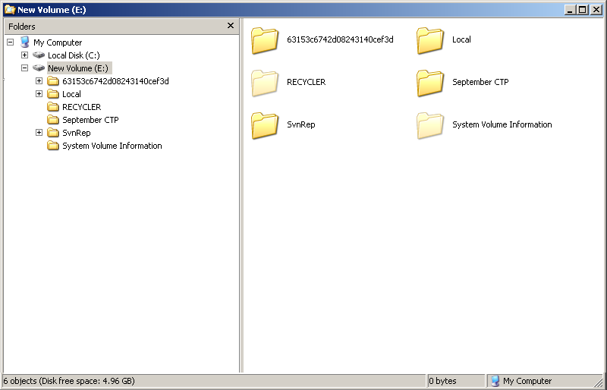
It should display both folders and files.
Limitation: Application should not use user events handlers (like MouseDown, KeyDown and so on). The only way for interaction allowed is DataBinding.
Helpful links:
- Jason Dolinger Screencast on MVVM. (direct link to video)
- Dr. WPF: ItemsControl A to Z.
- MSDN: DataBinding.
- Josh Smith on MVVM (MSDN Magazine).

