Run object-plasma simulation:

Build code:

first build/install and link if necessary in local.mk libraries for

-gsl
-hdf5
-fftw3

execute "make" command in main folder to build pinc
~make clean
~make

Copy test_object_32_16_16.grid.h5 to data/object.grid.h5
Note: the object used in simulation is searched for only at this specified destination

Run:
~mpirun -np 2 pinc workingExample.ini

For a quick look at the results run plotAverageGrid.py, plotObjCurr.py, or animate.py

the number of processors used is the multiplum of nSubdomains in .ini file used. And the actual simulated domain size is nSubdomain*trueSize.

for additional data output; this needs to be hard coded in run mode, eg: oCollMode, or oMode
change

if(n == nTimeSteps )

to

if(n%100 == 0 )

to write every 100 timestep.

New objects can be created with the object creation scrips from geometrical shapes, or

Set up custom Object in HDFview:

-Download HDFview: https://support.hdfgroup.org/products/java/release/download.html
-On Ubuntu install package libgconf-2-4

1: file->new->hdf5
2: right click new file | ->New->Dataset
3: Dataset name: Object
4: no. of dimensions: 3
5: Current size: 32,32,32 (or whatever size), dimensions are Z,Y,X
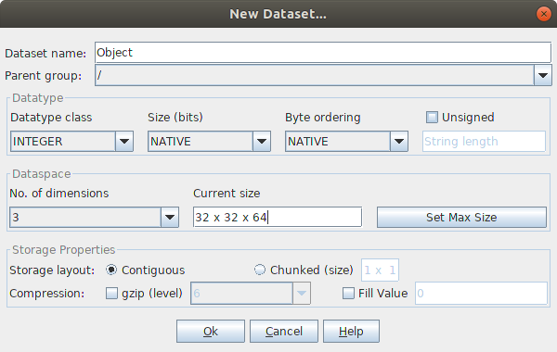
6: double click "new file"->double click "Object"
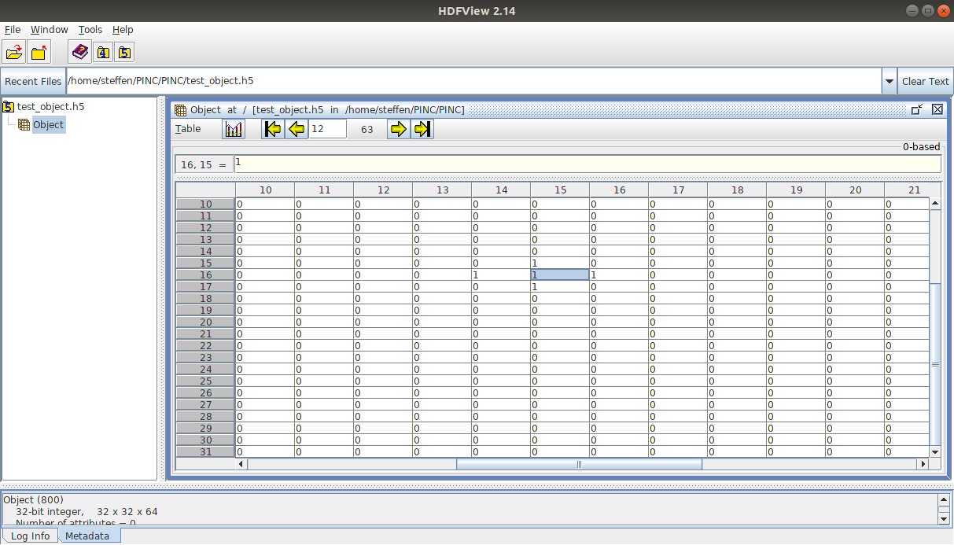
7:Specify shape of object as all ones “1” , move in X dimension with arrows at top.
8: save file

