**ASSETS FOR GAME DEVELOPERS**

**QUIZ#4.1**

|  |
| --- |
| **Table 1.1** |
| **Students’ names** |
| **Michael Courneya** |
|  |

Contents

Quiz 4.1: Activity 1 – Character Lines and Dimensionality 2

Quiz 4.1: Activity 2 – Lighting and Shadows 7

Quiz 2.1: Activity 3 – Head 10

Quiz 1.2: Activity 4 – Eyes 13

# Quiz 4.1: Activity 1 – Character Lines and Dimensionality

Character Lines and Dimensionality

A character without any body lines seems unnatural. A simple model can be created with a few body lines but for a more advanced approach, we need to add a few body lines. This tutorial presents a few tips, on how to add body lines to characters.  
Follow the steps below:

1. Double – click on the GIMP shortcut on your desktop.
2. Click File 🡪 Open…
3. Open the CharacterDetails.xcf file from Quiz3.1.
4. You should see something similar to the image below:

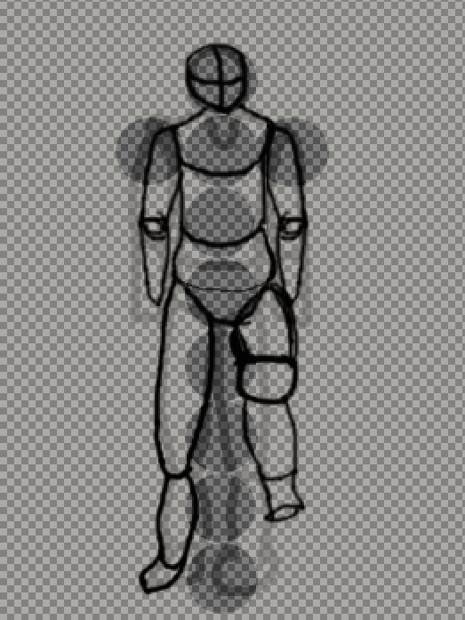

1. Right – click on the layer panel and 🡪 Add New Layer.
2. Set the Perspective level Opacity to 50 and hide the layers below.
3. Click View 🡪 Show Grid.
4. Click Image 🡪 Configure Grid.
5. Set the Vertical and Horizontal Spacing to 40 and press OK.
6. Click on the Ellipse Tool and draw a circle and a cross, such as the image below (Use the Stroke Selection and a Size of 1):

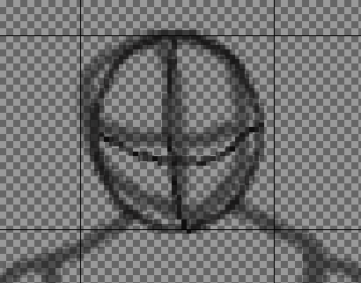

1. Pick the Paintbrush tool, set the size to 1 and draw the torso and the hands as shown below (always follow the basic guidelines from the lower layer):

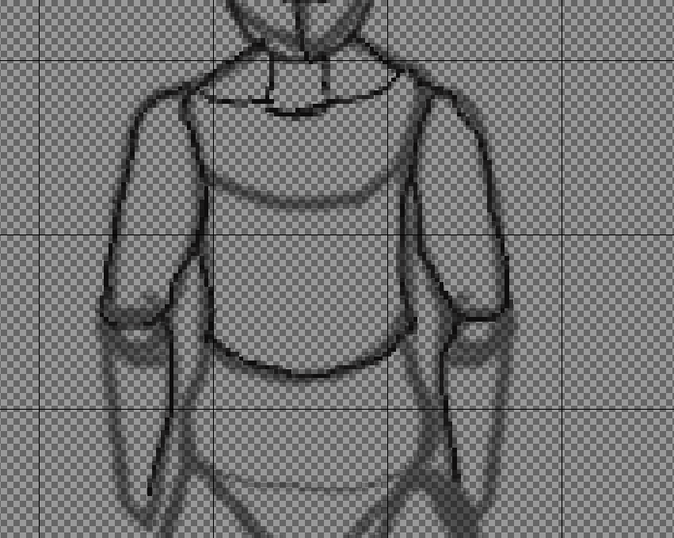

1. For better visualization, right – click under the layers panel 🡪 Add New Layer.
2. Name the layer BackgroundWhite and set the Fill with option to White.
3. Set it at the bottom of the layers’ stack.
4. Draw the lower torso and a part of the right hand as shown below:

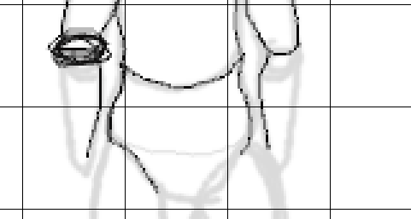

1. Follow the How to Draw a Moving Foot video and draw two circles at the left foot, to draw a raised foot.
2. Erase if needed and draw the lower foot as shown below:

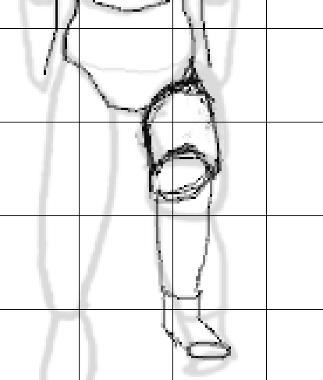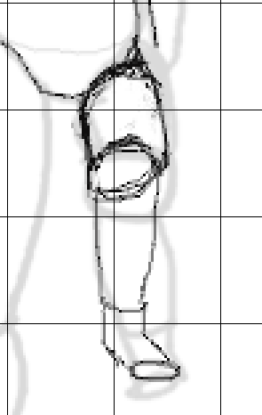

1. Draw an elongated version of the right foot as shown below:

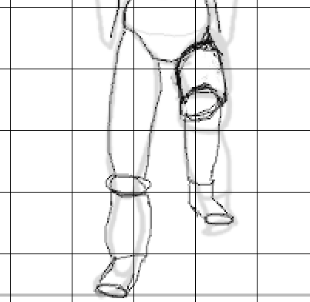

1. Go at the right hand a draw it leaning backwards as shown below:

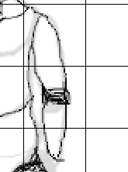

1. Add all the upper body details.
2. Click on the Eraser Tool and erase the hard lines at the joints.
3. Click on the Painbush tool, set its Opacity to 30 to 40 and add softer lines.
4. Click Export as 🡪 BodyLinesTutorial.png.
5. Select the head of the character using the Free Select tool.
6. Move the head slightly up.
7. Draw a neck that connects the head and the body.
8. Erase the hard lines from the upper torso, as shown below:

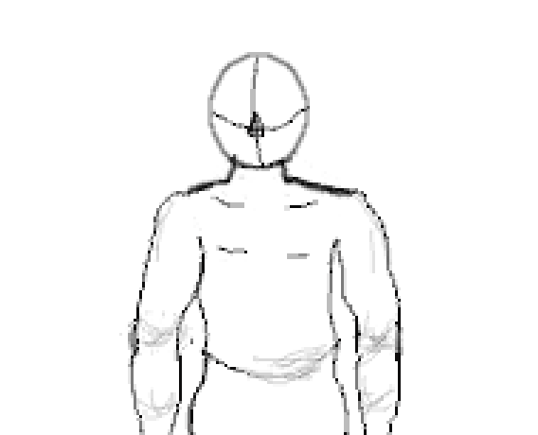

1. Continue and add lines to the entire body.

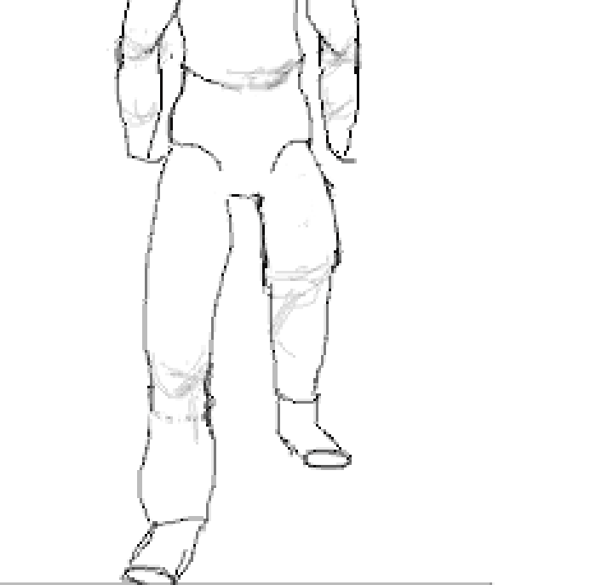

|  |
| --- |
| Q1. Upload the BodyLines.png file to Quiz#4.1 dropbox in E-Centennial. |
|  |

# Quiz 4.1: Activity 2 – Lighting and Shadows

Lighting and Shadows

Another technique for enhancing the appearance of a characters is to apply Shadows or Shiny areas. This gives the clear impression of dimensionality.   
Follow the steps below:

1. Continue working with the same BodyLines image.
2. Click on the Airbrush Tool, select a dark gray color, set the Opacity to 50 and the Size to 5.
3. Draw the shadows as shown below:

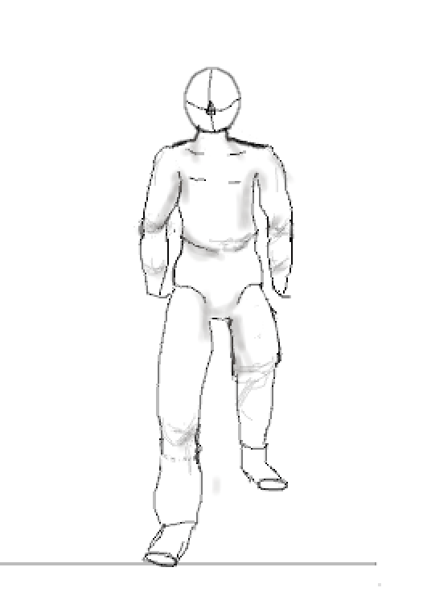

1. Under the Airbrush tool raise the Opacity to 80 and enhance the top and lower torso areas.

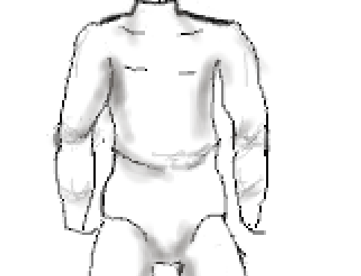

1. Right – click on the Layer panel 🡪 Add New Layer.
2. Name the new layer ShadowsLayer, set the Fill With to Transparent.
3. Under the Airbrush tool set the Opacity to 90.
4. Draw more intensive shadows at specific spots, such as shown below:

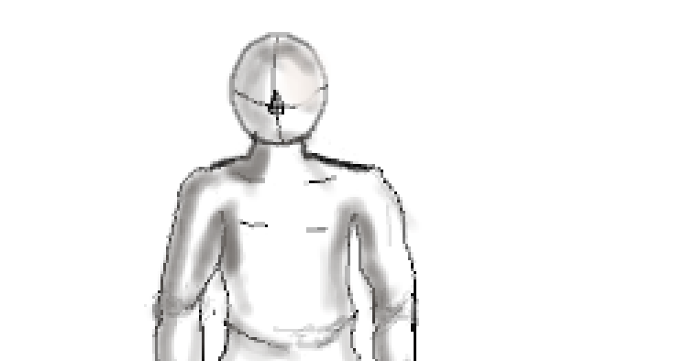

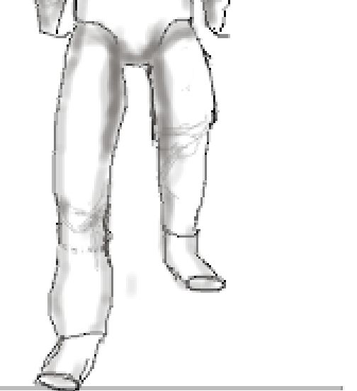

1. Click File 🡪 Export as…
2. Name the file BodyLinesWithShadows.png.

|  |
| --- |
| Q2. Upload the BodyLinesWithShadows.png file to Quiz#4.1 dropbox in E-Centennial. |
|  |

Quiz 2.1: Activity 3 – Head  
HEAD

This tutorial demonstrates how to draw a basic head in two layers. The head is a crucial and complicated part of the human anatomy as it is composed by various figures (eyes, nose, mouth etc).

Follow the steps below:

1. Click File 🡪 New…
2. Set the dimensions to 1200x800 and press OK.
3. Set the Grid to 10 Vertical and 10 Horizontal.
4. Draw a shape similar to the one below (try to create the two sides symettrical)

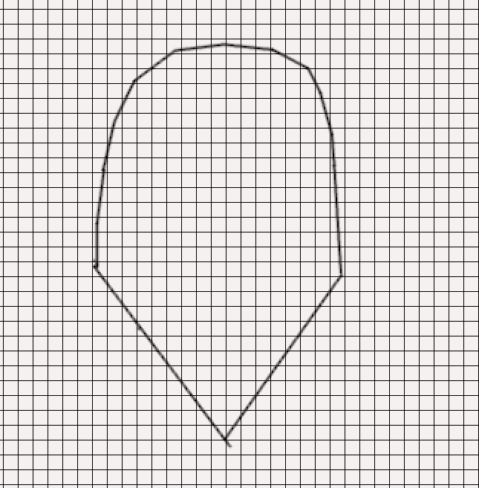

1. Add two guides (one Horizontal and one Vertical) in the middle of the Head.
2. Design an Eyebrow, at the left size of the head next to the Guide, as shown below:

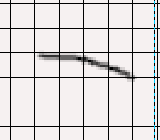

1. Click on the Rectangle select tool and select the Eyebrow.
2. Move it to the other side of the Head and click on the Flip too.
3. Select Horizontal and click on the Eyebrow.
4. Draw the Nose and the Lips as shown below:

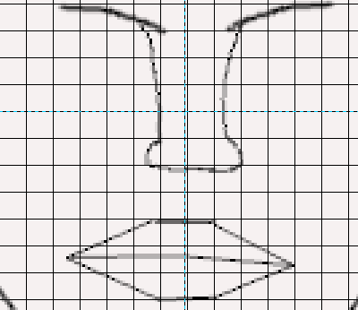

1. Under the Eyebrow draw an ellipse and then click Edit 🡪 Stroke Selection.
2. Set the Line to 1.0 and press OK.
3. Click on the Move tool.
4. Under the Move tool pick Selection.
5. Move the selection to the other side of the head.
6. Repeat steps 11 – 12.
7. The Head should look like this:

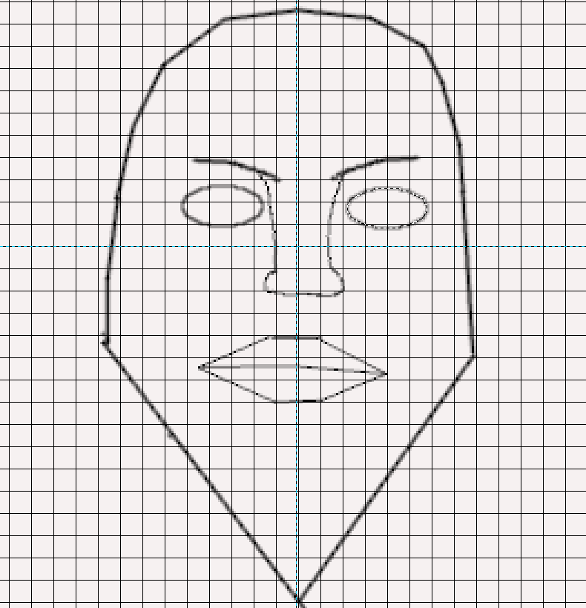

1. Based on the Triangle at the bottom of the Head design the character’s Chin.
2. Try to design similar to the image below:

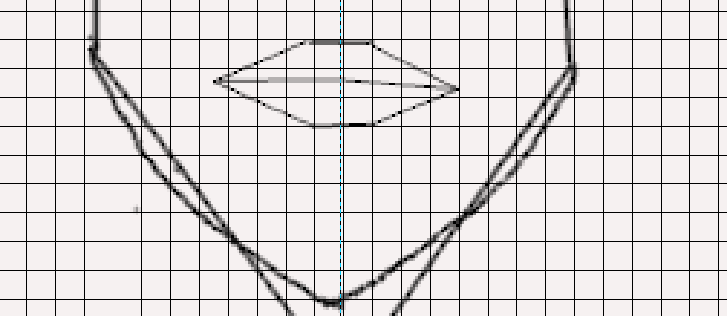

1. Add a new Layer and name it Head Layer.
2. Set the Background Layer’s Opacity to 30%.
3. Draw the Head as shown below:

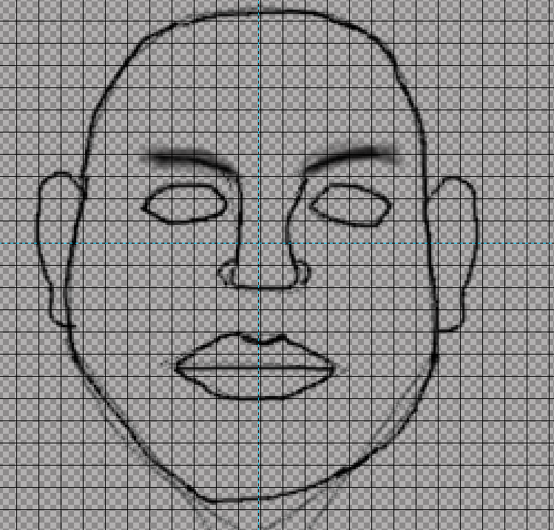

1. Export As Head.png

|  |
| --- |
| Q3. Upload the Head.png image on E-Centennial, Quiz#4.1 dropbox. |
|  |

# Quiz 1.2: Activity 4 – Eyes

Eyes

The eyes are complicated and challenging to design. It includes the eyelids, the pupil etc… Nevertheless, this tutorial demonstrates how to design a simple eye.

Follow the steps below:

1. Zoom in to the Head.
2. Set the Head Layer’s Opacity to 30%.
3. Delete the existing eye.
4. Add a new Layer and name it Eye Layer.
5. Work in the Eye Layer clicking on it.
6. Pick the Paintbrush tool.
7. Draw over the eye (from the Head layer) as shown below:

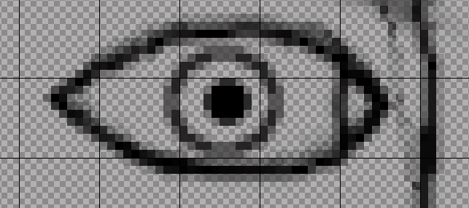

1. Draw the upper eye line as shown below with the Paintbrush tool at size 1.0.

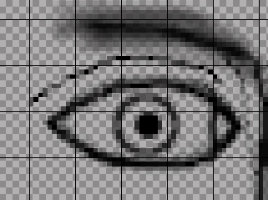

1. Click on the Pencil Tool, set the Size to 1.0 and the Opacity to 80%.
2. Draw the Eyelashes as shown below:

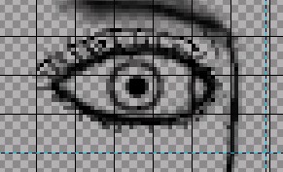

1. Add a new layer and name it Iris.
2. Pick the Ellipse Tool and draw over the Iris area.
3. Move it upwards to and cover a part with the eyelid.
4. Set the Background Color to Blue.
5. Click Edit 🡪 Fill with Background Color.
6. Pick the Eraser tool and delete the upper part of the eye (the part covered by the eyelid).
7. Fix the color by using the Eraser and the Paintbrush Tool.
8. Click on the Fuzzy Select Tool and pick the Iris outline area.
9. Click Edit 🡪 Stroke Selection.
10. Set the Line width to 0.8 and press OK.
11. The eye should look like the image below:

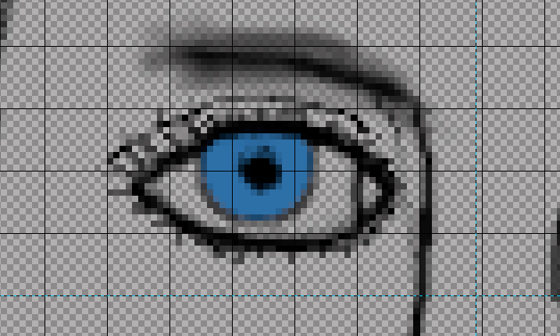

1. Select the Eye using the Fuzzy Select Tool and press Ctrl – C.
2. Press Ctrl – V.Move the eye to the right Side of the head.
3. Click on the Flip Tool and select Horizontal.Click on the Eye.
4. Repeat steps 22 – 26 for the Iris layer.
5. Export as Eye.png.

|  |
| --- |
| Q4. Upload the Eye.png image on E-Centennial, Quiz#4.1 dropbox. |
|  |

|  |
| --- |
| Q5. Apply all the techniques (Shadows, Lines, Head, Eyes) to the Ninja model and upload it to E-Centennial, Quiz#4.1 dropbox. |
|  |

Once you have submitted the assignment, your instructor will be able to view your submission and will grade the submission in the near future.