# **Heritage Treasures: An In-Depth Analysis of UNESCO World Heritage Sites (2019)**

## **Project Overview**

This project explores the UNESCO World Heritage Sites dataset using Tableau to create insightful visualizations. The analysis focuses on trends, distributions, and risks associated with these heritage sites. By leveraging data visualization, the project aims to assist stakeholders in heritage conservation and decision-making.

## **Project Deliverables**

1. **Data Collection & Preparation**
   * Dataset acquired from Kaggle: [UNESCO World Heritage Sites Dataset](https://www.kaggle.com/datasets/ujwalkandi/unesco-world-heritage-sites/data)
   * Connected dataset to Tableau
   * Cleaned missing values and prepared the dataset for analysis
2. **Data Visualizations**
   * **Heritage Sites by Country** (Tree Map)
   * **Heritage Sites at Risk** (Pie Chart)
   * **Regional Inscription Trends** (Line Chart)
   * **Countries per Region**
   * **Top 10 Regions by Area**
   * **Regions by Heritage Ended**
   * **Top 10 Danger Sites Prone to Extinction**
   * **Year Forecasting of Heritage Sites**
   * **Categories by Sites Count**
   * **Site Count per Region**
   * **Analysis of Danger Sites and Area of Heritages**
3. **Dashboard Development**
   * **Dashboard 1: UNESCO World Heritage Site Overview**
   * Designed an interactive and responsive Tableau dashboard
   * Applied filters for dynamic analysis (e.g., filtering by regions like Latin America & Europe)
4. **Storytelling with Data**
   * Developed a multi-scene Tableau Story to present key insights
   * Created a logical flow of analysis to convey meaningful information
5. **Performance Testing**
   * Checked data load performance
   * Applied filters for efficiency
   * Optimized calculation fields and visualizations
6. **Web Integration**
   * Embedded the Tableau dashboard in a Flask web application (if applicable)
   * Published the dashboard on **Tableau Public**
7. **Project Documentation & Demonstration**
   * Documented step-by-step project development
   * Captured and added visualization screenshots
   * Created an optional project demonstration video

## **Data Cleaning & Preprocessing**

### **Handling Missing Values**

* **date_end** → Replaced missing values with **“Active”** if the site is still listed
* **danger_list** → Replaced missing values with **“Not in Danger”**
* **area_hectares** → Filled missing values using the **median area**
* **iso_code, udnp_code** → Replaced missing values with **“Unknown”**

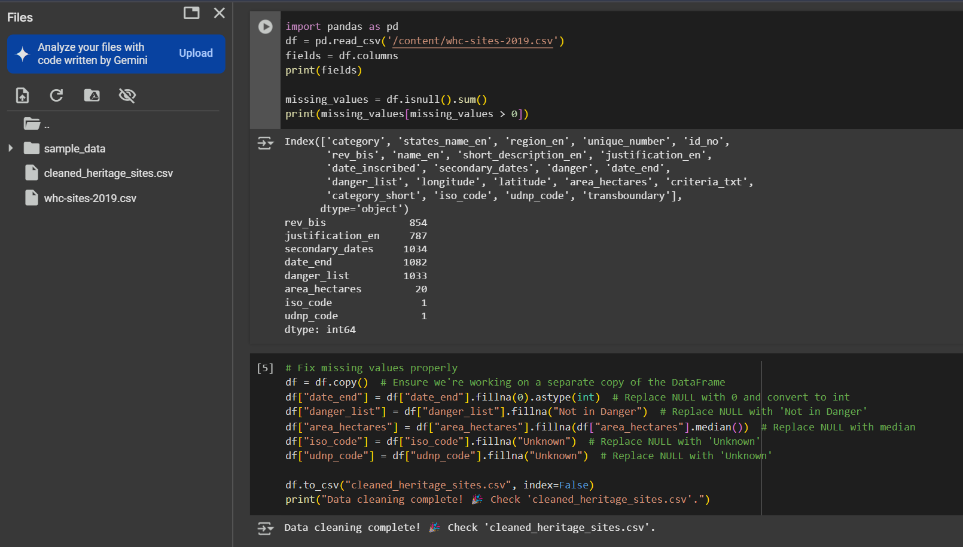

## **Results & Insights**

* Some countries have significantly more heritage sites than others.
* Certain regions are more prone to heritage sites being endangered.
* Forecasting suggests that more sites are likely to be inscribed in future years.
* Specific categories (Cultural, Natural, Mixed) show different distribution patter

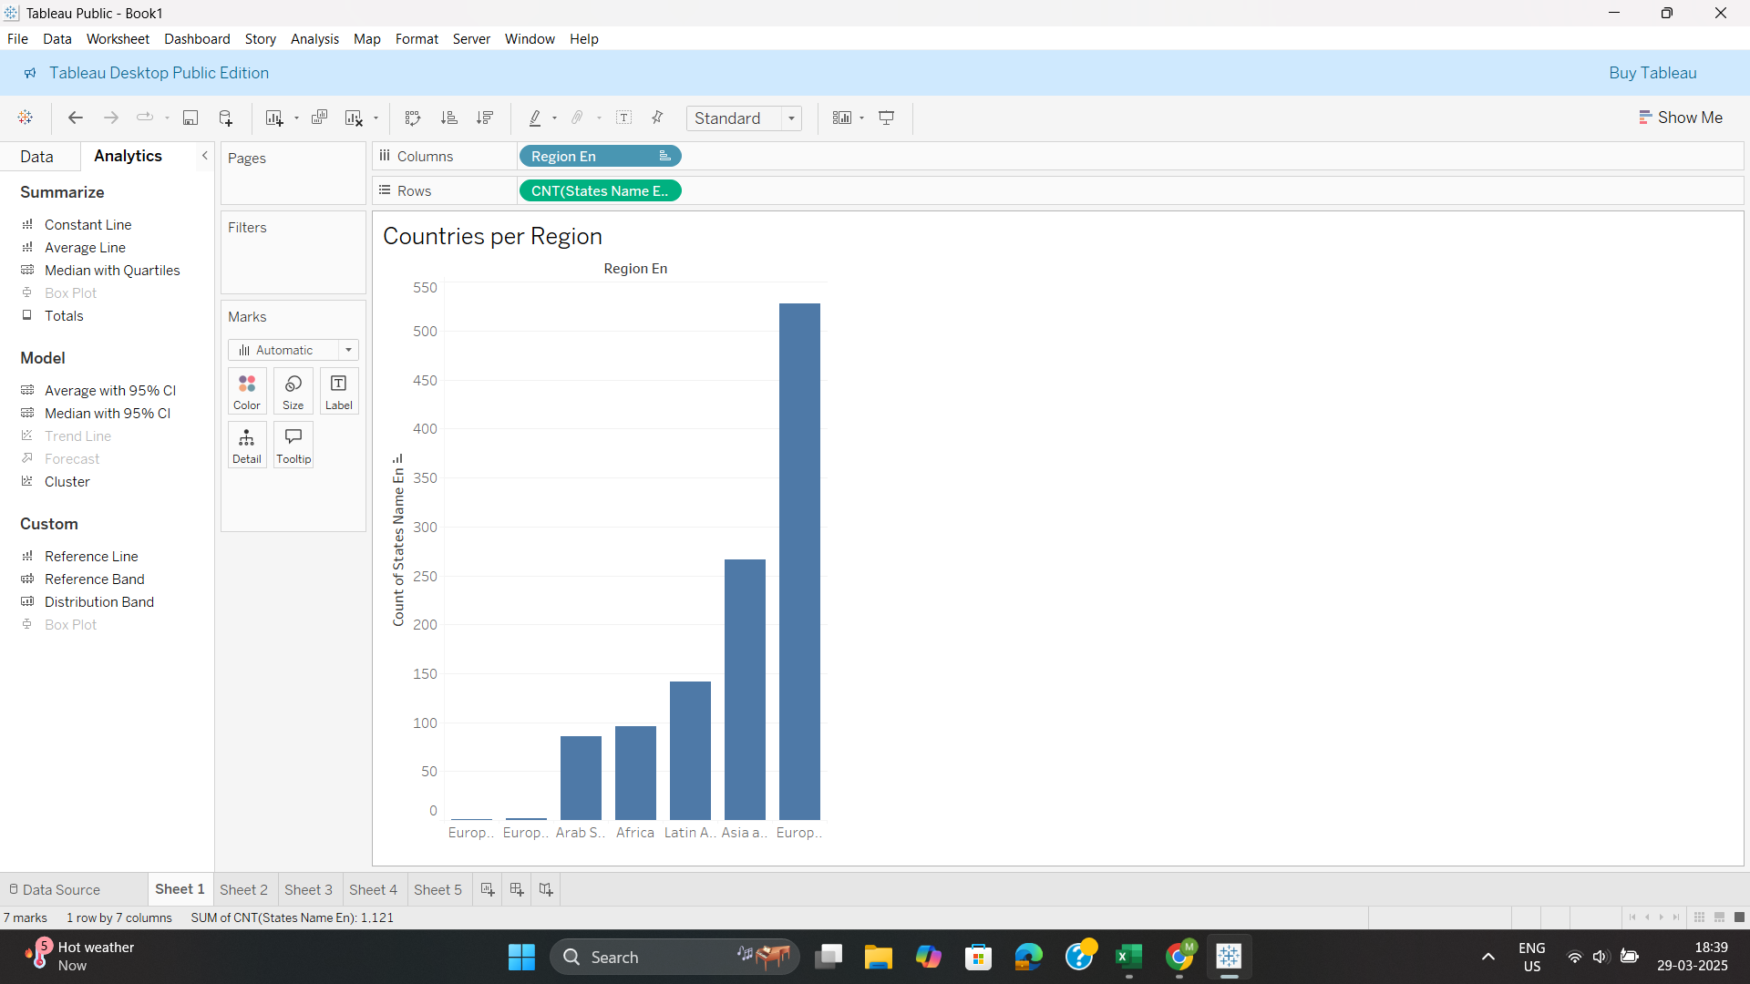

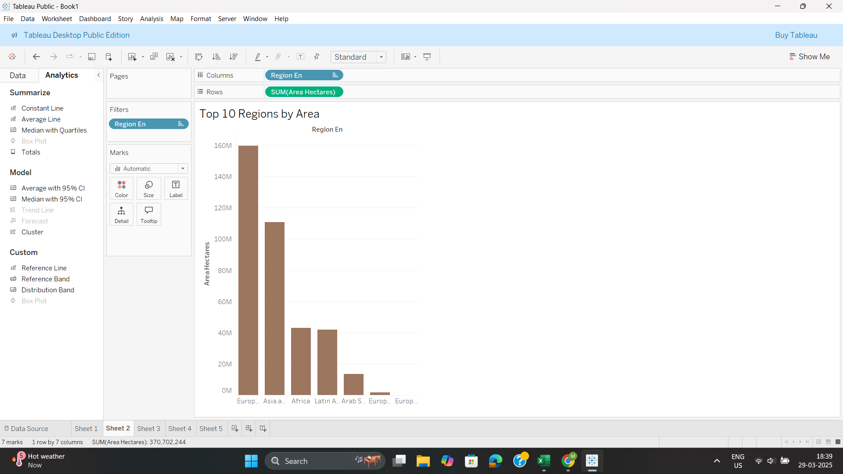

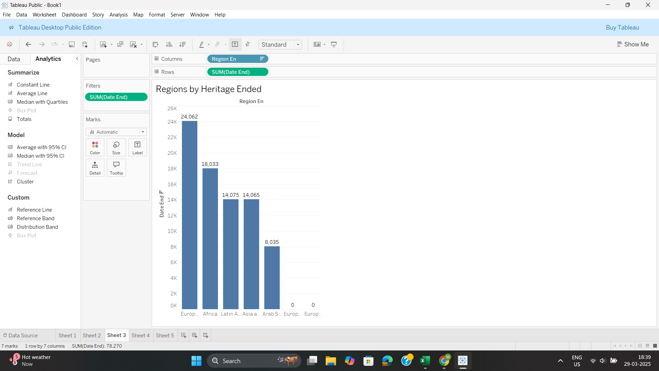

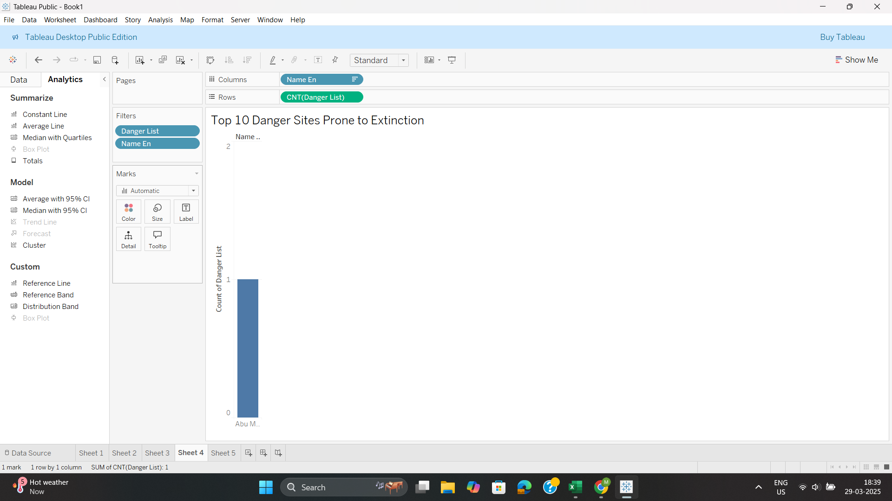

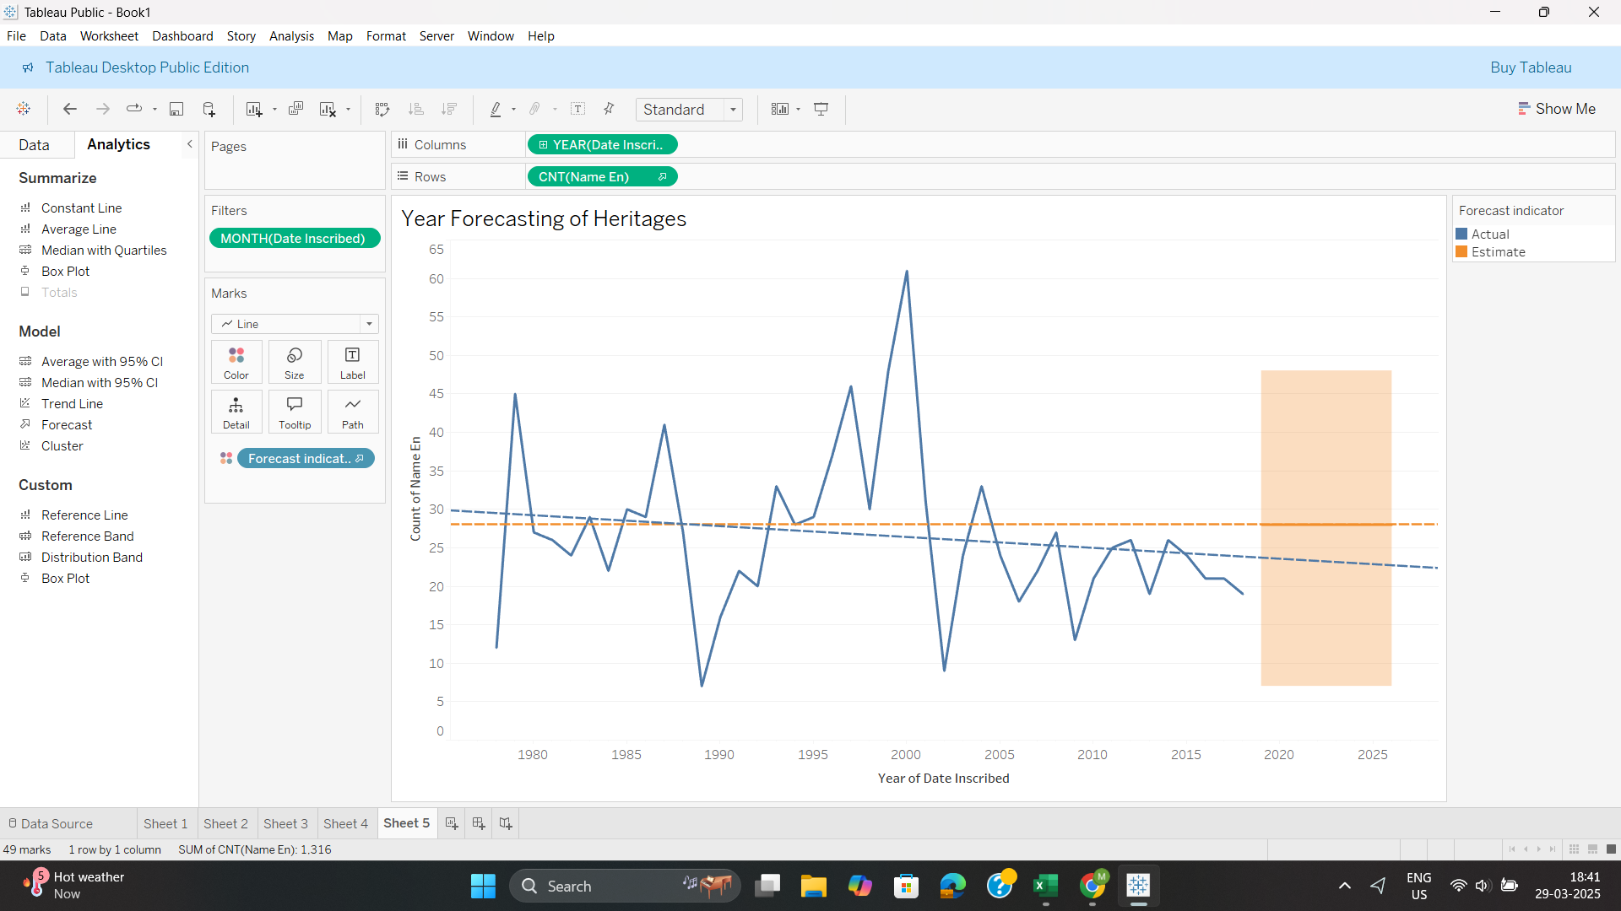

## **Project Repository**

All project files, including Tableau dashboards, datasets, and reports, are uploaded to GitHub:  
**GitHub Repository:**<https://github.com/pindimahii/tableau-project>

## **Conclusion**

This project successfully utilized Tableau to analyze and visualize UNESCO World Heritage Sites data. It provides valuable insights into site distribution, endangerment risks, and heritage trends, supporting better preservation efforts.

**Prepared By:**

**Team ID :** LTVIP2025TMID20115

**Team Size :** 4

**Team Leader :** Pindi Maheswari Devi (21481A05H2)

**Team member :** Nancharla Akhila (21481A05E3)

**Team member :** Shaik Asif (22485A4207)

**Team member :** Remalli Divya Teja (21481A05J4)