Q 1. Write code for build in data types in python.

Ans.

(i) Numeric Types :-

# Integer

x = 42

print(type(x))

# Float

y = 3.14

print(round(y))

# Complex

z = 2 + 3j

print(z.real)

print(z.imag)

Output:-

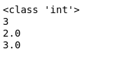

(ii) Sequence Types :-

# String Methods

s = "Python"

print(s.upper())

print(s.lower()) #

print(s.startswith("Py"))

print(s.replace("Py", "Fy"))

print()

# List Methods:

lst = [1, 2, 3]

lst.append(4)

lst.remove(2)

lst.reverse()

print(lst)

print()

# Tuple

t = (1, 2, 3, 1)

print(t.count(3))

print(t.index(1))

print()

# Range

r = range(1, 10, 3)

print(list(r))

Output :-

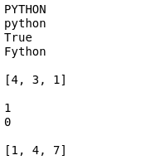

(iii) Mapping Type :-

d = {"a": 26, "b": 25}

print(d.keys())

print(d.values())

print(d.get("a"))

d.update({"c": 24})

print(d)

Output :-

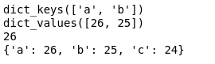

(iv) Set Type :-

s = {1, 2, 3}

s.add(4)

s.remove(2)

print(s.union({5, 6}))

print(s.intersection({3, 4, 5}))

fs = frozenset([1, 2, 3])

Output :-



(v) Boolean Type :-

a = True

b = False

print(a and b)

print(a or b)

print(not a)

Output :-

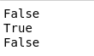

(vi) Binary Types :-

b = b"Python"

print(b.decode())

ba = bytearray(b)

ba[0] = 80

print(ba)

print(type(b))

print(type(ba))

Output :-

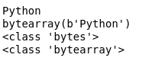

(vii) None Type :-

x = None

if x is None:

print("x has no value")

Output :-



Q 2. Write code for operators in python.

Ans.  (i) Arithmetic operators :-

a = 7

b = 2

# addition

print('Sum: ', a + b)

# subtraction

print('Subtraction: ', a - b)

# multiplication

print('Multiplication: ', a * b)

# division

print('Division: ', a / b)

# floor division

print('Floor Division: ', a // b)

# modulo

print('Modulo: ', a % b)

# a to the power b

print('Power: ', a ** b)

Output :-

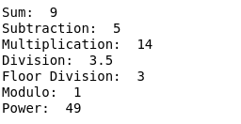

(ii) Assignment operator :-

a = 10

b = 5

# assign the sum of a and b to a

a += b

# assign the multiply of a and b to a

a *= b

# assign the sub of a and b to a

a -= b

# assign the divison of a and b to a

a /= b

# assign the modulus of a and b to a

a %= b

# print the final value of a

print(a)

Output :-



(iii) Comparison operators :-

a = 5

b = 2

# equal to operator

print('a == b =', a == b)

# not equal to operator

print('a != b =', a != b)

# greater than operator

print('a > b =', a > b)

# less than operator

print('a < b =', a < b)

# greater than or equal to operator

print('a >= b =', a >= b)

# less than or equal to operator

print('a <= b =', a <= b)

Output :-

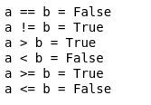

(iv) Logical Operators :-

# logical AND

print(True and True)

print(True and False)

# logical OR

print(True or False)

# logical NOT

print(not True)

Output :-

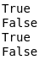

(v) Bitwise operators :-

x = 12

y = 5

# Returns the result of bitwise AND operation.

print(f'x & y : {x & y}')

# Returns the result of bitwise OR operation.

print(f'x | y : {x | y}')

# Returns the bitwise NOT of x.

print(f'~x : {~x}')

# Returns the result of bitwise XOR operation.

print(f'x ^ y : {x ^ y}')

# Left shifts the bits of x by y positions, and returns the result.

print(f'x << y : {x << y}')

# Right shifts the bits of x by y positions, and returns the result.

print(f'x >> y : {x >> y}')

Output :-

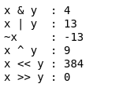

(vi) Special operators :-

Identity operator :-

x1 = 5

y1 = 5

x2 = 'Hello'

y2 = 'Hello'

x3 = [1,2,3]

y3 = [1,2,3]

print(x1 is not y2)

print(x2 is y2)

print(x3 is y3)

Output :-

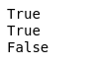

(vii) Membership operator :-

message = 'Hello world'

dict1 = {1:'a', 2:'b'}

print('H' in message)

print('hello' not in message)

print(1 in dict1)

print('a' in dict1)

Output :-

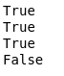

Q 3. Write code for conditional statements in python.

Ans.  (i) If statement :-

x=10

if x > 5:

print("x is greather than 5")

Output :-



(ii) If-Else statement :-

x = int(input("Enter the number for checking odd or even"))

if x % 2 == 0:

print("x is even")

else :

print("x is odd")

Output :-



(iii) If-Elif-Else statement :-

x = 0

if x > 0:

print(" x is positive")

elif x < 0:

print(" x is negative")

else:

print(" x is zero")

Output :-



(iv) Nested if statement :-

x = 15

if x > 0:

if x % 3 == 0:

print("x is a positive number divisible by 3")

Output :-



(v) Ternary statement :-

age = 20

s = "Adult" if age >= 18 else "Minor"

print(s)

Output :-



Q 4. Write code for loop control statements in python.

Ans.  (i) for loop :-

# Example of a for loop iterating over a list

fruits = ['apple', 'banana', 'cherry']

for fruit in fruits:

print(fruit)

Output :-

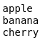

(ii) while loop :-

number = 1

while number <= 3:

print(number)

number = number + 1

Output :-



Q 5. Write code for user defined function module and package in python.

Ans.  (i) User defined module :-

# First creating a module named math_operations.py

def add(a, b):

return a + b

def subtract(a, b):

return a - b

def multiply(a, b):

return a * b

def divide(a, b):

if b == 0:

raise ZeroDivisionError("Cannot divide by zero")

return a / b

# Import the function module in another file

from math_operations import add, subtract, multiply, divide

# Use the functions in the module

result = add(5, 4)

print(result)

result = subtract(5, 3)

print(result)

result = multiply(5, 3)

print(result)

result = divide(10, 2)

print(result)

Output :-



(ii) User defined package :-

Q 6. Write code for handling a csv file in python.

Ans. # Creating a cvs file

import csv

with open("example.csv", "w",newline="") as file:

write = csv.writer(file)

write.writerow(["Name","Age","City"])

write.writerow(["Rahul","25","Neemrana"])

write.writerow(["Vinay","28","New york"])

write.writerow(["Khali Rahul","29","Majri"])

print("example.csv file successfully!")

with open("example.csv","r") as file:

reader = csv.reader(file)

for row in reader:

print(row)

# Appending a csv file

import csv

with open("example.csv","a", newline="") as file:

write = csv.writer(file)

write.writerow(["Atul","23","Neemrana"])

write.writerow(["Bhara Rahul","29","Ransim Majri"])

print("example.csv file created successfully!")

with open("example.csv","r") as file:

reader = csv.reader(file)

for row in reader:

print(row)

# Printing a csv file using pandas

import pandas as pd

df = pd.read_csv("output.csv")

print(df)

Output :-

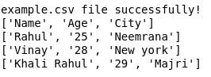

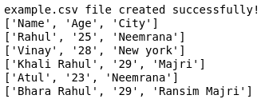

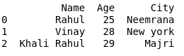

Q 7. Write a python code for doing data pre-processing task on a dataset.

Ans. import pandas as pd

import numpy as np

from scipy import stats

df = pd.read_csv("/home/vinayyadav/Downloads/results_with_crew.csv", low_memory = False)

print(df.info())

print("Initial shape: ",df.shape)

print(df.head(2))

print(df.tail(2))

print("Initial Class distribution: ",df['rank'].value_counts())

df.replace('-',np.nan,inplace=True)

before_drop_shape = df.shape

df.dropna(inplace=True)

print("Shape after dropping NaNs : ", df.shape, "Dropped rows : ", before_drop_shape[0]- df.shape[0])

num_feature = 'averageRating'

df['z_score'] = np.abs(stats.zscore(df[num_feature]))

outliers_z = df[df['z_score']>3]

print("outliers detected using z-score : ", outliers_z.shape[0])

df = df[df['z_score']<=3]

df.drop(columns=['z_score'],inplace=True)

print("Shape after removing Z-score outliers : ",df.shape)

Q1 = df[num_feature].quantile(0.25)

Q3 = df[num_feature].quantile(0.75)

IQR = Q3- Q1

lower_bound = Q1 -1.5 * IQR

upper_bound = Q3 + 1.5 * IQR

outliers_iqr = df[(df[num_feature] < lower_bound) | (df[num_feature] > upper_bound)]

print("Outliers detected using IQR: " , outliers_iqr.shape[0])

df = df[(df[num_feature] >= lower_bound) & (df[num_feature] <= upper_bound)]

print("Shape after removing IQR outliers : " , outliers_iqr.shape)

Output :-

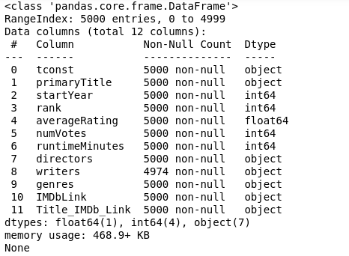



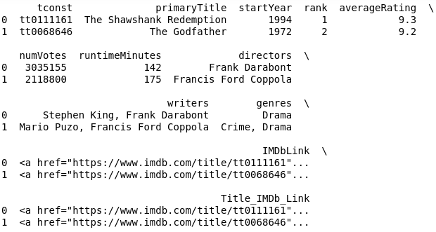

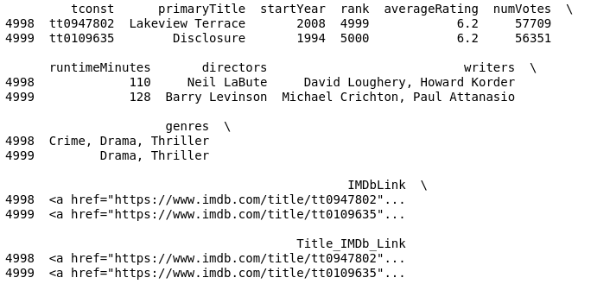

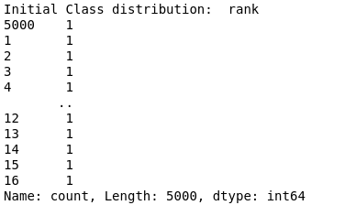







Q 8. Write code for basic html tag.

Ans.

<!DOCTYPE html>

<html>

<head>

<title>Basic HTML Tags</title>

</head>

<body>

<!-- Headings -->

<h1>Heading 1</h1>

<h2>Heading 2</h2>

<h3>Heading 3</h3>

<h4>Heading 4</h4>

<h5>Heading 5</h5>

<h6>Heading 6</h6>

<!-- Paragraphs -->

<p>This is a paragraph of text.</p>

<p>This is another paragraph of text.</p>

<!-- Bold and Italic Text -->

<b>Bold text</b>

<i>Italic text</i>

<strong>Strong emphasis</strong>

<em>Emphasis</em>

<!-- Links -->

<a href="https://www.example.com">Visit example.com</a>

<a href="https://www.google.com">Visit Google</a>

<!-- Images -->

<img src="image.png" alt="An image" width="10%">

<!-- Lists -->

<h2>Unordered List</h2>

<ul>

<li>Item 1</li>

<li>Item 2</li>

<li>Item 3</li>

</ul>

<h2>Ordered List</h2>

<ol>

<li>Item 1</li>

<li>Item 2</li>

<li>Item 3</li>

</ol>

</body>

</html>

Output :-

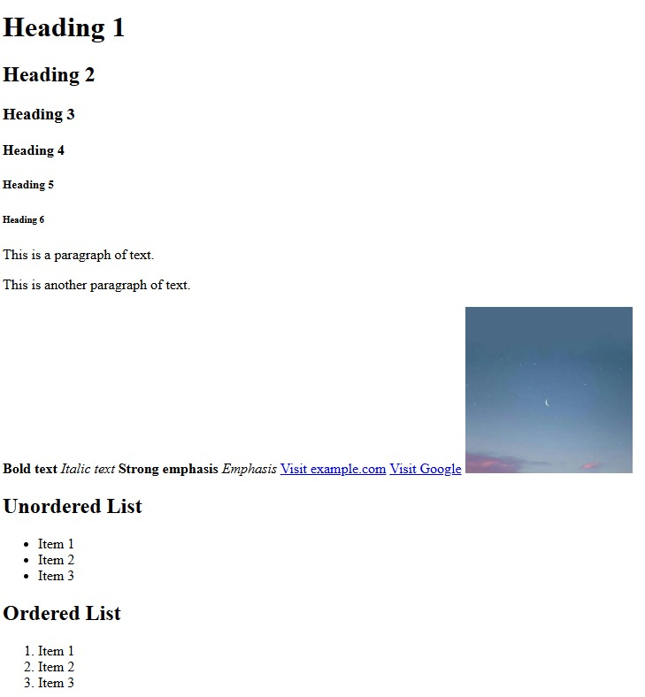

Q 9. Write a code for creating college timetable using table tag.

Ans.

<!DOCTYPE html>

<html>

<head>

<title>timetable</title>

</head>

<body>

<h1 align="center">Timetable IV<sup>th</sup> sem</h1>

<table border="1" align="center" width="90%" cellpadding="10px" cellspacing="3px" bgcolor="White" bordercolor="black">

<tr>

<th></th>

<th></th>

<th>9:30-10:25</th>

<th>cr</th>

<th>10:30-11:25</th>

<th>cr</th>

<th>11:35-12:30</th>

<th>cr</th>

<th>12:30-1:12</th>

<th>1:20-2:15</th>

<th>cr</th>

<th>2:20-3:15</th>

<th>cr</th>

<th>3:20-4:15</th>

<th>cr</th>

</tr>

<tr>

<td>Monday</td>

<td rowspan="5">B.Sc CS</td>

<td>Library</td>

<td></td>

<td>CSC 404<br>Mr.NS</td>

<td align="center">7</td>

<td>AEC 401 <br>Dr. BK</td>

<td align="center">6</td>

<td rowspan="5"> Lunch</td>

<td>CSC 401 <br> Mr.NS</td>

<td align="center">2</td>

<td>Totural</td>

<td></td>

<td>CSC 403 <br> Dr. DH</td>

<td align="center">1</td>

</tr>

<tr>

<td>Tuesday</td>

<td>Library</td>

<td></td>

<td>CSC 402<br>Mr.NS</td>

<td align="center">7</td>

<td>VAC 401 <br>Dr. NP</td>

<td align="center">6</td>

<td>CSC 405 <br> DR.AB</td>

<td align="center">7</td>

<td colspan="3">CSC 403 (Practical) <br>Mr.NS </td>

<td>Comp.lab</td>

</tr>

<tr>

<td>Wednesday</td>

<td colspan="3">CSC 404 (Practical) <br>Mr.NS </td>

<td>Comp.lab</td>

<td>AEC 401 <br>Dr. BK</td>

<td align="center">6</td>

<td>CSC 405<br>Mr.NS</td>

<td align="center">6</td>

<td>CSC 402<br>Mr.NS</td>

<td align="center">6</td>

<td>Seminor</td>

<td></td>

</tr>

<tr>

<td>Thursday</td>

<td>CSC 404<br>Mr.NS</td>

<td align="center">7</td>

<td>CSC 405 <br> (DR.AB)</td>

<td align="center">7</td>

<td>VAC 401 <br>Dr. NP</td>

<td align="center">6</td>

<td colspan="3">CSC 402 (Practical) <br>Mr.NS </td>

<td>Comp.lab</td>

<td>CSC 403 <br> Dr. DH</td>

<td align="center">7</td>

</tr>

<tr>

<td>Friday</td>

<td colspan="3">CSC 405 (Practical) <br>Dr. AB </td>

<td>Comp.lab</td>

<td>Library</td>

<td></td>

<td>CSC 403 <br> Dr. DH</td>

<td align="center">1</td>

<td colspan="3">CSC 401 (Practical) <br>Mr.NS </td>

<td>Comp.lab</td>

</tr>

</table>

</body>

</html>

Output :-

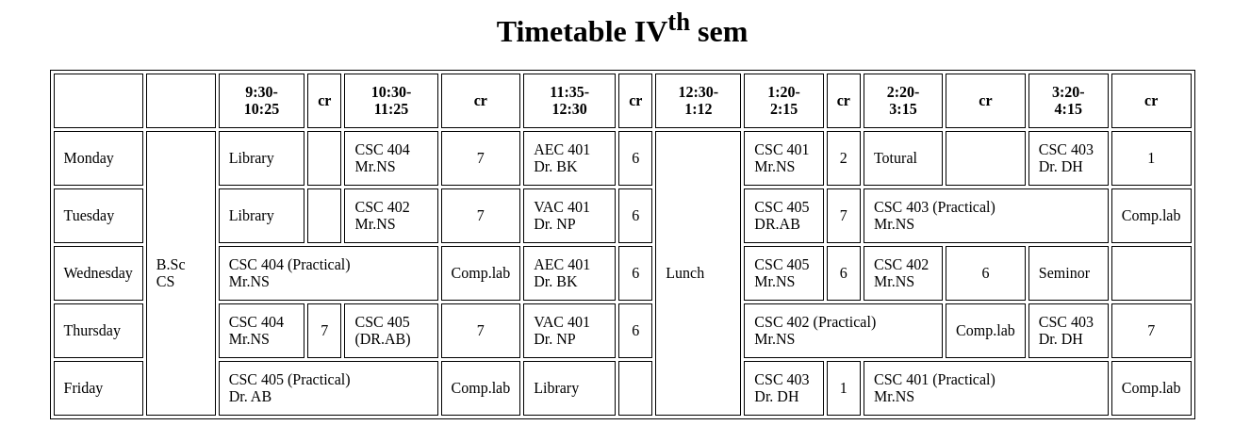

Q 10. Write a code for creating college website using table tag.

Ans.

<!DOCTYPE html>

<html>

<head>

<title>College website using table tag</title>

</head>

<body>

<table width="90%" align="center" border="1" cellspacing="0" cellpadding="10px">

<tr align="center" bgcolor="orange">

<td align="center" colspan="2">

<font size="7" color="white">Tribhuvan College</font>

</td>

</tr>

<tr height="80px" align="center">

<td colspan="2" bgcolor="white">

<a href="#" style="margin: 15px;">Home</a>

<a href="#" style="margin: 15px;">About us</a>

<a href="#" style="margin: 15px;">Courses</a>

<a href="#" style="margin: 15px;">Exam date</a>

<a href="#" style="margin: 15px;">Result</a>

<a href="#" style="margin: 15px;">Gallery</a>

</td>

</tr>

<tr bgcolor="green" height="80px">

<td colspan="2">

<marquee><i><b>

<font color="white">Welcome to Tribhuvan College</font>

</i></b></marquee>

</td>

</tr>

<tr height="400px" bgcolor="gray">

<td width="70%" valign="top">

<h1>Welcome to Tribhuvan College page</h1>

<hr color="white"/>

<img src="tribhuvan.jpg" width="120px" height="150px" align="left" hspace="30px" border="3"/>

<font color="white">

<p align="justify">

Tribhuvan College, Nalanda University Centre is situated in Neemrana, Rajasthan. The Centre has been established in a public-private-partnership and offers multidisciplinary Undergraduate programs of Nalanda University Tribhuvan College encourages and promotes a research paradigm where experiential learning and innovative thoughts are encouraged. The College aims to be an interdisciplinary institution of higher learning incorporating strong regional, national, and international linkages to inculcate a high degree of specialization.

</p>

<p align="justify">

Nalanda University, is an institution of national importance, like IITs, NITs, IIMs, AIIMS etc. by the Ministry of Education, Govt. of India. Click to view Nalanda University mentioned at S.No 152 https://www.education.gov.in/en/institutions-national-importance.

</p>

</font>

</td>

<td width="30%" valign="top" bgcolor="skyblue">

<h2>Our Members</h2>

<hr color="red"/>

<marquee direction="up" height="300px">

<center>

<img src="profile.png" width="120px"/><br/><b>Director</b><br/><br/>

<img src="profile1.png" width="120px"/><br/><b>Manager</b><br/><br/>

</center>

</marquee>

</td>

</tr>

<tr height="50px" bgcolor="orange">

<td colspan="2" align="center">

Copyright &copy; 2025 All Rights Resevered

</td>

</tr>

</table>

</body>

</html>

Output :-



Q 11. Write code for creating a registration form in html.

Ans.

<!DOCTYPE html>

<html>

<head>

<title>Regestration form using table </title>

</head>

<body leftmargin="200px" bgcolor="#99ee90">

<center><h3>APLICATION FORM</h3></center>

<form action="submit_form.php" method="post" enctype="multipart/form-data">

<fieldset>

<legend> Personal details</legend>

<table width="100%" cellpadding="10px">

<tr>

<td>Applicant's full Name</td>

<td>

<select>

<option>---select---</option>

<option>Mr.</option>

<option>Mr.s</option>

<option>Others</option>

</select>

<input type="text" size="20" placeholder="Name"/>

</td>

<td>Care of</td>

<td><lable>Parents</lable><input type="radio" name="care" checked/><lable>Gurdian</lable><input type="radio" name="care" checked/></td>

</tr>

<tr>

<td>Father's Name</td>

<td>

<select disabled>

<option>Mr.</option>

</select>

<input type="text" size="20" placeholder="Father's Name"/>

</td>

<td>Mother's Name</td>

<td>

<select disabled>

<option>Mr.s</option>

</select>

<input type="text" size="20" placeholder="Mother's Name"/>

</td>

</tr>

<tr>

<td>Gender</td>

<td>

<label>Male</label><input type="radio" name="Gender"/>

<label>Female</label><input type="radio" name="Gender"/>

<label>Other</label><input type="radio" name="Gender"/>

</td>

<td>Date of Birth</td>

<td>

<input type="date"/>

</td>

</tr>

<tr>

<td>Marital status</td>

<td>

<select>

<option>---select---</option>

<option>Single</option>

<option>Marrige</option>

<option>Divorced</option>

<option>Widowed</option>

</select>

</td>

<td>Cast</td>

<td>

<select>

<option>---select---</option>

<option>General</option>

<option>Obc</option>

<option>Sc</option>

<option>St</option>

</select>

</td>

</tr>

<tr>

<td>Handicapped</td>

<td><label>No<input type="radio" name="Handicapped" checked></label><label>yes<input type="radio" name="Handicapped" checked></label></td>

<td>ex-serviceman</td>

<td><label>No<input type="radio" name="ex-serviceman" checked></label><label>yes<input type="radio" name="ex-serviceman" checked></label></td>

</tr>

<tr>

<td>EWS</td>

<td><label>No<input type="radio" name="EWS" checked></label><label>yes<input type="radio" name="EWS" checked></label></td>

<td>Religion</td>

<td>

<select>

<option>---select---</option>

<option>Muslim</option>

<option>Hindu</option>

<option>Jain</option>

<option>Charistianity</option>

</select>

</td>

</tr>

</table>

</fieldset>

<fieldset>

<legend>Contect Details</legend>

<table width="100%" cellpading="10px">

<tr>

<td>Mobile Number</td>

<td><input type="tel" placeholder="+91,0000000000"/></td>

<td>Email Id</td>

<td><input type="email" placeholder="abc@gmail.com"/></td>

</tr>

<tr>

<td>Address line 1</td>

<td><input type="text" placeholder="Address"/></td>

<td>Address line 2</td>

<td><input type="text" placeholder="Address"/></td>

</tr>

<tr>

<td>City</td>

<td><input type="text" placeholder="City"/></td>

<td>State</td>

<td>

<select>

<option>---select---</option>

<option >Andhra Pradesh</option>

<option >Arunachal Pradesh</option>

<option >Assam</option>

<option >Bihar</option>

<option >Chhattisgarh</option>

<option >Goa</option>

<option >Gujarat</option>

<option >Haryana</option>

<option >Himachal Pradesh</option>

<option >Jharkhand</option>

<option >Karnataka</option>

<option >Kerala</option>

<option >Madhya Pradesh</option>

<option >Maharashtra</option>

<option >Manipur</option>

<option >Meghalaya</option>

<option >Mizoram</option>

<option >Nagaland</option>

<option >Odisha</option>

<option >Punjab</option>

<option >Rajasthan</option>

<option >Sikkim</option>

<option >Tamil Nadu</option>

<option >Telangana</option>

<option >Tripura</option>

<option >Uttar Pradesh</option>

<option >Uttarakhand</option>

<option >West Bengal</option>

</select>

</td>

</tr>

<tr>

<td>Pincode</td>

<td><input type="text" placeholder="Zip code"/></td>

</tr>

</table>

</fieldset>

<fieldset>

<legend>Qualification Details</legend>

<table width="100%" cellpading="10px">

<tr>

<th>Sr no.</th>

<th>Qualification</th>

<th>Bord/University</th>

<th>Passing year</th>

<th>Max marks</th>

<th>Marks obtain</th>

<th>Percentage</th>

</tr>

<tr>

<td>1</td>

<td>

<select>

<option >---select---</option>

<option >10th</option>

<option >12th</option>

<option >Graduate</option>

<option >Post Graduate</option>

</select>

</td>

<td>

<input type="text"/>

</td>

<td>

<input type="number" min="1990" max="2022"/>

</td>

<td>

<input type="number" min="0" max="10000"/>

</td>

<td>

<input type="number" min="0" max="10000"/>

</td>

<td>

<input type="number" min="0" max="100"/>

</td>

</tr>

<tr>

<td>2</td>

<td>

<select>

<option >---select---</option>

<option >10th</option>

<option >12th</option>

<option >Graduate</option>

<option >Post Graduate</option>

</select>

</td>

<td>

<input type="text"/>

</td>

<td>

<input type="number" min="1990" max="2022"/>

</td>

<td>

<input type="number" min="0" max="10000"/>

</td>

<td>

<input type="number" min="0" max="10000"/>

</td>

<td>

<input type="number" min="0" max="100"/>

</td>

</tr>

<tr>

<td>3</td>

<td>

<select>

<option >---select---</option>

<option >10th</option>

<option >12th</option>

<option >Graduate</option>

<option >Post Graduate</option>

</select>

</td>

<td>

<input type="text"/>

</td>

<td>

<input type="number" min="1990" max="2022"/>

</td>

<td>

<input type="number" min="0" max="10000"/>

</td>

<td>

<input type="number" min="0" max="10000"/>

</td>

<td>

<input type="number" min="0" max="100"/>

</td>

</tr>

<tr>

<td>4</td>

<td>

<select>

<option >---select---</option>

<option >10th</option>

<option >12th</option>

<option >Graduate</option>

<option >Post Graduate</option>

</select>

</td>

<td>

<input type="text"/>

</td>

<td>

<input type="number" min="1990" max="2022"/>

</td>

<td>

<input type="number" min="0" max="10000"/>

</td>

<td>

<input type="number" min="0" max="10000"/>

</td>

<td>

<input type="number" min="0" max="100"/>

</td>

</tr>

<tr>

<td>5</td>

<td>

<select>

<option >---select---</option>

<option >10th</option>

<option >12th</option>

<option >Graduate</option>

<option >Post Graduate</option>

</select>

</td>

<td>

<input type="text"/>

</td>

<td>

<input type="number" min="1990" max="2022"/>

</td>

<td>

<input type="number" min="0" max="10000"/>

</td>

<td>

<input type="number" min="0" max="10000"/>

</td>

<td>

<input type="number" min="0" max="100"/>

</td>

</tr>

</table>

</fieldset>

<fieldset>

<legend>Language knowledge</legend>

<table width="100%">

<tr>

<td>Language</td>

<td>Reading</td>

<td>Writing</td>

<td>Spoken</td>

</tr>

<tr>

<td>Hindi</td>

<td><input type="checkbox"/></td>

<td><input type="checkbox"/></td>

<td><input type="checkbox"/></td>

</tr>

<tr>

<td>English</td>

<td><input type="checkbox"/></td>

<td><input type="checkbox"/></td>

<td><input type="checkbox"/></td>

</tr>

</table>

</fieldset>

<fieldset>

<legend>Identifiction Details</legend>

<table>

<tr>

<td>Aadhar Card</td>

<td><input type="text" maxlength="12" placeholder="XXXX-XXXX-XXXX"/></td>

<td>Pan Card</td>

<td><input type="text" maxlength="9" placeholder="XXXXXXXXX"/></td>

</tr>

<tr>

<td>Uplode Photo</td>

<td><input type="file"/></td>

<td>Uplode Signature</td>

<td><input type="file"/></td>

</tr>

</table>

</fieldset>

<fieldset>

<table width="100%" cellpading="10px">

<th>

<button>Back</button>

<button>Submit</button>

</th>

</table>

</fieldset>

</form>

</body>

</html>

Output :-

