The Solution to multiple runway problem:

---------------------------------------------------

The solution is similar to that of single runway but in this case , more runways so things become quite faster and more number of planes in a given interval of time. Planes do still land in a sequential manner. Like previously we were maintaining a gap to avoid collision between 2 planes back to back on a single runway ,

Now we also maintain a gap between 2 planes on 2 different runways so as to avoid collision sideways.

The interval for this gap can be similar to that of the gap on single runways. Time complexity will also increase as we now also have to assign planes to all of these runways and thus create a new schedule.

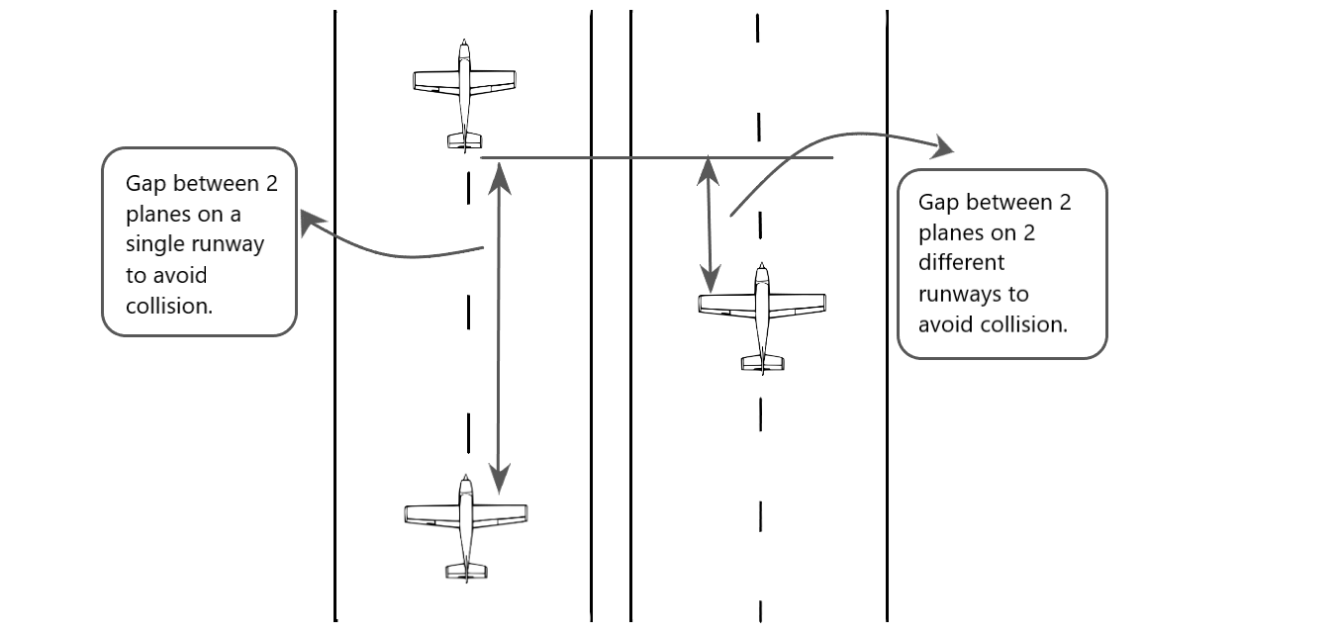

Diagram To display collision gap in single runway and multiple runway.