By-Anmol Gomra, Shubham Nimesh

**BANK MANAGEMENT SYSTEM**

**Aim: -** Define Problem statement and Project scope of Bank Management System.

**Theory**: This system provides the basic services to manage bank accounts at a bank. Bank has many branches, each of which has an address and branch number. A client opens accounts at a branch. Each account is uniquely identified by an account number; it has a balance and a credit or overdraft limit. There are many types of accounts, including: A mortgage account, a chequing account, and a credit card account. It is also possible to have a joint account.

**Information objective:** Bank Management System would be able to maintain information and able to keep records of that particular event.

**Problem Definition:**

Although the basic type of services offered by a bank depends upon the type of bank and the country, services provided usually include: Taking deposits from their customers and issuing current or checking accounts and savings accounts to individuals and business. Extending loans to individuals and business, Cashing cheque. Facilitating money transactions such as wire transfer and cashiers cheque, Consumer & commercial financial advisory services, financial transaction can be performed through many different channels.

**Motivation behind this project:**

To develop a system that will overlook the activities going transaction the particular bank without manual processing. All transaction will be updated automatically by using the information stored in record. The main motive behind this project is to develop a system which will able to handle the overall tasks going inside the institutions without much effort.

**Technology used: MySQL ,Java front end(using NetBeans IDE)**

**Scope of the project:**

This project can be implemented in any bank by fulfilling basic requirements.

**Facilities provided by bank-**

1-deposit and withdrawal(savings and current)

2-Fixed deposit facilities

3-loan facility

4-credit and debit card

5-cash transfer

6-login portal

**Entity sets-**

1-Branch(branch_id,branch_name,branch_address)

2-employee(employee_id,employee_name ,salary, designation)

3-customer(cust_name,acc_id,address,phone, nominees, DOB ,age)

4-accounts(acc_id,acc_date,acc_type,balance)

5-loan(acc_id,loan_id,rate,amount)

6-Fixed Deposit(FD_id,acc_id,time,rate,amount)

**Tables**

1-Branch

2-employee

3-customer

4-accounts

5-loan

6-Fixed Deposit

**Relations-**

1)Branch and bank(branch_id)

2)employees and bank(employee_id)

3)employees and branch(employee_id)

4)accounts and branch(acc_id)

5)accounts and FD(FD_id)

6)accounts and loan(loan_id)

**Conclusion:** This Bank Management System will provide the transaction going inside the bank without manual processing. All information will be updated automatically by using the information stored in the system files.

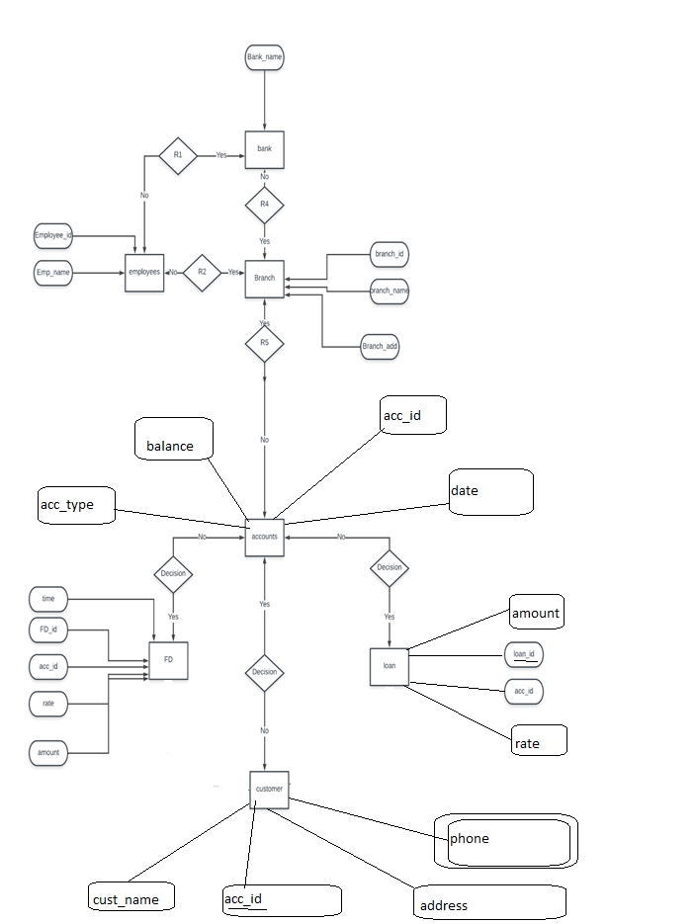

Created using-lucidcharts.com