PiyaNota: A Mobile Application for Optical Music Recognition and
Piano Audio Rendering of Filipino SATB Choral Sheet Music
College of Information and Computer Studies
De La Salle University - Dasmariñas
Dasmariñas, Cavite, Philippines
Macalindong, Paula Sophia V. — Student Author, BS Computer Science
with Specialization in Intelligent Systems, 4th Year

Herradura, Tita R. — Adviser, College of Information and Computer Studies

Abstract
Choral singing, a centuries-old Filipino tradition, thrives in churches, schools, and communities, yet many choir members cannot read sheet music and learn their parts from conductors. Optical Music Recognition (OMR) models degrade on phone photos and are rarely deployed; commercial apps assume musical literacy, and the only Filipino system is rule-based, piano-only. PiyaNota is an Android app converting smartphone photos of open-score SATB (Soprano, Alto, Tenor, Bass) scores into per-voice piano audio. YOLOv8 isolates each staff; a convolutional recurrent network fine-tuned on multi-font renderings, with a clef and key-signature classifier, transcribes it. On 12 pages, digital and photographed, all 100 staves were detected; camera pitch accuracy reached 83.3–83.4% (88.7–89.1% digital), up from under 5% initially, though symbol error remains 33.8–34.8%. PiyaNota contributes, to our knowledge, the first annotated Filipino SATB dataset, a pipeline tested on phone photos, and an app for singers without formal training.
Keywords
Optical Music Recognition, SATB Choral Music, Music Literacy, Filipino Choral Music, Mobile Application, Camera-Captured Sheet Music, YOLOv8, Convolutional Recurrent Neural Network
Contact Author
Name: Paula Sophia V. Macalindong
Phone: 09190747420
Email: mpv0154@dlsud.edu.ph
Supporting Material
PiyaNota: Work-in-Progress Status
1. System Overview and Development Status
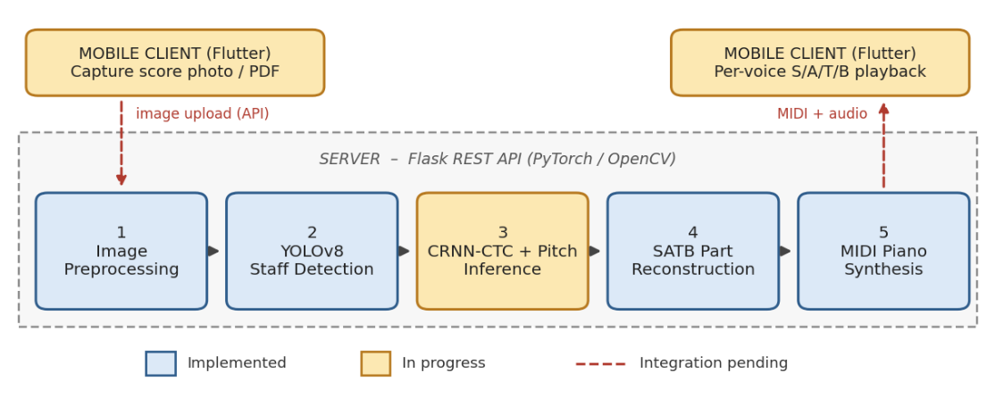
Figure 1. PiyaNota pipeline: mobile capture, five-stage server-side processing, and per-voice audio playback.

2. Preliminary Results: Camera-Captured vs. Digital Input
Input Condition | Staff Detection (recall) | Symbol Error Rate (SER) | Pitch Inference Acc.
Digital (PDF render) | 100.0% | 25.0–25.5% | 88.7–89.1%
Camera-captured photo | 100.0% | 33.8–34.8% | 83.3–83.4%
Degradation (Δ) | 0.0 pp | +8.8 to +9.2 pp | −5.4 to −5.7 pp
Table 1. Final system (fine-tuned CRNN-CTC + clef/key classifier) on 12 test pages (100 staves, 1,008 notes per condition). Ranges span two training seeds. Staff detection = share of staves found and assigned the correct voice; pitch accuracy ignores note duration; lower SER is better.

(a) Digital score page  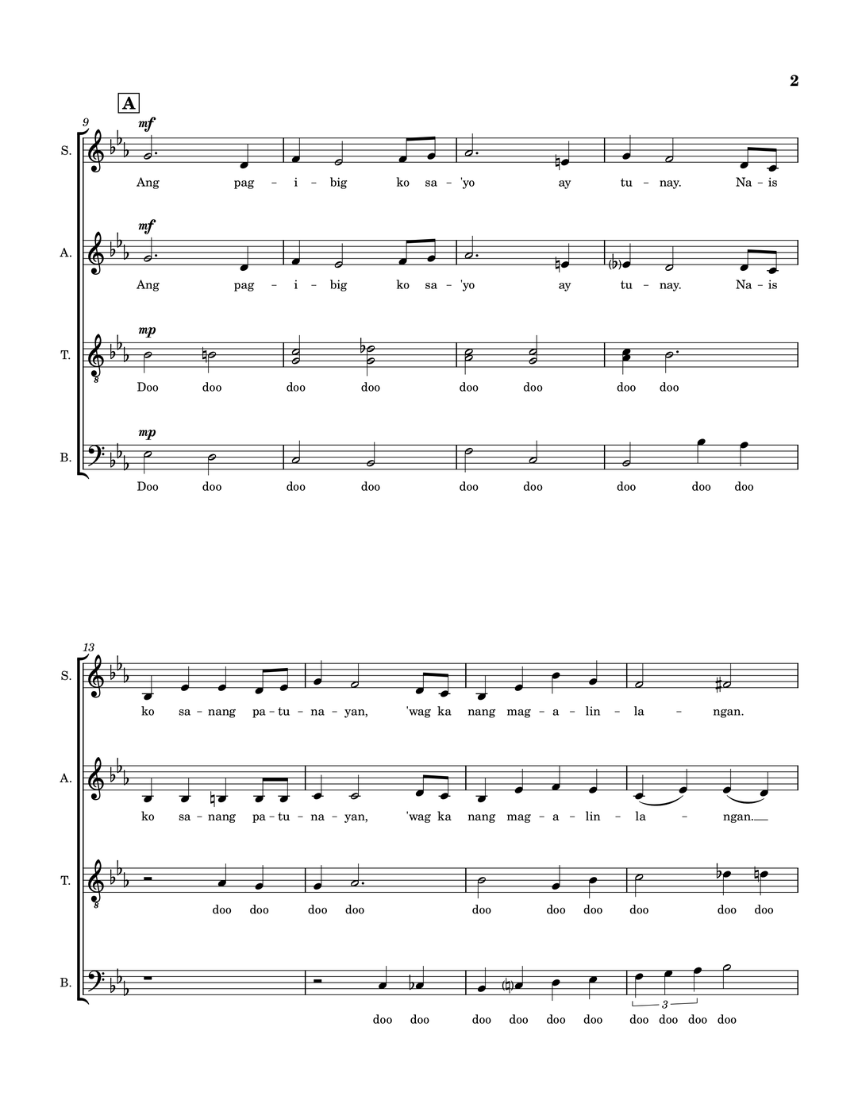 | (b) Camera-captured page  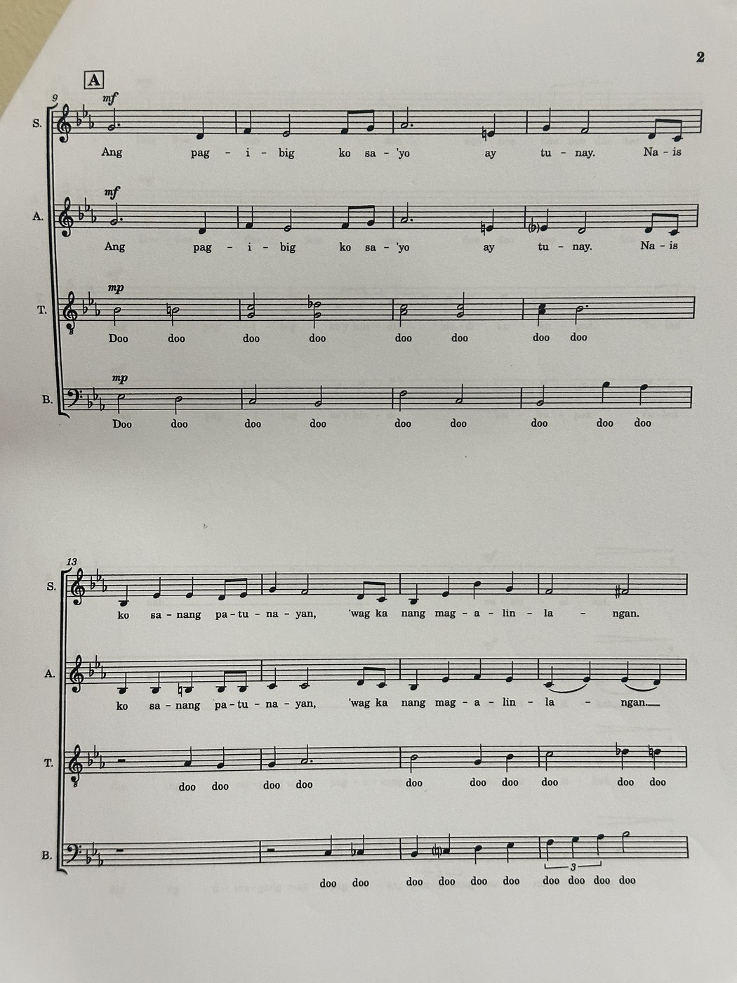
Figure 2. The same test page (Gaano Ko Ikaw Kamahal, p. 2) as digital render (a) and smartphone capture (b), showing lighting, skew, and noise artifacts.

The initial pipeline (CRNN-CTC trained only on single-font synthetic data) detected 84.0% of staves on digital and 56.0% on camera input, with pitch accuracy below 5% in both because it read no clef correctly. Pitch accuracy does not penalise extra notes: about one in three predicted notes is spurious or wrong-pitched (note precision 66–69%).
3. Remaining Work
Remaining work involves (1) reducing spurious notes and rhythm errors, which drive the remaining symbol error, and raising camera pitch accuracy toward the 85% target; (2) evaluating on a larger held-out set of Filipino SATB scores; (3) completing the Flutter mobile application and connecting it to the Flask backend; and (4) a usability evaluation with Filipino choir members using the System Usability Scale.

