PiyaNota: A Mobile Application for Optical Music Recognition and
Piano Audio Rendering of Filipino SATB Choral Sheet Music
College of Information and Computer Studies
De La Salle University - Dasmariñas
Dasmariñas, Cavite, Philippines
Macalindong, Paula Sophia V. — Student Author, BS Computer Science
with Specialization in Intelligent Systems, 4th Year

Herradura, Tita R. — Adviser, College of Information and Computer Studies

Abstract
Choral singing holds cultural significance in the Philippines, yet limited music literacy leaves many choir members dependent on conductors rather than able to read scores independently. Few Optical Music Recognition (OMR) studies translate trained recognition models into deployable, community-facing applications, and existing systems are largely limited to monophonic scores without lyrics or textual annotations — leaving polyphonic, text-integrated choral notation, and Filipino choirs specifically, unaddressed. This work presents PiyaNota, a mobile application integrating a YOLOv8 staff-detection and CRNN-CTC transcription pipeline to convert mobile-captured Filipino SATB (Soprano, Alto, Tenor, Bass) scores into per-voice piano audio. SKIMusic, the only prior Filipino OMR system, offers a natural benchmark but relies on a rule-based pipeline without machine learning. Model training is underway, with the mobile front-end complete and backend integration pending. PiyaNota aims to deliver the first deep learning–based OMR pipeline and annotated dataset for Filipino choral music, advancing accessible music technology research in the Philippines.
Keywords
Optical Music Recognition, Choral Music, Mobile Computing, YOLOv8, CRNN-CTC, Deep Learning, Human-Centered Computing, Filipino Music Technology
Contact Author
Name: Paula Sophia V. Macalindong
Phone: 09190747420
Email: mpv0154@dlsud.edu.ph

Supporting Material
PiyaNota: Work-in-Progress Status
1. System Overview and Development Status
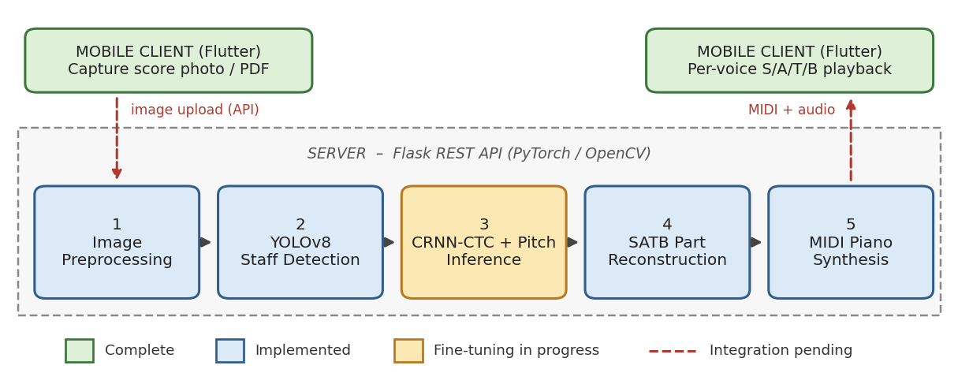
Figure 1. PiyaNota pipeline: mobile capture, five-stage server-side processing, and per-voice audio playback.

2. Preliminary Results: Camera-Captured vs. Digital Input
Input Condition | Staff Detection (mAP50) | Symbol Error Rate (SER) | Pitch Inference Acc.
Digital (PDF / screenshot) | [XX.X]% | [XX.X]% | [XX.X]%
Camera-captured photo | [XX.X]% | [XX.X]% | [XX.X]%
Degradation (Δ) | [X.X] pp | [X.X] pp | [X.X] pp
Table 1. Recognition performance on the same score under digital and camera-captured input (placeholder values).
(a) Digital score page  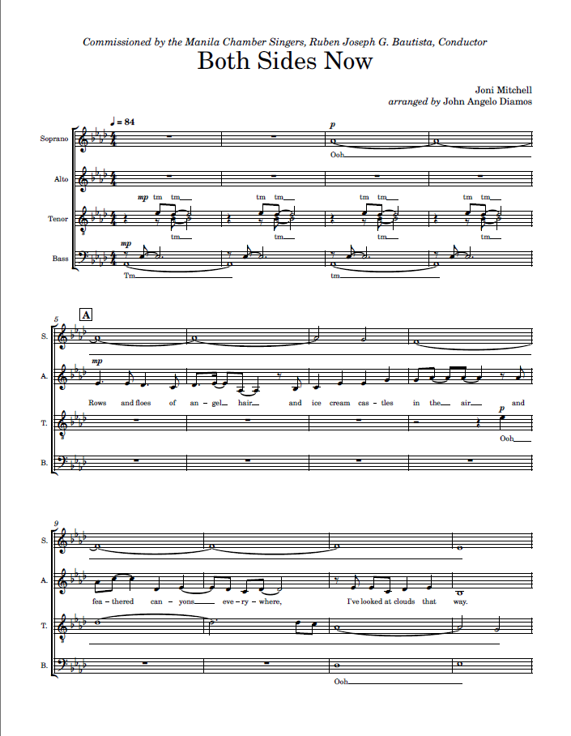 | (b) Camera-captured page  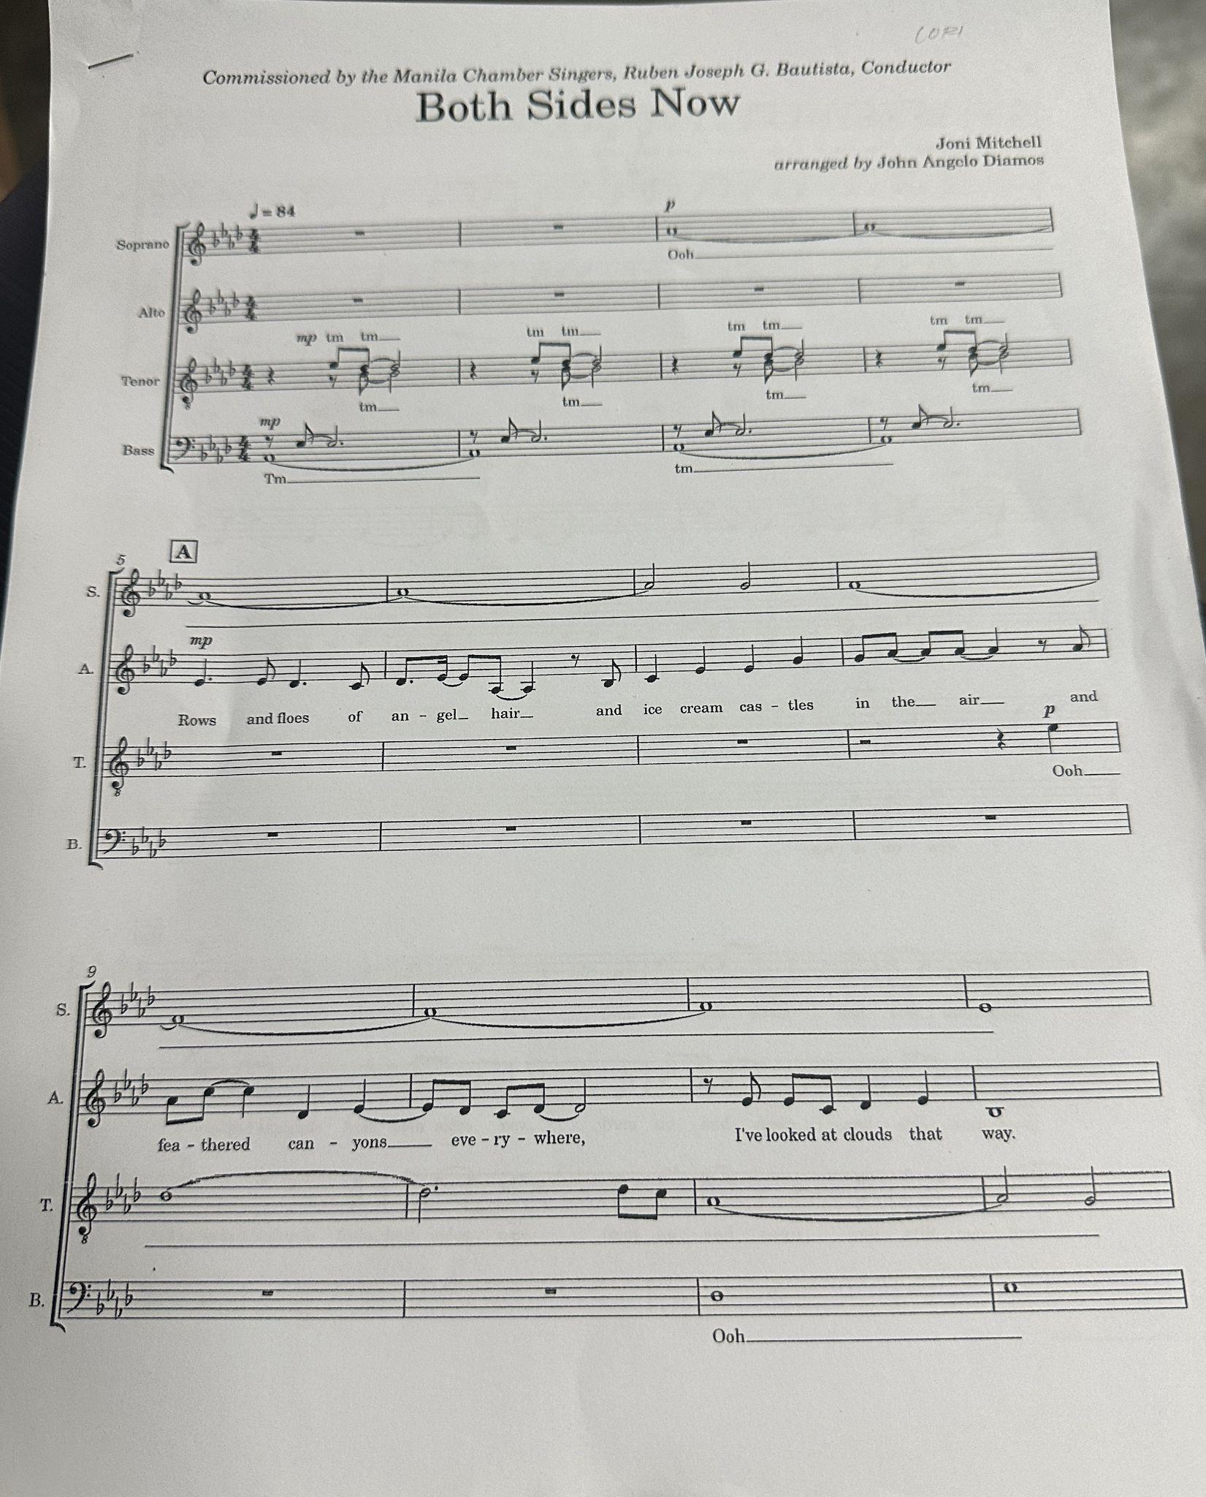
Figure 2. Same score page as digital render (a) and smartphone capture (b), showing lighting, skew, and noise artifacts.
3. Remaining Work
Remaining work involves (1) fine-tuning the CRNN-CTC model on camera-captured Filipino SATB data to lower the Symbol Error Rate and improve accuracy under real-world capture conditions, and (2) integrating the finalized model into the PiyaNota mobile application, whose front-end is complete and whose backend integration is pending.

