*1. Starting from the strong form of the partial differential equation, derive the relevant weak form that will be used as the basis of the finite element method.*

The strong form of the potential flow equation is given by (1) with boundary conditions (2):

$∇²u=0$ (1)  
 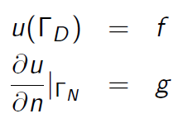 (2)

Multiplying by a weighting function and integrating over the domain yields (3):

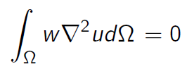 (3)

Using Green’s theorem and substitution of similar problem variables yields (4):

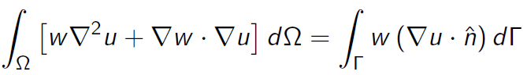 (4)

To satisfy the potential equation, the $w∇²u$ term in (4) is zero; rearranging yields (5), the weak form of (1):

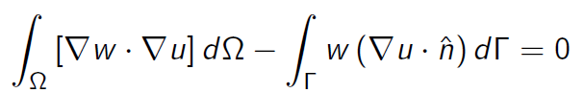 (5)

*2. Show how the weak form that you have derived represents the minimization of the kinetic energy in the potential flow representation.*

For a non-dimensionalized unit mass, kinetic energy is given by (6), and for the whole domain by (7):

$\frac{1}{2}u²=\frac{1}{2}∇ψ∙∇ψ$ (6)

${KE}_{domain}=\int{\int{\frac{1}{2}∇ψ∙∇ψ}} dΩ$ (7)

A perturbation to the potential flow *w*, adds additional kinetic energy to the domain, calculated in (8), (9), and (10):

${KE}_{domain}=\int{\int{\frac{1}{2}∇(ψ+w)∙∇(ψ+w)}} dΩ$ (8)

$=\int{\int{\left(\frac{1}{2}∇ψ∙∇ψ\right)+(∇ψ∙∇w)+(\frac{1}{2}∇w∙∇w)}} dΩ$ (9)

$=\int{\int{{KE}_{ψ}+{KE}_{w}+(∇ψ∙∇w)}} dΩ$ (10)

The kinetic energy due to the perturbative field must be greater than zero, unless the perturbation is trivially zero. No such explicit imposition is placed on the $(∇ψ∙∇w)$ term. Therefore minimizing the kinetic energy in the domain entails finding the configuration that sets $\left(∇ψ∙∇w\right)=0$, precisely the approach taken by FEM in (5).

*3. You will use linear-hat nodal basis functions to represent the solution and the test functions in your solver. Describe/draw how these linear hat basis functions look in two dimensions for:*

*(a) For a node i in the triangulation, show the "tent" basis function (nodal hat basis function)*

*(b) For an element k, show the three linear basis functions on a triangular element.*

Figure 1 represents graphically the nodal linear hat functions: Green indicates lines in the x-y plane, red represents vertical lines (parallel to the z-axis), and blue indicates lines in a non-specific direction not in the x-y plane. All red lines are 1 unit tall, all nodes are on the x-y plane. All three elements in b) are the same identical element, with each basis function indicated for each node. The z-value of the function of a point on the plane defined by the two blue vectors indicates the value of the basis function from at a point in the x-y plane correlated with the projection of that point onto the x-y plane.

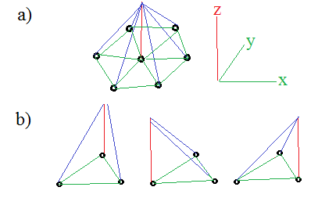

Figure : Graphical representation of linear hat functions

*4. Write the discrete form of the weak form of the equation for a weighting function/node i in the domain.*

Equation (5) can be discretized in general by substituting in the appropriate functions for the weighting function and test function for the potential by (11):

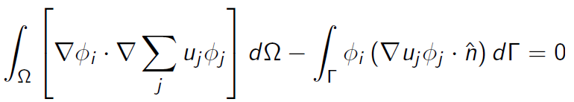 (11)

If the basis function is described as a plane as indicated in Figure 1, its equation can be parameterized as ax+by+c = z. The divergence of this function is given by (12):

$∇ϕ=a\vec{i}+b\vec{j}$ (12)

Therefore using (11) and (12) an individual node would be given by (13) for a node i and basis function from j:

$u_{i}\left(∇ϕ_{i}∙∇ϕ_{j}\right)= u_{i}(a_{i}a_{j}+b_{i}b_{j})$ (13)

*5. Write the discrete form of the weak form of the equation for a node i on the boundary of the domain where you have Dirichlet BCs.*

As given in the first equation of (1) the Dirichlet BC is an explicit setting of the value of *u* at that boundary node. This simply involves insertion of an explicit ‘1’ at Ai,i  and zeroing the rest of that row. This implicitly gives the relation as given in (14):

$u_{i}=f_{i}$ (14)

*6. Write the discrete form of the weak form of the equation for a node i on the boundary of the domain where you have Neumann BCs.*

At the boundary the discrete weak form from (11) with a BC ‘f’, is given by (15):

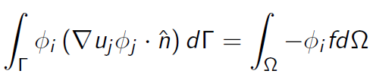 (15)

where the weighting basis function at the node of interest on the boundary is 1. $∇u_{i}$ is precisely the Neumann BC, therefore examining at a particular node, using (15) and applying the relation in (13) yields (16):

$u_{i-1}\left(a_{i}a_{j-1}+b_{i}b_{j-1}\right)+u_{i}\left(a_{i}a_{j}+b_{i}b_{j}\right)+u_{i+1}\left(a_{i}a_{j+1}+b_{i}b_{j+1}\right)=f_{i}$ (16)

This is satisfied naturally by the FEM with no modification of the ‘A’ matrix required other than to insert the desired BC value.

*7. Derive the elemental matrices that will be used to build the overall A-matrix (stiffness matrix). Also derive the elemental load vectors that will be used to determine the RHS. Include how you will calculate the gradient values using the equation for a plane surface.*

Using the discrete form from (11) and applying the relation between the basis functions in (13)

*8. Describe the Stamping procedure that will be used to construct the global matrix using the*

*elemental matrices. You may use both words and example matrices.*

*9. For each boundary condition, describe the implementation in your FEM code.*

*10. Write pseudo code describing the finite element method implementation that you will use.*

*11. Add the elemental matrices and boundary conditions to the provided pseudo code and complete the FEM solver so that it works (currently the solver has some random numbers in places to allow it to "work"). You may optionally develop your own two-dimensional FEM solver. If you choose to use the Matlab version provided, please read through and understand the comments and structure. If you choose to develop your own solver, please use the geometry definition tool provided.*

*12. Solve the potential flow problem and plot the scalar potential using a minimum grid refinement value of 3.*

*13. Show how the value of your scalar potential solution at the front of the object (location 0,0) converges with grid refinement.*