**Summary**

A finite volume approach will be used to investigate the propagation of a shock wave in a 1-D bar.

**Physical Problem**

The 1-D solid bar will be treated as a Riemann problem using the Mie–Gruneisen equation of state with linear Rankine–Hugoniot jump conditions.

In general conservation of momentum, energy, and mass must be satisfied according to:

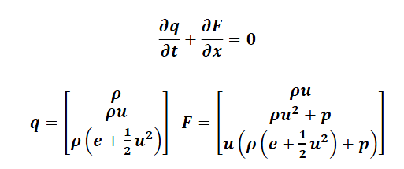

Additionally a constitutive equation is required to describe the behavior of the material. The Gruneisen model relates pressure and volume change as:

\Gamma = V \left(\frac{dp}{de}\right)_V

With the equation of state being:


   p - p_0 = \frac{\Gamma}{V} (e - e_0)
 

where p0 and e0 are at a particular reference state. The system will consist of a semi-infinite slab, reducing possible difficulties due to reflections at boundaries of the domain

**Numerical Method**

The system will be solved using a finite volume approach, using a Lax-Friedrich flux scheme to model the conserved quantities. The domain will consist of 1 meter section of a semi-infinite slab with a contact discontinuity at x=0.5m. Initial conditions for pressure, density, and velocity will be specified throughout the domain. It is expected that resolving the large gradients at the shock wave, expansion fan, and contact discontinuity will be challenging at artificial viscosity will need to be introduced to prevent local divergence near these discontinuities.

**Validation**

The system will be setup with a particular set of ICs and then observed at a later specified time and compared to the results of a model from the literature, specifically that of Ward [2]

**Approximate Timeline**

It is expected that research will take up the bulk of the time looking at implementation specifics, relevant theory, and investigation of model limitations/applicability. Four weeks before the due date coding will begin and is expected to take two weeks. One week will be allowed for troubleshooting. The final week is intended for presentation creation and final result generation.

**References**

[1] Linear and Nonlinear Waves  
<http://www.math.umn.edu/~olver/pdn.html>

[2] The simulation of shock- and impact-driven flows with Mie-Gruneisen equations of state  
<http://thesis.library.caltech.edu/6211/1/ward_thesis.pdf>

[3] Shock and detonation modeling with the Mie-Gruneisen equation of state  
<http://www2.galcit.caltech.edu/EDL/publications/reprints/galcit_fm99-8.pdf>

[4] The Mechanical Threshold Stress model for various tempers of AISI 4340 steel  
<http://www.csafe.utah.edu/pdf/papers/2005_Banerjee_(AISI_4340_Steel).pdf>

[5] An Exact Solution of the Riemann Problem for Solids with the Grüneisen Equation of State  
<http://jpsj.ipap.jp/link?JPSJ/57/9>

[6] Grüneisen equation of state for solids and solution of the Riemann problem  
<http://link.springer.com/chapter/10.1007%2F978-3-642-77648-9_70>

[7] A lattice Boltzmann method for shock wave propagation in solids  
<http://www.ewp.rpi.edu/hartford/~ernesto/F2010/EP1/Materials4Students/Danyluk/Xiao2007.pdf>

[8] The Method of Characteristics with applications to Conservation Laws  
<http://www.scottsarra.org/shock/shock.html>

[9] Handbook of Shock Waves, “General Laws for Propagation of Shock Waves through Matter (Ch 2)”, Leroy F. Henderson