Supermongo Tutorial

Supermongo Tutorial
Default Style Guide:
Setting Limits
Labels
Points
Box
Useful Built-in Commands
Interpolating Data
Scripts
On Startup
Log Plots
Color Scales
Looping, Error Bars, Panels, and Colors
Scripts Run From the Command Line
Manipulating Vectors
Reading and Manipulating Strings
Many Panels
Links

Default Style Guide:

Single Graph

ctype black
box
ylabel SFR,GMLR [M_\odot/yr]
xlabel lookback time [Gyr]

$grid
lweight 4.

.
.
.
lweight 4.
expand 2.
LOCATION \$(\$gx1 + 1500) \$gx2 \$(\$gy1 + 500) \$gy2
window 1 1 1 1
limits ..................................
ticksize ..................................
ctype black
box
ylabel SFR,GMLR [M_\odot/yr]
xlabel lookback time [Gyr]

$grid
lweight 4.
set jn=100
set xj=15
set xm=xj-10
set xp=xj-1

Panels

=============================

Setting Limits
Plot limits can be set manually in supermongo with the command limits 0 10 -10 9 for a plot from x1=0,10 and y1=-10,9.
SM also has a nice feature where if you're plotting array x against array y the program will determine minima and maxima for the limits if you type limits x1 y1 .<p> If you want to overplot a second set of data x2,y2,y3 and use the maxima and minima of the sets {x1,x2} and {y1,y2,y3} for the limits one work around is to concatenate each set of arrays (maybe there's a better way?).
read {x1 1 y1 2 x2 3 y2 4 y3 5}
set xlim=x1 concat x2
set ylim=y1 concat y2 concat y3
limits xlim ylim

Labels
#center label "Title" at 51% from the y-axis position and 114% from the x-axis position.
relocate $($fx1+($fx2-$fx1)*.51) $($fy1+($fy2-$fy1)*1.14)
putlabel 5 "Title"

Points
ptype n s
n=number of sides
s= side type (0open 1skeletal (center connected to vertices) 2starred 3solid)
for open be sure ltype 0

Box
The box command draws a box in the "window" area complete with tickmarks and axis numbers. To modify where/whether tickmarks appear and whether they're labeled, box takes 4 arguments: box ix1 iy1 ix2 iy2
- ix1 controls settings for the bottom side of the box (the "x-axis").
- iy1 controls settings for the left side of the box (the "y-axis")
- ix2 controls settings for the top side of the box.
- iy2 controls settings for the right side line of the box.

These arguments may have 4 values
- 0 sets the side to be a line with tickmarks but w/o numbering
- 1 sets the side to be a line with tickmarks and with numbering
- 2 sets the side to be a line with tickmarks and withnumbering who's text is oriented perpendicular to the tickmarks (eg y-axis numbering is oriented like x-axis).
- 3 sets the side to be a line w/o tickmarks and w/o numbering
- 4 sets the side to not exist.

Useful Built-in Commands
- Find the minimum and maximum of a vector y: vecminmax y miny maxy

Interpolating Data
SM has a few built-in interpolation routines. The routines are particularly nice for comparing 2 arrays with differently spaced dependent variables (useful for getting percent error from seperate data sets for example).
The following fits a cubic spline through vectors x1 and y1, it then outputs the values of the fit at positions given in vector x2 into a new vector y2. The routine linearly interpolates beyond x1 if necessary. It also requires that x1 is monotonic increasing which can be accomplished using the sort routine.
spline x1 y1 x2 y2

Scripts

On Startup
- start.sm : This script adds a few extra color labels (dred-dark red,dgreen-dark green etc) and creates some useful shortcuts. It is also useful as a template for more complex/specific start up scripts.<p>
If you would like to run this script everytime sm starts, move it to a directory like /home/me/.smstuff/ and alias sm:
alias sm='sm -m /home/me/.smstuff/start.sm'

- A more technical startup script containing a bunch of useful commands and written by an astronomer can be found here. It's not for the faint of heart.

Log Plots
The simple script linked below creates a log plot (the ticksize command is really the key thing to take away if you want to have log axes). This plot's output is pictured below.
ticksize -1 0 -1 0
- log.sm
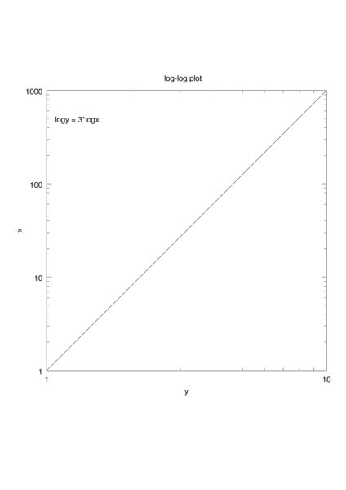

Color Scales
It is possible to add a 3rd dimension to your supermongo plots by defining a continuous color scale. The following simple script demonstrates how colors are set in supermongo and outputs a simple color scale.
- colordemo.sm
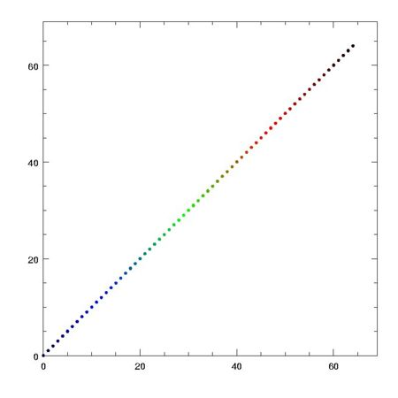

Image:Simpledemo.ps
A more complex set of routines lets you interpolate a color palet from a file. The sm file in the tar below demonstrates how a vector scaled between 0 and 1 can be used to pick out colors from blue->green->red.
- color.tar
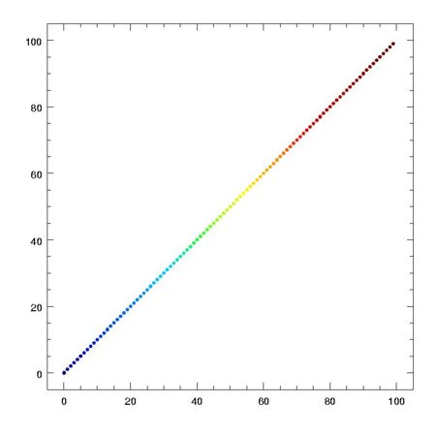
Image:Color.ps

Looping, Error Bars, Panels, and Colors
- wp_all.sm : This script is fairly involved, but demonstrates the power of sm. Documentation or a simpler version will follow eventually (if there's interest), feel free to ask in the meantime.
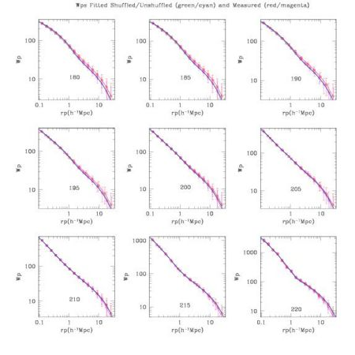
Image:Wp all.ps

Scripts Run From the Command Line

Manipulating Vectors
create a vector: set x=0,1,0.001
chopping up vectors (assign elements to a new vector under a condition): set x5=x+5 IF(x<0.2)

find the minimum and maximum...
vecminmax vector min max
limits x1 x2 $min $max

Reading and Manipulating Strings
#read files from a file "list-of-fnames"
data "list-of-fnames"
read '%s ' { filepre }
set maxfiles=DIMEN(filepre)
echo $(maxfiles)
#loop over file names in list
set i=1
while {i < maxfiles} {
DEFINE ip ( i )
#My filenames were too long to read in (>40 characters)
#so I cut off the end when I list them in the file "list-of-fnames"
#and concatenate the prefix and suffix here
DEFINE file <$(filepre[i])-saw-mth>
DEFINE file1 <\"histograms/$file\">
DEFINE out1 <\"wiki/$file.ps\">
#open the files for output and label
device postencap $out1
toplabel $file
#print to screen
echo
echo ---------File
echo input: $file1 Total: $(maxfiles)
echo output: $out1
echo ---------

Many Panels

The idea here is to use the window command to indicate how many different plots you want on a single page. Window is used in the following way:

window Nx Ny x y

Where Nx is the number of panels in the x direction and Ny is the number of panels in the y direction. (x,y) is the panel in which your next commands will be placed until you use the window command again to move into another panel (using the same values of Nx and Ny, with different x,y specified).
- file.sm
<Image>

webusers.astro.umn.edu/~caustin/sm.html

Syntax: WINDOW nx ny x y

WINDOW makes the current plot location the window at (x,y), where there are nx
windows across and ny windows up and down. WINDOW 1 1 1 1 resets the plot location
to the entire plot area. The size and placement of the windows is decided by the
value of EXPAND when the WINDOW commands are issued, so be sure that EXPAND has the
same value for every window in a set. (It's used to figure out the axis labels, and
spacings between boxes). While plotting to a given window you can of course change
EXPAND to your heart's content.

If the number of windows in either the x or y direction is negative no space is
left between the boxes in that direction (try DO i=1,3 { WINDOW 1 -3 1 $i BOX }).
It's possible to overload `window' and `box' to only label external axes in blocks
of touching boxes.

If either x or y is specified as, e.g. 2:4, the window is set to cover the range 2-4
(i.e. the part of the screen covered by windows 2, 3, and 4). Note that this feature
can be used to split the screen in arbitrary ways, e.g.

window -1 -6 1 1:5 box
window -1 -6 1 6 box

(or you could say window -20 -20 15:19 15:19 as an alternative to a LOCATION
command).

If you don't want boxes that touch, but you don't like the gaps left between boxes
by the WINDOW command, you can now do something about it legally, without lying to
SM. After we calculate the widths of the `gutters' between the windows that we think
that you need, they are multiplied by the values of the SM variables x_gutter and
y_gutter, so if you think that the spacing is too large in the x direction you can
say

define x_gutter 0.5
window 2 2 1 1 box
window 2 2 1 2 box

to make things look better. Within a macro it can be convenient to say local
define x_gutter 0.5, as then the gutter value softly and suddenly vanishes at
the end of the macro.

It's confusing to change LOCATIONs while using WINDOWs; you probably want to say
WINDOW 1 1 1 1 first.

Axis/labels
Syntax: AXIS A1 A2 VSMALL VBIG AX AY ALEN ILABEL ICLOCK
AXIS A1 A2 VSMALL VBIG VLAB AX AY ALEN ILABEL ICLOCK
AXIS A1 A2 ASMALL ABIG AX AY ALEN ILABEL ICLOCK
Makes an axis labeled from A1 to A2 at location AX, AY, length ALEN. The first form (with VSMALL and VBIG) specifies the values where you want small and big ticks explicitly; if you specify the string-valued vector VLAB it will be used to label the big ticks. The third form is more obscure: If ABIG > 0 use that for spacing of large ticks. If ASMALL < 0 make a logarithmic axis, if ASMALL = 0, do the default. (See TICKSIZE for more on the meaning of negative ASMALL and/or ABIG). If ASMALL > 0 try to use that for the spacing of small ticks.
ILABEL is 0 for no labels, 1 for labels parallel to axis, 2 for perpendicular to axis, and 3 for neither labels nor ticks. ANGLE determines the angle of the axis.
ICLOCK is used for (too) many purposes; it's treated as three integers of 1, 2, and 1 bits respectively.
ICLOCK & 0x1: Control the ticks orientation:
0 Anticlockwise from the axis
1 Clockwise from the axis
(ICLOCK>>1) & 0x3: Control the tick direction:
0 Ticks are perpendicular to axis
1 Ticks are vertical
2 Ticks are vertical
3 Don't draw any ticks
(ICLOCK>>3) & 0x1: Control which side of the axis the ticks appear:
0 The same size as the labels
1 The opposite side to the labels
If you prefer not to think in terms of bitwise operators, this can be written as if ICLOCK is even the ticks are anticlockwise on the axis, if odd they are clockwise. You usually want the ticks perpendicular to the axes, and this is what you get with ICLOCK 0 or 1; if it is 2 or 3 the ticks are vertical, and if 4 or 5 they are horizontal. The labels are on the opposite side of the axis from the ticks unless you add 8 to the numbers given above.
For example, the following commands are equivalent to BOX:
ANGLE 0
AXIS $fx1 $fx2 0 0 $gx1 $gy1 $($gx2-$gx1) 1 $(0|8)
AXIS $fx1 $fx2 0 0 $gx1 $gy2 $($gx2-$gx1) 0 $(1|8)
ANGLE 90
AXIS $fy1 $fy2 0 0 $gx1 $gy1 $($gy2-$gy1) 2 $(1|8)
AXIS $fy1 $fy2 0 0 $gx2 $gy1 $($gy2-$gy1) 0 $(0|8)
ANGLE 0
(except that I set ICLOCK's 0x8 bit to draw the ticks outside the box).
If you want to label the bottom axis of some plot only at prime points try
SET b={1 2 3 5 7 11 13 17 19} SET s=0,20
AXIS 0 20 s b 3500 3500 27500 1 0
If you have used LIMITS to scale the axes and LOCATION or WINDOW to move them, you could say something like
AXIS $fx1 $fx2 s b $gx1 $gy1 $($gx2-$gx1) 1 0
An example of using your own string valued labels would be:
set s=1,7,.5 set b=1,7 set labs={ O B A F G K M }
LIMITS 1 7 0 0
AXIS 0 10 s b labs 3500 3500 27500 1 0
which works as expected. If you don't have a shift key and try using lower case (obafgkm) you'll be surprised as all the letters are not at the same level (as they don't all have the same height). The easiest way to deal with this is to make them all the same height:
set labs={ o b a f g k m } + '\\strut'
(a strut is a TeXism that has the height and depth of a parenthesis; I'm afraid that you do have to escape the \ in the string). If that leaves too much space try:
set labs='\\move 100' + { o b a f g k m } + '\\strut'
I think that you get the point.
If you want more control over placement and sizes of axis labels and ticks, you can force SM to draw them separately:
EXPAND 0.5
AXIS $fx1 $fx2 0 0 $gx1 $gy1 $($gx2-$gx1) 0 $(1<<3)
EXPAND 1.44
AXIS $fx1 $fx2 0 0 $gx1 $gy1 $($gx2-$gx1) 1 $(3<<1)
gives smaller-than-usual ticks outside the box with larger-than-usual labels (you could have used define default_font "2" to achieve the latter)
The distance of labels from axes is controlled by the SM variable label_offset; increase it to move them further away.
Rather than use AXIS to draw all of your axes, it may be easier to use BOX with some 3's to disable its axis-drawing habits. You'll still get a box, but no ticks or labels. For example,
LIMITS 0 1 0 10 BOX 1 2 0 3 TICKSIZE 0 0 -1 0 BOX 3 3 1 3
will label the y-axis with both linear and logarithmic axes.
This was changed in V2.1: To specify logarithmic axes you should now specify the logarithms, just as you do to BOX. For example, to draw a logarithmic axis running from 1 to 1000, specify A1 as 0 and A2 as 3, rather than 1 and 1000.
See NOTATION if you want to control the use of floating point or exponential notation. You can control the font used by setting the variable default_font. If you want your positive and negative exponents to line up define the SM variable line_up_exponents; if it's 1 they'll be padded with a space, if 2 or more, with a + (you can do this in your `.sm' file).

Links
- The Official Homepage
- Full Official Manual
- Crystal G. Austin -- SM A Nice Introduction

