multi_reg_2.R

SANGHOOJEFFREY

Tue Jun 26 19:46:55 2018

# 아이스크림 섭취량과 아이스크림의 가격, 가족의 월수입, 평균기온의 관계를 연구하기 위해  
# 다음의 자료를 수집했다.   
setwd("F:/work/2018/0. R-work/2018_R_intermediate")  
load("data/icecream.rda")  
  
if (!require(psych)) install.packages("psych"); library(psych)

## Loading required package: psych

## Warning: package 'psych' was built under R version 3.4.4

pairs.panels(ice[,1:4])

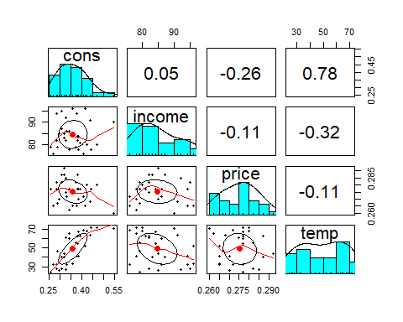

r.full = lm(cons~price+income+temp, data=ice)  
summary(r.full)

##   
## Call:  
## lm(formula = cons ~ price + income + temp, data = ice)  
##   
## Residuals:  
## Min 1Q Median 3Q Max   
## -0.065302 -0.011873 0.002737 0.015953 0.078986   
##   
## Coefficients:  
## Estimate Std. Error t value Pr(>|t|)   
## (Intercept) 0.1973151 0.2702162 0.730 0.47179   
## price -1.0444140 0.8343573 -1.252 0.22180   
## income 0.0033078 0.0011714 2.824 0.00899 **   
## temp 0.0034584 0.0004455 7.762 3.1e-08 ***  
## ---  
## Signif. codes: 0 '***' 0.001 '**' 0.01 '*' 0.05 '.' 0.1 ' ' 1  
##   
## Residual standard error: 0.03683 on 26 degrees of freedom  
## Multiple R-squared: 0.719, Adjusted R-squared: 0.6866   
## F-statistic: 22.17 on 3 and 26 DF, p-value: 2.451e-07

# model selection-stepwise  
step(r.full, direction="both")

## Start: AIC=-194.38  
## cons ~ price + income + temp  
##   
## Df Sum of Sq RSS AIC  
## - price 1 0.002126 0.037399 -194.62  
## <none> 0.035273 -194.38  
## - income 1 0.010817 0.046090 -188.35  
## - temp 1 0.081741 0.117013 -160.40  
##   
## Step: AIC=-194.62  
## cons ~ income + temp  
##   
## Df Sum of Sq RSS AIC  
## <none> 0.037399 -194.62  
## + price 1 0.002126 0.035273 -194.38  
## - income 1 0.012611 0.050009 -187.90  
## - temp 1 0.087836 0.125235 -160.36

##   
## Call:  
## lm(formula = cons ~ income + temp, data = ice)  
##   
## Coefficients:  
## (Intercept) income temp   
## -0.113195 0.003530 0.003543

r.reduce = lm(cons~income+temp, data=ice)  
  
anova(r.full, r.reduce) # 두 모형에 차이가 없다. price 설명변수를 제거해도 된다.

## Analysis of Variance Table  
##   
## Model 1: cons ~ price + income + temp  
## Model 2: cons ~ income + temp  
## Res.Df RSS Df Sum of Sq F Pr(>F)  
## 1 26 0.035273   
## 2 27 0.037399 -1 -0.0021257 1.5669 0.2218

# Q1. 다중공선성 확인  
  
# Q2. 정규성 확인  
  
# Q3. 독립성 확인  
  
# Q4. 등분산성 확인  
  
# Q5. 영향점, 이상점, 지렛대점 확인  
  
# Q6. 이상점을 제거한 회귀모형은?