review_reg.R

SANGHOOJEFFREY

Wed Jun 27 23:13:13 2018

# 회귀분석을 위해 필요한 팩키지 설치 또는 불러오기  
if(!require(car)) install.packages("car", repos = "http://cran.us.r-project.org"); library(car)

## Loading required package: car

## Warning: package 'car' was built under R version 3.4.4

## Loading required package: carData

## Warning: package 'carData' was built under R version 3.4.4

if(!require(lmtest)) install.packages("lmtest", repos = "http://cran.us.r-project.org"); library(lmtest)

## Loading required package: lmtest

## Warning: package 'lmtest' was built under R version 3.4.4

## Loading required package: zoo

## Warning: package 'zoo' was built under R version 3.4.4

##   
## Attaching package: 'zoo'

## The following objects are masked from 'package:base':  
##   
## as.Date, as.Date.numeric

# 분석을 위한 자료 불러오기  
  
load(file='data/data2.rda')  
head(data2)

## id light prec rh s_30 s_60 s_90 s_temp  
## 1 1 0.3953990 0.000000000 74.87500 62.24833 65.37250 56.67375 20.07417  
## 2 2 0.4716573 0.000000000 80.38417 59.39917 60.05708 56.08708 18.80713  
## 3 4 0.3397830 0.002433239 80.80167 58.39167 62.56333 57.47583 22.90226  
## 4 5 0.4375250 0.000000000 71.94375 54.62958 61.21750 59.27583 20.60042  
## 5 1 0.4288470 0.000000000 83.62865 64.94625 70.97458 51.79833 19.93833  
## 6 2 0.4387887 0.046666667 89.72399 62.46333 57.33125 64.06708 18.71500  
## s_trans temp ws l  
## 1 0.00125 24.19333 1.3340909 31.7  
## 2 0.00000 23.74822 1.8795652 27.6  
## 3 23.75000 23.24781 1.1700000 30.6  
## 4 0.00000 24.53833 1.7139130 24.0  
## 5 0.00625 18.44750 0.6579167 33.4  
## 6 0.00000 19.25958 1.6591667 31.5

# 위 자료는 엽장(l)과 관측된 기상요소 간 관계성을 규명하고자 수집된 자료입니다.  
# 다중회귀모형을 통해 엽장(l)을 위한 최적회귀모형을 찾으세요  
  
# Q1. 산점도를 통한 설명변수와 반응변수 간 관계 파악  
  
# Q2. lm()함수를 이용한 회귀모형 세우기  
out=lm(l~.-id,data=data2)  
summary(out) # 얻어진 결과를 해석해보세요

##   
## Call:  
## lm(formula = l ~ . - id, data = data2)  
##   
## Residuals:  
## Min 1Q Median 3Q Max   
## -9.720 -2.180 1.049 2.171 7.093   
##   
## Coefficients:  
## Estimate Std. Error t value Pr(>|t|)   
## (Intercept) 41.51504 9.06888 4.578 2.47e-05 ***  
## light -2.01961 5.01354 -0.403 0.6885   
## prec 1.97701 3.75025 0.527 0.6001   
## rh 0.01977 0.07401 0.267 0.7902   
## s_30 0.04690 0.03066 1.529 0.1315   
## s_60 -0.04912 0.02634 -1.865 0.0671 .   
## s_90 0.03698 0.02720 1.359 0.1792   
## s_temp -0.13621 0.38781 -0.351 0.7267   
## s_trans -0.01297 0.17610 -0.074 0.9416   
## temp -0.46174 0.27273 -1.693 0.0957 .   
## ws 0.50876 0.56152 0.906 0.3686   
## ---  
## Signif. codes: 0 '***' 0.001 '**' 0.01 '*' 0.05 '.' 0.1 ' ' 1  
##   
## Residual standard error: 3.97 on 59 degrees of freedom  
## Multiple R-squared: 0.2917, Adjusted R-squared: 0.1717   
## F-statistic: 2.43 on 10 and 59 DF, p-value: 0.01689

# Q3. vif()함수를 이용한 다중 공선성 확인  
  
  
# Q4. 정규성 검정 (정규성을 만족하지 않음)  
  
  
  
# Q5. 잔차도표와 DurbinWatson을 통한 독립성 검정(독립성을 만족하지 않음)  
  
  
  
# Q6. 등분산성 검토 (등분산성을 만족하지 않음)  
  
  
  
  
  
power=spreadLevelPlot(out)$PowerTransformation # 적합한 power

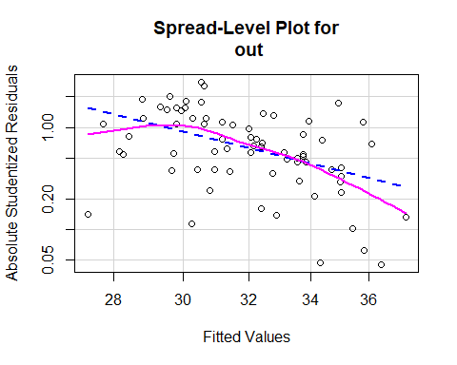

# 반응변수 변환  
out2=lm(l^power~.-id,data=data2)  
summary(out2)

##   
## Call:  
## lm(formula = l^power ~ . - id, data = data2)  
##   
## Residuals:  
## Min 1Q Median 3Q Max   
## -1.953e+10 -8.601e+09 9.618e+08 6.251e+09 2.191e+10   
##   
## Coefficients:  
## Estimate Std. Error t value Pr(>|t|)   
## (Intercept) 7.561e+10 2.461e+10 3.072 0.00321 **  
## light -3.552e+09 1.360e+10 -0.261 0.79492   
## prec 1.253e+09 1.018e+10 0.123 0.90245   
## rh -6.859e+07 2.008e+08 -0.342 0.73392   
## s_30 1.081e+08 8.321e+07 1.299 0.19886   
## s_60 -1.138e+08 7.146e+07 -1.592 0.11674   
## s_90 7.612e+07 7.381e+07 1.031 0.30660   
## s_temp -6.539e+08 1.052e+09 -0.621 0.53678   
## s_trans -1.261e+08 4.779e+08 -0.264 0.79278   
## temp -1.885e+09 7.401e+08 -2.547 0.01349 *   
## ws 9.915e+08 1.524e+09 0.651 0.51778   
## ---  
## Signif. codes: 0 '***' 0.001 '**' 0.01 '*' 0.05 '.' 0.1 ' ' 1  
##   
## Residual standard error: 1.077e+10 on 59 degrees of freedom  
## Multiple R-squared: 0.3513, Adjusted R-squared: 0.2414   
## F-statistic: 3.196 on 10 and 59 DF, p-value: 0.00244

shapiro.test(out2$residuals) #정규성 만족

##   
## Shapiro-Wilk normality test  
##   
## data: out2$residuals  
## W = 0.96828, p-value = 0.07279

durbinWatsonTest(out2) # 독립성은 만족되지 않음

## lag Autocorrelation D-W Statistic p-value  
## 1 0.5242338 0.9507617 0  
## Alternative hypothesis: rho != 0

ncvTest(out2) #등분산성 만족

## Non-constant Variance Score Test   
## Variance formula: ~ fitted.values   
## Chisquare = 1.956769 Df = 1 p = 0.1618593

influencePlot(out2)

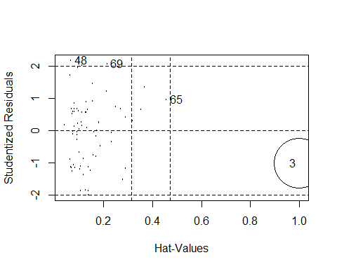

## StudRes Hat CookD  
## 3 -1.0207943 0.99987199 739.40050763  
## 48 2.1716285 0.06764959 0.02926430  
## 65 0.9562592 0.45754418 0.07021948  
## 69 2.0687561 0.21542444 0.10120250

outlierTest(out2)

## No Studentized residuals with Bonferonni p < 0.05  
## Largest |rstudent|:  
## rstudent unadjusted p-value Bonferonni p  
## 48 2.171628 0.033987 NA

# 3 영향점, 48 이상점, 69번째는 영항점이면서 이상점으로 의심됨  
  
k=10  
#hat(값의 임계값)  
2*(k+1)/nrow(data2)

## [1] 0.3142857

#cookD 임계값  
4/(nrow(data2)-k-1)

## [1] 0.06779661

# 자료를 제거하고 다시 회귀모형 세우기  
data3=data2[-c(3,48, 69),]  
  
rownames(data3)<-1:nrow(data3)  
out3=lm(l^power~.-id,data3)  
summary(out3)

##   
## Call:  
## lm(formula = l^power ~ . - id, data = data3)  
##   
## Residuals:  
## Min 1Q Median 3Q Max   
## -2.069e+10 -7.993e+09 1.565e+09 6.932e+09 1.752e+10   
##   
## Coefficients:  
## Estimate Std. Error t value Pr(>|t|)   
## (Intercept) 4.752e+10 2.394e+10 1.985 0.0521 .  
## light -6.691e+09 1.263e+10 -0.530 0.5983   
## prec 3.824e+09 9.331e+09 0.410 0.6835   
## rh -1.176e+07 1.970e+08 -0.060 0.9526   
## s_30 1.966e+08 8.495e+07 2.314 0.0243 *  
## s_60 -9.089e+07 6.639e+07 -1.369 0.1765   
## s_90 1.480e+08 7.270e+07 2.036 0.0465 *  
## s_temp -7.332e+08 9.921e+08 -0.739 0.4630   
## s_trans 7.613e+10 3.869e+10 1.967 0.0541 .  
## temp -1.142e+09 7.340e+08 -1.556 0.1253   
## ws 8.875e+08 1.403e+09 0.633 0.5295   
## ---  
## Signif. codes: 0 '***' 0.001 '**' 0.01 '*' 0.05 '.' 0.1 ' ' 1  
##   
## Residual standard error: 9.85e+09 on 56 degrees of freedom  
## Multiple R-squared: 0.4204, Adjusted R-squared: 0.3169   
## F-statistic: 4.062 on 10 and 56 DF, p-value: 0.0003193

shapiro.test(out3$residuals)

##   
## Shapiro-Wilk normality test  
##   
## data: out3$residuals  
## W = 0.96454, p-value = 0.05302

durbinWatsonTest(out3)

## lag Autocorrelation D-W Statistic p-value  
## 1 0.4124547 1.162901 0.002  
## Alternative hypothesis: rho != 0

ncvTest(out3)

## Non-constant Variance Score Test   
## Variance formula: ~ fitted.values   
## Chisquare = 0.02417289 Df = 1 p = 0.8764458

influencePlot(out3)

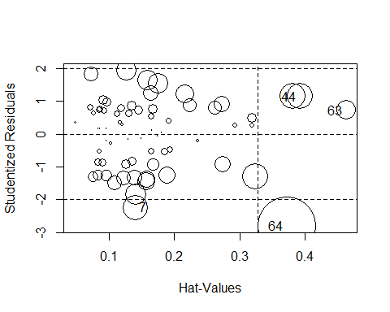

## StudRes Hat CookD  
## 7 -2.2336454 0.1404548 0.06918609  
## 44 1.1457497 0.3924529 0.07666123  
## 63 0.7223982 0.4633754 0.04131874  
## 64 -2.8103449 0.3723649 0.37926165

# 분석결과 64번째 자료가 영향점이면서 이상점으로 보임  
  
# 64번째를 다시 제거하고 회귀모형 세우  
data4=data3[-c(64),]  
rownames(data4)<-1:nrow(data4)  
out4=lm(l^power~.-id,data4)  
summary(out4)

##   
## Call:  
## lm(formula = l^power ~ . - id, data = data4)  
##   
## Residuals:  
## Min 1Q Median 3Q Max   
## -1.847e+10 -7.064e+09 1.286e+09 6.206e+09 1.577e+10   
##   
## Coefficients:  
## Estimate Std. Error t value Pr(>|t|)   
## (Intercept) 4.944e+10 2.260e+10 2.188 0.03297 *   
## light -6.757e+09 1.191e+10 -0.567 0.57294   
## prec 1.364e+10 9.472e+09 1.440 0.15552   
## rh -2.630e+07 1.860e+08 -0.141 0.88806   
## s_30 2.397e+08 8.161e+07 2.938 0.00482 **  
## s_60 -1.112e+08 6.306e+07 -1.763 0.08349 .   
## s_90 1.800e+08 6.953e+07 2.588 0.01232 *   
## s_temp -1.333e+09 9.601e+08 -1.389 0.17052   
## s_trans 1.156e+11 3.912e+10 2.955 0.00460 **  
## temp -7.752e+08 7.048e+08 -1.100 0.27617   
## ws 5.409e+08 1.329e+09 0.407 0.68565   
## ---  
## Signif. codes: 0 '***' 0.001 '**' 0.01 '*' 0.05 '.' 0.1 ' ' 1  
##   
## Residual standard error: 9.294e+09 on 55 degrees of freedom  
## Multiple R-squared: 0.4921, Adjusted R-squared: 0.3998   
## F-statistic: 5.329 on 10 and 55 DF, p-value: 1.858e-05

shapiro.test(out4$residuals)

##   
## Shapiro-Wilk normality test  
##   
## data: out4$residuals  
## W = 0.96552, p-value = 0.06334

durbinWatsonTest(out4)

## lag Autocorrelation D-W Statistic p-value  
## 1 0.3968569 1.187187 0  
## Alternative hypothesis: rho != 0

ncvTest(out4)

## Non-constant Variance Score Test   
## Variance formula: ~ fitted.values   
## Chisquare = 0.5683629 Df = 1 p = 0.4509102

influencePlot(out4)

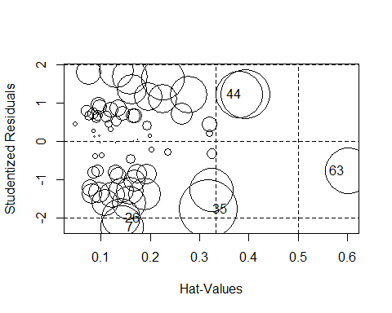

## StudRes Hat CookD  
## 7 -2.2216984 0.1427033 0.06970481  
## 26 -1.9810046 0.1407694 0.05549810  
## 35 -1.7619901 0.3178324 0.12665226  
## 44 1.2421570 0.3925015 0.08974083  
## 63 -0.7552603 0.6009124 0.07869534

# Q7. 변수선택 했을 때 결과는??  
  
  
  
# 관측값과 예측값 간 그림 그려보기  
obs.lm <- data4$l  
pred.lm <- out4$fitted.values^(1/power)  
  
(lm.rmse<-sqrt(sum((obs.lm-pred.lm)^2,na.rm=T)/length(out$residuals)))

## [1] 3.472486

plot(obs.lm, pred.lm, pch=16)

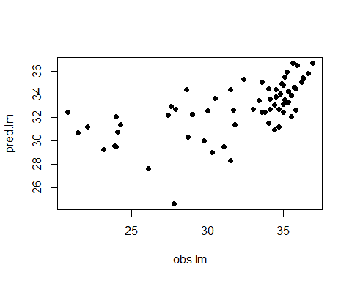

# randomforest모형과 비교해보기  
if(!require(randomForest)) install.packages("randomForest", repos = "http://cran.us.r-project.org");library(randomForest)

## Loading required package: randomForest

## Warning: package 'randomForest' was built under R version 3.4.4

## randomForest 4.6-14

## Type rfNews() to see new features/changes/bug fixes.

colnames(data2)

## [1] "id" "light" "prec" "rh" "s_30" "s_60" "s_90"   
## [8] "s_temp" "s_trans" "temp" "ws" "l"

rf_l=randomForest(l~.-id,data2)  
pred.rf<-predict(rf_l,newdata=data2)  
obs.rf <- data2$l  
(rf.rmse<-sqrt(sum((obs.rf-pred.rf)^2,na.rm=T)/length(obs.rf)))

## [1] 1.687784

plot(obs.rf, pred.rf, pch=15)

