Fall Detection by 1D-CNN based on public dataset
Songsheng LI
Saint Francis University, Hong Kong
Abstract. Falls among the elderly population pose a significant threat, often leading to severe injuries, loss of independence, and even fatality. To address this critical issue, researchers have been exploring various approaches to develop effective fall detection systems. In this study, we present a novel fall detection algorithm that leverages the WEDA-FALL dataset, a comprehensive dataset that includes data from wrist-worn sensors capturing both simulated and real-world fall incidents involving elderly individuals. The key insight behind our approach is the observation that falls often exhibit distinct patterns in sensor data. To capture these patterns, we employ a one-dimensional convolutional neural network (1D-CNN) architecture, which has been shown to be well-suited for time-series data analysis. By training our model on the WEDA-FALL dataset, we were able to achieve an impressive accuracy of 94% in fall detection, surpassing the commonly reported accuracy levels of around 90% in the existing literature. The high performance of our algorithm can be attributed to the use of the WEDA-FALL dataset and the effectiveness of the 1D-CNN architecture in extracting and learning the characteristic patterns in the sensor data. Notably, our algorithm offers the key features of being quick, highly accurate, and cost-effective, making it a promising solution for practical deployment in real-world settings to improve the safety and well-being of the aging population.
Keywords. Fall Detection, gyroscope, 1D-CNN, WEDA-FALL

Introduction
First paragraph.
Second paragraph.

Experimental methods
First paragraph.
Second paragraph.

Fall pattern

CNN
Convolutional neural networks (CNNs) are a type of deep learning architecture particularly well-suited for processing and analyzing spatial data, such as images. CNNs consist of multiple layers that perform convolution, pooling, and fully connected operations to extract relevant features from the input data. The convolutional layers apply filters to local regions of the input, allowing the network to learn spatial patterns. The pooling layers then reduce the spatial dimensions of the feature maps, while the fully connected layers perform classification or regression tasks based on the extracted features. For time-series data like sensor readings, a 1D-CNN architecture is more appropriate, as it operates on 1-dimensional sequences rather than 2D images. 1D-CNNs are able to effectively capture the temporal patterns in sensor data, making them a suitable choice for the fall detection task at hand, where the sensor readings exhibit characteristic patterns associated with fall events.

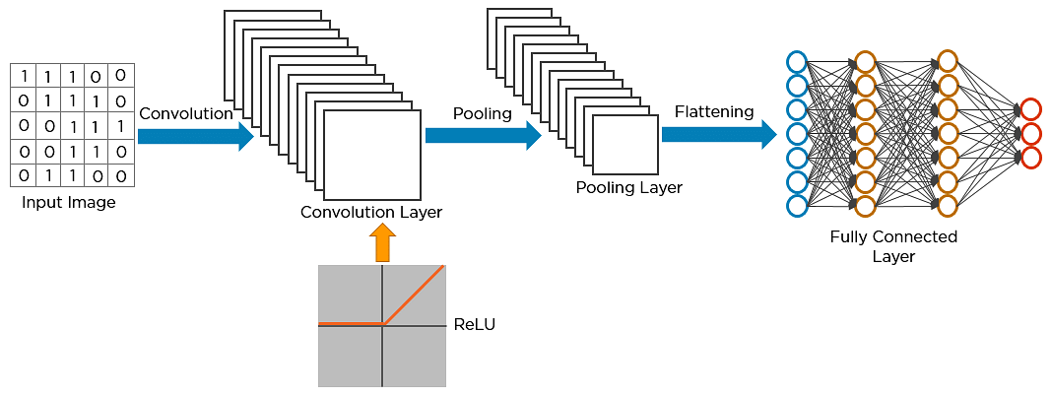
Figure 1. Short caption.

Dataset selection

Data Preparation
First paragraph.
- Item
- Item
- Item
Second paragraph.
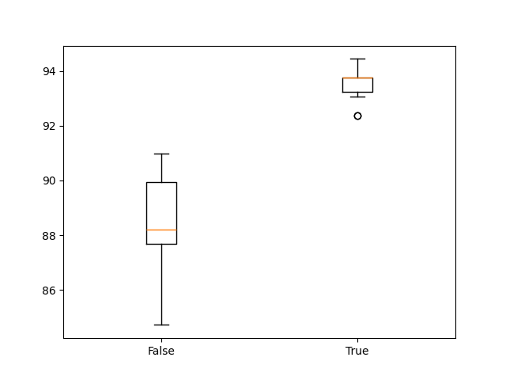
Figure 1. Short caption.

Table 1. Long caption. Long caption. Long caption. Long caption. Long caption. Long caption. Long caption. Long caption. Long caption
Column1 | Column2 | Column3
–10.2 | 10.2 | 10.2
5.36 | 6.32 | 6.32
–5.7 | 5.7 | 0.326
(1)

Results and discussion

Conclusions

References
- Petitti DB, Crooks VC, Buckwalter JG, Chiu V. Blood pressure levels before dementia. Arch Neurol. 2005 Jan;62(1):112-6.
- Rice AS, Farquhar-Smith WP, Bridges D, Brooks JW. Canabinoids and pain. In: Dostorovsky JO, Carr DB, Koltzenburg M, editors. Proceedings of the 10th World Congress on Pain; 2002 Aug 17-22; San Diego, CA. Seattle (WA): IASP Press; c2003. p. 437-68.

