# Clip 1 | Part 1: What a Hybris? Hybris 2105 b2c accelerator installation

## Part 1: Hybris Introduction

* What is hybris? For eCommerce
  + Single channel
  + Multi channel
  + Cross channel
  + Omni channel
* History
  + 1997 in Switzerland then locate to German
  + Aug 1st, 2013: acquired by SAP company
* Base on Spring framework to develop. The concepts need to know:
  + Dependency Injection (Inversion of control)
  + AOP (Aspect oriented programming)
  + Spring Security
  + Spring MVC

## Part 2: Hybris B2C Recipe Installation.

1. unzip the suite file and install b2c accelorator. Run cmd:

<hybris_root>\installer> installer.bat -r b2c_acc_plus -A initAdminPassword=admin

2. Setting ant command. run cmd:

<hybris_root>\hybris\bin\platform> setantenv.bat

<hybris_root>\hybris\bin\platform> ant -version // checking ant is set in env var.

se.cms.dragAndDrop

3. Generating the module for training purpose Run cmd:

<hybris_root>\hybris\bin\platform> ant modulegen -Dinput.module=accelerator -Dinput.name=training -Dinput.package=de.hybris.training -Dinput.plate=develop

4. Following these steps listed by command after running finished.

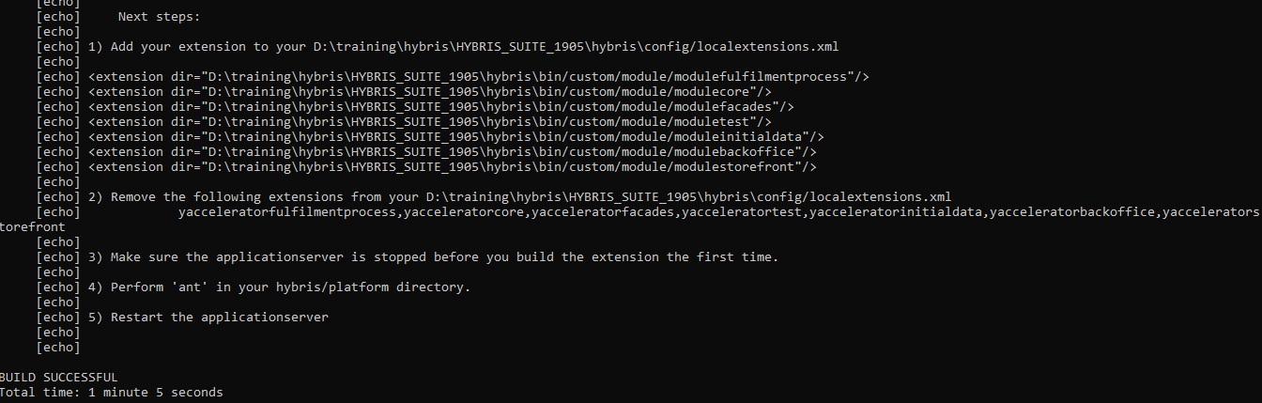

5. Add domain name for path:

* Open the local.properties file under <hybris_root>\hybris\config and add these line

*website.electronics.http=http://electronics.local:9001/modulestorefront*

*website.electronics.https=https://electronics.local:9002/modulestorefront*

*website.apparel-uk.http=http://apparel-uk.local:9001/modulestorefront*

*website.apparel-uk.https=https://apparel-uk.local:9002/modulestorefront*

*website.apparel-de.http=http://apparel-de.local:9001/modulestorefront*

*website.apparel-de.https=https://apparel-de.local:9002/modulestorefront*

* Open the host file under C:\Windows\System32\drivers\etc then modify:

*127.0.0.1 localhost electronics.local apparel-uk.local apparel-de.local*

6. Initialize system: database, structure, setup system. Take ~30 minutes

<hybris_root>\hybris\bin\platform> ant initialize

7. Start site. Run cmd:

<hybris_root>\hybris\bin\platform> hybrisserver.bat

8. Stop site. Ctrl + C on Command Line Console

# Clip 1 | Part 2: Import Hybris Project into IDE (IntelliJ, Eclipse) ---- DONE

<https://www.youtube.com/watch?v=TT0Bv1USjWk>

### Part 1: Import Hybris Project into Intellij IDE

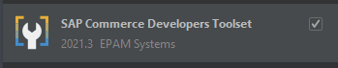

* Install plugin: ***SAP Commerce Developers Toolset*** by EPAM Systems
  + 1. Open File > Setting > Plugin
  + 2. Search the plugin by name > Install
* Steps to import:
  + 1. Click on File > New > Project from existing sources…
  + 2. Navigate to ***bin*** folder of your hybris project. > click ok
  + 3. Choose ***Import Project from External Model*** > choose ***hybris***
  + 4. Click on ***next*** to keep every setting as default.
  + 5. Change your JDK version (if any)
  + 6. Click on ***finish*** to import Hybris Project.

### Part 2: Import Hybris Project into Eclipse IDE

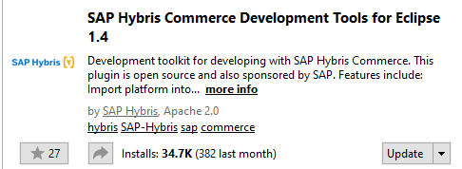

* Install Tool: **SAP Hybris Commerce Development Tools for Eclipse** x.x
  + On menu click Help > Eclipse Marketplace…
  + Search the tool name > install
* Steps to import:
  + On menu click File > import > SAP > Import SAP Platform > Next
  + Platform Home: Browse to **platform** folder of your Hybris project
  + Select on all other options.
  + Click on **Finish** to import project.

# Unit 2: Creating Custom Template --- DONE

<https://www.youtube.com/watch?v=ypU5X08oqvo>

# Unit 3: Creating Custom Component ---- DONE

<https://www.youtube.com/watch?v=lhRjfiMYX1w>

# Unit 4: Publishing a Page from Staged Mode to Online Mode ---- DONE

<https://www.youtube.com/watch?v=-uYEm9yuF58>

# Unit 5: Giving an Entry for Page ---DONE

<https://www.youtube.com/watch?v=wXUbSGpoOok>

# Unit 6: Create Content Slot for Page | Unique Content for Page ---- DONE

<https://www.youtube.com/watch?v=Fy-WY0qVIUU>