Beaconfire Inc, Home Work, Week3 Day14.

By (Ping) Nalongsone Danddank.

[ndanddank@gmail.com](mailto:ndanddank@gmail.com)

wechatID: ndanddank

**Short Answer:**

1. What is Dispatcher Servlet? How does it work?

-> The job of the DispatcherServlet is to take an incoming URI and find the right combination of handlers (generally methods on Controller classes) and views (generally JSPs) that combine to form the page or resource that's supposed to be found at that location.

The Dispatcher servlet is the bit that "knows" to call that method when a browser requests the page, and to combine its results with the matching JSP file to make an html document.

-> How does DispatchServlet process a request?

• Unifying the Request Processing

• Enriching the Request

• Dispatching the Request

• Handling the Request

• Processing Arguments and Return Values (Controller)

• Rendering the View

1. What is ViewResolver in Spring?

-> In the ModelAndView object, we will specify the view name, such as

login.jsp, so Spring has to look it up. This is where the ViewResolvers list

comes into play.

Spring uses ViewResolver to translate the view names in @Controller to actual View. The Spring auto-configuration (in this case WebMvcAutoConfiguration) will add few default ViewResolvers in your context. One of such view resolver is InternalResourceViewResolver . This defines prefix and suffix to the view name.

1. How is an incoming request mapped to a controller and mapped to a method?

-> When a request is issued to the application:

DispatcherServlet of the application receives the request.

DispatcherServlet maps the request to a method in a controller.

DispatcherServlet holds a list of classes implementing the HandlerMapping interface.

DispatcherServlet dispatches the request to the controller.

The method in the controller is executed.

1. What are the differences between @RequestParam and @PathVariable?

-> The key difference between @RequestParam and @PathVariable is that @RequestParam used for accessing the values of the query parameters where as @PathVariable used for accessing the values from the URI template.

1. What is the Spring MVC workflow?

-> 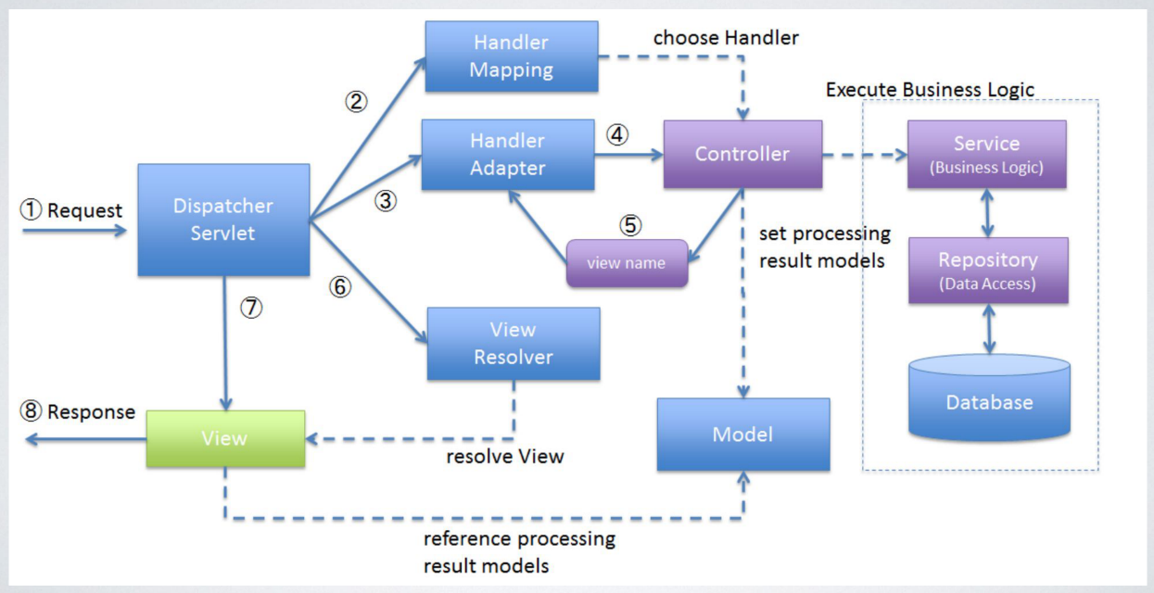

1. What is MVC? What are its advantages?

->MVC is an architecture that separates business logic, presentation and data.

In MVC,

• M stands for Model

• V stands for View

• C stands for controller

Advantages: Separation of Concern

• Loose coupling between model, view, and controller

• Can have multiple views

1. What is JSP?

-> JSP — Java Server Pages is a technology which is used to develop web pages by

inserting Java code into the HTML pages by making special JSP tags

1. What are JSP implicit objects?

-> represent some commonly used objects for servlets that JSP page developers might need to use.

There several build-in object in JSP. We can use them directly.

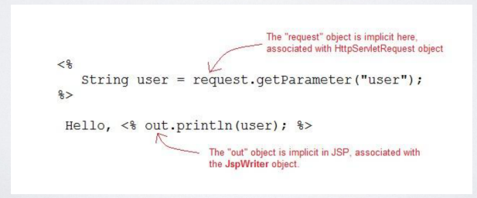

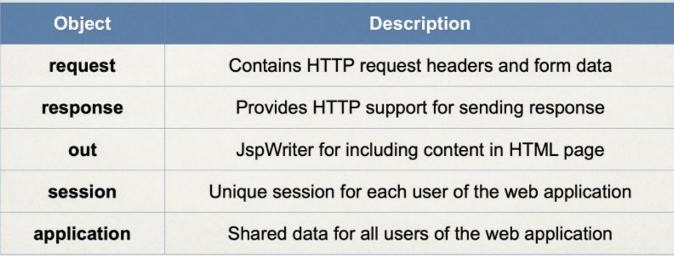

1. What is the difference between include directive and jsp:include action?

-> 1) Include directive includes the file at translation time (the phase of JSP life cycle where the JSP gets converted into the equivalent servlet) whereas the include action includes the file at runtime.

2) If the included file is changed but not the JSP which is including it then the changes will reflect only when we use include action tag. The changes will not reflect if you are using include directive as the JSP is not changed so it will not be translated (during this phase only the file gets included when using directive) for request processing and hence the changes will not reflect.

3) Syntax difference: Include directive: <%@ include file="file_name" %> whereas include action has like this <jsp:include page="file_name" />

4) **When using include action tag we can also pass the parameters to the included page by using param action tag but in case of include directive it’s not possible.**

<jsp:include page="file_name" />

<jsp:param name="parameter_name" value="parameter_value" />

</jsp:include>

1. What is JSTL?

-> JSP Standard Tag Library, It is a collection of custom JSP tag libraries that provide common web development functionality.