Beaconfire Inc, Home Work, Week5 Day19.

By (Ping) Nalongsone Danddank.

[ndanddank@gmail.com](mailto:ndanddank@gmail.com)

wechatID: ndanddank

**Short Answer:**

1. What is a web service?

-> Web services provide a common platform that allows multiple applications built on various programming languages to have the ability to **communicate** with each other.

• Web service is a standardized medium to propagate communication between the **client and server** applications on the World Wide Web.

1. What are the differences between REST and SOAP?

->

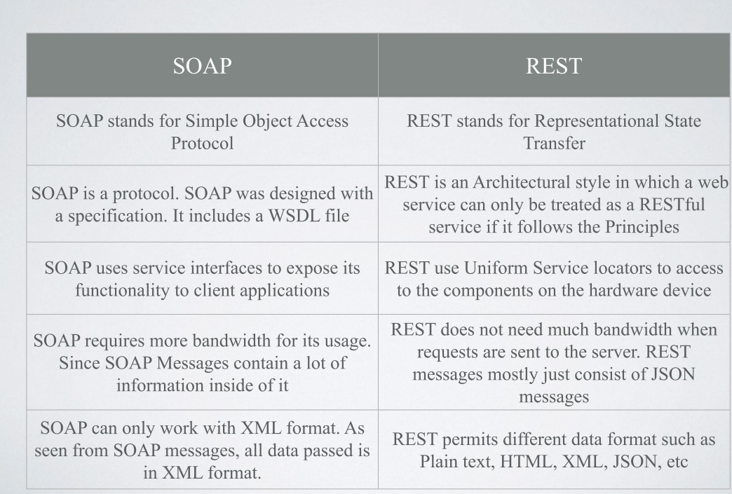

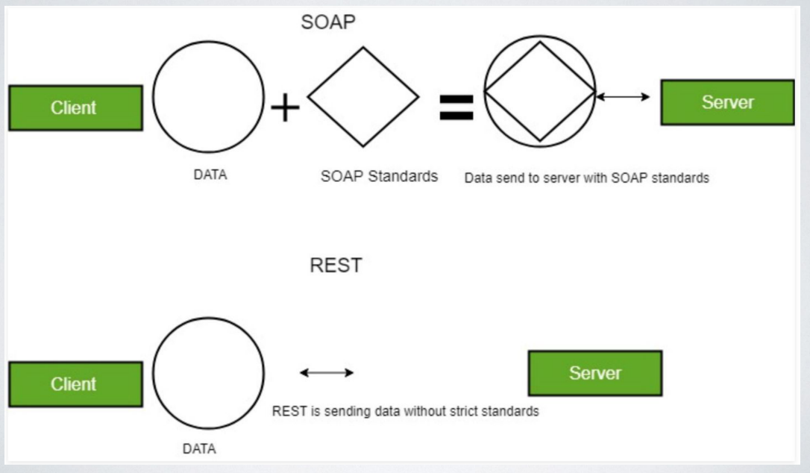

1. What is RESTful web service? List some of its advantages?

-> REST stands for Representational State Transfer • REST is used to build Web services that are lightweight, maintainable, and scalable in nature.

• A service which is built on the REST architecture is called a RESTful service.

• The underlying protocol for REST is HTTP, which is the basic HTTP protocol.

• Request

• Response

• Http Method

One of the key advantages of REST APIs is that they provide a great deal of flexibility. Data is not tied to resources or methods, so REST can handle multiple types of calls, return different data formats and even change structurally with the correct implementation of hypermedia.

1. Describe the RESTful principles.

-> **Client-Server** — It means that the server will have a **RESTful web service** which would provide the required functionality to the client.

• **Stateless** — It's up to the client to ensure that all the required information is provided to the server; The **server** should **not maintain** any sort of **information** between **requests from the client.**

• **Cache** — The cache is a concept implemented on the **client** to **store requests** which have already been **sent** to the **server**. So if the same request is given by the client, instead of going to the server, it would **go** to the **cache** and **get** the required **information**.

• **Layered System** — An application architecture needs to be **composed of multiple layers**. **Each layer doesn’t know** anything about **any layer** other than that of immediate layer and here can be lot of intermediate servers between client and the end server (Like the cache layer to improve the performance)

• **Uniform Interface** — It suggests that there should be a uniform way of interacting with a given server irrespective of device or type of application (website, mobile app)

• **Code on demand** — **Servers** can also **provide executable code** to the **client**. For example, the server may provide executable **JavaScript** to the client.

1. What is the usage of @RestController?

-> The **@RestController** is the **central** artifact in the entire Web Tier of the RESTful API.

The @RestController is a shorthand to **include** both the **@ResponseBody** and the **@Controller** annotations in our class.

• As with any controller, the actual value of the mapping, as well as the HTTP method, determine the target method for the request.

• @RequestBody will bind the parameters of the method to the body of the HTTP request.

• @ResponseBody does the same for the response and return type.

1. What is RestTemplate?

-> if need to **invoke one** or **more RESTful web services** in our backend code

-> The RestTemplate is the central Spring class for client-side HTTP access. Conceptually, it is very similar to the JdbcTemplate, JmsTemplate, and the various other templates found in the Spring Framework and other portfolio projects.

-> **To Exchange message**