Beaconfire Inc, Home Work, Week5 Day21.

By (Ping) Nalongsone Danddank.

[ndanddank@gmail.com](mailto:ndanddank@gmail.com)

wechatID: ndanddank

**Short Answer:**

1. How do you monitor your application? Please provides examples.

-> Mostly we use Actuator, it is a manufacturing term that refers to a mechanical device for moving or controlling something. **Actuators can generate a large amount of motion from a small change**.

In spring boot app we just add Actuator dependency to pom.xml, then it provides many features to monitor our app through http endpoint like /health /info, /beans...

• /health – summaries the health status of our application

• /info – returns general information. It might be custom data, build information or details about the latest commit.

• /beans – displays a complete list of all the Spring beans in your application

1. Explain the difference between these log level: INFO, WARN and ERROR.

-> INFO: used to log the information of app is working as expected.

WARN: show that some part of our program or app still have problems but not impact to all functions.

ERROR: is the highest log level and serious problem that affect a significant part of the system or some part of the app that has failed and stop the program.

1. What is AOP and Why do we need it?

-> AOP — Aspect-Oriented Programming

The key unit of modularity in OOP is the class, whereas in **AOP the unit of modularity is the aspect.**

Aspects enable the modularization of concerns (such as audit log) that cut across multiple types and objects. (Such concerns are often termed **“crosscutting” concerns** in AOP literature.)

-> The Spring AOP helps in breaking down the logic of the program into several distinct parts called as concerns. Cross-cutting concerns is the functions which span multiple points of an application.

1. What is Proxy design pattern?

-> Proxy design pattern provides an object of class that has the functionality of another class. A proxy controls access to the original object, allowing you to perform something either before or after the request gets through to the original object.

A proxy is a wrapper or agent object that is being called by the client to access the real serving object behind the scenes. Use of the proxy can simply be forwarding to the read object or can provide additional logic.

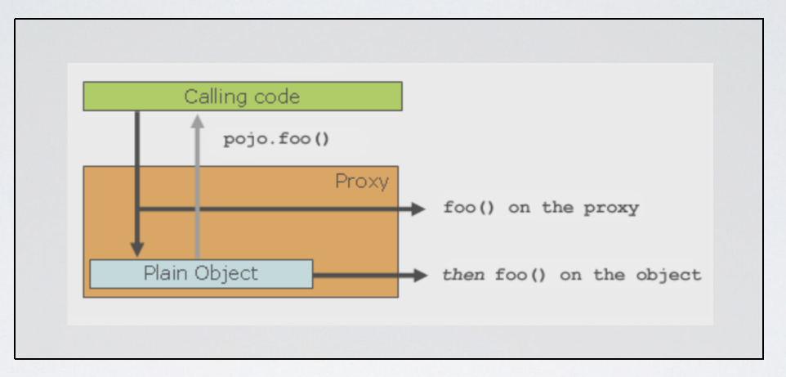

1. What is Joint Point?

-> A join point is a specific point in the application such as method execution, exception handling, changing object variable values, etc. In Spring AOP a join point always represents a method execution.

1. What is Advice?

->Advice: action taken by an aspect at a particular join point. Different types of advice include "around," "before" and "after" advice.

1. What is Point Cut?

-> Pointcut is a set of one or more JoinPoint where an advice should be executed.

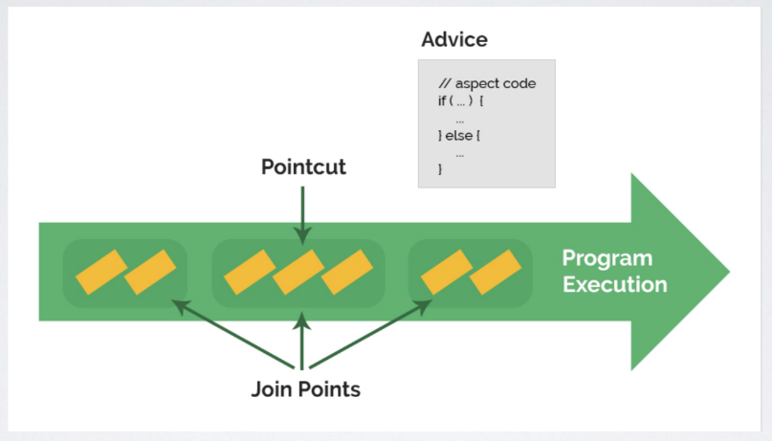

AOP

@ExceptionHandler

@ControllerAdvice

ResponseEntity