(Ping) Nalongsone Danddank
CSCI2016
MIPS Assignment #1

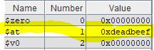
-
--------------oo----------------

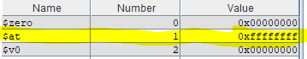
## Ch12-3.asm
## Put 0xFFFFFFFF into register $1
.text
.globl main

main:
ori $1, $0, 0x01 # put 0x01 into register $1
srl $1, $1, 1 # shift right logical by 4
nor $1, $1, $1 # using nor register flip $1 from 0 to 1.
## End of file
--------------oo----------------

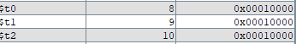
## Ch13-2.asm
## Shifting and Adding
.text
.globl main

main:
#Adding 0x1000 16 times.
ori $8, $0, 0 #0
addi $8, $8, 0x1000 #1
addi $8, $8, 0x1000 #2
addi $8, $8, 0x1000 #3
addi $8, $8, 0x1000 #4
addi $8, $8, 0x1000 #5
addi $8, $8, 0x1000 #6
addi $8, $8, 0x1000 #7
addi $8, $8, 0x1000 #8
addi $8, $8, 0x1000 #9
addi $8, $8, 0x1000 #10
addi $8, $8, 0x1000 #11
addi $8, $8, 0x1000 #12
addi $8, $8, 0x1000 #13
addi $8, $8, 0x1000 #14
addi $8, $8, 0x1000 #15
addi $8, $8, 0x1000 #16

#Shifting to left 4
ori $9, $0, 0x1000 #1
sll $9, $9, 4 #shift 4

#Adding itself
ori $10, $0, 4096 #1
add $10, $10, $10 #2
add $10, $10, $10 #3
add $10, $10, $10 #4
add $10, $10, $10 #5

## End of file
--------------oo----------------

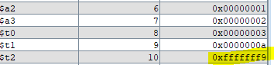
## Ch13-4.asm
## Arithmetic Expression: 3x - 5y, initialize x=1, y=2
.text
.globl main

main:
ori $8, $0, 0x01 # initialize $8(x) to 1
ori $9, $0, 0x02 # initialize $9(y) to 2
or $6, $0, $8 # set x to $6 for temporary
or $7, $0, $9 # set y to $7 for temporary
sll $8, $8, 1 # 2*x by shift $8 left l
add $8, $8, $6 # 2*x + x= 3x by add $6
sll $9, $9, 2 # 4*y by shift $9 left 2
add $9, $9, $7 # 4*y + y =5y by add $7
sub $10, $8, $9 # 3x - 5y then store to $10

## End of file
--------------oo----------------

