(Ping) Nalongsone Danddank
CSCI2016
MIPS Assignment #3
March 25, 2019

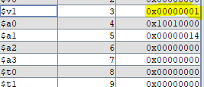
## Ch18-3.asm
## Check that 20 <= temp <= 40 60 <= temp <= 80
## Set flag to 1 if in range, to 0 if out of range
## Registers:
## $5 --- temperature
## $3 --- in/out range indicator flag
## $8 --- scratc

.data
w1: .word 20
w2: .word 100
.text
.globl main
main:
# Set range indicator to 1
ori $3, $0, 1 # set $3 to 1
lui $4, 0x1001 # Init base register to $7
lw $5, 0($4) # Laod 30 for test.
#lw $5, 4($4) # Laod 100 for test.

# Test 60 <= temp <= 80
sltiu $8, $5, 81
beq $8, $0, out
sll $0, $0, 0
sltiu $8, $5, 60
beq $8, $0, cont
sll $0, $0, 0

# Test 20 <= temp <= 40
sltiu $8, $5, 41
beq $8, $0, out
sll $0, $0, 0
sltiu $8, $5, 20
beq $8, $0, cont
sll $0, $0, 0

out: ori $3, $0, 0 # clear flag to 0
cont: sll $0, $0, 0 # Stop the programming
## End of file
--------------oo----------------
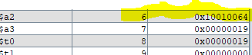
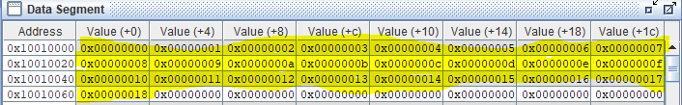
## Ch19-1.asm
## Program to store 0 to 24 to memory address.
## Regesters
## $6 base address
## $7 start number
## $8 last number
.data
array: .space 100
.text
.globl main
main:
lui $6,0x1001 # Save base address
ori $7, $0, 0 # Initialize $7 <- 0
ori $8, $0, 25 # set $8 <- 25

loop:
beq $7, $8, exit
sll $0, $0, 0
sw $7, 0($6)
sll $0, $0, 0
addiu $7, $7, 1
addiu $6, $6, 4

j loop
sll $0, $0, 0

exit: # Stop the programming
sll $0, $0, 0

## End of file
--------------oo----------------

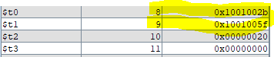
## Ch20-3.asm
## Space Removal
## Registers:
## $8 -- pointer to the original string
## $9 -- pointer to the resulting string
## $10 -- space char
## $11 -- temporary to load char to store to $9
.data
string: .asciiz "Is this a dagger which I see before me?"
.text
.globl main

# Initialize
main: ori $10, $0, 0x20
lui $8, 0x1001 # point at first original string
Lui $1, 0x1001 # pointer to the resulting string
ori $9, $1, 0x40

# while not ch==null do
loop:
lbu $11,0($8) # get the char
sll $0,$0,0 # branch delay

# If char is the space skip it.
beq $11, $10, space
sll $0,$0,0 # branch delay

# If char is the null or the end of string, end program.
beq $11,$0, done # exit loop if char == null
sll $0,$0,0 # branch delay

# store the characters without space to memory address $9
Sb $11, 0($9)
addi $8, $8, 1 # point at the next original char
addi $9, $9, 1 # point at the next resulting char

j loop
sll $0,$0,0 # branch delay slot

space:
addi $8, $8, 1
j loop
sll $0,$0,0 # branch delay slot

done:
sll $0,$0,0 # target for branch

## End of file
--------------oo----------------

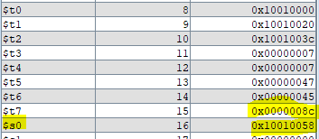
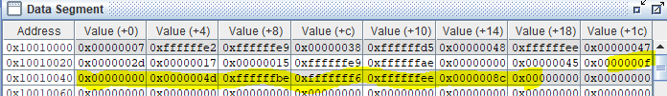
## Ch21-2.asm
## program Pair-wise Addition, implement a loop that adds corresponding elements in the first two arrays and stores the result in the corresponding element of the result array.
## Registers:
## $t0 -- pointer to size of array
## $t1 -- pointer to array1
## $t2 -- pointer to array2
## $s0 -- pointer to result
## $t4-7 -- they are temporary availible
.data
size: .word 7
array1: .word -30, -23, 56, -43, 72, -18, 71
array2: .word 45, 23, 21, -23, -82, 0, 69
result: .word 0, 0, 0, 0, 0, 0, 0
.text
.globl main
# Initialize each availible
main:
la $t0, size
la $t1, array1
la $t2, array2
la $s0, result
li $t3, 0
lw $t4, 0($t0)
nop

loop: beq $t3, $t4, done #if $t3 == size of array, exit.
nop

lw $t5, 0($t1)
lw $t6, 0($t2)
addu $t7, $t5, $t6 #$t7 <- add each corresponding elements
sw $t7, 0($s0) #store resultof adding to $s0.
nop

#Increasing the index and address of arrays
addi $t3, $t3, 1
addi $t1, $t1, 4
addi $t2, $t2, 4
addi $s0, $s0, 4
nop

# Jump to loop for continue
j loop
done: nop # end the program.
## End of file
--------------oo----------------

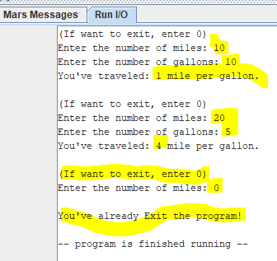
## Ch22-1.asm
## program Miles per Gallon. repeatedly prompts the user for the number of miles traveled and the gallons of gasoline consumed, and then prints out the miles per gallon. Exit when the user enters 0.

.data
M_prompt: .asciiz "(If want to exit, enter 0)\nEnter the number of miles: "
G_prompt: .asciiz "Enter the number of gallons: "
E_prompt: .asciiz "\nYou've already Exit the program!\n"
R_prompt: .asciiz "You've traveled: "
mpp: .asciiz " mile per gallon.\n\n"
.text
.globl main
main:
li $v0, 4 # print prompt for entering miles
la $a0, M_prompt
syscall
li $v0, 5 # wait user enter number for miles
syscall
beq $v0, $0, done # If user enter 0, end program
nop
or $t1, $0, $v0 # put data of mile to $t1

li $v0, 4 # print prompt for entering gallons
la $a0, G_prompt
syscall
li $v0, 5 # wait user enter number for gallons
syscall
beq $v0, $0, done # If user enter 0, end program
nop
or $t2, $0, $v0 # put data of gallon to $t2

li $v0, 4 # print prompt for showing result
la $a0, R_prompt
syscall

divu $t1, $t2 # miles / gallons -> $a0
mflo $a0
li $v0, 1 # print the integers of result of division
syscall
li $v0, 4
la $a0, mpp
syscall
j main # Loop until user entering zero number.

done:
li $v0, 4 # When exit the program print the exit prompt.
la $a0, E_prompt
syscall
li $v0, 10 # Exit the program.
Syscall

## End of file
--------------oo----------------

