Week 08 Activities
Read Chapters 14-17 in the Kjell Tutorial
Completed at 2:21 AM on Tuesday, March 5, 2019
Read Chapters 14-17 in the Kjell tutorial
Complete MIPS Assignment 02
Completed at 2:21 AM on Tuesday, March 5, 2019
- Complete the following problems:
- Chapter 14, Exercise 2 (use x=1 as test values). Put result in $10.
- Chapter 15, Exercise 2 (use x=0, y=1 as test values). Put result in $10.
- Chapter 16, Exercise 1. Put result in $10 in addition to storing in a memory location.
- Chapter 17, Exercise 3. Put result in $15.
- Please only use MIPS instructions presented up to the chapter in which the problems are. In other words, don't use instructions presented in Chapter 13 to solve problems presented in Chapter 12.
- Paste source code and screenshots of registers and data locations into a Word document and upload to the MIPS Assignment 02.
- Please make the screenshots readable. Seriously, please don't make the size so small I need a magnifying glass to read it! :) Highlight in yellow, the registers containing the final values specified by the problem.
Please note!
- When using MARS, please make sure that the Settings looks like:
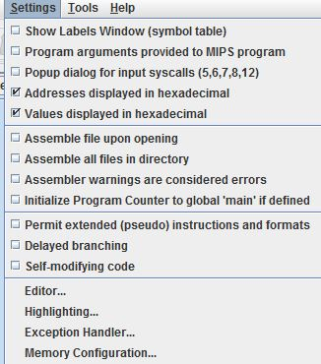
- Please uncheck the box permitting the use of the extended instructions
- You can, however, uncheck the two checked boxes ( ...displayed in hexadecimal) if you wish

