Greetings,

Sent on behalf of Lori Kirkeby Associate Registrar

This email is going to all instructors on Fall 2021 instructor listserv and you may disregard if you have already posted grades.

Fall course grades must be submitted within 2 business days of the end of the semester which ends Dec 12th.**Fall Semester 2021** grade deadline is **Tuesday Dec 14th, 11:59 PM** and it is critical for grades to be posted by this deadline. Please make sure you are able to login before deadline. See attached LDA/Grade Entry Power Point.

* **Metro does not use a A+ as a valid grade.** *(If you give an A+ it confuses the student when it is manually removed)*

Below is the link to take you directly to log in page for Faculty Management.

[https://eservices.minnstate.edu/faculty/public/secure/home/index?campusid=076](https://nam02.safelinks.protection.outlook.com/?url=https%3A%2F%2Feservices.minnstate.edu%2Ffaculty%2Fpublic%2Fsecure%2Fhome%2Findex%3Fcampusid%3D076&data=04%7C01%7Conline.learning%40metrostate.edu%7Ccfdf3bfa3abd42b5f11a08d9b444d042%7C5011c7c60ab446ab9ef4fae74a921a7f%7C0%7C0%7C637739031074422826%7CUnknown%7CTWFpbGZsb3d8eyJWIjoiMC4wLjAwMDAiLCJQIjoiV2luMzIiLCJBTiI6Ik1haWwiLCJXVCI6Mn0%3D%7C3000&sdata=EOnOx1%2BcRvAuxDqmYqMECNZJIIm0cdxP7%2Ban5EkOIFs%3D&reserved=0)

**Tips for successful grade entry:** *(Forgetting  to verify grades and entering password to Post Final Grades is the number one mistake made when an instructor has thought grades had been posted).*

1. **LDA entry should only be used if giving a grade of F.  Do not enter a LDA if giving a grade other than an F.**
2. **Grading System Pass/ No credit: S= performance at a "C-" level or better and "B" or better for graduate courses.**
3. After grades have been entered the display will include a count of selected students that will be posted.  This display is for review of selected students to validate grades entered are correctly.  After everything has been verified and is correct, the password needs to be re-entered as an e-signature.

* *Earned F* – fully participated in course
* *Unearned F* – stopped attending/participating before course end
* Click Partially Attended and enter LDA last date student attended/ participated see Calendar
* *Unearned F* – never attended
* Click “Never Attended” LDA will Auto Load
* Failure to record Non Attendance at the beginning of the term requires that you to do so now.

1. 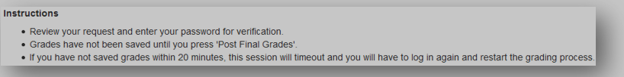

**5**. Click on **“Post”**

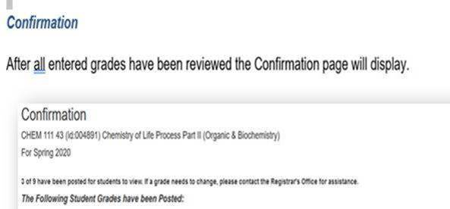

**Reminder:** Students who enroll for Faculty Designed Independent Studies (FDIS) are now expected to complete their work by the end of the semester. A student who completes a substantial amount of the required course work may request the instructor assign an incomplete (an "I" grade). Instructors are not required to give incompletes**.**

* Creative Learning Strategies: Student Designed Independent Studies (SDIS) PRIORS and Individualized Internships that begin in one term and end in the succeeding term must receive a grade of Incomplete ("I") at the end of the term in which the enrollment begins.
* **To confirm that your grades are posted: Click on Class List and all posted grades will show in the grade column.**

**If there are no grades showing you did not complete the last step when entering grades. After all grades are entered and you click on submit- you must verify your grade entry, enter your password and select post final grades. You will receive a confirmation that x number of grades have now posted for students to view**

* **To make a grade change:  Log back into Faculty Management and select Change of Grade from drop down menu.**

I am available day/evening by email/phone if you have any questions or need assistance.

Thank you

Laurie

Laurie Salin

Registrar’s Office – Grades/Registration Coordinator

[Laurie.salin@metrostate.edu](mailto:Laurie.salin@metrostate.edu)

651-793-1223 **(o)** **|** 763-783-7161 **(C** | [www.metrostate.edu](https://nam02.safelinks.protection.outlook.com/?url=http%3A%2F%2Fwww.metrostate.edu%2F&data=04%7C01%7Conline.learning%40metrostate.edu%7Ccfdf3bfa3abd42b5f11a08d9b444d042%7C5011c7c60ab446ab9ef4fae74a921a7f%7C0%7C0%7C637739031074432751%7CUnknown%7CTWFpbGZsb3d8eyJWIjoiMC4wLjAwMDAiLCJQIjoiV2luMzIiLCJBTiI6Ik1haWwiLCJXVCI6Mn0%3D%7C3000&sdata=m8qjLkbycRGVoqwzDeixy6uRwanUjeOLOXBIzGvsnVY%3D&reserved=0)

1450 Energy Park Drive **|** Saint Paul, MN **|** 55106

