D.K.T.E. Society’s Textile and Engineering Institute, Ichalkaranji
(An Autonomous Institute, Affiliated to Shivaji University, Kolhapur)

Accredited with ‘A+’ Grade by NAAC

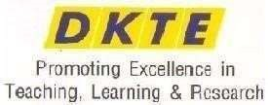

Department of Computer Science and Engineering (Artificial Intelligence and Machine Learning) 2025-2026.

THE COMMUNITY ENGAGEMENT PROJECT REPORT ON

“ECO-FRIENDLY CHALK FROM EGGSHELL WASTE”

Under the guidance of: Prof. Rekha Kamble

Developed By:
- Sneha Buchade 25UAM031
- Sanika pingale 25UAM040
- Anju koli 25UAM034
- Aditi pise 25UAM041
- . Swalehin Shikh 25UAM023

CERTIFICATE

This is to certify that,

1.Sneha Buchade 25UAM031
2. Sanika pingale 25UAM040
3.Anju koli 25UAM034
4.Aditi pise 25UAM041
5. Swalehin Shikh 25UAM023

Have successfully completed the project work, entitled

“ECO-FRIENDLY CHALK FROM EGGSHELL WASTE”

In partial fulfilment for the award of degree of Bachelor of Technology in Computer Science and Engineering (Artificial Intelligence and Machine Learning). This is record of their work carried out during academic year 2025- 26.

Prof. Rekha Kamble Prof. Dr. S.K.Shirgave [Project Guide] [Head of Department]

Date:07/10/2026

Place: Ichalkaranji

DECLARATION

We, the undersigned students of S.Y.C.S.E. (AIML), declare that the Community Engagement Project work report entitled “ECO-FRIENDLY CHALK FROM EGGSHELL WASTE”, prepared under the guidance of the project guide, is our original work. The field-visit information presented in this report was collected by us during our visit to the Egg Maggi House shop for studying the availability and disposal of eggshell waste. The project aims to reuse eggshell waste as a useful material for making eco-friendly chalk.
The work described in this report is prepared for academic purposes and reflects our study, observations, proposed preparation method, and community engagement activities.

Name PRN
- Sneha buchade 25UAM031
- Sanika pingale 25UAM040
- Anju koli 25UAM034
- Aditi pise 25UAM041
- Swalehin Shikh 25UAM023

Date: 07/10/2026

Place: Ichalkaranji

INDEX

CONTENTS

- Introduction
- Problem Statement
- Problem Description
4. Objectives and Requirements
- Field Visit Report
- Technical Solutions on Problem
- Authority Letter
- Conclusion
- References

INTRODUCTION
Eggshells are a common food waste material generated by homes, restaurants, food stalls, and other small food businesses. A large quantity of eggshell waste is usually thrown away along with general waste. Instead of treating eggshells only as waste, this project studies their reuse in the preparation of eco-friendly chalk.
Eggshells are mainly composed of calcium carbonate. After proper cleaning, drying, and grinding, the eggshells can be converted into a fine powder that can be incorporated into a chalk-making mixture. The project therefore connects community waste collection with a simple reuse idea.
As part of the Community Engagement Project, our team visited the Egg Maggi House shop to understand how eggs are used, how eggshell waste is generated, how it is stored or disposed of, and whether the waste can be collected for project use. The visit helped us understand the problem at the source and collect eggshell waste for further processing.
The project promotes the basic principles of waste reduction, reuse, and sustainable product development. The proposed eco-friendly chalk can be studied as an alternative product made partly from a locally available waste material.

PROBLEM STATEMENT

Eggshell waste generated from food shops and households is commonly discarded after the edible portion of the egg is used. If this waste is not handled properly, it becomes part of the general waste stream and is not reused.
At the same time, chalk is a frequently used educational material in schools, colleges, tuition classes, and other learning spaces. This project addresses both issues by exploring a simple method of converting collected eggshell waste into a useful chalk material.
The main problem addressed by this project is: “How can locally available eggshell waste from a food shop be collected, processed, and reused to develop an eco-friendly chalk product?”

PROBLEM DESCRIPTION

During food preparation, eggshells are left after eggs are used. At a small food business such as Egg Maggi House, repeated use of eggs can produce a regular amount of eggshell waste. Without a planned collection method, the shells are mixed with other waste and lose their potential value as a reusable material.
Our project focuses on collecting this waste from the source, cleaning it properly, drying it, and grinding it into a fine powder. The powder can then be mixed with suitable chalk-making ingredients and shaped into chalk sticks.
The project also creates awareness about waste segregation. Instead of immediately throwing eggshells away, food shops can keep them separately so that they may be reused for suitable educational or craft applications.

4. OBJECTIVES AND REQUIREMENTS
Objectives:
• To identify a locally available source of eggshell waste.
• To visit the Egg Maggi House shop and study eggshell generation and disposal.
• To collect eggshell waste for project experimentation.
• To clean, dry, and grind eggshells into a fine powder.
• To study a simple method for preparing chalk using eggshell powder.
• To promote the reuse of food waste and environmental awareness.
• To develop a low-cost academic prototype of eco-friendly chalk.
Basic material requirements:
• Collected eggshell waste
• Clean water for washing
• Container/tray for cleaning and drying
• Sunlight or a suitable drying method
• Mortar and pestle/grinder for making fine powder
• Suitable chalk binder/base material
• Mixing bowl and spoon
• Chalk moulds or suitable cylindrical moulds
• Gloves and mask for hygienic handling

FIELD VISIT PHOTOS
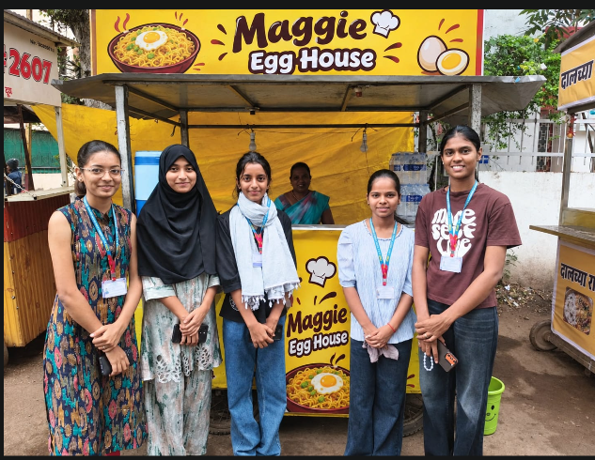

Image 1 : Visiting Egg Maggi House shop

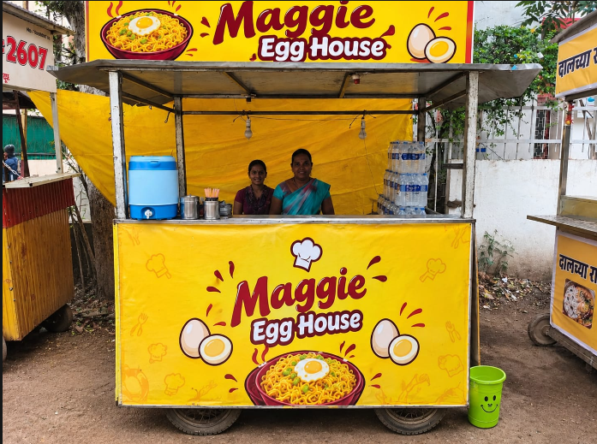

TECHNICAL SOLUTIONS ON PROBLEM

The proposed solution is to reuse cleaned eggshell waste as a powdered component in an eco-friendly chalk formulation. The following process can be followed for the academic prototype:
Step 1 – Collection
Collect discarded eggshells from the Egg Maggi House shop and keep them separately from other waste.
Step 2 – Cleaning
Wash the shells thoroughly with clean water to remove remaining egg material and surface dirt.
Step 3 – Drying
Dry the cleaned shells completely using sunlight or another suitable hygienic drying method.
Step 4 – Grinding
Crush and grind the dry eggshells into a fine powder. Sieve the powder if necessary to remove larger particles.
Step 5 – Mixing
Mix the fine eggshell powder with a suitable chalk base/binder according to the selected prototype formulation. Add water gradually to obtain a workable paste.
Step 6 – Moulding
Fill the prepared mixture into chalk moulds and compact it properly to obtain the desired shape.
Step 7 – Drying and Finishing
Allow the moulded chalk to dry completely. Remove the chalk sticks carefully and smooth rough edges if required.
Step 8 – Testing
Test the prototype for basic properties such as hardness, writing performance, breakage, smoothness, and ease of handling.
Simple process flow:
Eggshell Waste → Collection → Washing → Drying → Grinding → Fine Eggshell Powder → Mixing with Chalk Base → Moulding → Drying → Eco-Friendly Chalk Prototype

AUTHORITY LETTER

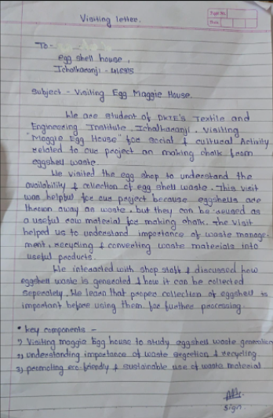

CONCLUSION

The Eco-Friendly Chalk from Eggshell Waste project demonstrates a simple way to connect community waste collection with sustainable product development. By visiting the Egg Maggi House shop, our team identified a local source of eggshell waste and collected the discarded shells for project use.
The proposed process involves collection, cleaning, drying, grinding, mixing, moulding, drying, and basic testing. Through this activity, eggshell waste can be given a useful second purpose instead of being immediately discarded.
The project also highlights the importance of community participation. Local food shops can contribute to waste-reuse activities by separating suitable waste materials. Further experimentation and testing can be carried out to improve the chalk formulation, strength, smoothness, writing quality, and overall performance of the prototype.

REFERENCES
1. U.S. Food and Drug Administration (FDA), information on egg safety and hygienic handling.
2. General educational resources on eggshell composition and calcium carbonate.
3. Community Engagement Project field observations and information collected during the visit to Egg Maggi House shop.
4. Team observations and experimental work carried out for the Eco-Friendly Chalk from Eggshell Waste project.

