Ping Jiang
Prof. Rebin A Muhammad
DATA 110
29 October 2025
NHL Top Goalie Performance Analysis (2024–2025 Season)

1. Introduction
In this project for DATA 110, I analyzed NHL goaltender performance during the 2024–2025 season using real-world hockey data. The dataset contains goalie statistics such as goals allowed, expected goals (xGoals), ice time, rebound counts, freezes, and shots faced (onGoal) across multiple game situations. The analysis focuses on the four semifinal goalies—Sergei Bobrovsky, Igor Shesterkin, Stuart Skinner, and Jake Oettinger—to discover patterns, consistency, and play styles using data visualization.

2. EDA Process and Key Observations
The Exploratory Data Analysis (EDA) process involved loading and cleaning the dataset, understanding data structure, and identifying key variables. It is the foundation of this project, it helped me prepare, understand, clean, and interpret the data before creating meaningful visualizations. Before visualization, I identified through EDA the key variables in the dataset such as goals, xGoals, icetime, rebounds, and freeze; understood what each column represents (e.g., onGoal = shots faced, xGoals = expected goals); recognize how different situations (5-on-5, 4-on-5, 5-on-4) affect goalie stats. It also let me filter out only the four semifinal goalies (Bobrovsky, Shesterkin, Skinner, Oettinger), as well as checking for missing or incorrect values to ensure the charts show accurate and fair comparisons, rather than misleading data. This foundation allowed me to decide which data to visualize so I could focus on meaningful metrics rather than random numbers.
Through the visualization process, EDA guided which charts to use. By creating bar graphs, KDE curves, and pair plots, EDA, I learned how ice time, goals, and rebound control vary by goalie, the relationship between freezes vs. rebounds (play style), and the connection between xGoals and actual goals (performance above or below expectation).These insights shaped my data story, showing who’s consistent or aggressive.
Key Observations:
- Bobrovsky and Shesterkin showed highly consistent performance with few outlier games.
- Skinner displayed greater variability, reflecting an aggressive style.
- Oettinger balanced control and adaptability, performing reliably across game situations.
- Freeze vs. Rebound rates highlighted differences in play style.
- The correlation between xGoals and goals revealed performance above or below expectation.

3. Visualization Summaries and Insights

A. Combined Bar Graph — Total Danger Shots (Low + Medium + High)
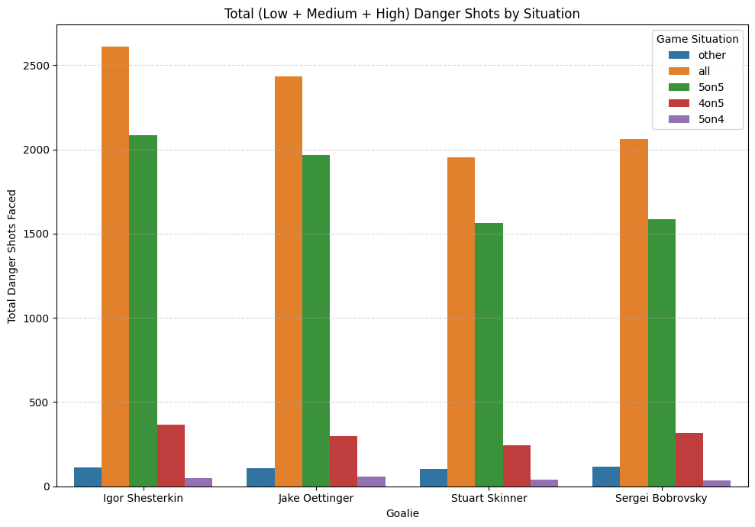
- Rationale: To summarize the overall shot quality faced by each goalie, combining danger levels provides a complete view of workload difficulty.
- Insights: Bobrovsky and Shesterkin faced slightly fewer total danger shots but maintained strong performance. Skinner faced more high-danger shots, contributing to his variability in GSAx.

B. Ice Time Distribution (KDE Plot)
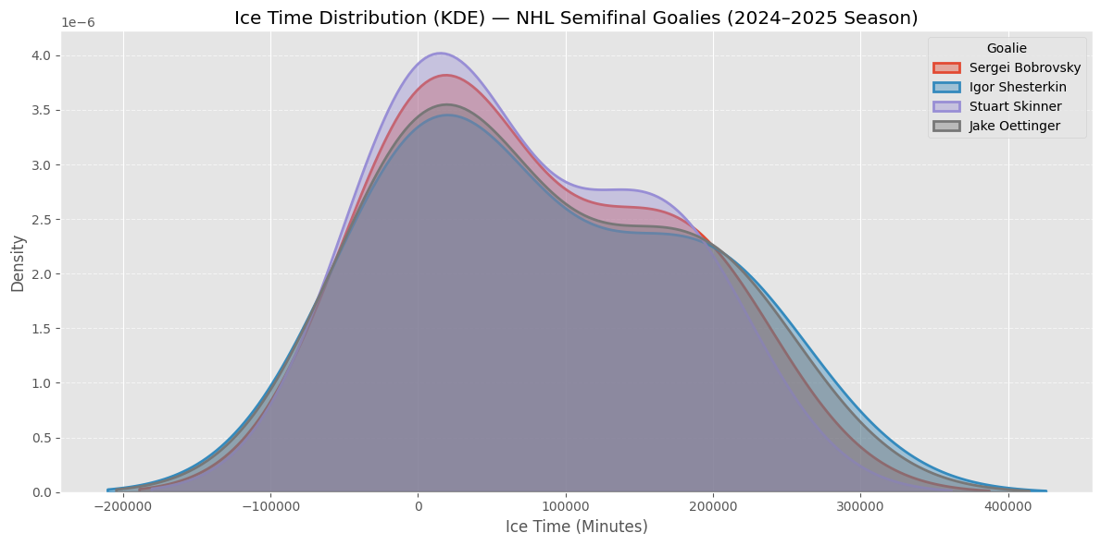
- Rationale: The KDE plot shows the smooth distribution of ice time, revealing consistency and workload differences.
- Insights: Shesterkin and Bobrovsky have narrow peaks, indicating steady game usage. Skinner’s wider curve shows variation, while Oettinger is in between.

C. Individual Bar Graph — GSAx by Game Situation
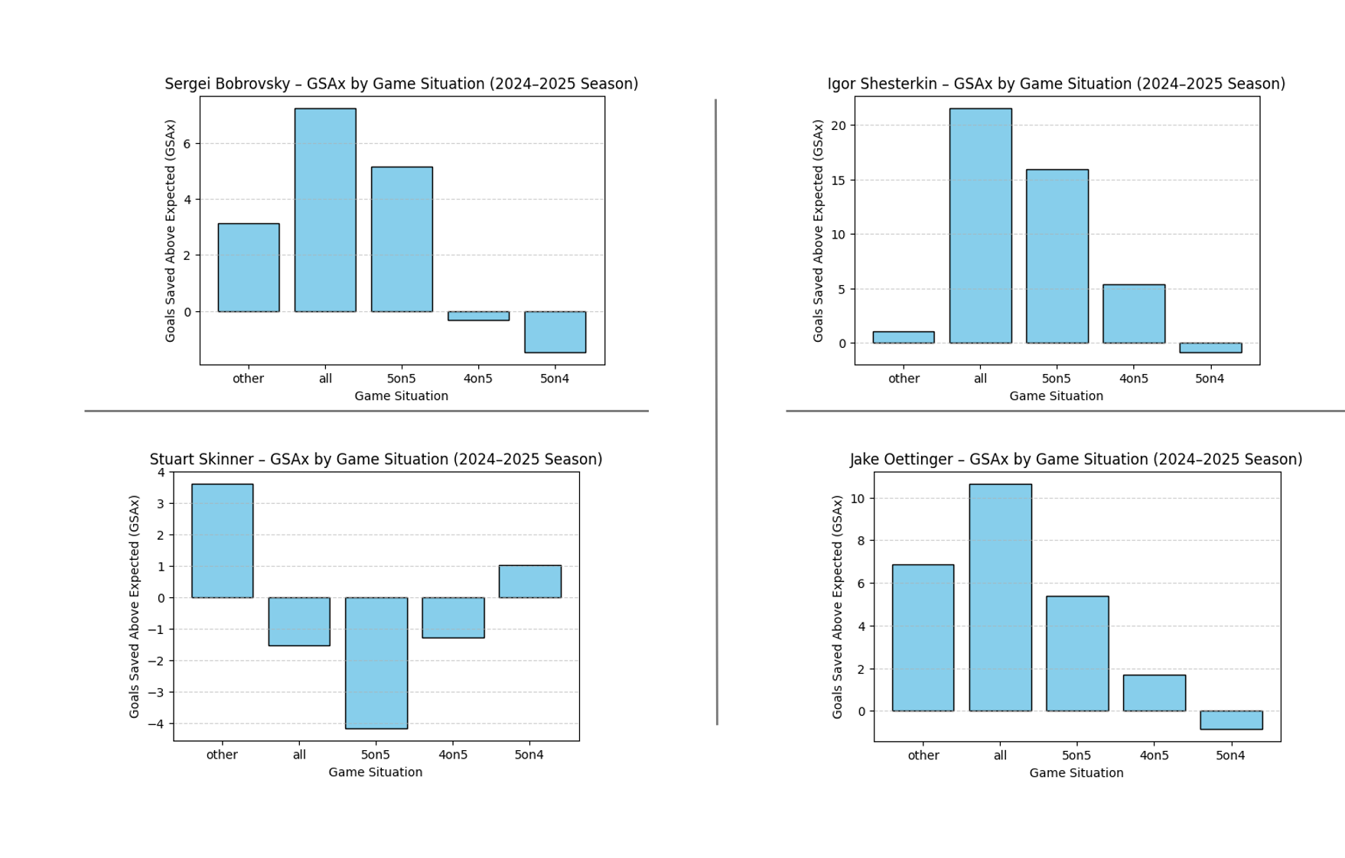
- Rationale: A bar chart effectively compares GSAx across game situations like 5-on-5 and 4-on-5.
- Insights: Positive GSAx indicates above-expected performance. Shesterkin performed strongest facing the strongest team in the NHL, while Skinner fluctuated and Oettinger remained balanced.

D. Individual Bar Graph — Play Style (Freezes vs. Rebounds)
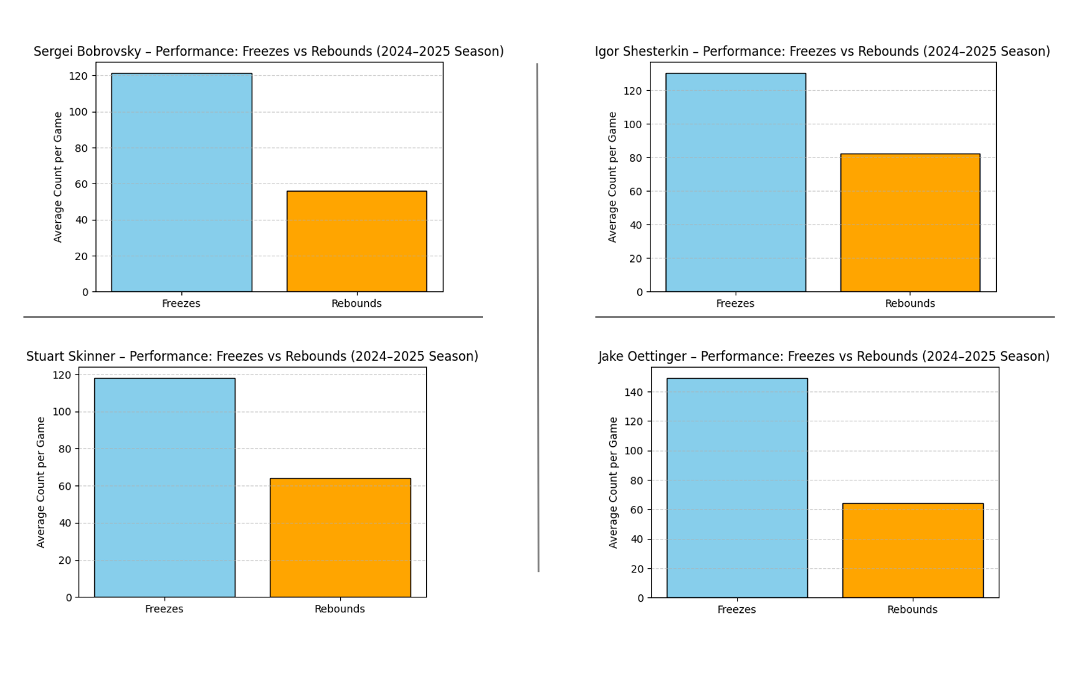
- Rationale: This visualization compares how goalies manage puck control. High freeze counts reflect conservative play; high rebounds show aggressiveness.
- Insights: Bobrovsky and Shesterkin favored puck control with high freezes, while Skinner showed an aggressive, rebound-heavy approach. Oettinger displayed balance.

E. Seaborn Pairplot — Relationships Between Key Metrics

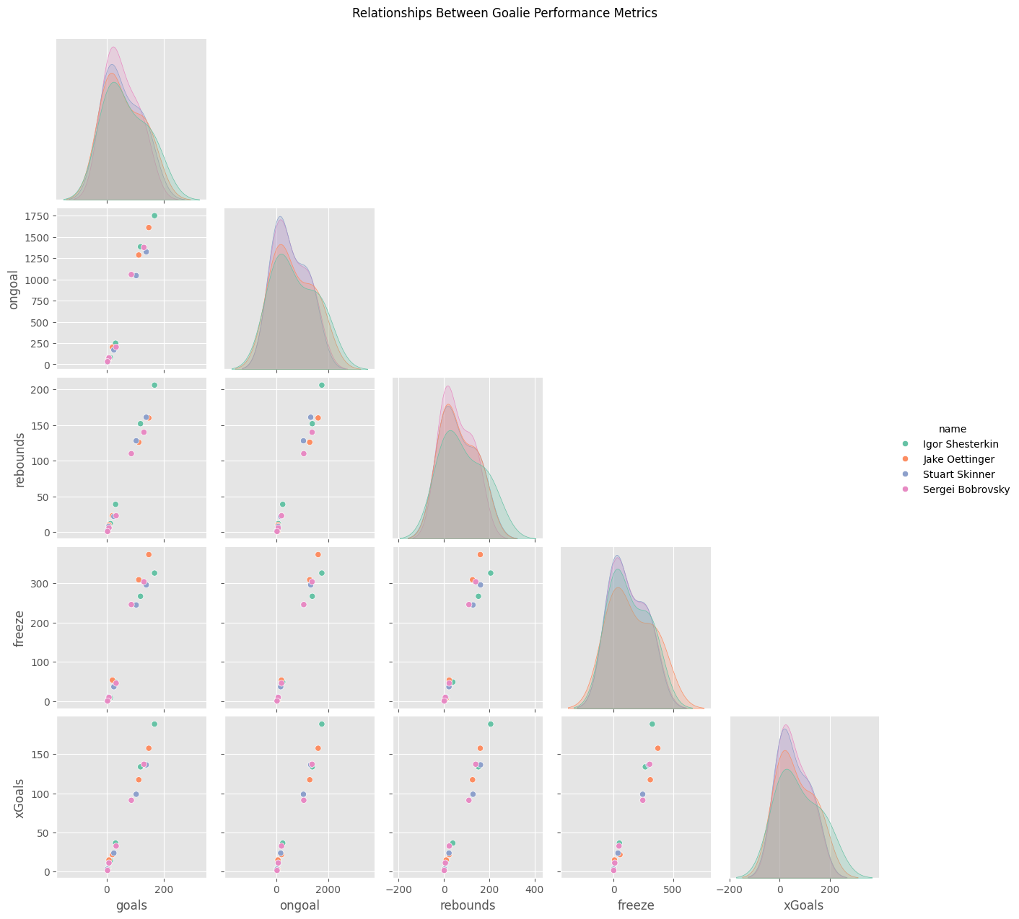
- Rationale: The pairplot shows correlations between multiple variables simultaneously.
- Insights: A positive correlation appears between goals and xGoals, while freezes and rebounds are negatively correlated. Bobrovsky and Shesterkin show tight clustering (consistent play), Skinner shows more spread (variable performance), and Oettinger sits in between.

4. Conclusion and Recommendations
This project demonstrated that data visualization with thorough EDA can reveal important insights into goalie performance and style. Bobrovsky and Shesterkin are consistent and controlled, Skinner is aggressive and variable, and Oettinger is balanced. It’s a great way to learn how EDA guides data cleaning, visualization selection, and interpretation to turn raw data into meaningful insights.
Recommendations for myself on future projects:
- Expand analysis to all goalies for full-season comparison.
- Use time-series analysis to study performance trends over time.
- Consider interactive dashboards for more dynamic exploration.

References
MoneyPuck.com. (n.d.). NHL goaltender analytics. Retrieved October 1, 2025, from https://moneypuck.com/goalies.htm
Pinterest. (n.d.). Home. Retrieved October 1, 2025, from https://www.pinterest.com/

