1 Write a program that has the following outputs:
JAVA is a programming language.
In this lesson, we will study basic Java syntax.

2
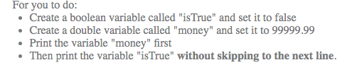
public class lesson1{
public static void main(String[] args) {

}
}
1 Write a program to print Average , Variance and Standard deviation:

if the list is {78,80,77}.
Average =78.33333333333333
Variance = 1.5555555555555556
Standard deviation = 1.247219128924647
public class Statistics{
public static void main(String[] args) {
int x=78,y=80,z=77;

}
}

