Computer Science Lab

Lab contents

x is a integer list form -20 to 20, inclusive.
y is a integer list calculated as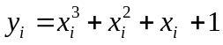
The output of your program should meet the following requirements:
1 Print x and y.
2 Print the average of y and the variance of y.
3 Using Matplotlib package, plot the 2D figure of x and y.
Formula: 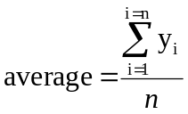 ,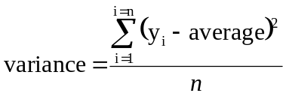

Python code

Results

