1
// given two integers x and y, returns their average.
public static double average(int x, int y)
{…}
// given two points (x1, y1) and (x2,y2), returns
// the slope of the line through them. You may assume
// x1 is not equal to x2.
public static double slope(int x1,int y1,int x2,int y2)
{…}

Write your main() method so that your program has an output similar to:
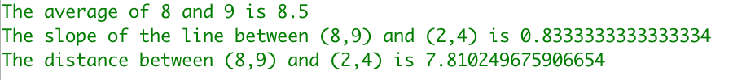
2.
class Main {
public static void main(String[] args) {
// fill in the code
// create a random double in the range [0, 10), store in variable b, print out b
// print out a random double in the range [-2,8),
// print out a random integer from the set {5, 6, ..., 16}
// create a variable called min which is the smallest possible integer, print it
// subtract 1 from min, print it, what happened?
// create a variable called max which is the largest possible integer, print it
// add 1 to max, print it, what happened?
}
}

