Formula for body mass index (BMI):

|  |  |
| --- | --- |
| **BMI** | **Weight class** |
| below 18.5 | underweight |
| [18.5 – 25) | normal |
| [25.0 – 30) | overweight |
| 30.0 and up | obese |

Write a program that produces output like the following. Use Scanner for input.

Your program must include two methods:1) the method bmi which takes two double parameters height and weight and returns the bmi and 2) the method weightClass which takes two double parameters height and weight and returns a string classifying the weight class. The weightClass method must call the bmi method!



public static double bmi(double height, double weight)

{…}

public static String weightClass(double height, double weight)

{…}

Example：

|  |
| --- |
| Height (in inches): 70.0  Weight (in pounds) 194.25  BMI = 27.868928571428572  Overweight |

Write a method **quadrant** that accepts a pair of real numbers x and y and returns the quadrant for that point:

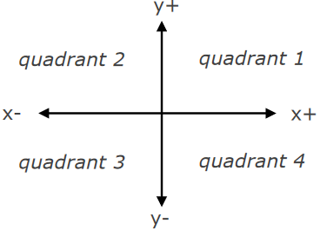

Example: quadrant(-4.2, 17.3) returns 2

If the point falls directly on either axis, return 0.