1.Write a static method named printTwoDigit that accepts an integer n as a parameter and that prints a series of n randomly generated numbers. The method should use Math.random() to select numbers in the range of 10 to 19 inclusive where each number is equally likely to be chosen.

After displaying each number that was produced, the method should indicate whether the number 13 was ever selected ("we saw a 13!") or not ("no 13 was seen."). You may assume that the value of n passed is at least 0.

You should an output similar to below. (see next slide)

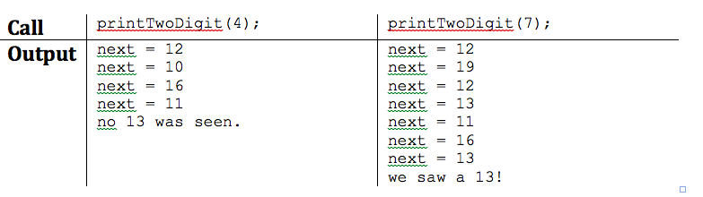

2.Implement a static void method called multiplicationTable which accepts a positive integer n and print the multiplication table starting at 1 up to and including n.(use tab to separate values "\t")

multiplicationTable(2);

|  |
| --- |
| Output:  1 2 3 4 5 6 7 8 9 10  2 4 6 8 10 12 14 16 18 20 |

multiplicationTable(3);

|  |
| --- |
| Output:  1 2 3 4 5 6 7 8 9 10  2 4 6 8 10 12 14 16 18 20  3 6 9 12 15 18 21 24 27 30 |