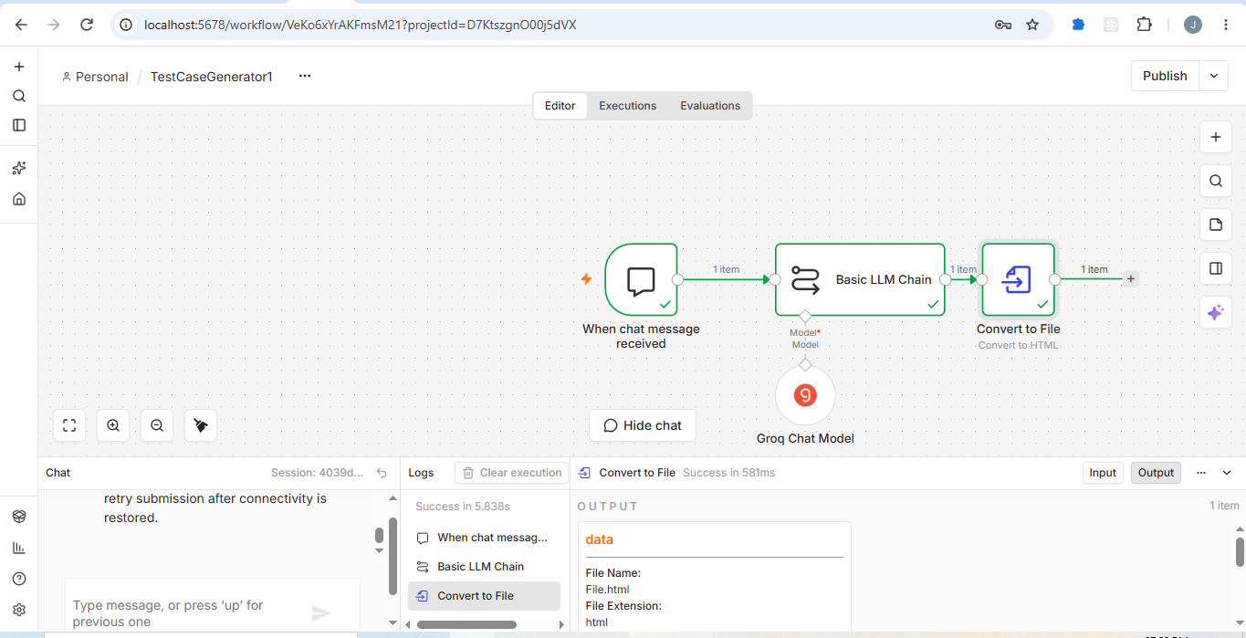

http://localhost:5678/workflow/VeKo6xYrAKFmsM21?projectId=D7KtszgnO00j5dVX

