Part A

Q1. What is an Intrusion Detection System…

- An Intrusion Detection System (IDS) is a security tool designed to monitor and analyze data in real-time or post-event recordings to detect malicious activities, policy violations, or suspicious behavior that could indicate a security breach or threat to a system or network. The primary goal of an IDS is to detect attacks and alert the system administrators so that they can take appropriate action to mitigate the threat.
- Yes, it is indeed possible to implement an Intrusion Detection System (IDS) using the KDD Cup 1999 dataset.
- The workflow steps are as follows:
  - Data Loading: Import the dataset into Apache Spark for distributed processing.
  - Preprocessing: Convert categorical variables to numeric; Standardize continuous features for consistent scaling.
  - Feature Selection: Use ChiSq Selector to identify and retain the most relevant features.
  - Model Selection: Choose an SVM classifier for its effectiveness in high-dimensional spaces.
  - Training: Split the data into training and test sets; Train the SVM model on the training set.
  - Evaluation: Assess model performance using AUROC and AUPR metrics.
  - Comparison: Compare SVM's performance with other classifiers like Logistic Regression.
  - Optimization: Adjust model parameters for better accuracy and efficiency.
  - Deployment: Deploy the trained model for real-time intrusion detection.
  - Maintenance: Regularly update the model with new data to adapt to new threats.

Q2. Use the python urllib library to extract the KDD Cup 99 data from their web repository…

Code:
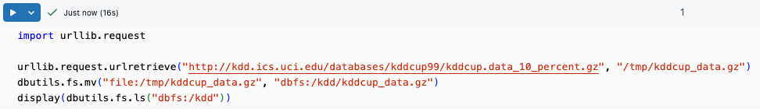

Output:
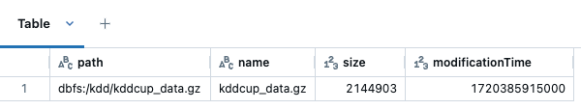

Q3. Load your data from the disk into Spark's RDD…

Code:
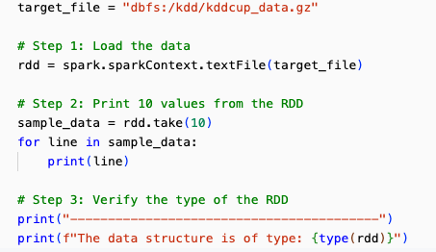
Output:
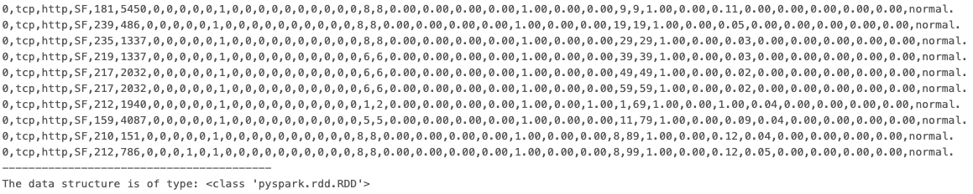

Q4. Split the data…
Code:
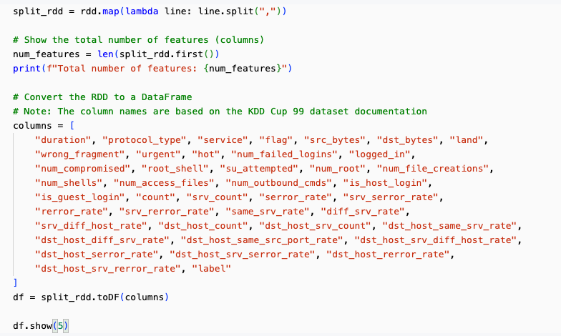
Output:
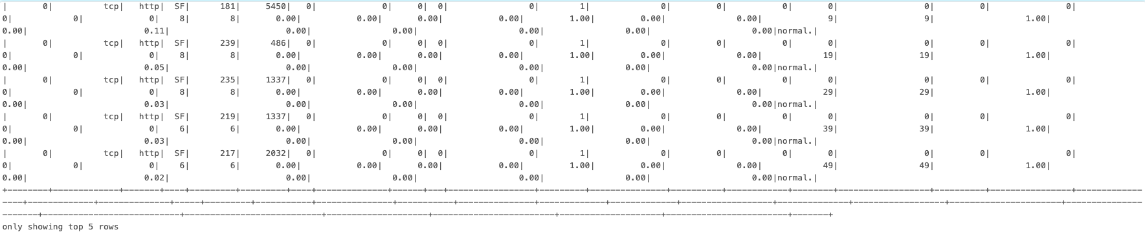

Q5. Now extract these 6 columns…
Code:
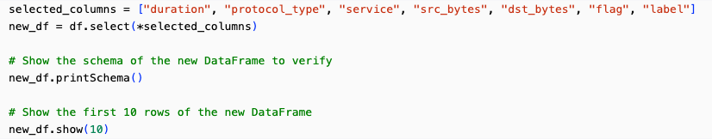
Output：
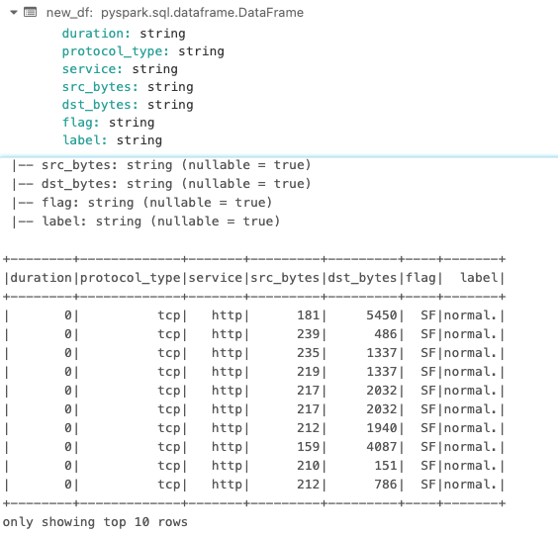
Q6. Get the total number of connections based on the protocol_type…

Code:
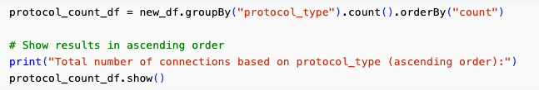
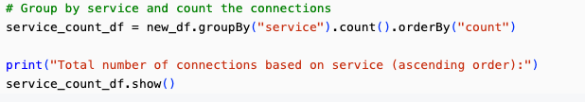
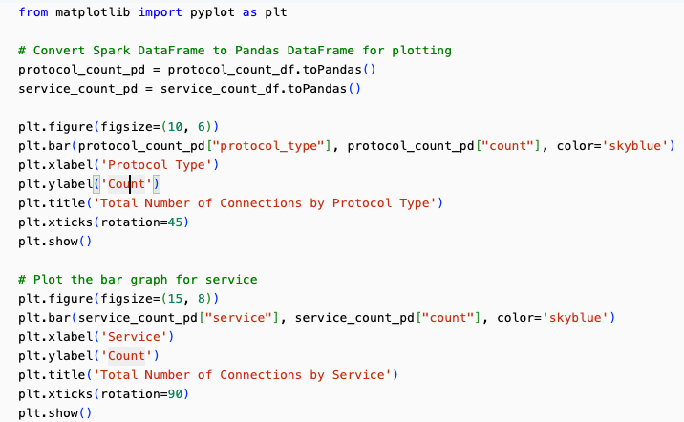
Output:
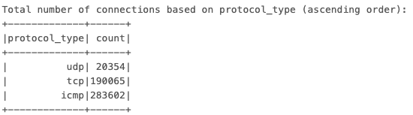
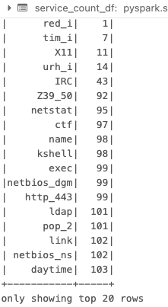
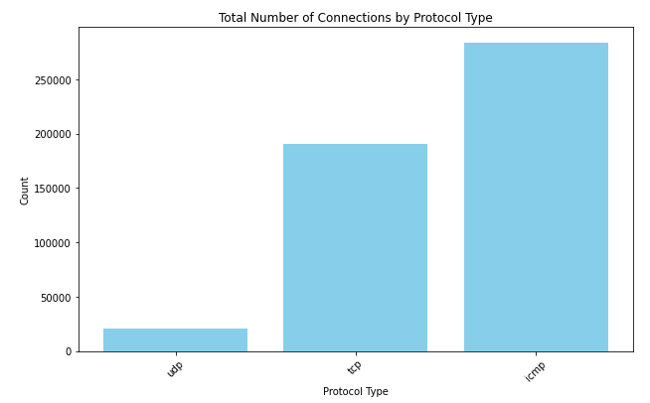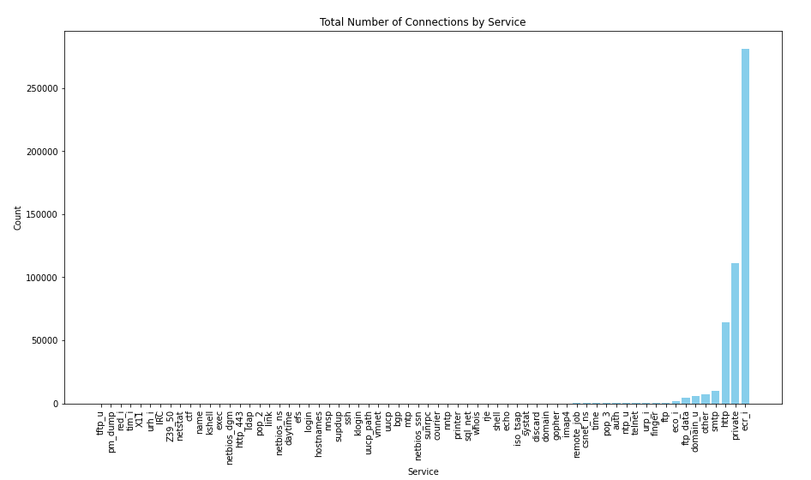

Q7. Do a further exploratory data analysis…

- Analysis of duration column.
Code:
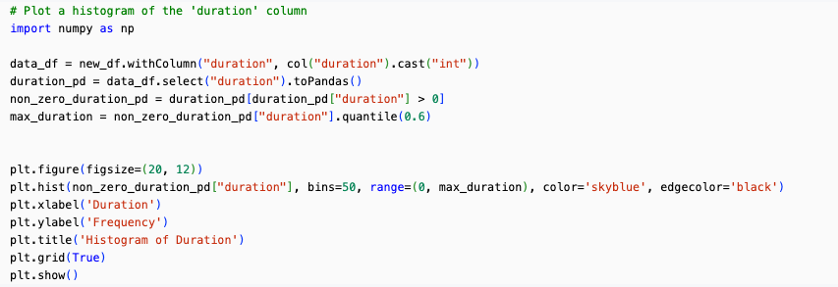
Output:
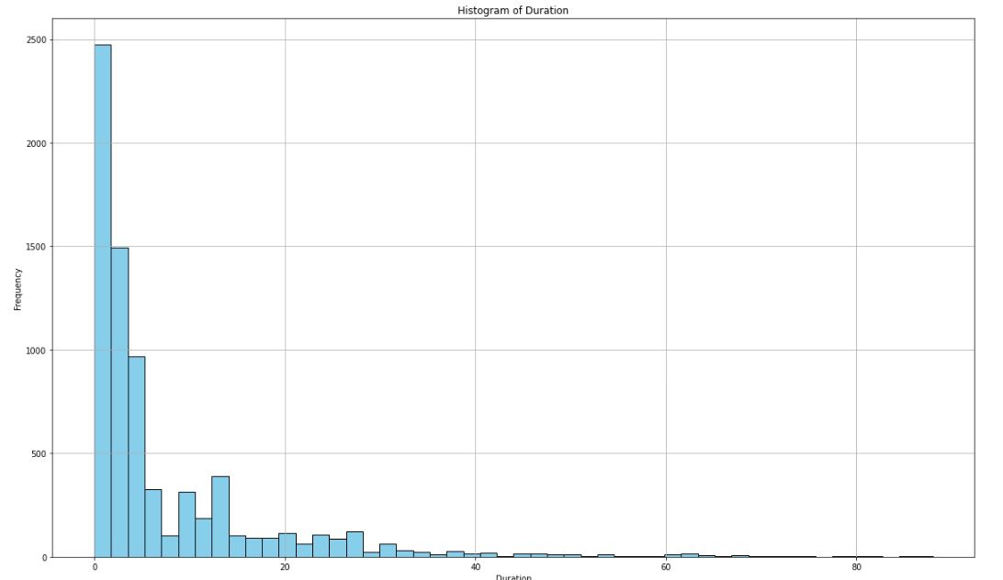
Analysis:
The histogram of the duration column, limited to the 60th percentile, effectively highlights the distribution of connection durations in the KDD Cup 99 dataset. The data predominantly consists of very short connections, with a rapid decline in frequency as the duration increases. The long tail and secondary peaks provide additional insights into less common but longer connections.

- Analysis of src_bytes and dst_bytes columns.
Code：
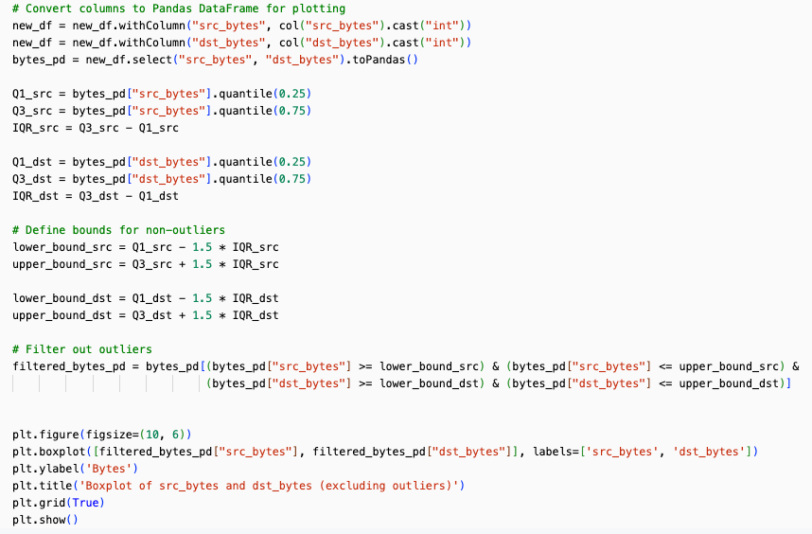
Output：
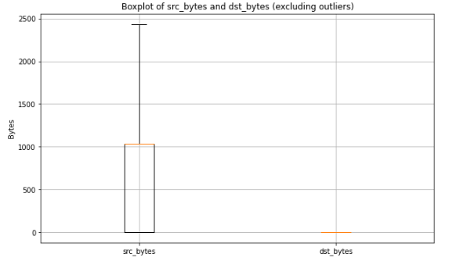
Analysis:
The boxplot analysis of src_bytes reveals a median value around 600 bytes, with the interquartile range (IQR) extending from approximately 200 to 1,000 bytes. The data within the whiskers extends up to about 2,500 bytes, indicating that the majority of connections fall within this range when outliers are excluded. On the other hand, dst_bytes shows most values are very close to zero, with a very small IQR, suggesting that in most connections, the amount of data sent to the destination is minimal. This highlights a significant difference in data transfer sizes between source and destination, with source bytes varying more widely while destination bytes remain consistently low.

- Anlysis of flag column.
Code:
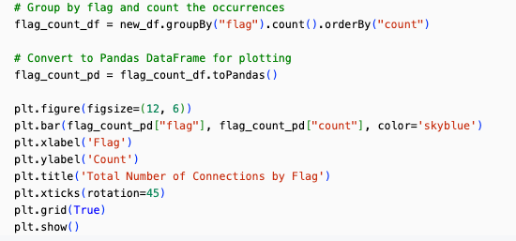
Output:
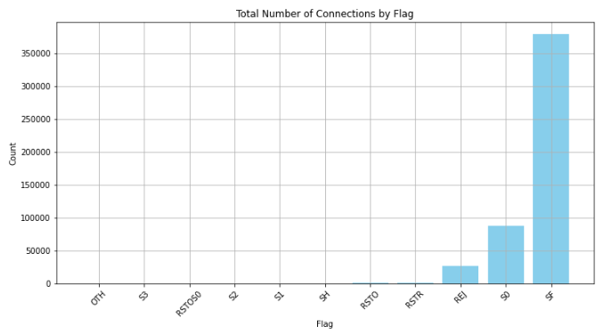
Analysis:
As for flat column, above figure reveals that the SF flag is overwhelmingly the most common, with over 350,000 connections, indicating successful connections with the data being fully acknowledged. The S0 flag is the second most frequent, representing connections where only the SYN packet is sent. Other flags such as REJ, RSTR, and RSTO have significantly lower counts, indicating fewer instances of rejected connections or connections reset by the originator or receiver. Flags like OTH, S1, S2, S3, SH, and RSTOS0 are rare, each with minimal occurrences. This distribution highlights that the majority of the network traffic consists of successful connections and initial SYN packets, with a smaller portion of other connection types.
Q8. Look at the label column where label == ‘normal’…

For this task, I prefer to use a Logistic Regression algorithm because it’s simple and efficient for binary classification and it also provides probabilistic outputs which are useful for understanding the confidence of predictions.

Code:
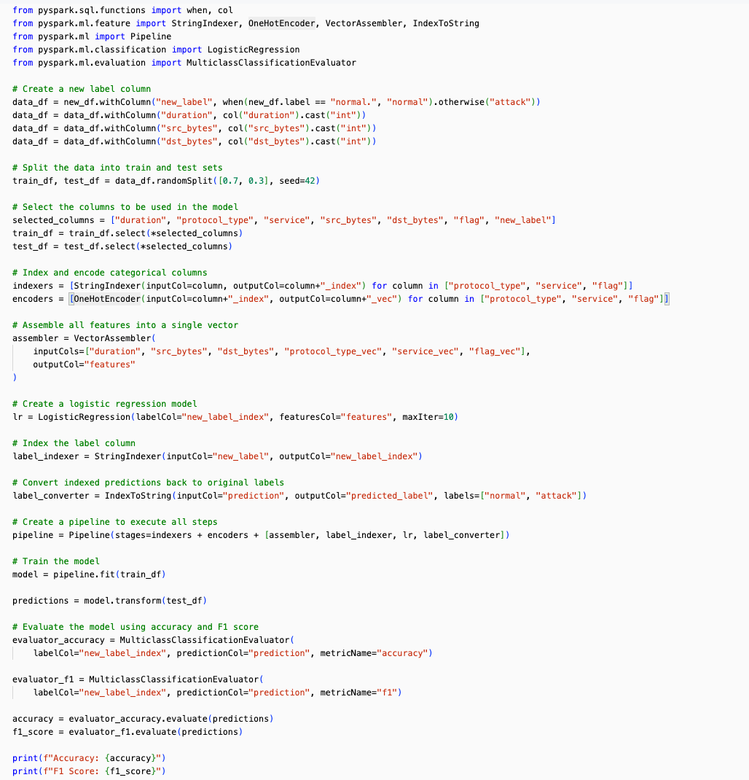

Output:

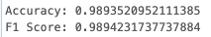

Part B
Q1. Read the below statements…

- The answer is No. A PaaS solution that hosts web apps in Azure provides a platform for developing, running, and managing applications without dealing with the underlying infrastructure. However, it does not inherently include professional development services to continuously add features to custom applications. Instead, it provides the tools and environment necessary for developers to build and deploy applications. Continuous addition of features to custom applications is typically handled by the development teams who use the PaaS platform.
- The answer is Yes. Azure PaaS database offerings, such as Azure SQL Database and Azure Cosmos DB, are designed with built-in high availability features. These services automatically handle database maintenance, patching, and backups, and they are built on highly available and resilient infrastructure. This means they provide high availability and disaster recovery capabilities out of the box, ensuring that the database is accessible and reliable without requiring additional configuration from the user.

Q2. Read the below statement, choose the correct answer, and provide explanations.

The answer is D. Strong consistency guarantees are required.

Explanations:
a: A dynamic schema is required Relational databases use a fixed schema. For dynamic schemas, NoSQL databases are more suitable.
b: Data will be stored as key/value pairs. Key/value pair storage is typical of NoSQL databases, not relational databases.
c: Storing large images and videos. Relational databases are not optimized for storing large binary objects; object storage solutions are better.
d: Strong consistency guarantees are required. Relational databases provide strong consistency through ACID transactions, ensuring reliable and consistent data.

Q3. Read the below statement, choose the correct answer…

The answer is D. Configuring the SaaS solution.

Explanations:
a: Configuring high availability. In a SaaS model, the service provider is responsible for ensuring high availability. The infrastructure and necessary configurations to maintain high availability are managed by the SaaS provider.
b: Defining scalability rules. Scalability, including the ability to handle varying loads, is managed by the SaaS provider. Users typically benefit from the inherent scalability provided by the SaaS solution without having to define the rules themselves.
c: Installing the SaaS solution. SaaS solutions are hosted and maintained by the service provider. Users access the software via the internet and do not need to install it on their own servers or devices.
d: Configuring the SaaS solution. Users of a SaaS solution are responsible for configuring it to meet their specific needs. This includes setting up user accounts, configuring application settings, customizing workflows, and integrating with other services as needed.

Q4. Read the below statements, choose the correct answer, and provide…

- The answer is No. A hybrid cloud model integrates both private and public cloud resources. A company can start with either a private or public cloud and then integrate the other. Migration from a private cloud is not a mandatory step; a company can also integrate public cloud resources with their existing on-premises infrastructure.
- The answer is Yes. Public cloud services allow companies to extend their existing IT infrastructure by leveraging scalable resources such as storage, computing power, and networking capabilities provided by public cloud providers. This helps in handling increased workloads and scaling operations without the need for additional physical hardware.
- The answer is No. In a public cloud model, access to resources is not limited to guest users. Authorized users within the company, including employees and administrators, can access the cloud resources. Access control mechanisms are implemented to ensure that only authorized users can access specific resources based on their roles and permissions.

Q5. Read the below statements, choose the correct answer…

- The answer is Fault Tolerance. Fault tolerance refers to the capability of a system to continue operating properly in the event of a failure of some of its components. A fault-tolerant cloud service remains available and operational even when failures occur.
- The answer is Disaster Recovery. Disaster recovery is the process of restoring access and functionality to IT infrastructure after a disaster or failure. It involves procedures and policies to recover from failures and ensure continuity of operations.
- The answer is Dynamic Scalability. Dynamic scalability refers to the ability of a cloud service to automatically scale resources up or down based on demand. This ensures that the service performs efficiently and quickly as the demand increases.
- The answer is Low Latency. Low latency refers to the minimal delay in data transfer over the network. A low-latency cloud service ensures that users can access the service quickly from the internet, providing a fast and responsive experience.

