Name: xxxxxx

Number: 123456

Report

1. Overview

Fort this project, I used Bootstrap responsive layout; adapted to different screens through css media. Combining all css into one css, speeding up the loading speed of webpage nodes, at the same time improving page rendering capabilities.

The project is divided into homepage, product list, product details, shopping cart, registration and login ,etc.

1. Instructions
2. The project uses html css js; The framework uses bootstrap,jq;css uses media differenttiation; Adobe XD is used in the prototype;
3. Some effects of the project use the animal method of Css, Minimize page rendering and replay of the page as much as possible;
4. In the project, CSS is packaged into a folder and compressed to reduce the volume and loading process as much as possible. For some relatively large JS plug-ins, CDN method is used to speed up the loading speed.
5. The 12 bar grid mode of bootstrap is adopted for different screen sizes. CSS is divided into mobile tablet and computer. It is divided into three parts by @media to customize the display of detail module.
6. view

The interaction choice used is the Adobe XD，In Adobe XD, the connection and thinking orientation of each page are planned.

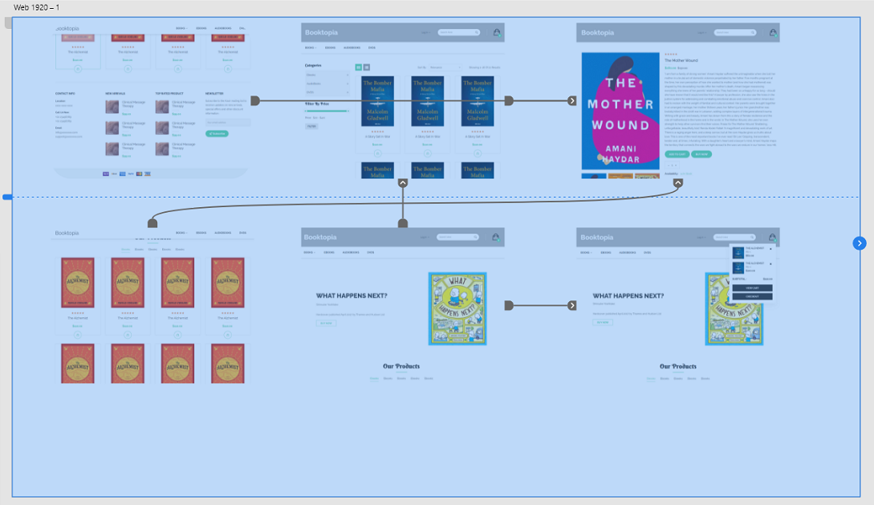

1. Homepage

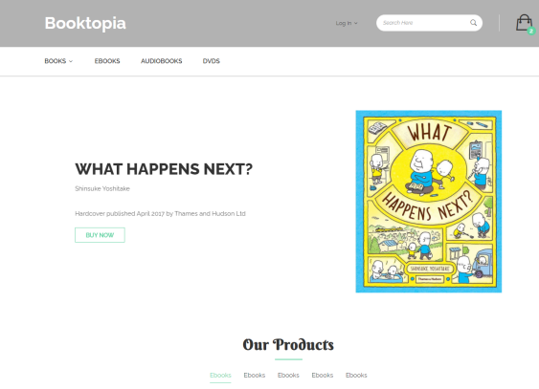  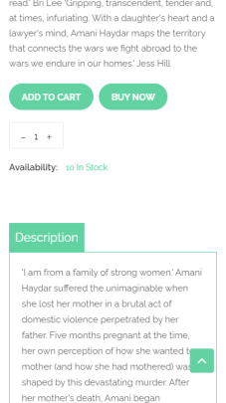

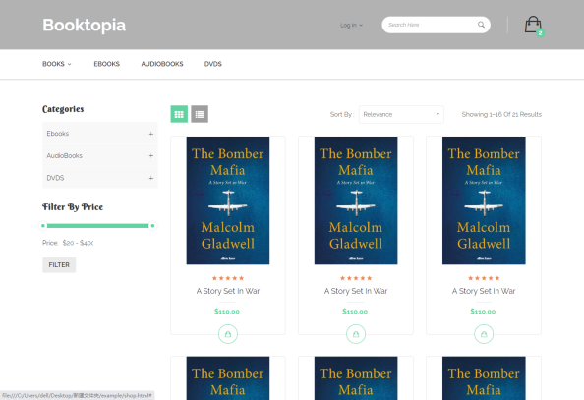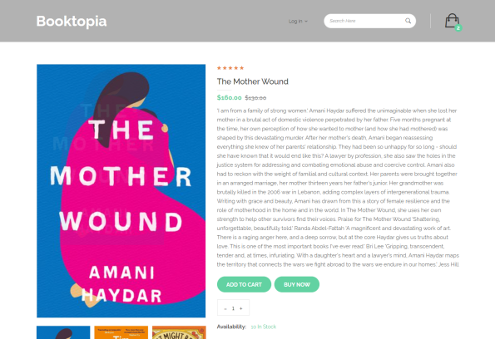

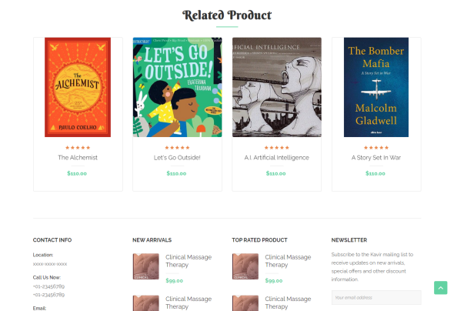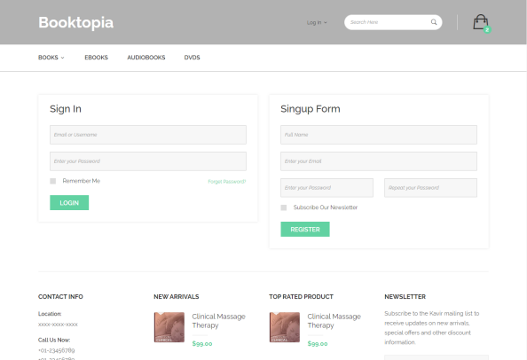

1. **Analysis of Design**



The homepage is very brief



The product category page has two different styles, and users can choose to switch between different styles to quickly find the corresponding products.



The purchase page lacks the corresponding configuration information, this function can be improved later.





**Summarization**

Good Points

The project profile is clear, you can quickly find the books you want through search, you can also quickly find the books you need in the classification module, and then buy or add to the shopping cart.

BadPoints

The purchase process of the entire project is clear, but the details are many inadequate, such as shopping cart additions and deletions, product classifications are not detailed enough, and the page UI is not deautiful enough; there is still a lot of room for improvement in details.