StackOverlow

## UML analysis

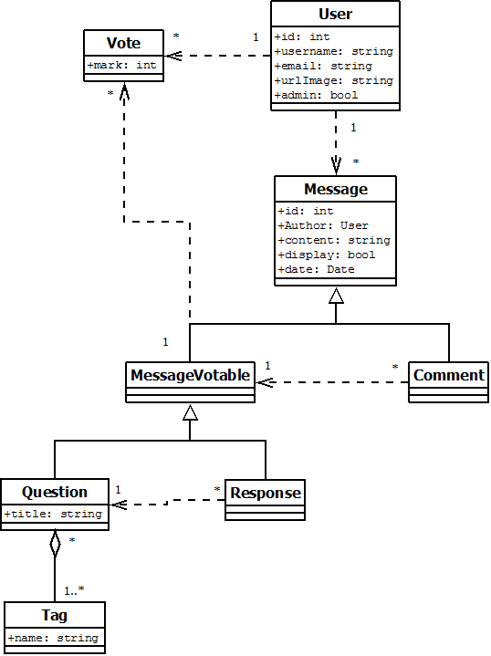

## Functional/technical specifications

The project will offer a system to ask and answer questions.

Signed-in users can post questions, answers, comment question and answer, and vote for questions and answers from other users. A user can not vote for his own question, or his own answer. A same user can not vote twice for a same question of answer.

While displaying, answers have to be sort with decreasing vote result.

All question can be associated with different tags. Those tags will be use to show all related question.

Answers and question can be edit.

A reputation mechanism brings a gamification to the application. The reputation is compute from adding all vote on user’s message. Depending the reputation, the user can win some badge:

|  |  |
| --- | --- |
| Badge | What is it |
|  | Beginer, you have a reputation of less than 20, but more than 0 |
|  | Novice, you have a reputation of more than 20 |
|  | Competent, you have a reputation of more than 50 |
|  | Professor, you have a reputation of more than 100 |
|  | Guru, you have a reputation of more than 500 |
|  | God, you have a reputation of more than 1000 |

Some actions not based on the reputation will allow the user to gain some badges:

|  |  |
| --- | --- |
| Badge | What is it |
|  | Bronze Medal of Curiosity, you have ask between 1 and 10 questions |
|  | Silver Medal of Curiosity, you have ask between 11 and 50 questions |
|  | Gold Medal of Curiosity, you have ask more than 50 questions |
|  | Bronze Medal of Helper, you have post between 1 and 10 responses |
|  | Silver Medal of Helper, you have post between 11 and 50 responses |
|  | Gold Medal of Helper, you have post more than 50 responses |
|  | Bronze Medal of Tagger, you have create between 1 and 10 tags |
|  | Silver Medal of Tagger, you have create between 11 and 50 tags |
|  | Gold Medal of Tagger, you have create more than 50 tags |
|  | Bronze Medal of Good Citizen, you have vote between 1 and 10 time |
|  | Silver Medal of Good Citizen, you have vote between 11 and 50 times |
|  | Gold Medal of Good Citizen, you have vote more than 50 times |

Users can manage a profile: Creating, editing and deleting.

The profile show page will sum up all the user's actions and informations:  
 -Profile picture  
 -email  
 -if the user is an admin  
 -reputation  
 -earned badges  
 -questions asked  
 -reponses posted  
 -reputation evolution (wich user’s message have been votes by other users)  
 -tags created  
 -user’s votes information  
 -activity sorted by date.

Administrators can act as moderator: they can managed all users and topics. When a user is deleted, all his topics, answers, comments and votes are deleted.

The application is internationalized (French and english)

The application is developed in english

The application is tested (see below).

The application is logged.

The application follow coding standards.

The application is versioned using GitHub (pinget63-stackoverlow)

## Test

Here are all the unit test of our application.

### Service:

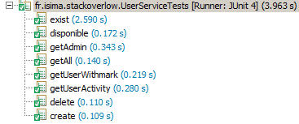

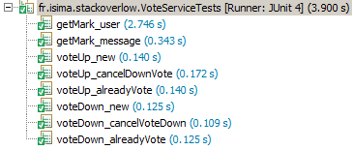

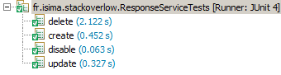

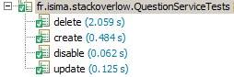

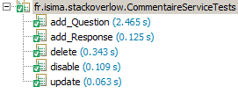

### Controlleur:

//inserer tout les autre test

## UI Mockups

### Vue des questions:

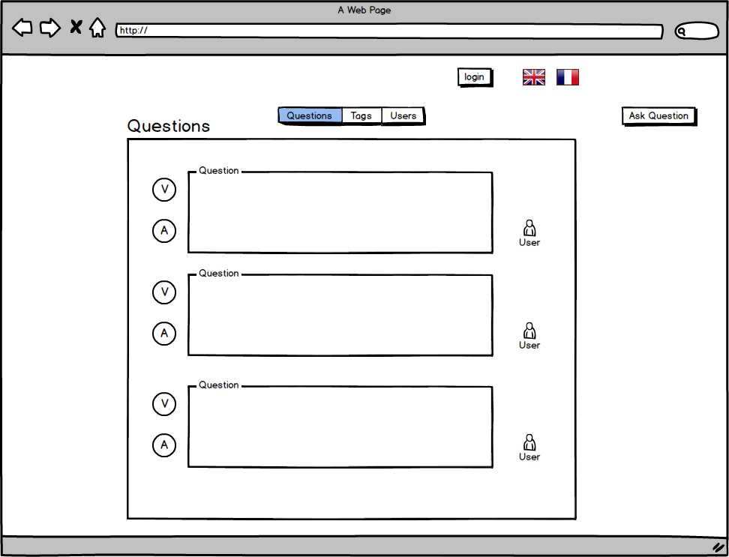

### Vue d’une question, des réponses et des commentaires:

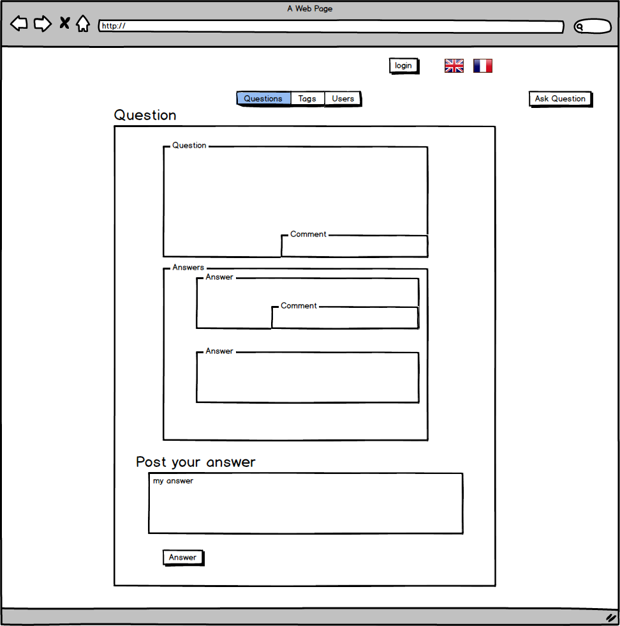

### Vue des utilisateurs:

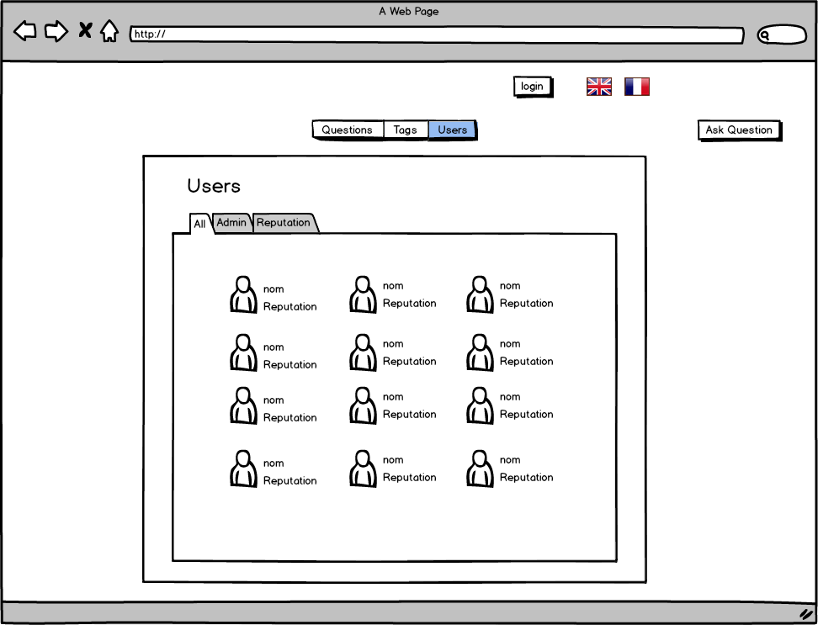

### Vue d’un utilisateur:

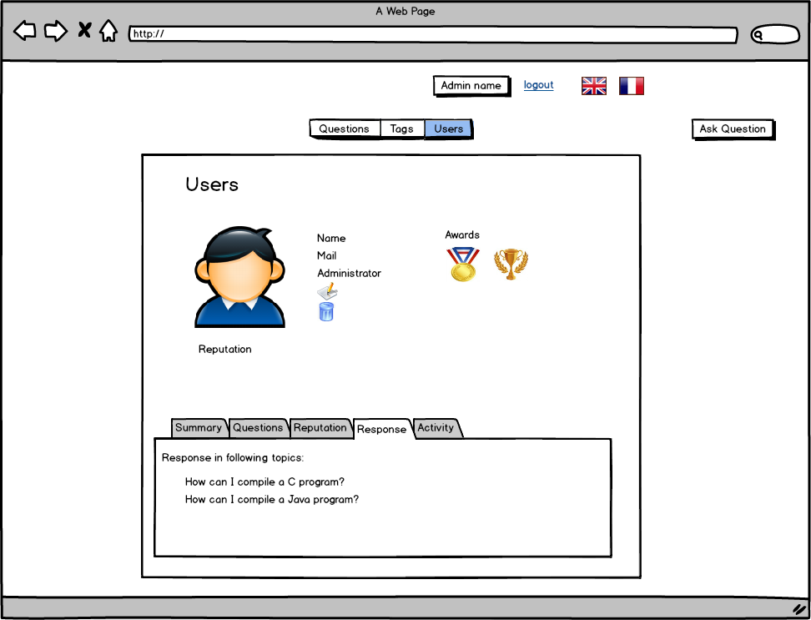

### Vue formulaire de création/édition d’un utilisateur:

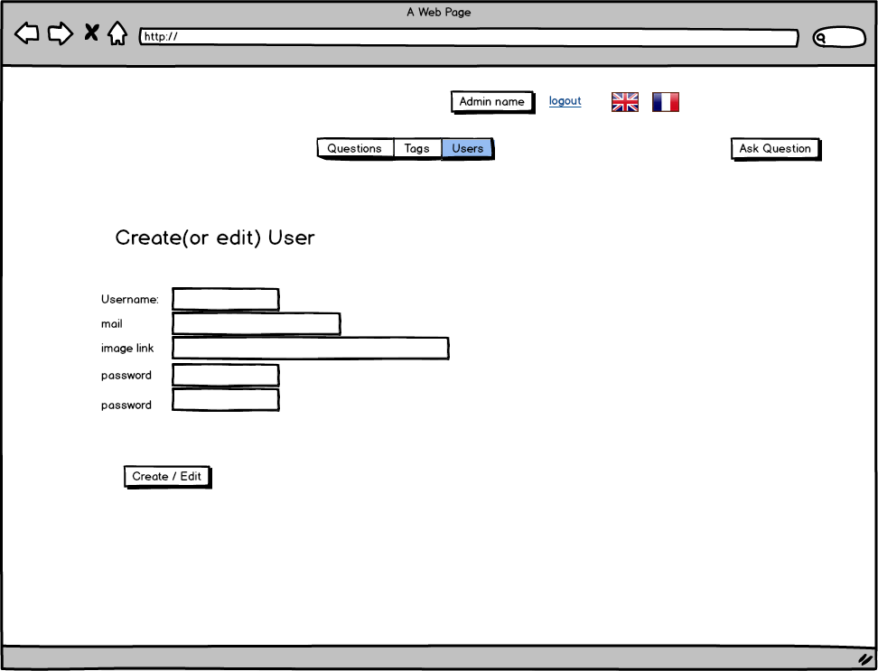

### Vue de l’écran de login:

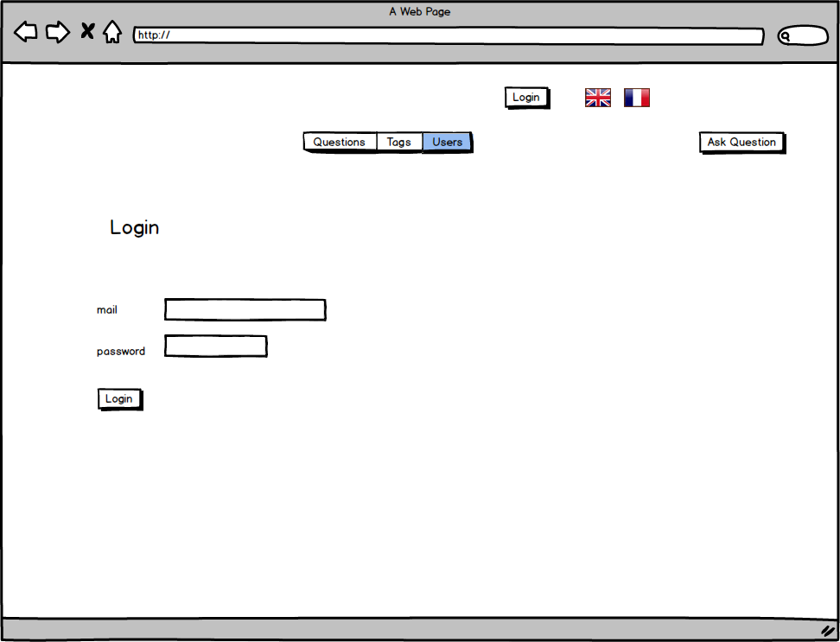

### Vue de l’écran de création/edition d’une question:

