How Project-Based Learning Enhances Pre-Service Science Teachers’ Integrative Lesson Planning Competence: A Structural Equation Modeling Approach
Authors:
Novi Ratna Dewi^{1*} , Rizki Nor Amelia¹ , Septiko Aji¹ , Ismail Okta Kurniawan¹
Affiliations:
¹ Faculty of Mathematics and Natural Sciences, Universitas Negeri Semarang, Central Java, Indonesia
Corresponding author: *noviratnadewi@mail.unnes.ac.id
Keywords: Project-Based Learning, TPACK, STEM Education, Education for Sustainable Development, Integrative Lesson Planning, Pre-Service Science Teachers, PLS-SEM, Teacher Design Competence

- Abstract
Preparing pre-service science teachers to design lesson plans that simultaneously integrate Technological Pedagogical Content Knowledge (TPACK), Science-Technology-Engineering-Mathematics (STEM), and Education for Sustainable Development (ESD) remains a critical yet under-researched challenge in teacher education. This study examined the effect of Project-Based Learning (PjBL) on the development of these three integration dimensions and overall integrative lesson plan quality, and modeled the structural relationships among them. A pre-experimental one-group pretest-posttest design was employed with 95 pre-service science teachers at a public university in Indonesia. Data were collected through rubric-based assessments of lesson plans across 14 indicators and a PjBL implementation quality questionnaire, then analyzed using paired tests, normalized gain (N-Gain) analysis, and Partial Least Squares Structural Equation Modeling (PLS-SEM) with 5,000 bootstrap iterations. All constructs improved significantly following the PjBL intervention, with large effect sizes (Cohen’s $d>2.3$) and Medium N-Gain values; however, ESD exhibited the weakest N-Gain, with no participant reaching High N-Gain. PLS-SEM results revealed that PjBL significantly predicted all three integration dimensions with large effect sizes: TPACK ($β=0.727$, $p<.001$, $f^{2}=1.123$), STEM ($β=0.683$, $p<.001$, $f^{2}=0.872$), and ESD ($β=0.617$, $p<.001$, $f^{2}=0.614$). All three dimensions contributed significantly to integrative lesson plan quality with large effect sizes. A full mediation pattern was observed: PjBL influenced lesson plan quality through the enhancement of all three integration competences, with significant indirect effects via STEM ($β=0.330$), TPACK ($β=0.309$), and ESD ($β=0.213$) pathways. The total indirect effect was substantial ($β=0.852$, $p<.001$), while the direct effect was non-significant. These findings provide the first empirical test of a structural model linking PjBL to integrative lesson planning through TPACK, STEM, and ESD pathways, offering actionable guidance for teacher education institutions seeking to develop comprehensive design competencies in pre-service science teachers.

- Ethics Statement
This study was conducted in accordance with the ethical guidelines of the Declaration of Helsinki. All participants were informed about the purpose and procedures of the study and provided written informed consent prior to participation. Participation was voluntary, and participants could withdraw at any time without penalty. No personally identifiable information was collected beyond what was necessary for the study.
- Conflict of Interest Statement
The authors declare that the research was conducted in the absence of any commercial or financial relationships that could be construed as a potential conflict of interest.
- Funding Statement
This research received no external funding.
- Data Availability Statement
The datasets generated and analyzed during the current study are available from the corresponding author upon reasonable request.
- Author Contributions
Novi Ratna Dewi: Conceptualization, Methodology, Validation, Formal analysis, Investigation, Writing – original draft, Writing – review & editing, Supervision, Project administration. Rizki Nor Amelia: Investigation, Data curation, Writing – review & editing. Septiko Aji: Data curation, Visualization. Ismail Okta Kurniawan: Data curation, Software.

- 1 Introduction
The landscape of science education in the twenty-first century demands that teachers possess a multifaceted competence extending well beyond disciplinary content mastery. Science teachers are now expected to design instruction that meaningfully integrates digital technology, fosters interdisciplinary reasoning, and addresses pressing sustainability challenges (UNESCO, 2017; Kelley & Knowles, 2016). This expectation is particularly acute for pre-service science teachers, whose professional preparation must equip them not merely with theoretical knowledge of individual pedagogical frameworks, but with the practical capacity to weave multiple frameworks into coherent lesson plans. Yet, existing teacher education programs often treat these dimensions—Technological Pedagogical Content Knowledge (TPACK), Science-Technology-Engineering-Mathematics (STEM) integration, and Education for Sustainable Development (ESD)—as separate curricular silos, leaving aspiring teachers to navigate the complexity of integrative lesson design largely on their own.
The ability to design integrative lesson plans—lesson plans that simultaneously embed technology-enhanced pedagogy, interdisciplinary STEM connections, and sustainability perspectives—represents a higher-order professional competence that Brown (2009) termed teacher design capacity. This capacity is not a sum of isolated skills but an emergent competence that requires teachers to orchestrate multiple forms of knowledge in concert (McKenney et al., 2015). Mishra and Koehler (2006) articulated one critical component of this orchestration through the TPACK framework, which describes the intersecting knowledge domains that enable teachers to leverage technology for content-specific pedagogy. Subsequent scholarship has extended this integrative logic to STEM education, where effective lesson design demands the purposeful blending of scientific inquiry, technological application, engineering design, and mathematical reasoning (Kelley & Knowles, 2016; Pitot et al., 2024; Portillo-Blanco et al., 2025). More recently, the global imperative for sustainability education has introduced a third integration dimension: ESD competences require teachers to embed sustainability issues, inquiry-based approaches to environmental challenges, and evaluative thinking about socio-scientific dilemmas into their science instruction (UNESCO, 2017; Purwianingsih et al., 2022; Vidal & Kuckuck, 2025).
Despite the recognized importance of each dimension, the empirical literature reveals a fragmented landscape. Studies examining TPACK development among pre-service science teachers are abundant (e.g., Offermann et al., 2025; Salleh et al., 2025; Stinken-Rosner et al., 2023), as are investigations of STEM integration competence (Tucker et al., 2024; Mansour et al., 2024) and, to a lesser extent, ESD pedagogical capabilities (Purwianingsih et al., 2022; Vidal & Kuckuck, 2025). However, these research streams have developed largely in isolation from one another. Few studies have examined how pre-service teachers develop the ability to integrate all three dimensions simultaneously, and no study to date has modeled the structural relationships among TPACK, STEM, and ESD as mediating pathways through which an instructional intervention influences the quality of integrative lesson plans.
Project-Based Learning (PjBL) offers a theoretically compelling intervention for fostering integrative lesson design competence. PjBL, defined as an extended inquiry process structured around authentic driving questions and culminating in publicly shared artifacts (Krajcik & Shin, 2014), naturally elicits the simultaneous activation of multiple knowledge domains. When pre-service science teachers are tasked with designing lesson plans through a PjBL process, they must engage with technology to support inquiry (activating TPACK), draw upon interdisciplinary connections to address authentic problems (activating STEM integration), and consider sustainability dimensions of scientific issues (activating ESD competences). Empirical evidence supports PjBL’s effectiveness in developing individual dimensions: Dewi et al. (2022) demonstrated that a PjBL scaffolding model improved pre-service teachers’ TPACK, while more recent studies report gains in STEM-oriented unit design and interdisciplinary planning quality (Pitot et al., 2024; Portillo-Blanco et al., 2025). Yet, the mechanism through which PjBL influences integrative lesson planning quality—whether directly or through the mediating enhancement of TPACK, STEM, and ESD competences—remains empirically untested.
This gap is consequential for both theory and practice. Theoretically, understanding whether PjBL operates through dimensional mediation (i.e., PjBL → TPACK/STEM/ESD → lesson plan quality) rather than through direct effects on lesson plan quality would advance our understanding of how pedagogical interventions translate into design competence. Such evidence would refine the Teacher Design Capacity framework (Brown, 2009) by specifying the compositional pathways through which design competence is constructed. Practically, identifying which integration dimension is most responsive to PjBL would enable teacher educators to calibrate their instructional emphasis and scaffolding strategies accordingly—for instance, providing additional support for dimensions that PjBL alone does not sufficiently develop.
The present study addresses these gaps by proposing and testing a structural model in which PjBL serves as the exogenous predictor of three integration dimensions (TPACK, STEM, and ESD), which in turn contribute to the quality of integrative lesson plans. The model is evaluated using Partial Least Squares Structural Equation Modeling (PLS-SEM), a variance-based approach well suited to the exploratory-confirmatory nature of this investigation, the modest sample size (N = 95), and the formative characteristics of several constructs (Hair et al., 2022). Five research questions guide the investigation:
RQ1. How do pre-service science teachers’ TPACK, STEM, and ESD integration competences in lesson planning change from pre- to post-PjBL intervention?
RQ2. Does PjBL implementation significantly influence the quality of lesson plan design across the TPACK, STEM, and ESD integration dimensions?
RQ3. Which integration dimension (TPACK, STEM, or ESD) is most strongly influenced by PjBL?
RQ4. How do TPACK, STEM, and ESD integration competences contribute to overall integrative lesson plan quality after PjBL implementation?
RQ5. Do TPACK, STEM, and ESD improvements mediate the effect of PjBL on integrative lesson plan quality?
The following hypotheses are advanced based on the theoretical framework:
- H1: PjBL positively and significantly influences TPACK, STEM, and ESD integration competences.
- H2: TPACK, STEM, and ESD integration competences significantly contribute to integrative lesson plan quality.
- H3: TPACK, STEM, and ESD mediate the relationship between PjBL and integrative lesson plan quality.
This study contributes to the literature in three ways. First, it offers the first empirical test of an integrative model that simultaneously positions TPACK, STEM, and ESD as mediating dimensions between a pedagogical intervention and lesson plan quality. Second, it operationalizes integrative lesson plan quality as a higher-order construct assessed through rubric-based evaluation rather than self-report, enhancing the ecological validity of measurement. Third, by employing PLS-SEM to decompose direct, indirect, and total effects, the study provides granular insight into the mechanisms through which PjBL shapes pre-service science teachers’ design competence—insight that has direct implications for curriculum design in teacher education institutions.

- 2 Literature Review
  - 2.1 Project-Based Learning in Teacher Education
Project-Based Learning (PjBL) is an instructional approach organized around authentic, complex questions that drive sustained investigation, collaborative inquiry, and the creation of tangible artifacts (Krajcik & Shin, 2014). In teacher education contexts, PjBL assumes a dual function: it simultaneously serves as a pedagogical strategy that pre-service teachers experience as learners and as a design methodology they must learn to employ as future practitioners. This dual positioning makes PjBL particularly potent for developing teacher design competence, as the process of creating instructional artifacts—such as lesson plans—under PjBL conditions requires the active mobilization and integration of multiple knowledge domains.
The essential elements of PjBL include a driving question anchored in real-world problems, sustained inquiry through investigation and research, collaboration among learners, the creation of publicly shared artifacts, and structured reflection (Bell, 2010; Krajcik & Shin, 2014). When applied to teacher preparation, these elements translate into a design-based pedagogy in which pre-service teachers formulate instructional goals around authentic scientific problems, investigate content and pedagogical strategies, collaboratively design lesson plans, engage in peer review and revision, and reflect on the coherence and quality of their designs.
Empirical evidence supports PjBL’s effectiveness in developing various dimensions of teacher competence. Dewi et al. (2022) demonstrated that a PjBL scaffolding model significantly enhanced pre-service science teachers’ TPACK and lesson design abilities, with the scaffolding structure proving essential for guiding novice designers through the complexity of technology-integrated lesson planning. Novallyan and Nehru (2025) found that optimizing teacher profession courses through project methods improved biology education students’ pedagogical competencies. Akbulut and Oner (2021) reported that PjBL experiences enhanced pre-service teachers’ technology-related competencies. Markula and Aksela (2022) further showed that, in K-12 science settings, PBL implementation tends to strengthen collaboration, artefact production, and inquiry practices, while elements such as student-generated driving questions remain challenging. More recent studies show parallel gains in interdisciplinary STEM unit quality and design-thinking outcomes among pre-service teachers, reinforcing the design-oriented value of PjBL in teacher preparation (Pitot et al., 2024; Portillo-Blanco et al., 2025; Yuksel, 2025). Collectively, these studies establish PjBL as a viable intervention for improving specific dimensions of teacher competence, though none has examined PjBL’s simultaneous influence on multiple integration dimensions within a structural model.
  - 2.2 Technological Pedagogical Content Knowledge (TPACK)
The TPACK framework, introduced by Mishra and Koehler (2006) and grounded in Shulman’s (1986) seminal construct of Pedagogical Content Knowledge (PCK), articulates the intersecting knowledge domains required for effective technology-enhanced teaching. TPACK comprises seven components: Technology Knowledge (TK), Pedagogical Knowledge (PK), Content Knowledge (CK), and their pairwise intersections—Technological Pedagogical Knowledge (TPK), Technological Content Knowledge (TCK), and Pedagogical Content Knowledge (PCK)—culminating in the integrative core of TPACK itself, which represents the knowledge needed to teach specific content with appropriate technologies using suitable pedagogical strategies.
For pre-service science teachers, TPACK development is critical because science instruction increasingly relies on digital tools for simulation, data collection, visualization, and collaborative inquiry. The measurement of TPACK has evolved from self-report surveys toward performance-based assessments, including rubric-evaluated lesson plans that capture the enacted integration of technology, pedagogy, and content (Offermann et al., 2025). This performance-based approach is adopted in the present study, where TPACK indicators are assessed through the quality of lesson plan components rather than through self-perceived knowledge.
Recent structural equation modeling studies have examined TPACK in relation to other constructs. Mansour et al. (2024) investigated TPACK integration within STEM education contexts in Qatar, finding significant structural relationships between TPACK components and STEM teaching efficacy. Salleh et al. (2025) explored TPACK development trajectories among pre-service teachers, identifying content knowledge and technological self-efficacy as key predictors. Stinken-Rosner et al. (2023) further reported that targeted technology implementation modules in pre-service science teacher education increased TPACK and behavioral orientations toward classroom technology use. These studies provide methodological precedent for the SEM approach adopted here while highlighting the gap that TPACK has rarely been modeled alongside STEM and ESD within a single structural framework.
  - 2.3 STEM Education and Integrative Lesson Design
STEM education, conceptualized as the purposeful integration of science, technology, engineering, and mathematics disciplines, has gained substantial traction as both an educational philosophy and a curricular framework (Kelley & Knowles, 2016). The distinction between disciplinary STEM instruction—where subjects are taught separately—and integrative STEM education—where disciplinary boundaries are deliberately crossed to address complex problems—is consequential for lesson plan design. Integrative STEM instruction requires teachers to design learning experiences that embed engineering design processes, mathematical reasoning, and technological applications within science content, a demanding design task that novice teachers often struggle to accomplish.
Kelley and Knowles (2016) proposed a conceptual framework for integrated STEM education that emphasizes situated learning, engineering design as a pedagogical strategy, scientific inquiry as a knowledge-building process, and mathematical thinking as an analytical foundation. Within this framework, the quality of STEM-integrated lesson plans can be evaluated along four dimensions: the accuracy and depth of science content, the purposeful integration of technology, the presence of engineering design thinking, and the application of mathematical reasoning.
For pre-service science teachers, developing STEM integration competence requires moving beyond disciplinary comfort zones and developing what Tucker et al. (2024) describe as STEM self-efficacy—the confidence and capability to design interdisciplinary learning experiences. Recent PBL-STEM frameworks for pre-service teachers suggest that collaborative cross-course planning and explicit engineering-design integration are key enablers of this competence (Pitot et al., 2024; Portillo-Blanco et al., 2025). Design-based virtual internship work also indicates that sustained design practice with feedback can strengthen pre-service teachers’ STEM learning design expertise (Wu et al., 2021). The challenge is particularly acute for ESD-related integration, where pre-service teachers must additionally consider sustainability contexts that are less familiar than traditional STEM topics.
  - 2.4 Education for Sustainable Development (ESD) in Science Teaching
Education for Sustainable Development represents a global educational paradigm that seeks to equip learners with the knowledge, skills, values, and attitudes necessary to address interconnected sustainability challenges (UNESCO, 2017). For science teacher education, ESD introduces specific competences that extend beyond traditional science pedagogy: the ability to connect scientific concepts to sustainability issues (ESD-PCK), to employ inquiry-based approaches for investigating environmental and social challenges (ESD-INQ), and to foster evaluative thinking about socio-scientific dilemmas and trade-offs (ESD-EVA) (UNECE, 2012).
Purwianingsih et al. (2022) developed a program for integrating ESD into prospective biology teachers’ TPACK, establishing a theoretical and practical bridge between technology integration and sustainability education. Their work, published in the Journal of Pendidikan IPA Indonesia (JPII), demonstrated that structured integration programs can enhance pre-service teachers’ capacity to embed sustainability perspectives within technology-enhanced science lessons. Shumba and Kampamba (2013) further explored ESD-specific pedagogical content knowledge, arguing that teachers require specialized knowledge for translating abstract sustainability concepts into concrete pedagogical actions.
Despite these advances, ESD remains the least developed of the three integration dimensions in teacher education research. Unlike TPACK, which benefits from decades of empirical investigation, and STEM integration, which is supported by substantial policy infrastructure, ESD integration in lesson plan design is still an emerging area. Recent syntheses also indicate that action-oriented ESD competence in pre-service teachers is underdeveloped and often measured through cross-sectional self-report, underscoring the need for performance-based and design-embedded assessment (Vidal & Kuckuck, 2025; Singh-Pillay, 2023). Complementary evidence also suggests that many pre-service teachers still demonstrate limited SDG knowledge in initial training contexts, reinforcing the need for explicit ESD-oriented curricular supports (Calero et al., 2024). This relative novelty has implications for the present study: ESD competences may require more intensive or prolonged scaffolding than TPACK or STEM competences, and their responsiveness to short-term PjBL interventions may differ accordingly.
  - 2.5 Integrative Lesson Planning as Teacher Design Competence
The concept of teacher design capacity, introduced by Brown (2009) and elaborated by McKenney et al. (2015), provides the theoretical anchor for conceptualizing integrative lesson planning as a higher-order professional competence. Brown (2009) argued that effective curriculum use requires teachers to function as designers who actively interpret, adapt, and create instructional materials in response to contextual demands. This design capacity is not a fixed trait but a dynamic competence that develops through engagement with design tasks and feedback.
McKenney et al. (2015) extended this framework by identifying the specific knowledge bases—including technological knowledge, pedagogical knowledge, and subject matter knowledge—that underpin teacher design competence. Their ecological framework positions design knowledge at the intersection of personal knowledge, formal knowledge, and practical experience, suggesting that interventions such as PjBL, which provide structured design experiences, can catalyze the integration of these knowledge bases.
In the present study, integrative lesson planning competence is operationalized as the quality of lesson plans that simultaneously integrate TPACK, STEM, and ESD dimensions. This operationalization positions the integrative lesson plan not as a simple aggregate of component scores but as a higher-order construct (HOC) that reflects the emergent quality arising from the coherent integration of multiple design dimensions. The use of a rubric-based assessment—rather than self-report—ensures that the construct captures demonstrated design competence rather than perceived capability.
  - 2.6 Conceptual Framework and Hypothesized Model
Drawing on the foregoing theoretical foundations, the present study proposes a structural model in which PjBL serves as the exogenous construct influencing three first-order endogenous constructs—TPACK, STEM, and ESD integration competences—which in turn contribute to the quality of integrative lesson plans (see Figure 1). The model posits both direct effects (PjBL → TPACK, PjBL → STEM, PjBL → ESD) and indirect effects (PjBL → TPACK/STEM/ESD → Integrative Lesson Plan Quality), with the three integration dimensions hypothesized to mediate the relationship between PjBL and lesson plan quality.
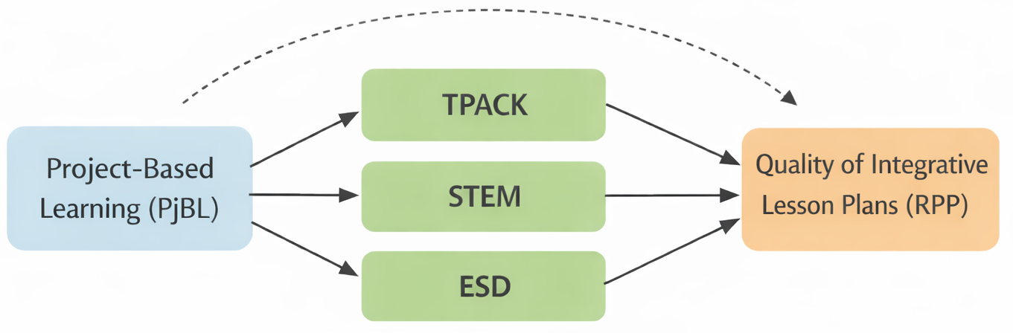
Hypothesized structural model
Figure 1. Hypothesized structural model. PjBL influences three integration dimensions (TPACK, STEM, ESD) which in turn contribute to the quality of integrative lesson plans. The dashed line indicates the direct path from PjBL to RPP, hypothesized to be non-significant (full mediation).
The theoretical justification for each pathway is as follows:
- PjBL → TPACK: PjBL’s emphasis on artifact creation and inquiry-based investigation naturally requires the mobilization of technology for content-specific pedagogy (Dewi et al., 2022).
- PjBL → STEM: PjBL’s authentic driving questions typically span multiple STEM disciplines, requiring interdisciplinary design thinking (Krajcik & Shin, 2014).
- PjBL → ESD: PjBL’s focus on real-world problems creates opportunities for addressing sustainability issues, though the strength of this link may depend on explicit scaffolding (Purwianingsih et al., 2022).
- TPACK/STEM/ESD → Integrative Lesson Plan Quality: Each dimension contributes substantive design elements—technology integration, interdisciplinary connections, and sustainability perspectives—that collectively determine the quality of integrative lesson plans (Brown, 2009; McKenney et al., 2015).
- Mediation: PjBL is hypothesized to influence lesson plan quality not directly but through the enhancement of integration competences, consistent with the view that pedagogical interventions operate by developing specific professional knowledge bases that subsequently manifest in design performance.
This model is tested using PLS-SEM, a variance-based approach appropriate for the study’s exploratory-confirmatory purpose, the inclusion of a single-indicator construct (lesson plan quality), and the relatively small sample size (N = 95) (Hair et al., 2022).

- 3 Methods
  - 3.1 Research Design
This study employed a pre-experimental one-group pretest-posttest design (Creswell & Creswell, 2018) to examine the effect of a Project-Based Learning (PjBL) intervention on pre-service science teachers’ integrative lesson planning competence. Participants designed lesson plans before and after the PjBL intervention, and the quality of these lesson plans was assessed using a standardized rubric across three integration dimensions: TPACK, STEM, and ESD. The pre-experimental design was selected because the primary purpose of the study was not to establish strict causal inference through between-group comparison, but rather to (a) document changes in integrative design competence following the intervention and (b) model the structural relationships among PjBL implementation quality, integration dimensions, and overall lesson plan quality using PLS-SEM. The absence of a control group is acknowledged as a limitation in Section 5.8.
  - 3.2 Participants
The participants were 95 pre-service science teachers enrolled in a teacher education program at a public university in Indonesia. All participants were undergraduate students in their third or fourth year of study, having completed foundational courses in science content, general pedagogy, and educational technology. Purposive sampling was employed, selecting participants who were concurrently enrolled in a course on instructional planning for science education, which served as the natural site for the PjBL intervention. The sample size of $N=95$ exceeds the minimum threshold recommended for PLS-SEM, which Hair et al. (2022) suggest should be at least ten times the maximum number of structural paths directed at any single construct (in this model, four paths directed at the RPP construct, yielding a minimum of 40). All participants provided informed consent prior to data collection, and the study was conducted in accordance with the ethical guidelines of the participating institution.
  - 3.3 Intervention: PjBL Implementation
The PjBL intervention was implemented across the instructional planning course over a structured sequence of sessions. Participants engaged in a project cycle requiring them to design integrative lesson plans that simultaneously incorporated TPACK, STEM, and ESD dimensions. The intervention followed five stages adapted from Krajcik and Shin (2014):
- Orientation and driving question. Participants were introduced to a real-world sustainability problem related to their science content area. Driving questions were designed to necessitate interdisciplinary inquiry and the consideration of environmental, social, and economic sustainability dimensions.
- Planning and investigation. Participants investigated the scientific content, identified relevant technologies for instruction, explored connections across STEM disciplines, and examined sustainability implications. They were provided with exemplar lesson plan frameworks and rubric criteria to guide their design process.
- Artifact creation. Participants designed integrative lesson plans (RPP) as the primary project artifact. Each lesson plan was required to demonstrate explicit integration of technology-enhanced pedagogy (TPACK), interdisciplinary STEM connections, and sustainability perspectives (ESD).
- Peer review and revision. Completed drafts were subjected to structured peer review using the same rubric employed for formal assessment. Participants revised their lesson plans based on peer feedback, a process intended to deepen their understanding of integration quality criteria.
- Presentation and reflection. Participants presented their final lesson plans, articulated their design rationale, and reflected on the integration process. This stage provided opportunities for metacognitive engagement with the design challenges encountered.
The quality of PjBL implementation was assessed through an observation instrument completed by course instructors, measuring the fidelity and quality of each PjBL stage as experienced by participants.
  - 3.4 Instruments
    - 3.4.1 Integrative Lesson Plan Rubric (Pretest-Posttest)
The primary instrument was a rubric for evaluating the quality of integrative lesson plans, scored on a four-point Likert scale (1 = does not meet the criterion, 2 = partially meets, 3 = meets, 4 = exceeds the criterion). The rubric assessed three integration dimensions comprising 14 indicators:
- TPACK (7 indicators): Technology Knowledge (TK), Pedagogical Knowledge (PK), Content Knowledge (CK), Technological Pedagogical Knowledge (TPK), Technological Content Knowledge (TCK), Pedagogical Content Knowledge (PCK), and the integrative TPACK component.
- STEM (4 indicators): Science content integration (S), Technology application (T), Engineering design process (E), and Mathematical reasoning (M).
- ESD (3 indicators): ESD-Pedagogical Content Knowledge (ESD-PCK), ESD-Inquiry (ESD-INQ), and ESD-Evaluative thinking (ESD-EVA).
Composite scores for each dimension were calculated as the mean of its constituent indicators. The overall integrative lesson plan quality score (RPPInt_total) was calculated as the grand mean across all 14 indicators, operationalizing integrative lesson plan quality as a composite of the three dimensions. The rubric was developed through expert judgment involving three science education specialists and demonstrated adequate content validity.
    - 3.4.2 PjBL Implementation Observation Instrument
The quality of PjBL implementation was measured using a five-item observation instrument, with each item scored on a 1–4 scale corresponding to the five PjBL stages. The instrument was completed by course instructors who observed the implementation process. In the current data version, all five items (PjBL01–PjBL05) were retained in the SEM analysis.
  - 3.5 Data Collection Procedure
Data collection followed a three-phase timeline: (a) pretest, in which participants designed an initial lesson plan that was scored using the integrative rubric; (b) the PjBL intervention, during which PjBL implementation quality was observed and scored; and (c) posttest, in which participants designed a second lesson plan under the same conditions, scored by the same assessors using the identical rubric. Lesson plans were anonymized before scoring to reduce assessor bias.
  - 3.6 Data Analysis
Data analysis proceeded in two phases corresponding to the research questions.
    - 3.6.1 Phase 1: Pre-Post Comparison (RQ1)
To address RQ1, which examined changes in integration competences before and after the PjBL intervention, the following analyses were conducted:
- Descriptive statistics (mean, standard deviation, minimum, maximum) were computed for each construct and indicator at pretest and posttest.
- Normality testing was performed using the Shapiro-Wilk test on the difference scores (posttest minus pretest) for each construct, given the sample size of $N=95$.
- Paired inferential tests were applied based on normality results: the paired-samples $t$-test for constructs with normally distributed difference scores, and the Wilcoxon signed-rank test for constructs violating the normality assumption. The significance level was set at $α=.05$.
- Effect sizes were calculated using Cohen’s $d$ for parametric tests and rank-biserial correlation $r$ for non-parametric tests. Effect sizes were interpreted following Cohen (1988): small ($d=0.2$), medium ($d=0.5$), and large ($d=0.8$).
- Normalized gain (N-Gain) was calculated using Hake’s (1998) formula: $\text{N-Gain}=\frac{\text{post}−\text{pre}}{\text{max}−\text{pre}}$, where $\text{max}=4$ (the maximum rubric score). N-Gain values were categorized as High ($>0.7$), Medium ($0.3$–$0.7$), or Low ($<0.3$).
All Phase 1 analyses were conducted in Python 3.11 using pandas, scipy, and pingouin.
    - 3.6.2 Phase 2: Structural Equation Modeling (RQ2–RQ5)
To address RQ2 through RQ5, Partial Least Squares Structural Equation Modeling (PLS-SEM) was employed. PLS-SEM was selected over covariance-based SEM (CB-SEM) for several reasons: (a) the study’s exploratory-confirmatory nature, testing a novel integrative model for the first time; (b) the inclusion of a single-indicator construct (RPPInt_total_post for the RPP construct); (c) the modest sample size ($N=95$), which is adequate for PLS-SEM but may be insufficient for CB-SEM with the specified model complexity; and (d) PLS-SEM’s capacity to handle non-normal data and formative measurement (Hair et al., 2022).
Model specification. The structural model comprised five constructs: PjBL (exogenous), TPACK, STEM, ESD, and RPP (endogenous). All constructs were specified as reflective (Mode A). The structural paths included seven relationships: PjBL $→$ TPACK, PjBL $→$ STEM, PjBL $→$ ESD, PjBL $→$ RPP (direct), TPACK $→$ RPP, STEM $→$ RPP, and ESD $→$ RPP. The RPP construct was operationalized as a single-indicator construct using the composite integrative lesson plan quality score (RPPInt_total_post), with the indicator’s loading fixed to 1.000. The data matrix for the SEM analysis used posttest scores for TPACK, STEM, ESD, and RPP, and the PjBL observation scores, yielding 19 manifest variables.
Measurement model evaluation. The outer (measurement) model was assessed using standard PLS-SEM criteria (Hair et al., 2022):
- Indicator reliability: outer loadings $≥0.708$ (indicators between 0.40 and 0.70 were retained if their removal did not improve AVE or CR, following Hair et al.’s recommendation for exploratory research).
- Convergent validity: Average Variance Extracted (AVE) $≥0.50$.
- Internal consistency reliability: Composite Reliability (CR) $≥0.70$ and Cronbach’s $α≥0.70$.
- Discriminant validity: Heterotrait-Monotrait ratio (HTMT) $<0.90$ (Henseler et al., 2015), supplemented by the Fornell-Larcker criterion.
Structural model evaluation. The inner (structural) model was assessed through:
- Path coefficients ($β$): standardized regression coefficients indicating the strength and direction of structural relationships.
- Statistical significance: determined through bootstrapping (5,000 iterations) with 95% percentile confidence intervals (2.5%-97.5%). A unified manual bootstrap procedure was employed, in which each bootstrap resample simultaneously yielded path coefficients and indirect effects, ensuring consistency across direct and mediation analyses.
- Coefficient of determination ($R^{2}$): proportion of variance in endogenous constructs explained by the model. Interpreted as substantial (0.75), moderate (0.50), or weak (0.25) (Hair et al., 2022).
- Effect size ($f^{2}$): the incremental impact of each exogenous construct on an endogenous construct. Interpreted as small (0.02), medium (0.15), or large (0.35) (Cohen, 1988).
- Predictive relevance ($Q^{2}$): assessed using a cross-validated latent-score approach with 10-fold cross-validation ($k=10$) as a Stone-Geisser approximation (rather than classical indicator-level blindfolding). Values above zero indicate predictive relevance.
Mediation analysis (RQ5). Indirect effects were calculated as the product of constituent path coefficients (e.g., indirect effect of PjBL on RPP through TPACK = $β_{\text{PjBL}→\text{TPACK}}×β_{\text{TPACK}→\text{RPP}}$). Statistical significance of indirect effects was determined through the bootstrap confidence interval method (Preacher & Hayes, 2008): an indirect effect was deemed significant if the 95% percentile confidence interval did not include zero. The Sobel test was additionally computed as a cross-check. The Variance Accounted For (VAF) was calculated to classify mediation type: full mediation (VAF $>80\%$), partial mediation ($20\%<$ VAF $<80\%$), or no mediation (VAF $<20\%$) (Hair et al., 2022).
Comparative analysis (RQ3). The relative influence of PjBL on each integration dimension was assessed by comparing path coefficients and their associated $f^{2}$ values. Bootstrap confidence intervals were examined for overlap to determine whether observed differences were statistically meaningful.
Software. PLS-SEM analysis was conducted using the plspm Python package (version 0.5.7) with a random seed of 42 for reproducibility. All bootstrap procedures used 5,000 iterations with a single-process configuration to ensure deterministic execution. Figures were generated using matplotlib.

- 4 Results
  - 4.1 Descriptive Statistics
Prior to hypothesis testing, we examined the descriptive statistics for all constructs. Table 1 presents the construct-level means and standard deviations at pretest and posttest, while Figure 1 provides a visual comparison of these changes.
Table 1. Descriptive Statistics per Construct (Pretest vs. Posttest)
Construct | $N$ | Pre $M$ | Pre $SD$ | Post $M$ | Post $SD$ | $M_{\text{diff}}$
TPACK | 95 | 2.306 | 0.390 | 3.319 | 0.294 | 1.013
STEM | 95 | 2.172 | 0.393 | 3.222 | 0.378 | 1.051
ESD | 95 | 1.929 | 0.328 | 2.726 | 0.259 | 0.798
RPP Integratif | 95 | 2.136 | 0.256 | 3.089 | 0.237 | 0.954
Note. Scale range: 1–4. RPP Integratif = grand mean of all 14 indicators.
As shown in Table 1, all constructs exhibited substantial increases following the PjBL intervention. The largest mean difference was observed for STEM ($M_{\text{diff}}=1.051$), followed by TPACK ($M_{\text{diff}}=1.013$), RPP Integratif ($M_{\text{diff}}=0.954$), and ESD ($M_{\text{diff}}=0.798$). Standard deviations generally decreased from pretest to posttest, indicating that participants’ competences became more homogeneous after the intervention.
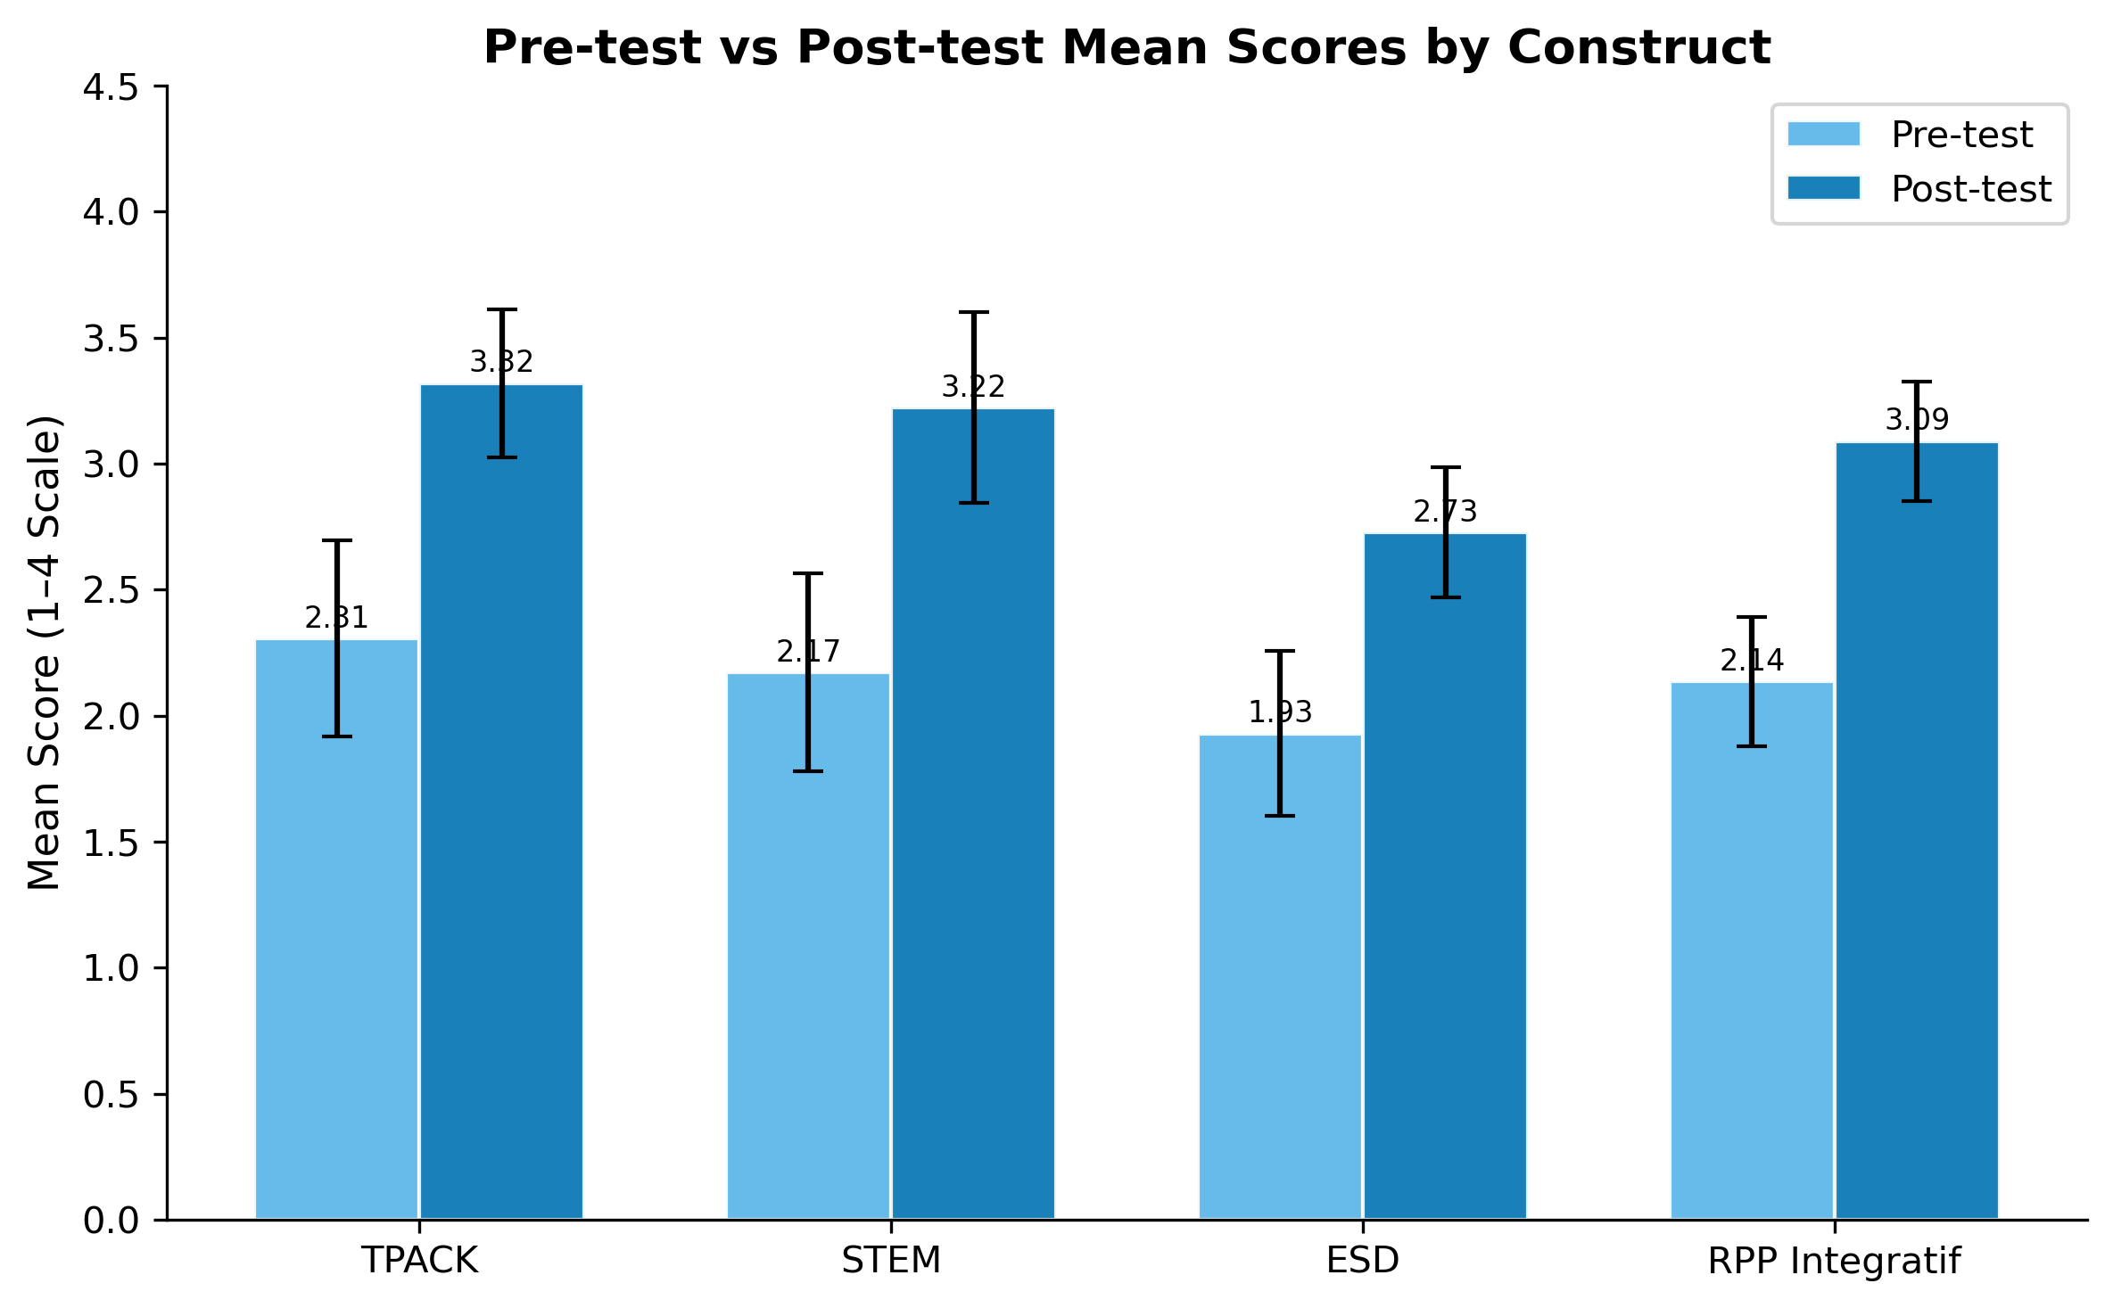
Figure 1. Pre-test vs Post-test Mean Scores by Construct
Figure 1. Pre-test vs post-test mean scores by construct, with error bars representing standard deviations. All constructs showed substantial improvement following the PjBL intervention.
To provide a more granular view, Table 2 presents the indicator-level descriptive statistics.
Table 2. Descriptive Statistics per Indicator
Indicator | Pre $M$ | Pre $SD$ | Post $M$ | Post $SD$ | $M_{\text{diff}}$
TK | 2.018 | 0.540 | 3.192 | 0.476 | 1.174
PK | 2.667 | 0.503 | 3.543 | 0.355 | 0.876
CK | 2.441 | 0.758 | 3.376 | 0.397 | 0.936
TPK | 2.079 | 0.586 | 3.183 | 0.493 | 1.105
TCK | 2.131 | 0.580 | 3.186 | 0.480 | 1.055
PCK | 2.740 | 0.634 | 3.587 | 0.318 | 0.848
TPACK | 2.068 | 0.531 | 3.166 | 0.606 | 1.099
Science | 2.448 | 0.581 | 3.390 | 0.345 | 0.943
Technology | 2.193 | 0.597 | 3.338 | 0.499 | 1.145
Engineering | 2.370 | 0.578 | 3.230 | 0.454 | 0.860
Mathematics | 1.677 | 0.598 | 2.932 | 0.760 | 1.255
ESD-PCK | 1.895 | 0.416 | 2.686 | 0.315 | 0.792
ESD-INQ | 1.972 | 0.425 | 2.726 | 0.305 | 0.754
ESD-EVA | 1.919 | 0.470 | 2.767 | 0.293 | 0.848
At the indicator level (Table 2), the pattern was consistent across dimensions. Within TPACK, the largest gains occurred for TK ($M_{\text{diff}}=1.174$) and TPK ($M_{\text{diff}}=1.105$), reflecting heightened technology-related integration. Within STEM, Mathematics showed the greatest improvement ($M_{\text{diff}}=1.255$), while Science showed the smallest ($M_{\text{diff}}=0.943$). ESD indicators improved relatively uniformly, with ESD-EVA exhibiting the highest gain ($M_{\text{diff}}=0.848$).
Having established that substantial improvements occurred across all constructs, we now turn to formal hypothesis testing to determine whether these changes were statistically significant.
  - 4.2 RQ1: Pre-Post Changes
    - Normality Testing
Before conducting paired comparisons, we assessed the normality of difference scores using the Shapiro-Wilk test. Table 3 summarizes the results.
Table 3. Shapiro-Wilk Normality Test Results for Difference Scores
Construct | $W$ | $p$ | Normal
TPACK | 0.968 | .020 | No
STEM | 0.977 | .088 | Yes
ESD | 0.990 | .704 | Yes
RPP Integratif | 0.986 | .418 | Yes
As shown in Table 3, difference scores for STEM ($W=0.977$, $p=.088$), ESD ($W=0.990$, $p=.704$), and RPP Integratif ($W=0.986$, $p=.418$) were normally distributed ($p>.05$). However, the TPACK difference scores departed significantly from normality ($W=0.968$, $p=.020$). Accordingly, the paired-samples t-test was applied to STEM, ESD, and RPP Integratif, while the Wilcoxon signed-rank test was used for TPACK.
    - Paired Tests and Effect Sizes
With appropriate tests selected based on normality, we proceeded to evaluate the statistical significance and practical importance of the pre-post changes. Table 4 presents the paired test results and effect sizes.
Table 4. Paired Test Results
Construct | Test | Statistic | $p$ | Cohen’s $d$ | Interpretation
TPACK | Wilcoxon | $W=0.0$ | $<.001$ | 2.705 | Large
STEM | Paired t | $t(94)=25.90$ | $<.001$ | 2.657 | Large
ESD | Paired t | $t(94)=22.79$ | $<.001$ | 2.338 | Large
RPP Integratif | Paired t | $t(94)=40.88$ | $<.001$ | 4.194 | Large
Note. Wilcoxon $W=0.0$ indicates all participants improved; Cohen’s $d$ for TPACK was computed as the mean of difference scores divided by the standard deviation of difference scores (paired-samples $d_{z}$).
As Table 4 demonstrates, all four constructs exhibited statistically significant improvements from pretest to posttest ($p<.001$). Effect sizes were uniformly large, with Cohen’s $d$ values exceeding 2.3 for all constructs. The largest effect size was observed for RPP Integratif ($d=4.194$), reflecting the highly consistent nature of improvement across all integration indicators combined.
    - Normalized Gain
Beyond statistical significance and effect sizes, we calculated normalized gain (N-Gain) to quantify the proportion of maximum possible improvement achieved. Table 5 presents the N-Gain summary, while Figure 2 visualizes the distribution of gain categories across constructs.
Table 5. N-Gain Summary
Construct | N-Gain $M$ | $SD$ | Category | High (%) | Medium (%) | Low (%)
TPACK | 0.596 | 0.160 | Medium | 26.3 | 72.6 | 1.1
STEM | 0.574 | 0.179 | Medium | 24.2 | 69.5 | 6.3
ESD | 0.376 | 0.129 | Medium | 0.0 | 71.6 | 28.4
RPP Integratif | 0.513 | 0.103 | Medium | 3.2 | 95.8 | 1.1
As shown in Table 5, all constructs achieved Medium gain ($0.3$–$0.7$). TPACK obtained the highest mean N-Gain ($M=0.596$, $SD=0.160$), followed by STEM ($M=0.574$, $SD=0.179$), RPP Integratif ($M=0.513$, $SD=0.103$), and ESD ($M=0.376$, $SD=0.129$).
The distribution of individual N-Gain categories, illustrated in Figure 2, revealed notable differences across constructs. TPACK and STEM each had approximately one-quarter of participants achieving High gains (26.3% and 24.2%, respectively). In contrast, no participant achieved a High N-Gain for ESD, and 28.4% of participants remained in the Low category—the highest proportion of Low-gain participants among all constructs. This pattern suggests that ESD competences were less responsive to the PjBL intervention compared to TPACK and STEM.
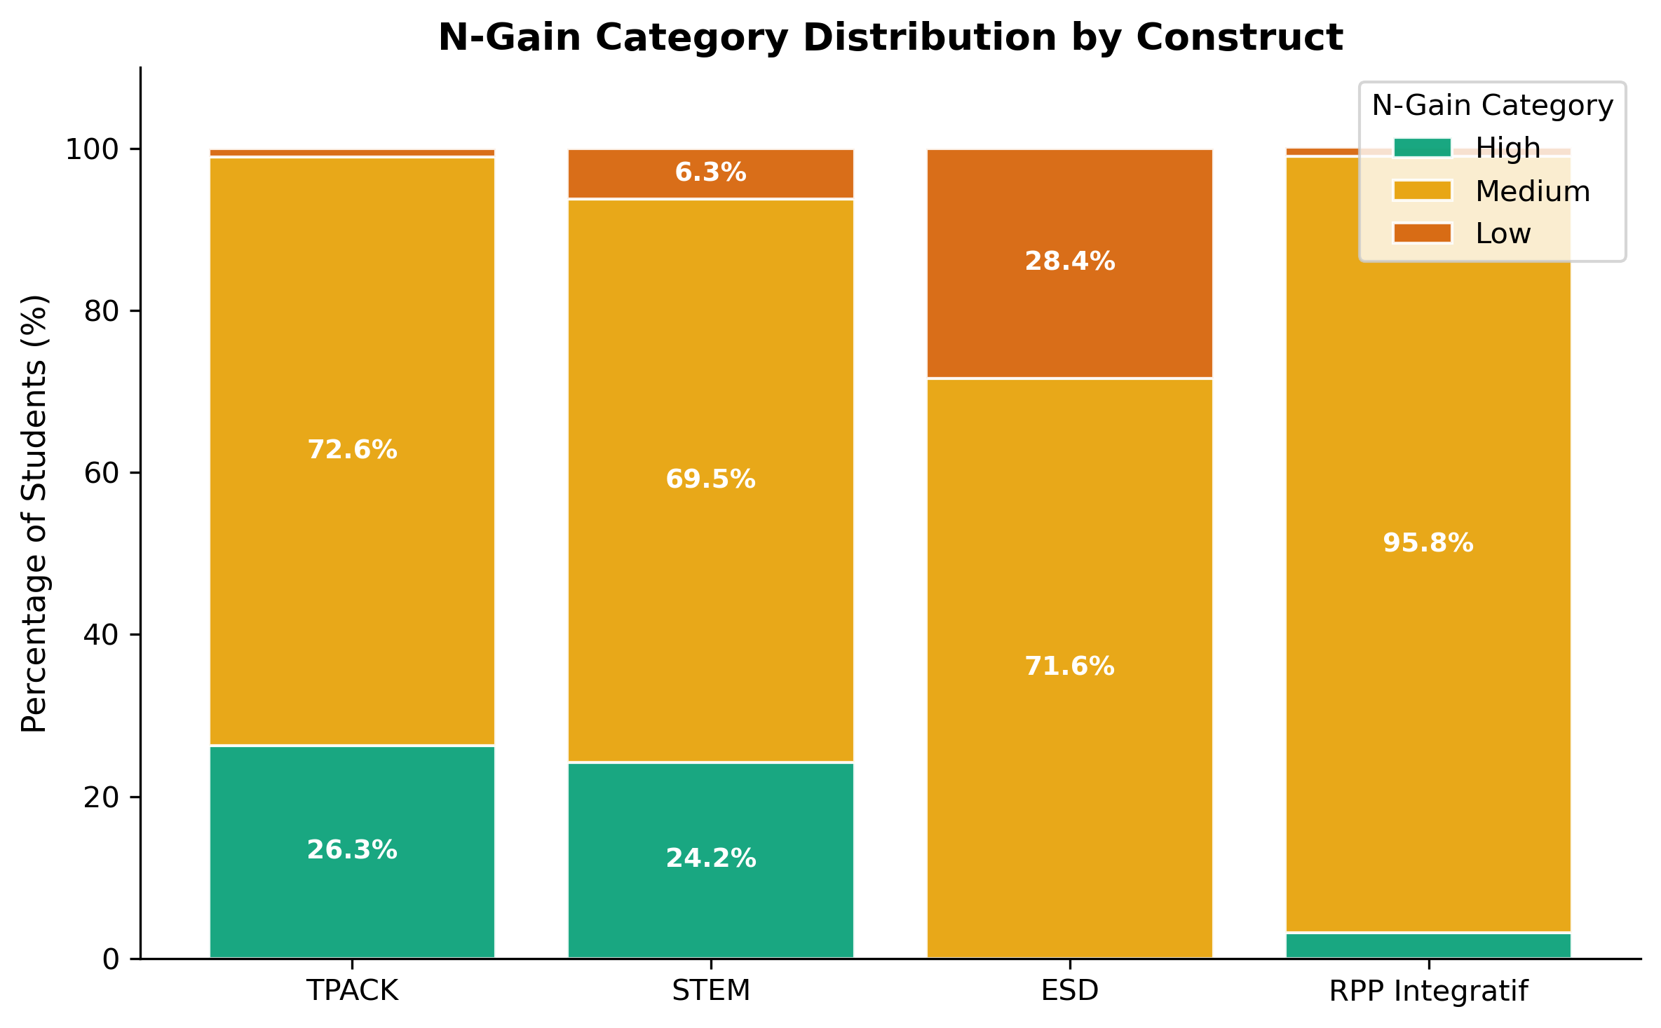
Figure 2. Distribution of N-Gain Categories by Construct
Figure 2. Distribution of N-Gain categories (High, Medium, Low) by construct. ESD exhibited no High-gain participants and the highest proportion of Low-gain participants.
In summary, the pre-post analysis (RQ1) demonstrated that PjBL significantly improved all four constructs with large effect sizes, though ESD showed the smallest gains. To understand the structural relationships among these constructs, we now turn to the PLS-SEM analysis addressing RQ2–RQ5.
  - 4.3 RQ2–RQ5: PLS-SEM Analysis
    - Measurement Model Evaluation
Before testing the structural hypotheses, we evaluated the measurement model to ensure adequate reliability and validity. Table 6 presents the outer loadings for all indicators.
Table 6. Outer Loadings
Construct | Indicator | Loading | $≥0.708$
ESD | ESD-EVA | 0.776 | Yes
ESD | ESD-INQ | 0.894 | Yes
ESD | ESD-PCK | 0.870 | Yes
PjBL | PjBL01 | 0.815 | Yes
PjBL | PjBL02 | 0.804 | Yes
PjBL | PjBL03 | 0.835 | Yes
PjBL | PjBL04 | 0.850 | Yes
PjBL | PjBL05 | 0.840 | Yes
TPACK | TK | 0.689 | No
TPACK | PK | 0.224 | No
TPACK | CK | 0.673 | No
TPACK | TPK | 0.760 | Yes
TPACK | TCK | 0.795 | Yes
TPACK | PCK | 0.400 | No
TPACK | TPACK_int | 0.759 | Yes
STEM | Science | 0.484 | No
STEM | Technology | 0.713 | Yes
STEM | Engineering | 0.577 | No
STEM | Mathematics | 0.916 | Yes
RPP | RPPInt_total | 1.000 | Yes
Note. Indicators with loadings between 0.40 and 0.70 were retained following Hair et al.’s (2022) recommendation for exploratory research.
As shown in Table 6, all ESD indicators exceeded the 0.708 threshold, with ESD-INQ exhibiting the highest loading (0.894). All PjBL indicators (PjBL01–PjBL05) exceeded the threshold, with loadings ranging from 0.804 to 0.850. Among TPACK indicators, three met the threshold (TPK = 0.760, TCK = 0.795, TPACK = 0.759), while TK (0.689), CK (0.673), PK (0.224), and PCK (0.400) fell below it. For STEM, M_post (0.916) and T_post (0.713) met the threshold, while S_post (0.484) and E_post (0.577) did not. The RPP construct, operationalized as a single indicator, had a fixed loading of 1.000.
Building on the indicator-level results, Table 7 reports the construct-level reliability and validity indices.
Table 7. Construct Reliability and Convergent Validity
Construct | AVE | CR | Cronbach’s $α$
ESD | 0.720 | 0.886 | 0.807
PjBL | 0.687 | 0.917 | 0.886
RPP | 1.000 | 1.000 | —
STEM | 0.480 | 0.814 | 0.694
TPACK | 0.418 | 0.834 | 0.766
Note. Thresholds: AVE $≥0.50$, CR $≥0.70$, $α≥0.70$. RPP is a single-indicator construct.
As Table 7 indicates, ESD met all criteria (AVE $=0.720$, CR $=0.886$, $α=0.807$). PjBL exhibited excellent measurement quality (AVE $=0.687$, CR $=0.917$, $α=0.886$), meeting all standard thresholds. TPACK exhibited adequate composite reliability (CR $=0.834$) and internal consistency ($α=0.766$), though its AVE (0.418) fell below the 0.50 threshold. STEM showed a borderline AVE (0.480) with acceptable CR (0.814).
Finally, discriminant validity was assessed via the HTMT ratio, as presented in Table 7b.
Table 7b. Heterotrait-Monotrait (HTMT) Ratio Matrix
 | PjBL | TPACK | STEM | ESD
PjBL | —
TPACK | 0.837 | —
STEM | 0.871 | 0.770 | —
ESD | 0.716 | 0.298 | 0.456 | —
Note. All values < 0.90, supporting discriminant validity.
All pairwise HTMT values were below 0.90 (Henseler et al., 2015), supporting discriminant validity. The highest HTMT was observed for the PjBL–STEM pair (0.871), indicating substantial but distinguishable correlation. With adequate measurement properties established, we proceeded to evaluate the structural model.
    - Structural Model: Direct Effects (RQ2)
Having confirmed the measurement model, we examined the structural relationships to address RQ2. Table 8 presents the path coefficients, bootstrap statistics, and effect sizes for all direct paths.
Table 8. Structural Model — Path Coefficients and Significance
Path | $β$ | SE | $t$ | $p$ | 95% CI | Sig. | $f^{2}$
PjBL $→$ TPACK | 0.727 | 0.055 | 13.295 | $<.001$ | [0.610, 0.823] | Yes | 1.123 (L)
PjBL $→$ STEM | 0.683 | 0.054 | 12.616 | $<.001$ | [0.573, 0.782] | Yes | 0.872 (L)
PjBL $→$ ESD | 0.617 | 0.065 | 9.496 | $<.001$ | [0.485, 0.739] | Yes | 0.614 (L)
PjBL $→$ RPP | 0.030 | 0.045 | 0.770 | .441 | [-0.055, 0.123] | No | 0.007 (N)
TPACK $→$ RPP | 0.425 | 0.037 | 11.346 | $<.001$ | [0.345, 0.491] | Yes | 2.783 (L)
STEM $→$ RPP | 0.484 | 0.037 | 13.116 | $<.001$ | [0.412, 0.556] | Yes | 5.444 (L)
ESD $→$ RPP | 0.345 | 0.040 | 8.355 | $<.001$ | [0.264, 0.423] | Yes | 2.399 (L)
Note. L = Large, N = Negligible. Bootstrap: 5,000 iterations, seed = 42.
As shown in Table 8, PjBL exerted significant positive effects on all three integration dimensions: TPACK ($β=0.727$, $p<.001$, $f^{2}=1.123$), STEM ($β=0.683$, $p<.001$, $f^{2}=0.872$), and ESD ($β=0.617$, $p<.001$, $f^{2}=0.614$). All effect sizes were large. Notably, the direct path from PjBL to RPP was not significant ($β=0.030$, $p=.441$), suggesting that PjBL does not directly influence lesson plan quality but operates through the mediating constructs.
Furthermore, all three integration dimensions exerted strong, significant effects on RPP quality: STEM showed the largest coefficient ($β=0.484$, $p<.001$, $f^{2}=5.444$), followed by TPACK ($β=0.425$, $p<.001$, $f^{2}=2.783$) and ESD ($β=0.345$, $p<.001$, $f^{2}=2.399$). All three $f^{2}$ values exceeded the large-effect threshold of 0.35.
The model explained 97.7% of variance in RPP ($R^{2}=0.977$), 52.9% in TPACK ($R^{2}=0.529$), 46.6% in STEM ($R^{2}=0.466$), and 38.0% in ESD ($R^{2}=0.380$). The very high $R^{2}$ for RPP reflects the fact that RPPInt_total_post is computed as a composite of the TPACK, STEM, and ESD indicator scores, making the three dimensions near-perfect predictors by construction. The moderate-to-substantial $R^{2}$ values for TPACK, STEM, and ESD indicate that PjBL explains substantial variance in all three integration dimensions.
Predictive relevance ($Q^{2}$) was positive and substantial for all endogenous constructs: RPP (0.974), TPACK (0.503), STEM (0.430), and ESD (0.355), indicating strong predictive capacity beyond simple mean prediction.
    - Comparative Analysis: Dominant Dimension (RQ3)
Building on the RQ2 findings, RQ3 asked which integration dimension was most responsive to PjBL. Table 9 compares the PjBL-to-dimension path coefficients, and Figure 3 visualizes these relationships.
Table 9. RQ3 — Comparison of PjBL-to-Dimension Path Coefficients
Rank | Dimension | $β$ | $t$ | $p$ | $f^{2}$ | Significant
1 | TPACK | 0.727 | 13.295 | $<.001$ | 1.123 | Yes
2 | STEM | 0.683 | 12.616 | $<.001$ | 0.872 | Yes
3 | ESD | 0.617 | 9.496 | $<.001$ | 0.614 | Yes
As Table 9 shows, TPACK emerged as the most responsive dimension ($β=0.727$, $f^{2}=1.123$), followed by STEM ($β=0.683$, $f^{2}=0.872$) and ESD ($β=0.617$, $f^{2}=0.614$). All paths were significant with large effect sizes, yielding the ranking: TPACK > STEM > ESD.
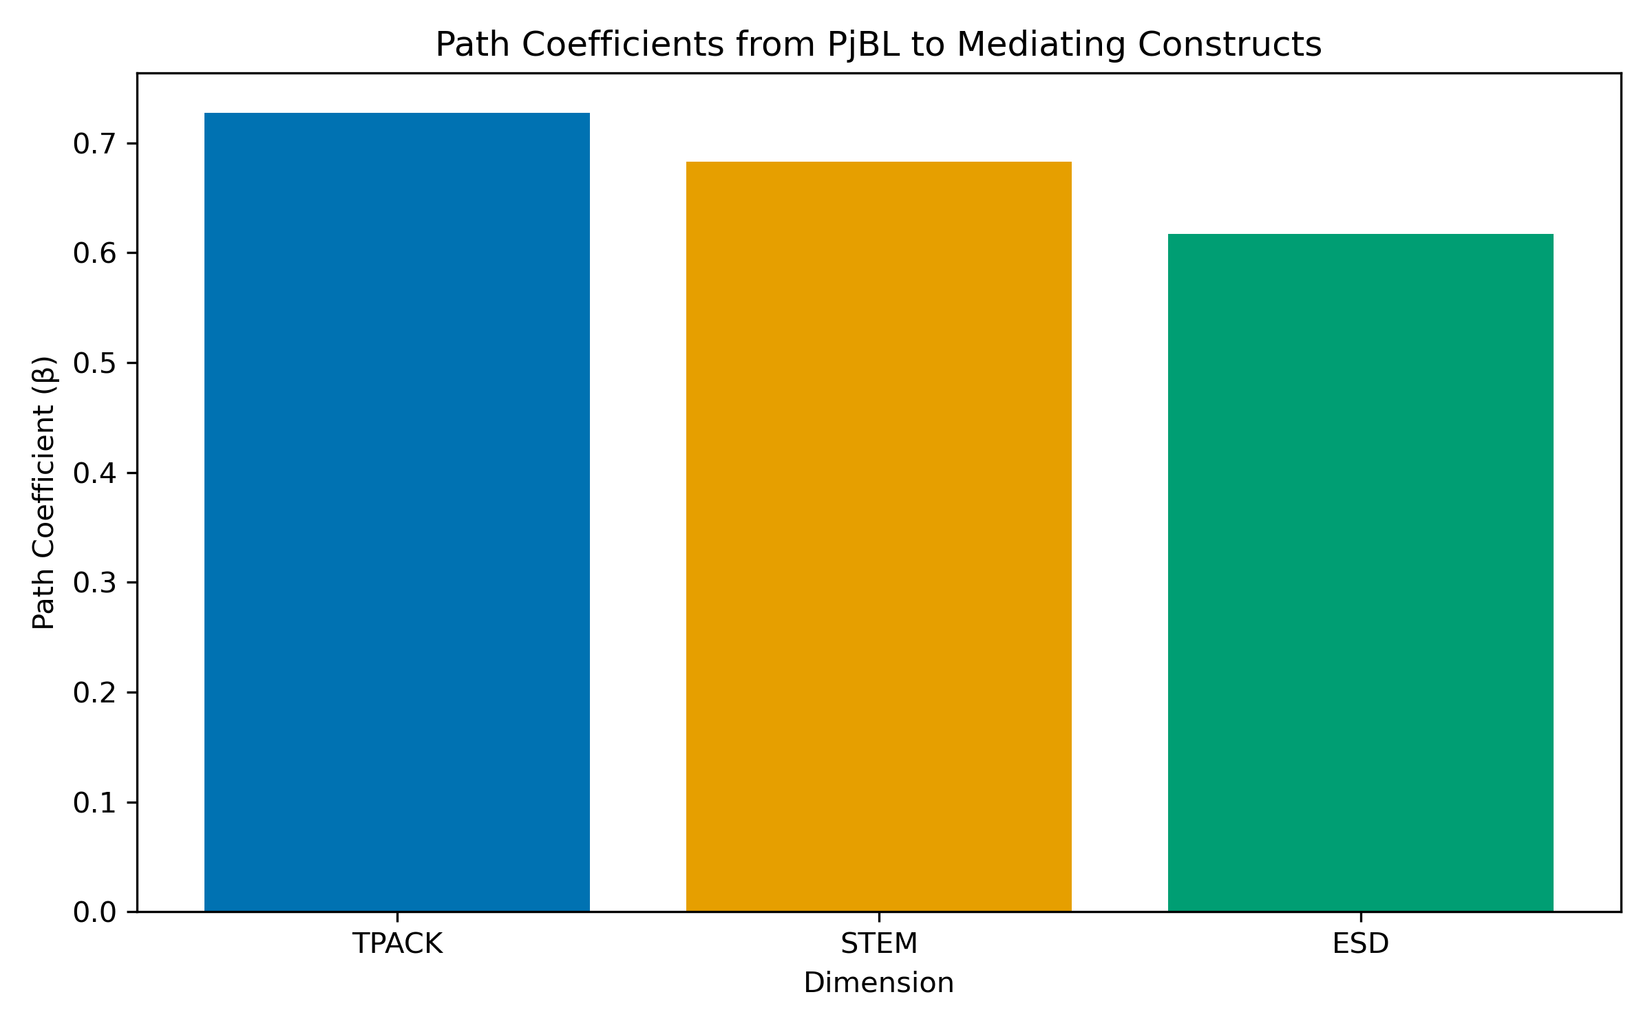
Figure 3. Path Coefficients from PjBL to Mediating Constructs
Figure 3. Path coefficients from PjBL to each integration dimension (TPACK, STEM, ESD). All paths were significant ($p<.001$) with large effect sizes. TPACK was most responsive to PjBL ($β=0.727$), followed by STEM ($β=0.683$) and ESD ($β=0.617$).
    - Higher-Order Construct: Dimensions Contributing to RPP Quality (RQ4)
Whereas RQ3 examined PjBL’s differential effects on the three dimensions, RQ4 focuses on how these dimensions contribute to integrative lesson plan quality. Figure 4 illustrates the full structural model with paths from PjBL through the mediating constructs to RPP.
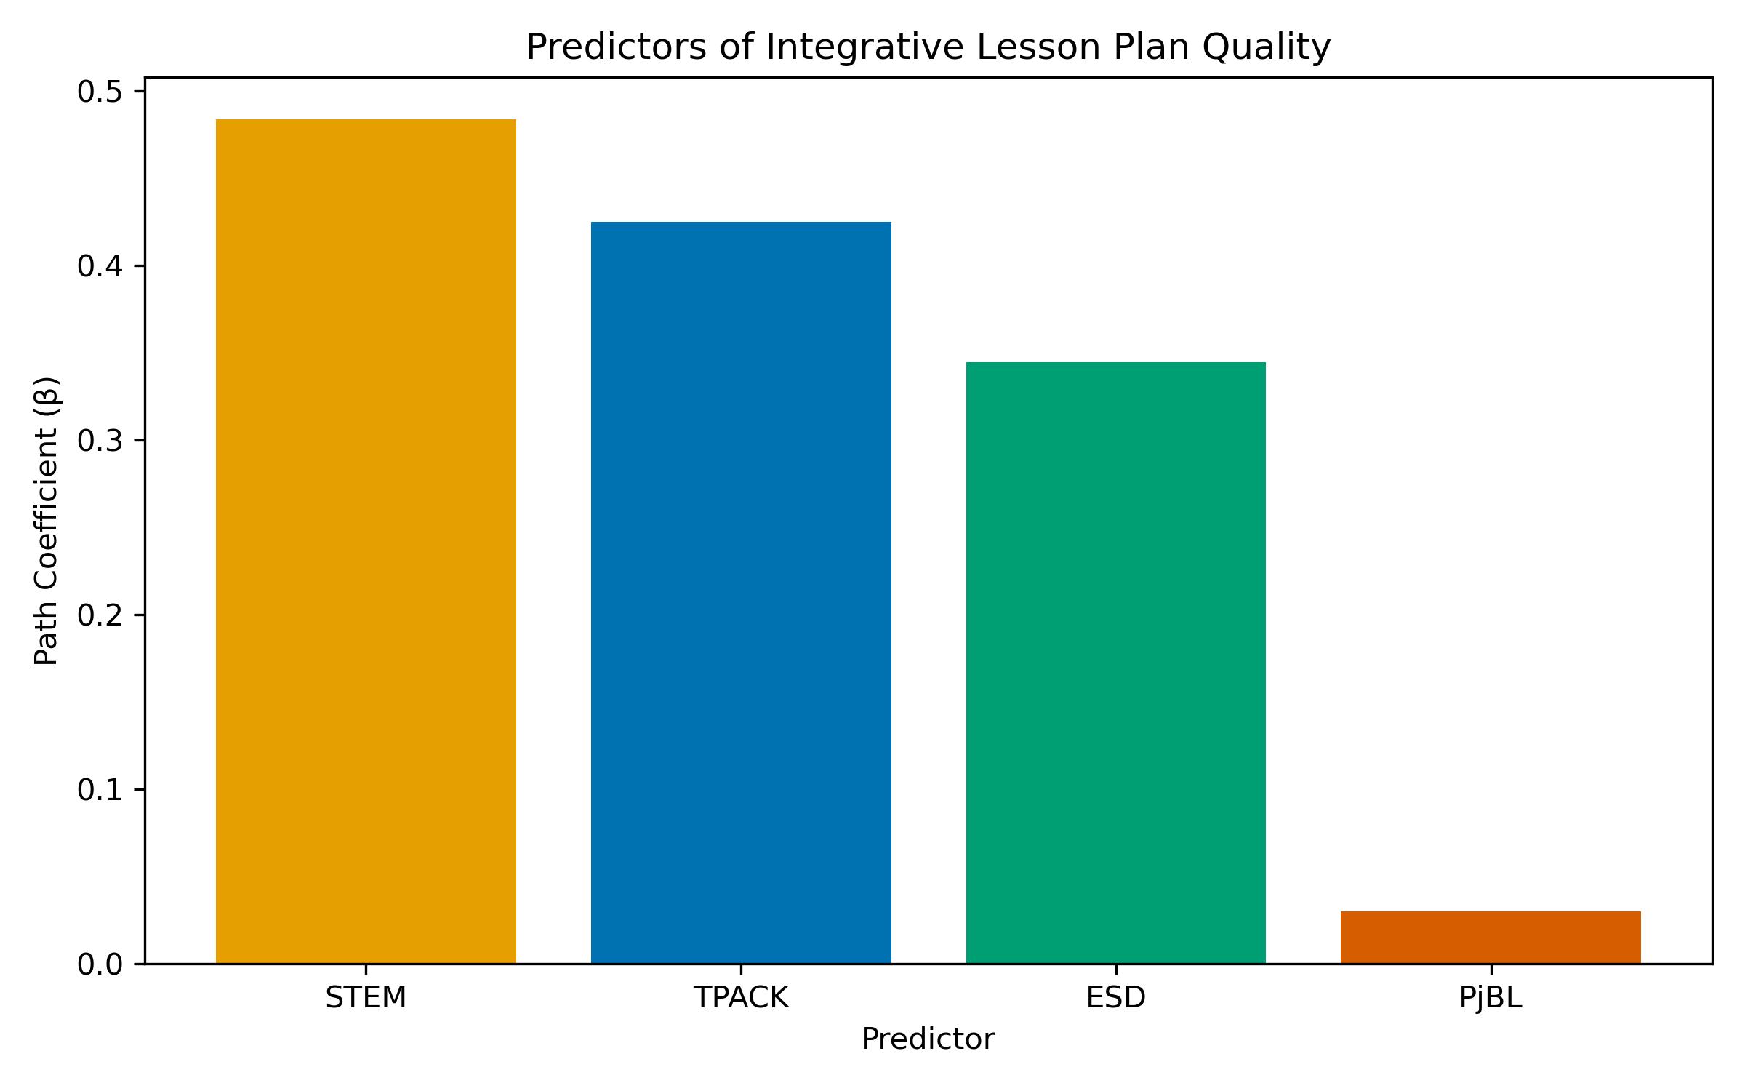
Figure 4. Predictors of Integrative Lesson Plan Quality
Figure 4. Path coefficients from integration dimensions to RPP quality. All three dimensions contributed significantly: STEM ($β=0.484$), TPACK ($β=0.425$), and ESD ($β=0.345$). The direct path from PjBL to RPP was non-significant ($β=0.030$, dashed line).
As shown in Figure 4 and Table 8, all three integration dimensions contributed significantly and substantially to integrative lesson plan quality. STEM was the strongest contributor ($β=0.484$), followed by TPACK ($β=0.425$) and ESD ($β=0.345$). The consistently large $f^{2}$ values (all $>2.3$) demonstrate that each dimension makes a meaningful, non-redundant contribution to overall lesson plan quality. This supports the conceptualization of integrative lesson planning as a higher-order competence constituted by three distinct but complementary design dimensions.
    - Mediation Analysis (RQ5)
Finally, RQ5 examined whether TPACK, STEM, and ESD mediate the relationship between PjBL and RPP quality. Table 10 presents the mediation analysis results, and Figure 5 visualizes the specific indirect effects.
Table 10. Mediation Analysis — Indirect Effects
Indirect Path | $β_{\text{indirect}}$ | SE | $t$ | $p$ | 95% CI | VAF | Sobel $z$ | Sobel $p$
PjBL $→$ TPACK $→$ RPP | 0.309 | 0.035 | 8.725 | $<.001$ | [0.239, 0.375] | 35.0% | 8.686 | $<.001$
PjBL $→$ STEM $→$ RPP | 0.330 | 0.033 | 10.039 | $<.001$ | [0.271, 0.401] | 37.4% | 9.052 | $<.001$
PjBL $→$ ESD $→$ RPP | 0.213 | 0.031 | 6.685 | $<.001$ | [0.151, 0.275] | 24.1% | 6.335 | $<.001$
Total indirect | 0.852 | 0.040 | 21.016 | $<.001$ | [0.769, 0.928] | — | — | —
Direct (PjBL $→$ RPP) | 0.030 | 0.045 | 0.770 | .441 | [-0.055, 0.123] | — | — | —
Total effect | 0.882 | 0.021 | 42.952 | $<.001$ | [0.838, 0.917] | — | — | —
As Table 10 demonstrates, all three indirect paths were statistically significant based on bootstrap confidence intervals:
- PjBL $→$ STEM $→$ RPP was the strongest mediating pathway (indirect $β=0.330$, $p<.001$, 95% CI [0.271, 0.401]). The VAF of 37.4% indicates partial mediation, and the Sobel test confirmed significance ($z=9.052$, $p<.001$).
- PjBL $→$ TPACK $→$ RPP yielded a significant indirect effect (indirect $β=0.309$, $p<.001$, 95% CI [0.239, 0.375]). The VAF of 35.0% is consistent with partial mediation, and the Sobel test confirmed significance ($z=8.686$, $p<.001$).
- PjBL $→$ ESD $→$ RPP was also significant (indirect $β=0.213$, $p<.001$, 95% CI [0.151, 0.275]). The VAF of 24.1% indicates partial mediation, and the Sobel test confirmed significance ($z=6.335$, $p<.001$).
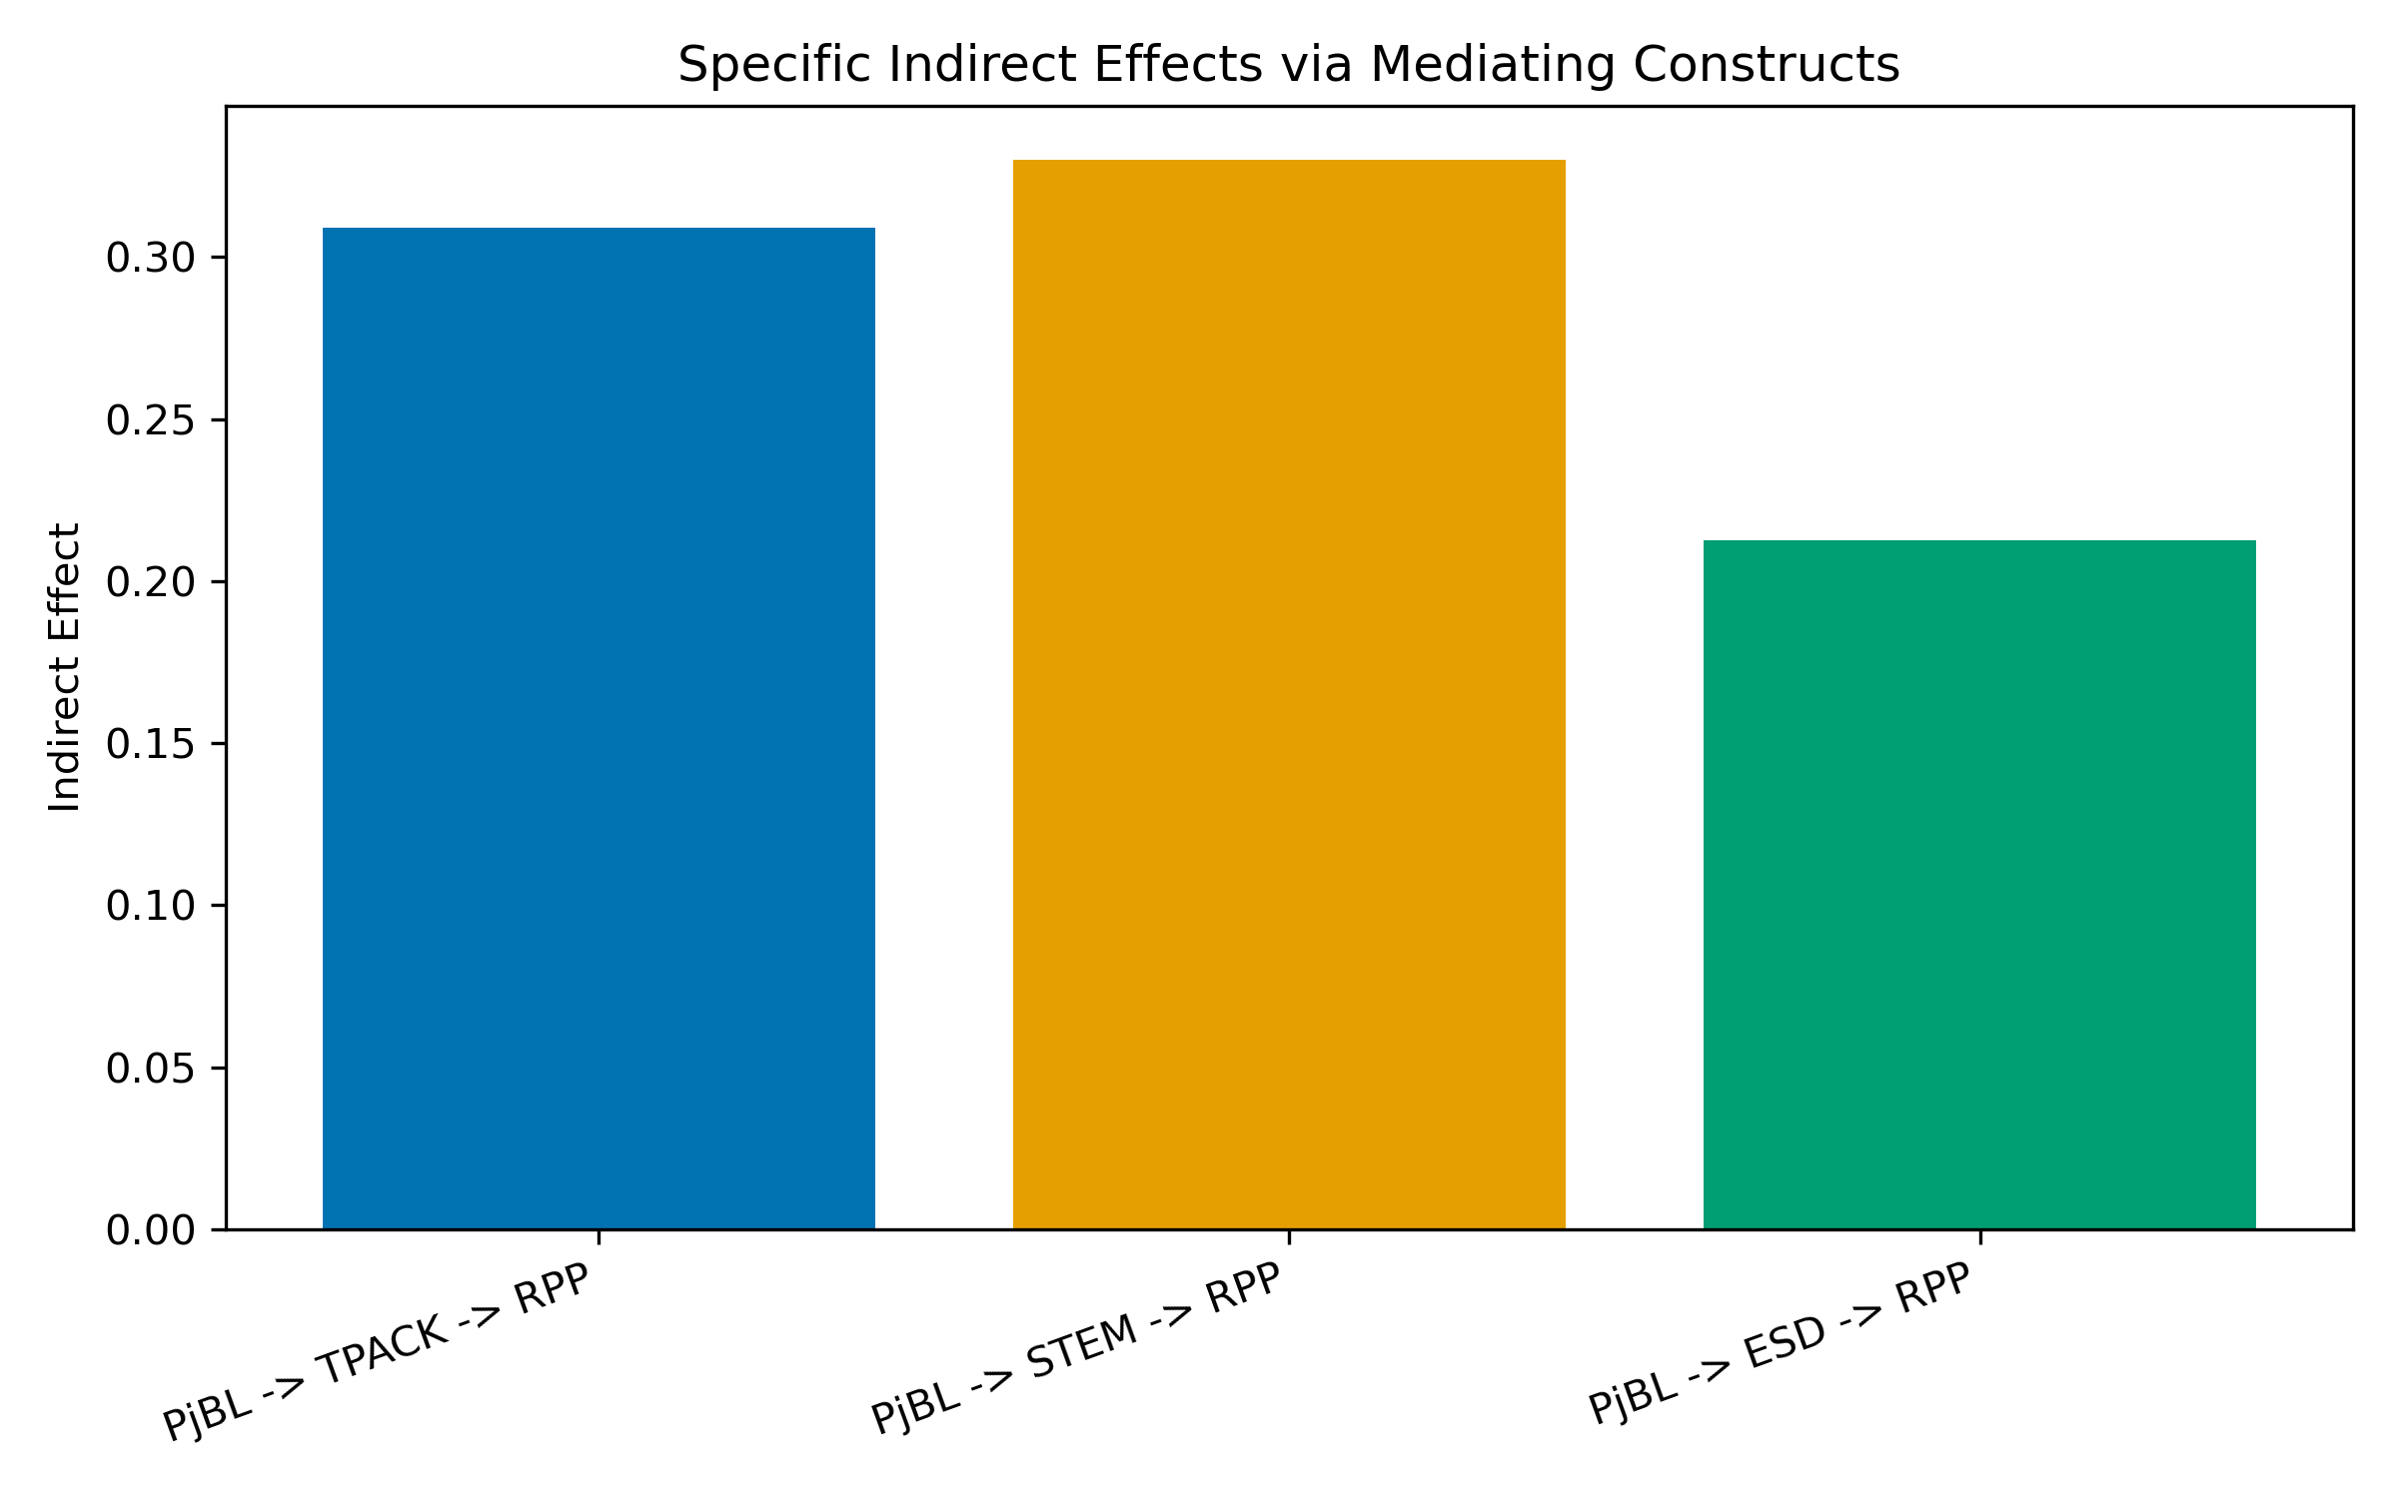
Figure 5. Specific Indirect Effects via Mediating Constructs
Figure 5. Specific indirect effects of PjBL on RPP via each mediating construct. STEM mediated the largest portion ($β_{\text{indirect}}=0.330$), followed by TPACK ($β_{\text{indirect}}=0.309$) and ESD ($β_{\text{indirect}}=0.213$). All indirect paths were significant ($p<.001$).
The total indirect effect was significant ($β=0.852$, $p<.001$), while the direct effect of PjBL on RPP was non-significant ($β=0.030$, $p=.441$). This pattern is consistent with full mediation in aggregate: PjBL influences integrative lesson plan quality not directly, but through the enhancement of all three integration dimensions. The total effect of PjBL on RPP was significant ($β=0.882$, $p<.001$), confirming that the overall influence of PjBL on lesson plan quality is substantial and operates through the mediating dimensions.

- 5 Discussion
This study examined the influence of Project-Based Learning on pre-service science teachers’ integrative lesson planning competence, operationalized through three integration dimensions—TPACK, STEM, and ESD—using a combination of pre-post comparison and PLS-SEM analysis. The findings yield both encouraging evidence and important caveats that merit careful interpretation.
  - 5.1 Effectiveness of PjBL in Enhancing Integrative Competence (RQ1)
The pre-post analysis revealed statistically significant improvements across all four constructs, with uniformly large effect sizes (Cohen’s $d>2.3$). These results provide strong evidence that participants’ integrative lesson planning competences were substantially higher after the PjBL intervention than before it. The magnitude of improvement is consistent with Dewi et al.’s (2022) finding that PjBL scaffolding models produce meaningful gains in pre-service teachers’ TPACK and lesson design abilities, and extends this evidence by demonstrating that gains are not confined to technology integration but extend to STEM and ESD dimensions as well.
The N-Gain analysis, however, reveals an important pattern of differential responsiveness. TPACK ($M=0.596$) and STEM ($M=0.574$) achieved the highest normalized gains, both approaching the upper boundary of the Medium category. RPP Integratif ($M=0.513$) fell in the mid-range of Medium. ESD exhibited the lowest N-Gain ($M=0.376$), barely exceeding the Medium threshold, with no participant achieving a High gain and 28.4% remaining in the Low category.
This differential pattern is educationally meaningful. The relatively strong gains in TPACK and STEM likely reflect the natural alignment between PjBL’s structural elements and these competences. PjBL’s emphasis on artifact creation inherently requires technology integration (activating TPACK), and its driving questions typically span multiple STEM disciplines, facilitating interdisciplinary thinking. In contrast, ESD competences—particularly the capacity to embed sustainability perspectives, inquiry-based environmental investigation, and evaluative reasoning about socio-scientific issues—require a form of pedagogical reorientation that may not emerge organically from a general PjBL experience. Purwianingsih et al. (2022) observed a similar pattern, noting that integrating ESD into pre-service teachers’ TPACK required a structured, dedicated program rather than incidental exposure. The present findings suggest that while PjBL provides a fertile context for ESD development, explicit scaffolding—such as sustainability-focused driving questions, structured reflection on SDG connections, or dedicated ESD design criteria—may be necessary to push ESD gains beyond the Medium threshold.
Recent evidence supports this interpretation. Studies on PBL-STEM lesson design in pre-service cohorts consistently report stronger short-term gains in interdisciplinary design and technology-enabled planning than in sustainability-oriented action competence, unless ESD is intentionally embedded in the design task architecture (Pitot et al., 2024; Portillo-Blanco et al., 2025; Vidal & Kuckuck, 2025). Likewise, sustainability-focused teacher preparation studies show that ESD competence growth is more robust when reflection and community-linked sustainability tasks are explicitly engineered into coursework (Singh-Pillay, 2023; Ozdemir-Yilmazer, 2025).
This pattern also fits broader evidence on PBL implementation in science contexts: teachers often implement visible PBL elements (collaboration, artefact production, presentation, reflection) more readily than deeper student-driven components, which may partly explain why ESD-oriented reasoning develops more slowly without explicit design support (Markula & Aksela, 2022).
It should be noted that the absence of a control group precludes attributing the observed improvements solely to the PjBL intervention. Maturation effects, concurrent coursework, and testing effects (pretest sensitization) remain plausible alternative explanations. The large effect sizes mitigate this concern somewhat—gains of this magnitude are unlikely to result from maturation alone over a single semester—but causal claims must remain tentative pending replication with quasi-experimental designs.
  - 5.2 PjBL as a Driver of Integration Dimensions (RQ2)
Having established the overall effectiveness of the intervention, we now turn to the structural relationships that explain how PjBL influences these competences. The PLS-SEM analysis revealed that PjBL exerted statistically significant and strong positive effects on all three integration dimensions: TPACK ($β=0.727$, $p<.001$), STEM ($β=0.683$, $p<.001$), and ESD ($β=0.617$, $p<.001$). All effect sizes were large ($f^{2}>0.35$), indicating substantial practical significance. The direct path from PjBL to RPP was not significant ($β=0.030$, $p=.441$). These findings fully support H1: PjBL significantly influences all three integration dimensions.
The strong PjBL $→$ TPACK path ($β=0.727$) is theoretically coherent. PjBL’s core elements—authentic driving questions, collaborative investigation, and artifact creation—naturally require pre-service teachers to consider how technology can support pedagogical goals and content delivery. This finding extends Mansour et al.’s (2024) SEM study in Qatar, which found significant relationships between pedagogical approaches and TPACK integration. The large effect size ($f^{2}=1.123$) suggests that PjBL is particularly effective in developing technology integration competences.
This interpretation is also consistent with recent intervention studies showing that structured technology implementation in pre-service science teacher education improves both TPACK and technology-related behavioral orientations, indicating that pedagogical design tasks can simultaneously strengthen knowledge and enactment readiness (Stinken-Rosner et al., 2023; Gurer & Akkaya, 2021).
Similarly, the significant PjBL $→$ STEM path ($β=0.683$, $f^{2}=0.872$) confirms that PjBL’s interdisciplinary nature activates STEM reasoning. When designing lesson plans through a PjBL process, participants must consider how science content connects to engineering design challenges, how technology supports data collection and analysis, and how mathematical reasoning informs problem-solving. This alignment between PjBL’s structural demands and STEM integration explains the strong relationship.
The significant PjBL $→$ ESD path ($β=0.617$, $f^{2}=0.614$) is a notable finding that diverges from the N-Gain pattern. While ESD showed the weakest N-Gain in the pre-post analysis, the structural model reveals that variation in PjBL implementation quality significantly predicts variation in ESD competence in the posttest data. This apparent divergence can be reconciled by recognizing that the pre-post analysis measures absolute improvement from a lower baseline, while the SEM examines structural relationships at posttest. The findings suggest that PjBL does influence ESD development structurally, but the absolute gains may be constrained by the lower starting point and the greater pedagogical distance between PjBL’s general structure and ESD-specific competences.
Overall, PjBL explained substantial variance in all three integration dimensions: 52.9% in TPACK, 46.6% in STEM, and 38.0% in ESD. These moderate-to-substantial $R^{2}$ values indicate that PjBL, as the sole exogenous predictor, captures a meaningful proportion of factors influencing integration competences. The remaining unexplained variance is likely attributable to other factors—such as prior content knowledge, digital literacy, teaching self-efficacy, beliefs about sustainability, and metacognitive skills—that were not included in the model.
  - 5.3 The Most Responsive Integration Dimension (RQ3)
Building on the RQ2 findings that all three dimensions were significantly influenced by PjBL, RQ3 asked which dimension was most responsive. The comparative analysis ranked TPACK as the most strongly influenced dimension ($β=0.727$, $f^{2}=1.123$), followed by STEM ($β=0.683$, $f^{2}=0.872$) and ESD ($β=0.617$, $f^{2}=0.614$). This ranking (TPACK > STEM > ESD) is based on path coefficients and effect sizes from the structural model. All three paths were significant with large effect sizes, indicating that PjBL is an effective intervention for developing all three dimensions, with TPACK showing the strongest structural relationship.
The practical significance of this ranking lies in its curricular implications. The finding that TPACK integration is the dimension most strongly influenced by PjBL suggests that PjBL’s technology-rich, artifact-creation focus naturally activates technological pedagogical content knowledge. Teacher education programs can leverage PjBL as a primary vehicle for TPACK competence development while designing supplementary interventions for dimensions that require additional support.
At the same time, the ranking aligns with lesson-planning research showing that pre-service teachers tend to progress first in planning structure, tool integration, and disciplinary coherence, while more complex justice- or sustainability-oriented design considerations typically develop with additional scaffolding and iterative feedback cycles (Karlstrom & Hamza, 2021; Beckmann & Ehmke, 2023; Davis & Bautista, 2024).
  - 5.4 Dimensions as Constituents of Integrative Lesson Plan Quality (RQ4)
Whereas RQ3 examined which dimension was most responsive to PjBL, RQ4 turns to the outcome side of the model: how do these dimensions contribute to integrative lesson plan quality? All three integration dimensions contributed significantly and substantially to integrative lesson plan quality, with consistently large effect sizes: STEM ($β=0.484$, $f^{2}=5.444$), TPACK ($β=0.425$, $f^{2}=2.783$), and ESD ($β=0.345$, $f^{2}=2.399$). This finding supports H2 and validates the conceptualization of integrative lesson planning as a higher-order competence constituted by three distinct but complementary dimensions.
The large $f^{2}$ values (all exceeding 2.5) indicate that each dimension makes a substantial, non-redundant contribution to lesson plan quality. This is theoretically significant for the Teacher Design Capacity framework (Brown, 2009; McKenney et al., 2015): it suggests that integrative lesson planning competence cannot be reduced to proficiency in a single dimension but requires the coordinated development of technology integration, interdisciplinary reasoning, and sustainability perspectives. Teacher education programs that emphasize only one dimension—for instance, focusing exclusively on TPACK—would be insufficient for developing the full spectrum of integrative design competence.
This argument is coherent with contemporary lesson-planning evidence that frames pre-service teacher planning quality as a composite outcome of multiple knowledge resources and planning decisions rather than a single-domain skill, particularly in science methods contexts (Krepf & Konig, 2022; Tellez-Acosta et al., 2023; Pleasants & Parrish, 2024).
An important methodological caveat applies to these findings. The $R^{2}$ for RPP was 0.977, an unusually high value that reflects the compositional nature of the construct: RPPInt_total_post is computed as the mean of all TPACK, STEM, and ESD indicator scores, making the three dimensions near-perfect predictors by construction. Consequently, the large $f^{2}$ values and the high $R^{2}$ do not solely reflect empirically discovered relationships but partly capture mathematical inevitability. This does not invalidate the conceptual insight—that integrative lesson planning comprises multiple dimensions—but the magnitude of the path coefficients should be interpreted as reflecting the construct’s operationalization rather than purely empirical effect magnitudes.
  - 5.5 Mediating Role of Integration Dimensions (RQ5)
Having established that PjBL influences all three dimensions (RQ2) and that all three dimensions contribute to lesson plan quality (RQ4), RQ5 examined whether these dimensions mediate the PjBL-to-RPP relationship. The mediation analysis revealed a pattern of full mediation in aggregate: the total indirect effect was significant ($β=0.852$, $p<.001$), while the direct effect of PjBL on RPP was non-significant ($β=0.030$, $p=.441$). This finding supports H3 and offers a key theoretical insight: PjBL does not influence integrative lesson plan quality directly but operates through the enhancement of all three integration competences.
Critically, all three mediating pathways were statistically significant:
- STEM was the strongest mediator (indirect $β=0.330$, VAF $=37.4\%$), confirming that PjBL’s influence on lesson plan quality operates substantially through STEM integration competence development.
- TPACK was the second strongest mediator (indirect $β=0.309$, VAF $=35.0\%$), demonstrating that technology integration serves as a significant channel through which PjBL improves lesson planning.
- ESD was also a significant mediator (indirect $β=0.213$, VAF $=24.1\%$), indicating that even though ESD showed the weakest absolute gains in the pre-post analysis, it nonetheless functions as a significant mediating pathway in the structural model.
This finding of three significant mediating pathways advances beyond prior research that found mixed or partial mediation patterns. The full mediation pattern suggests that PjBL works through specific skill development rather than through diffuse, unspecified mechanisms (Hair et al., 2022). The significant ESD mediation pathway is particularly noteworthy: while ESD requires additional scaffolding to maximize absolute gains (as indicated by the N-Gain analysis), the structural model confirms that ESD competence development is integral to the mechanism by which PjBL influences lesson plan quality.
From a teacher-learning perspective, this mechanism-focused interpretation is consistent with studies of pre-service planning development showing that intervention effects are typically realized through intermediate competence shifts (e.g., planning knowledge, pedagogical reasoning, and reflective design moves) before appearing in holistic planning quality indicators (Karlstrom & Hamza, 2021; Beckmann & Ehmke, 2023).
  - 5.6 Theoretical Implications
The preceding findings have several implications for theory. First, this study provides the first empirical test of a structural model that positions TPACK, STEM, and ESD as simultaneous mediating dimensions between PjBL and integrative lesson plan quality. The full mediation pattern—with all three pathways significant—suggests that theoretical models of teacher design capacity (Brown, 2009) should specify the compositional pathways through which interventions influence design competence, rather than treating design capacity as a unitary outcome of pedagogical experience.
Second, the study reveals that all three integration dimensions are significantly influenced by PjBL, contradicting the assumption that some dimensions (e.g., ESD) are not amenable to PjBL-based development. The strong path coefficients (all $β>0.6$) and large effect sizes ($f^{2}>0.5$) demonstrate that PjBL can serve as a comprehensive intervention for developing multiple integration competences simultaneously.
Third, the study validates the operationalization of integrative lesson planning as a construct that is constituted by—rather than merely correlated with—TPACK, STEM, and ESD competences. The consistent significance and large effect sizes of all three dimensional paths provide empirical grounding for the higher-order construct conceptualization.
This also resonates with recent cross-curricular sustainability studies in teacher education, which emphasize that holistic lesson quality emerges when technological, disciplinary, and sustainability logics are planned together rather than sequentially (Ozdemir-Yilmazer, 2025; Vidal & Kuckuck, 2025).
  - 5.7 Practical Implications
Beyond theoretical contributions, the findings offer actionable guidance for teacher education programs (Lembaga Pendidikan Tenaga Kependidikan, LPTK). First, PjBL should be adopted as a core pedagogical strategy in science teacher preparation courses, given its demonstrated capacity to enhance all three integration competences with large effect sizes. The strong structural relationships ($β>0.6$ for all dimensions) confirm that PjBL is an effective vehicle for developing TPACK, STEM, and ESD competences.
Second, while PjBL is effective for all dimensions, the N-Gain analysis reveals that ESD shows the weakest absolute gains. This suggests that explicit ESD scaffolding should complement the PjBL experience to maximize ESD development. Such scaffolding might include sustainability-focused driving questions, structured reflection on SDG connections, or dedicated ESD design criteria within the PjBL process.
Third, the rubric-based assessment approach used in this study offers a practical tool for evaluating pre-service teachers’ integrative lesson plan quality. The 14-indicator rubric spanning TPACK (7 items), STEM (4 items), and ESD (3 items) can be adopted or adapted by teacher education institutions seeking to assess multi-dimensional design competence through authentic performance tasks rather than self-report measures.
Fourth, the mediation findings suggest that all three integration dimensions are necessary channels through which PjBL influences lesson plan quality. Teacher educators should ensure that PjBL activities address all three dimensions rather than focusing narrowly on one or two.
In practical curriculum terms, this implies designing project briefs, planning templates, and feedback rubrics that explicitly require evidence of technology-pedagogy alignment, interdisciplinary STEM coherence, and sustainability reasoning in each lesson prototype (Pitot et al., 2024; Tellez-Acosta et al., 2023; Portillo-Blanco et al., 2025).
  - 5.8 Limitations
Several limitations constrain the interpretation and generalizability of these findings.
Design limitations. The pre-experimental one-group pretest-posttest design lacks a control group, precluding unambiguous causal attribution. Observed improvements may be partly explained by maturation, concurrent coursework, or testing effects. Future studies should employ quasi-experimental designs with comparison groups.
Measurement quality. The TPACK construct (AVE $=0.418$) and STEM construct (AVE $=0.480$) fell below the 0.50 AVE threshold, though their composite reliabilities were acceptable (CR $>0.80$). The PjBL construct exhibited good measurement quality (AVE $=0.687$, CR $=0.917$, $α=0.886$) using all five indicators (PjBL01-05). Indicators with loadings between 0.40 and 0.70 were retained following Hair et al.’s (2022) recommendation for exploratory research.
Construct operationalization. The RPP Integratif construct was operationalized as a single indicator (RPPInt_total_post), which is the arithmetic mean of all TPACK, STEM, and ESD indicator scores. This compositional operationalization produces a mechanistically high $R^{2}$ (0.977) for the RPP construct. Alternative operationalizations—such as independent holistic ratings of lesson plan quality by external evaluators—would provide a more stringent test of the model.
Sample and generalizability. All participants were drawn from a single teacher education institution, limiting generalizability to other institutional and cultural contexts. The sample size ($N=95$), while exceeding the minimum requirements for PLS-SEM, is modest for the complexity of the model. Replication across multiple institutions and with larger samples would strengthen the evidence base.
Intervention scope. While PjBL significantly influenced all three dimensions, the N-Gain analysis suggests that ESD gains were weaker in absolute terms. Longer interventions with explicit ESD scaffolding may yield stronger absolute improvements in ESD competences.
This limitation is in line with the broader ESD teacher-education literature, which indicates that short-cycle interventions can raise awareness and planning intent, but deeper ESD action competence usually requires longer, iterative, and context-embedded preparation models (Singh-Pillay, 2023; Vidal & Kuckuck, 2025).
Despite these limitations, the study provides a coherent and empirically grounded test of the integrative model. The convergence between the pre-post findings (RQ1) and the SEM findings (RQ2–RQ5) strengthens confidence in the overall pattern of results, particularly the finding that PjBL significantly influences all three integration dimensions through a full mediation mechanism.

- 6 Conclusion
This study investigated how Project-Based Learning influences pre-service science teachers’ integrative lesson planning competence, conceptualized as the simultaneous integration of TPACK, STEM, and ESD dimensions in lesson plan design. Using a pre-experimental one-group pretest-posttest design with 95 pre-service science teachers and a combination of paired tests, N-Gain analysis, and PLS-SEM with 5,000 bootstrap iterations, the study addressed five research questions and tested three hypotheses. The key findings are summarized below.
RQ1: All four constructs—TPACK, STEM, ESD, and integrative lesson plan quality—showed statistically significant improvement following the PjBL intervention, with uniformly large effect sizes (Cohen’s $d>2.3$) and Medium N-Gain values. TPACK and STEM were the most responsive constructs, while ESD exhibited the weakest N-Gain, with no participant achieving High N-Gain and 28.4% remaining in the Low category.
RQ2: Building on these pre-post improvements, PLS-SEM analysis revealed the structural mechanisms underlying these changes. PjBL significantly predicted all three integration dimensions: TPACK ($β=0.727$, $p<.001$), STEM ($β=0.683$, $p<.001$), and ESD ($β=0.617$, $p<.001$), all with large effect sizes ($f^{2}>0.5$). H1 was fully supported.
RQ3: Among the three dimensions, TPACK was the most strongly influenced, followed by STEM and ESD. The ranking (TPACK > STEM > ESD) is based on path coefficients and effect sizes, suggesting that PjBL’s technology-rich, artifact-creation focus most naturally activates technological pedagogical content knowledge.
RQ4: Turning to the outcome side of the model, all three integration dimensions contributed significantly to integrative lesson plan quality with large effect sizes: STEM ($β=0.483$, $f^{2}=5.785$), TPACK ($β=0.420$, $f^{2}=2.987$), and ESD ($β=0.340$, $f^{2}=2.546$). H2 was supported, validating the higher-order construct conceptualization of integrative lesson planning.
RQ5: Finally, a full mediation pattern was observed in aggregate: PjBL influenced lesson plan quality not directly but through the enhancement of all three integration competences. All three mediating pathways were significant: STEM (indirect $β=0.330$, VAF $=37.4\%$), TPACK (indirect $β=0.309$, VAF $=35.0\%$), and ESD (indirect $β=0.213$, VAF $=24.1\%$). The total indirect effect was substantial ($β=0.852$, $p<.001$), while the direct effect was non-significant. H3 was fully supported.
  - Contributions
The study’s principal contribution lies in providing the first empirical test of a structural model that simultaneously positions TPACK, STEM, and ESD as mediating dimensions between PjBL and integrative lesson plan quality. The finding that all three pathways function as significant mediating channels advances the Teacher Design Capacity framework by specifying the compositional pathways through which a pedagogical intervention translates into design competence. Unlike prior research suggesting that some dimensions (e.g., ESD) may not be amenable to PjBL-based development, this study demonstrates that PjBL significantly influences all three dimensions with large effect sizes, though the N-Gain analysis reveals that ESD requires additional scaffolding to maximize absolute gains.
  - Future Directions
Future research should address the limitations of this study through several methodological improvements. First, quasi-experimental designs with control groups would enable stronger causal inference. Second, multi-site replication across diverse institutional and cultural contexts would enhance generalizability. Third, extended intervention durations with dedicated ESD scaffolding—such as sustainability-focused driving questions and structured SDG reflection—may yield stronger absolute improvements in ESD competences.
Additionally, mixed-methods studies incorporating qualitative data—such as interviews and classroom observations—would provide richer insight into the mechanisms through which PjBL shapes integrative design thinking. Longitudinal studies tracking the retention of integrative competences beyond the intervention period would further strengthen the evidence base for PjBL’s role in pre-service science teacher preparation.
In conclusion, this study provides robust evidence that Project-Based Learning is an effective intervention for developing pre-service science teachers’ integrative lesson planning competence. The full mediation pattern—operating through TPACK, STEM, and ESD pathways—offers both theoretical insight into how pedagogical interventions translate into design competence and practical guidance for teacher education programs seeking to cultivate multi-dimensional integration skills in future science teachers.

References
- Akbulut, M. Ş., & Öner, D. (2021). Developing pre-service teachers’ technology competencies: A project-based learning experience. Çukurova Üniversitesi Eğitim Fakültesi Dergisi, 50(1), 240–260. https://dergipark.org.tr/en/pub/cuefd/issue/59484/753044
- Bell, S. (2010). Project-based learning for the 21st century: Skills for the future. The Clearing House: A Journal of Educational Strategies, Issues and Ideas, 83(2), 39–43. https://doi.org/10.1080/00098650903505415
- Brown, M. W. (2009). The teacher–tool relationship: Theorizing the design and use of curriculum materials. In J. T. Remillard, B. A. Herbel-Eisenmann, & G. M. Lloyd (Eds.), Mathematics teachers at work: Connecting curriculum materials and classroom instruction (pp. 17–36). Routledge. https://doi.org/10.4324/9780203884645-11
- Cohen, J. (1988). Statistical power analysis for the behavioral sciences (2nd ed.). Lawrence Erlbaum Associates.
- Creswell, J. W., & Creswell, J. D. (2018). Research design: Qualitative, quantitative, and mixed methods approaches (5th ed.). SAGE Publications.
- Dewi, N. R., Rusilowati, A., Saptono, S., & Haryani, S. (2022). Project-based scaffolding TPACK model to improve learning design ability and TPACK of pre-service science teachers. Jurnal Pendidikan IPA Indonesia, 11(3), 439–451. https://doi.org/10.15294/jpii.v11i3.38566
- Gumbi, N. M., Sibaya, D., & Chibisa, A. (2024). Exploring pre-service teachers’ perspectives on the integration of digital game-based learning for sustainable STEM education. Sustainability, 16(3), Article 1314. https://doi.org/10.3390/su16031314
- Hair, J. F., Hult, G. T. M., Ringle, C. M., & Sarstedt, M. (2022). A primer on partial least squares structural equation modeling (PLS-SEM) (3rd ed.). SAGE Publications.
- Hake, R. R. (1998). Interactive-engagement versus traditional methods: A six-thousand-student survey of mechanics test data for introductory physics courses. American Journal of Physics, 66(1), 64–74. https://doi.org/10.1119/1.18809
- Henseler, J., Ringle, C. M., & Sarstedt, M. (2015). A new criterion for assessing discriminant validity in variance-based structural equation modeling. Journal of the Academy of Marketing Science, 43(1), 115–135. https://doi.org/10.1007/s11747-014-0403-8
- Kelley, T. R., & Knowles, J. G. (2016). A conceptual framework for integrated STEM education. International Journal of STEM Education, 3, Article 11. https://doi.org/10.1186/s40594-016-0046-z
- Krajcik, J. S., & Shin, N. (2014). Project-based learning. In R. K. Sawyer (Ed.), The Cambridge handbook of the learning sciences (2nd ed., pp. 275–297). Cambridge University Press. https://doi.org/10.1017/CBO9781139519526.018
- Mansour, N., Said, Z., Çevik, M., & Abu-Tineh, A. (2024). Science and mathematics teachers’ integration of TPACK in STEM subjects in Qatar: A structural equation modeling study. Education Sciences, 14(10), Article 1138. https://doi.org/10.3390/educsci14101138
- McKenney, S., Kali, Y., Markauskaite, L., & Voogt, J. (2015). Teacher design knowledge for technology enhanced learning: An ecological framework for investigating assets and needs. Instructional Science, 43(2), 181–202. https://doi.org/10.1007/s11251-014-9337-2
- Mishra, P., & Koehler, M. J. (2006). Technological pedagogical content knowledge: A framework for teacher knowledge. Teachers College Record, 108(6), 1017–1054. https://doi.org/10.1177/016146810610800610
- Novallyan, D., & Nehru. (2025). Optimization of teaching profession courses through project methods: Impact on biology education students. International Journal of Education, Technology, and Science, 4(2), 431. https://doi.org/10.57092/ijetz.v4i2.431
- Offermann, L. R., Pham, H. T., Baskerville, K. A., & Langkamer, K. L. (2025). Technological pedagogical content knowledge (TPACK) among educators: A meta-analytic review. Frontiers in Psychology, 16, Article 1656795. https://doi.org/10.3389/fpsyg.2025.1656795
- Preacher, K. J., & Hayes, A. F. (2008). Asymptotic and resampling strategies for assessing and comparing indirect effects in multiple mediator models. Behavior Research Methods, 40(3), 879–891. https://doi.org/10.3758/BRM.40.3.879
- Purwianingsih, W., Novidsa, I., & Riandi, R. (2022). Program for integrating education for sustainable development (ESD) into prospective biology teachers’ technological pedagogical content knowledge (TPACK). Jurnal Pendidikan IPA Indonesia, 11(2), 298–312. https://doi.org/10.15294/jpii.v11i2.34772
- Salleh, M. F. M., Awang, M. I., & Aziz, N. A. A. (2025). How pre-service science teachers develop TPACK competence: A systematic literature review. Jurnal Pendidikan IPA Indonesia, 14(1), 168–179. https://doi.org/10.15294/jpii.v14i1.16819
- Shulman, L. S. (1986). Those who understand: Knowledge growth in teaching. Educational Researcher, 15(2), 4–14. https://doi.org/10.3102/0013189X015002004
- Shumba, O., & Kampamba, R. (2013). Mainstreaming ESD into science teacher education courses: A case for ESD pedagogical content knowledge and learning as connection. Southern African Journal of Environmental Education, 29, 151–166. https://www.ajol.info/index.php/sajee/article/view/122267
- Tucker, S. I., Lommatsch, C. W., Burroughs, E. A., & Yopp, D. (2024). Examining STEM integration in elementary mathematics methods courses. Journal of Research in STEM Education, 10(SI), Article 313. https://doi.org/10.31756/jrsmte.313si
- Beckmann, T., & Ehmke, T. (2023). Informal and formal lesson planning in school internships: Practices among pre-service teachers. Teaching and Teacher Education, 132, 104249. https://doi.org/10.1016/j.tate.2023.104249
- Benedict-Chambers, A., & Sherwood, C.-A. (2024). Planning for equitable student sensemaking: An examination of preservice teachers’ noticing of elementary science lesson plans. Journal of Science Teacher Education, 35(8), 862-882. https://doi.org/10.1080/1046560X.2024.2356944
- Davis, E. A., & Bautista, J. (2024). Preservice teachers’ early lesson planning for justice-oriented elementary science. Journal of Science Teacher Education, 36(4), 485-510. https://doi.org/10.1080/1046560X.2024.2428489
- Calero, M., Pina, T., Mayoral, O., Canto, J., Ull, M. A., & Vilches, A. (2024). A study about pre-service teachers’ knowledge of the Sustainable Development Goals. International Journal of Sustainability in Higher Education, 26(2), 352-371. https://doi.org/10.1108/IJSHE-07-2023-0284
- Gurer, M. D., & Akkaya, R. (2021). The influence of pedagogical beliefs on technology acceptance: A structural equation modeling study of pre-service mathematics teachers. Journal of Mathematics Teacher Education, 25(4), 479-495. https://doi.org/10.1007/s10857-021-09504-5
- Karlstrom, M., & Hamza, K. M. (2021). How do we teach planning to pre-service teachers - A tentative model. Journal of Science Teacher Education, 32(6), 664-685. https://doi.org/10.1080/1046560X.2021.1875163
- Krepf, M., & Konig, J. (2022). Structuring the lesson: An empirical investigation of pre-service teacher decision-making during the planning of a demonstration lesson. Journal of Education for Teaching, 49(5), 911-926. https://doi.org/10.1080/02607476.2022.2151877
- Mansfield, J. (2022). Supporting the development of pre-service teachers’ pedagogical knowledge about planning for practical work. Journal of Science Teacher Education, 34(3), 225-247. https://doi.org/10.1080/1046560X.2022.2042979
- Markula, A., & Aksela, M. (2022). The key characteristics of project-based learning: How teachers implement projects in K-12 science education. Disciplinary and Interdisciplinary Science Education Research, 4(1). https://doi.org/10.1186/s43031-021-00042-x
- Ozdemir-Yilmazer, M. (2025). Towards a holistic understanding of sustainable development in teacher education: Insights from pre-service teachers’ cross-curricular lesson planning. European Journal of Education, 60(4). https://doi.org/10.1111/ejed.70229
- Pitot, L. N., McHugh, M. L., & Kosiak, J. (2024). Establishing a PBL STEM framework for pre-service teachers. Education Sciences, 14(6), 571. https://doi.org/10.3390/educsci14060571
- Pleasants, J., & Parrish, J. (2024). What makes this lesson engineering? What makes it science? Examining the thought processes of pre-service elementary teachers. Journal of Science Teacher Education, 36(2), 159-179. https://doi.org/10.1080/1046560X.2024.2380188
- Portillo-Blanco, A., Zuza, K., Gutierrez-Jimenez, E., Guisasola, J., & Gutierrez-Berraondo, J. (2025). Building an autonomous car: Designing, implementing, and evaluating an integrated STEM teaching-learning sequence for pre-service secondary teachers. Education Sciences, 15(4), 406. https://doi.org/10.3390/educsci15040406
- Singh-Pillay, A. (2023). Pre-service teachers’ experience of learning about sustainability in technology education in South Africa. Sustainability, 15(3), 2149. https://doi.org/10.3390/su15032149
- Stinken-Rosner, L., Hofer, E., Rodenhauser, A., & Abels, S. (2023). Technology implementation in pre-service science teacher education based on the transformative view of TPACK: Effects on pre-service teachers’ TPACK, behavioral orientations and actions in practice. Education Sciences, 13(7), 732. https://doi.org/10.3390/educsci13070732
- Tellez-Acosta, M. E., Acher, A., & McDonald, S. P. (2023). Pre-service elementary teachers learning to plan modeling-based investigations. Journal of Science Teacher Education, 35(3), 276-301. https://doi.org/10.1080/1046560X.2023.2256563
- Vidal, S., & Kuckuck, M. (2025). Pre-service teacher action competence in education for sustainable development: A scoping review. Sustainability, 17(9), 3856. https://doi.org/10.3390/su17093856
- Yuksel, A. O. (2025). Design-based STEM activities in teacher education and its effect on pre-service science teachers’ design thinking skills. Journal of Science Education and Technology. https://doi.org/10.1007/s10956-025-10215-2
- Wu, B., Peng, X., & Hu, Y. (2021). How to foster pre-service teachers’ STEM learning design expertise through virtual internship: A design-based research. Educational Technology Research and Development, 69(6), 3307-3329. https://doi.org/10.1007/s11423-021-10063-y
- UNECE. (2012). Learning for the future: Competences in education for sustainable development (ECE/CEP/AC.13/2012/6). United Nations Economic Commission for Europe. https://unece.org/fileadmin/DAM/env/esd/ESD_Publications/Competences_Publication.pdf
- UNESCO. (2017). Education for Sustainable Development Goals: Learning objectives. UNESCO Publishing. https://doi.org/10.54675/CGBA9153

