Week 23

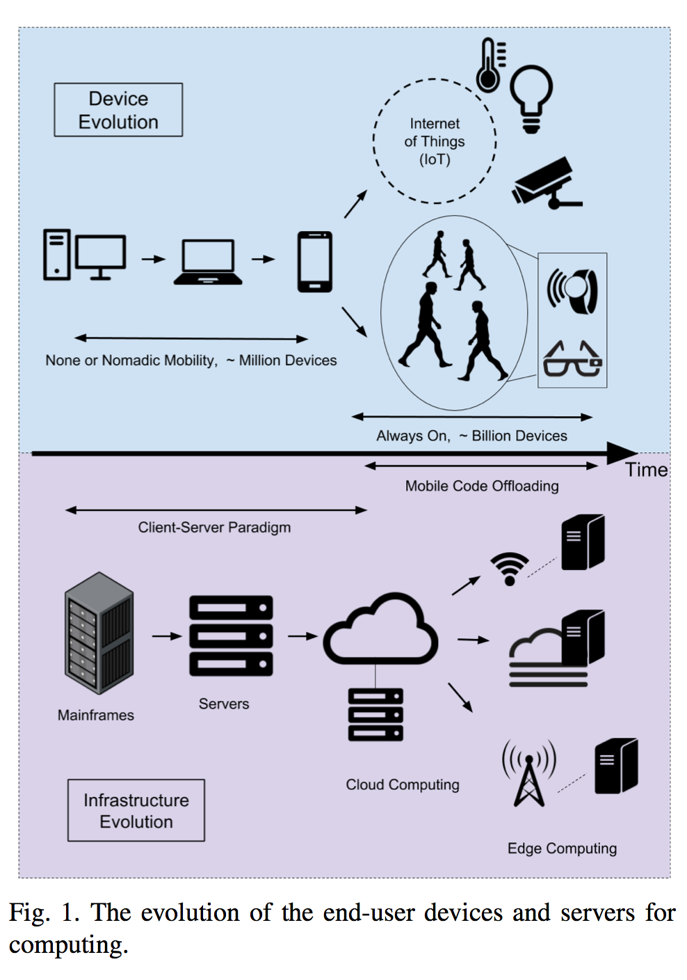

Either accompanied by the smartphones or in a standalone mode, a large variety of commercially available wearable gadgets also contribute to make the ubiquitous computing vision a reality. A new edge device like a Smart Glass, Smart Watch, Smart Bracelet and even Smart Plaster is appearing in the market. The evolution of the personal devices as the computational resources over the last years is illustrated in Figure 1. These new devices continuously log data, implement various services and pump intermittent audio-visual data traffic.

into the network. Yet, there exists a separate category under the umbrellas of Internet of Things (IoT) and Machine-to- Machine (M2M) Communications where machines themselves participate in various services. IEEE , All Seen Alliance, Thread Group , Open Interconnect Consortium, and many others have a large set of standards for IoT. Accompanying the ongoing research activities, great effort is put into developing real applications with the help of available standards bodies and specifications.

Combining all these, we see a pervasive computing infrastructure with a network of multimodal, multi-dimensional data sources, dispersed geospatially, potentially offering a wide range of novel services. One problem, however, is about how to implement complicated services for the envisioned novel use cases via mobile, tiny and gadget-like nodes that are computationally restricted. A straightforward alternative is to enhance the computational capabilities of these edge nodes using the centralized cloud computing resources. However, despite their "unlimited" computational capacities, legacy cloud computing infrastructures cannot be the remedy for solving all problems of these edge nodes due to the inherent latency constraints of the Wide Area Network (WAN) used for accessing the cloud services . Since a large variety of the new edge services have real-time requirements or interactive behavior with high Quality of Service (QoS) expectations, this drawback cannot be neglected. When the limitations of the public Internet connection are taken into consideration, another technical alternative is bringing the "Cloud" closer to these devices. Lately, we witness a relevant trend in ubiquitous computing called Edge Computing where the computational resources are being brought nearer to the end user.