Week 27

SDN-EDGE COMPUTING COOPERATION

The complexities resulted by deploying the cloud-like re- sources and related services at the edge of the network can be solved by a control mechanism that is able to orchestrate the distributed environment. The benefits of programmable networks align with all these requirements and the recent form of SDN has the inherent capability to mitigate the barriers that prevent Edge Computing to reach its full potential. All data flow management, service orchestration and other management tasks are accomplished by the central SDN controller that is transparent to the end-user.

Before getting into the technical details of the SDN paradigm, examining the real-life scenarios in detail helps to clarify the operations of the SDN-enabled Edge Computing systems. In this respect, different areas of use and possible scenarios are discussed from the perspective of SDN.

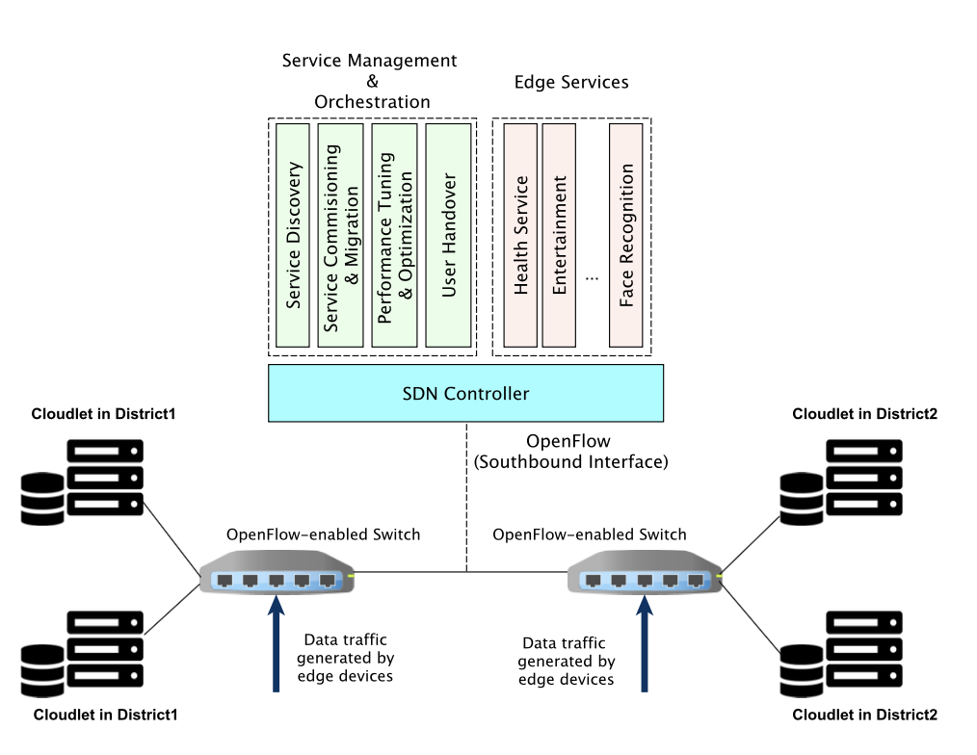

fig1.orchestrating edge computing facilities using SDN

A model for service orchestration through SDN and its components are illustrated in Figure 1. In this setup, Cloudlets are employed as the underlying Edge Computing technology. Cloudlets in different physical locations are connected via OpenFlow enabled switches and provide access to their users through a WLAN. These switches are controlled by an SDN controller through OpenFlow messages and other SDN management protocols such as OF-Config.

The controller hosts a variety of SDN northbound applications to execute the necessary functionalities and present the fundamental behavior for realizing the overall service management and orchestration. Another set of applications are directly related to the edge services themselves, such as health services, entertainment and video processing.